“ “IS THERE AN OCEAN IN THE HOUSE?”
Level | Investigations
Topic | Temperature
‘OITH bench-top’s | Introduction, Definitions, changing. The nature of water.  GTV 2.1  GTV 2.2 | Tool, (setup)  manufacturing, testing, modification.  GTV 2.2, 2.3 and 2.4 | Tool, standardization and calibration, issues of range and sensitivity. (and more system error.)  GTV 2.5 and 2.6 | Doing with the tool. Enquiry. Problem. Proposition.  GTV 2.7 and 2.8
Support material | Overview and  worksheets | Concept, analogy and creativity | Data handling, conversions. Graphing, (recording and statistical error)  GTV 2.3 and 2.9 | Review  GTV 2.10

Benchtop 2: manufacturing the instrument (GTV 2.3)
The kit
- Small (50ml, 100ml are best) glass bottles /jars with screw on lids.
- Disposable gloves and newspaper
- Straws and thin plastic tubes (from antiseptic spay bottles)
- Kitting needle, metal vegetable peeler or some sharp tool to make holes in lids
- Takeaway chopstick
- Glue (can be super glue) best is a 2 part epoxy (you can buy this in a small 2 tube pack)
- Red food colouring
- Measuring Jug
- Fridge and Freezer
- Vodka (or a spirit of similar alcohol content (Kirsch, grappa, etc)
- Labels and pen

- Match tube to jar, thinner the tube the smaller the jar. Straw (5ml internal diameter)with 200-250ml. Thinner tube (4ml internal diameter ) with 50-100ml containers. (2-3ml with 20-25ml containers.)
- Use the knitting needle or similar to make neat round hole in centre of container lids.
- Making sure the hole is a tight fit for selected tube.
- Place tube in hole, (use a piece of wood chopstick to act as a guide shaft for inserting plastic straw).
- Use epoxy glue around tube /lid joint on outside and inside.
- Set aside to dry.
- Put glass containers in fridge
- Put water in jug in fridge for water based thermometers
- Put vodka in freezer for alcohol based thermometer
- When glue is dry place bring container to bench on a stainless surface or in sink
- Put in a few drops of red food colouring and pour in the appropriate liquid-vodka or water
- Make sure the container is overfull.
- Screw the matched lid and tube on quickly and tightly.
- You can leave on the sink bench BUT keep a close eye on alcohol thermometers in case they expand too far up the tube.
- Keep thermometers in the fridge (by arrangement with the rest of the whanau bubble!).

Example of a finished homemade 50ml alcohol thermometer!

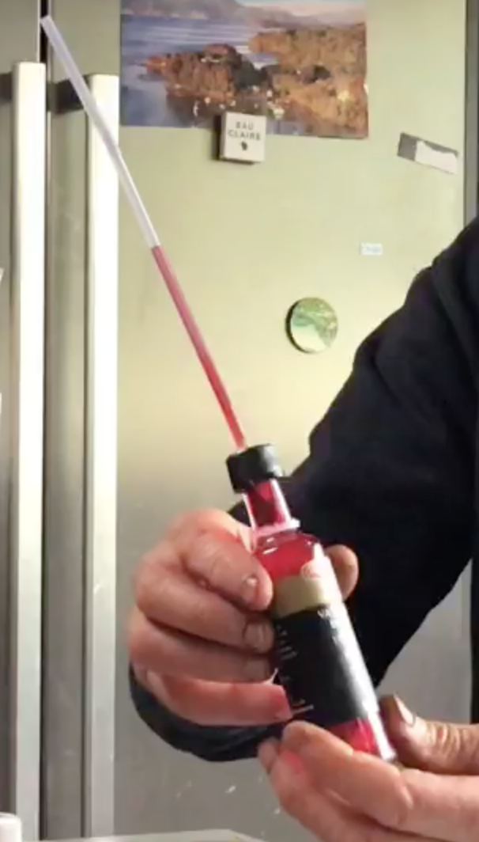

4ml clear tube

Red food dyed vodka

50ml glass container

Benchtop 3: standardization, calibration and conversion references (GTV 2.4, 2.5, 2.6)

For this you will need to add to the kit list
- plain white paper
- ruler and cellotape
- sharp pencil
- coloured pencils
- a healthy human body!
- sleeping bag or warm blanket!
- ice (600gm)
- cold water (2 L)
- salt (about 600 gm)
- 2L ice-cream container
- Kitchen scales

- Mark up a temporary reference scale in 5mm divisions and Sellotape to side of tube on each instrument
- Leave ‘thermometers’ on kitchen bench for 1st comparable reference – room temperature r1
- Check until level of liquids in tubes no longer changes this is the point where heat uptake by the thermometer is equal to heat loss , the equilibrium point is now measuring the temperature of the surrounding air. Mark on temporary scale and label r1
- Repeat this procedure for reference r2 in the fridge
- Repeat for the alcohol thermometers only for reference r3 in freezer
- Repeat these 2 or 3 times to check consistency . NOTE they probably will not be consistent!
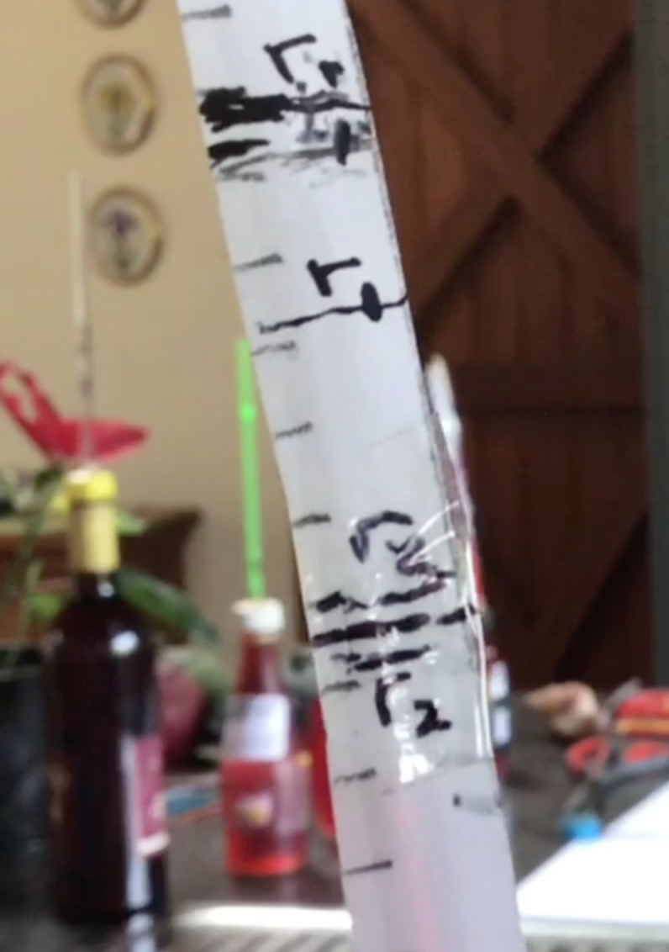
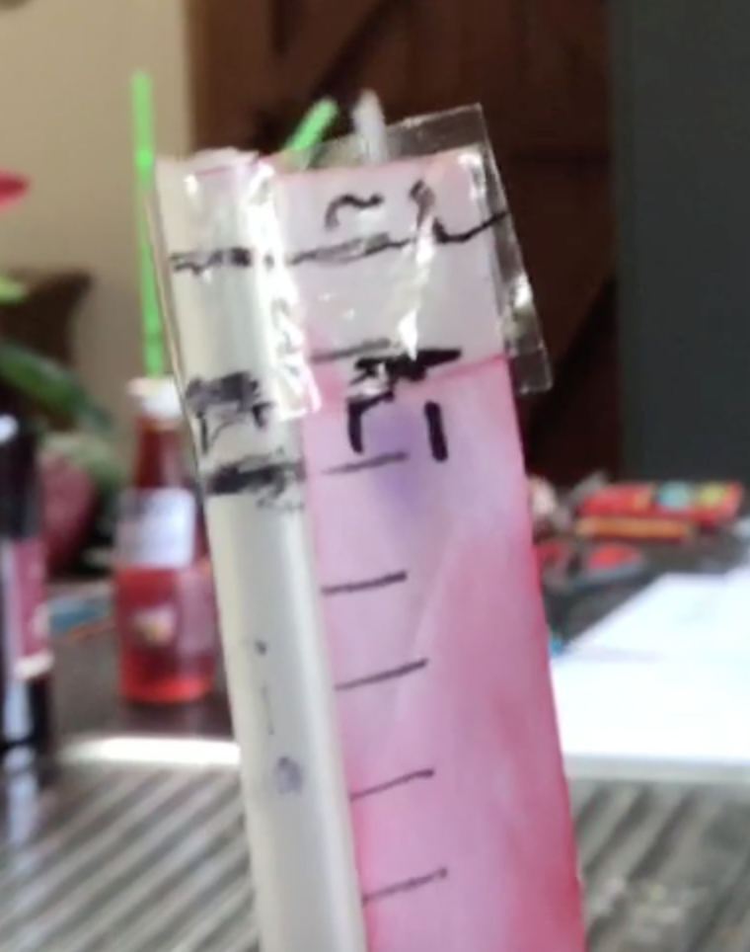

R1(room) and r2(fridge) reference marks These r1 (room ) reference marks
Where r2 is more consistent (and show that this thermometer should
Conserved) than r1 not be left in a warm room!!

- NOW use your own body temperature as a consistent and conserved reference standard r0
(As shown in GTV 2.5)
- Watch GTV 2.6 to see how to set up low reference that will allow us to set points for comparable conversion scales.
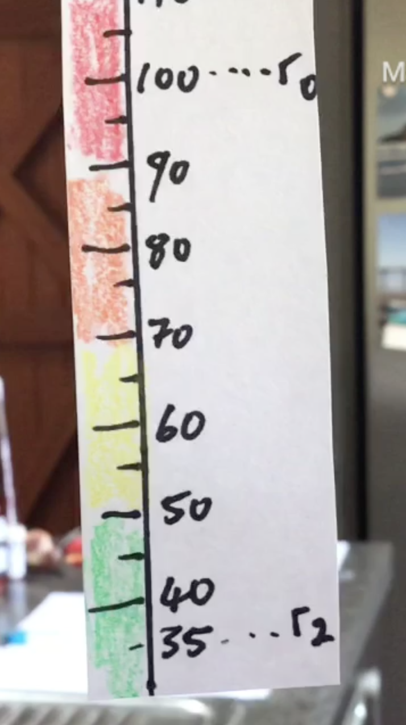
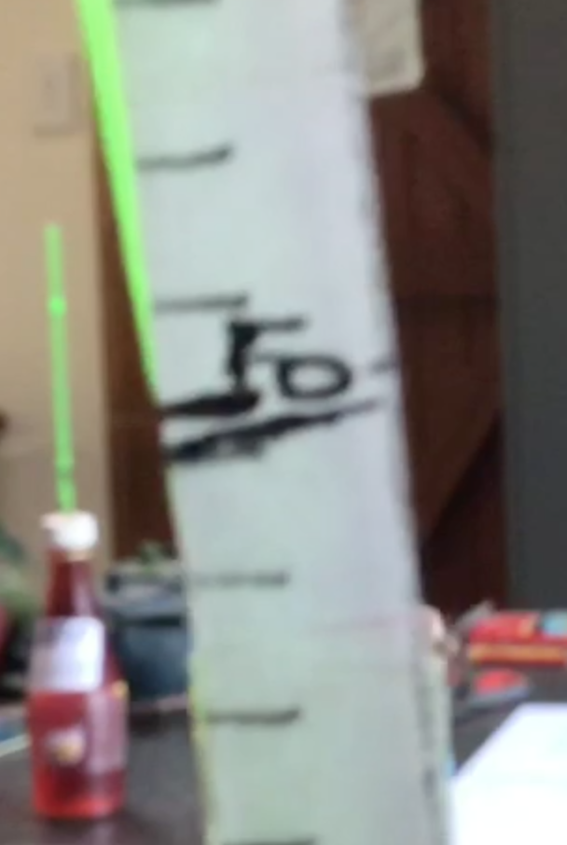

R0 (human body temperature) final ‘New Scale’ (the ‘humbod’ scale’
Shows the most consistent and calculated, measured out, marked up
Conserved values so it makes and colour coded for thermometer
Sense to use it as calibration “Karina”
Reference standard.

- Make a solution of equal parts water and ice (by wt) and place in 2L container place in thermometers and wait till levels reach equilibrium and stop changing. NOTE make sure containers are fully submerged and you may have to occasionally stir mixture gently to ensure optimum detection of temperature of the solution. Mark on scale and label ‘iw’ (ice-water).
- Repeat this procedure with a mixture of equal parts ice, water, salt (600 gm of each fits into 2L container well) mix thoroughly and place thermometers in again make sure containers are fully submerged and you may have to occasionally stir mixture gently to ensure optimum detection of temperature of the solution. Mark on scale and label ‘iws’ (ice-water-salt).

YOU WILL NOTICE that I set my scale and divisions between r0 and r3 before I did the iw and iws tests.
YOU don’t need to do this you can DO THE iw and iws tests instead of r2 and r3 and mark as reference points riw and riws. (It was only luck that had my iws = my r3).
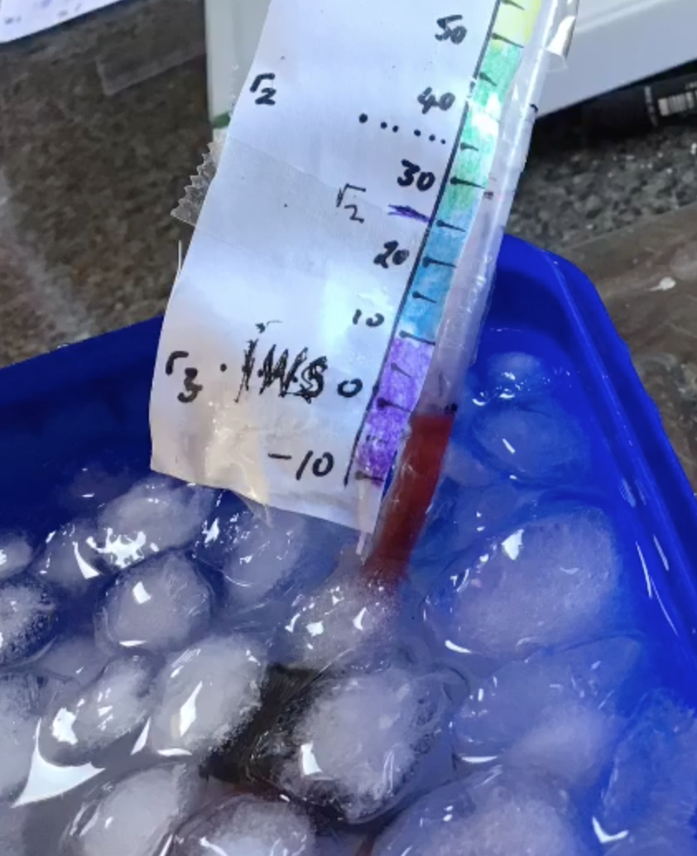
- Determine top and bottom of your scale. I chose r0 (human body ) as top =100 and r3 (or as it turned out riws) as bottom =0 (which is very similar to Fahrenheit’s decisions back in 1726)
- Decide on number of divisions. I chose 100 divisions (which is the decision Celsius made in 1742)
- Give your New Temperature scale a name (Celsius and Fahrenheit are already taken !!). I decided to call my scale the ‘Humbod’ scale
- Now to mark up scales for each thermometer the distance between ‘humbod’ 100 and ‘humbod’ 0 is measured in mm (how far the liquid will expand between these 2 temperatures) then this distance is divided by 100 (the number of divisions in our scale) to find the mm distance for each ‘humbod’ degree.

- Neatly and precisely draw up final scales for each thermometer based on these calculations and colour code . (For example I used ‘hot’ to ‘cold’ colour sequence : 110-90=red, 90-70=orange, 70-50=yellow, 50-30=green, 30-10=blue, +10- -10 = purple.)
- Cello tape final ‘humbod’scales to thermometer tubes.
- Store thermometers in fridge

NOTE: left out too long the liquids will evaporate, effecting calibration!!

Now we are ready to design and carryout an experimental investigation into Ocean science using our thermometers.

