ACC Accredited Employers
University of Otago

Getting Assistance
Information if you’ve
been injured at work

Introduction

If you’ve been injured at work, this guide provides you with useful information to help you recover from your injury.

Once you’ve read this guide, keep it somewhere handy because you may want to check some details later.

Contents

For injuries that happen at work 2
When an injury happens 3
Helping you get back to an everyday life 5
Your rehabilitation plan 6
The help you can get from us 7
Rights and responsibilities 10
Working together to resolve issues 12
Your privacy and personal information 14
Commonly used forms 15

This booklet has been jointly developed by representatives from; The Council of Trade Unions – Te Kauae Kaimahi, Accredited Employers and ACC.

For injuries that happen at work

You may know that New Zealand has ACC. ACC provides 24-hour, seven-day-a-week injury cover for everyone in the country, whether or not an injury happens at work.

Some organisations choose to ‘walk in the shoes’ of ACC and manage injuries that happen at work to provide at least the same level of help as ACC. You work for one of these organisations (called an Accredited Employer). This means you’ll deal with someone from your organisation (or someone your organisation uses to handle workplace injuries – called a third party administrator) who will help you recover from your injury.

If your injury didn’t happen at work, make sure you tell your employer – the help you’ll get will be provided through ACC, not the organisation you work for. Visit www.acc.co.nz for more information about the types of help available from ACC. The University of Otago works with Howden Care who can also manage you non work claim.

Important note

This guide provides general information about the help available to you. The help you receive will depend on your injury and individual circumstances, and accredited employers will have their own ways of providing the help you require.

Accredited Employers must follow the Accident Compensation Act 2001 that defines what is available through ACC. They must provide no less than what ACC would provide as entitlements and assistance, but they may provide more.

To confirm if you are eligible for a particular type of help or service, please talk to your support coordinator. Your support coordinator or manager can also tell you more about the types of help available to you.

Note: ‘we’, ‘our’ and ‘us’ can be used to refer to your employer, support coordinator or a third party administrator.

When an injury happens

The following diagram takes you through the first steps when an injury happens.

If you’ve received this guide a while after your injury, check that these first steps have happened.

You work for an Accredited Emm
p
lo
y
er

You get injured and need treatment.
Did the injury happen at work?
See a health professional

(
eg
doctor). They will help you
make an injury claim to
ACC. For more information
about making an ACC claim
visit
www.acc.co.nz

No
Yes
See a
health professional (eg doctor)
and say
you work for an Accredited Employer. The
health professional will help you make an injury
claim to your employer.

Depending on your injury
and how quickly you need
treatment:
-

it may be a good idea to
see if your employer
uses a preferred health
professional and, if so,
see them
-

get someone to report
the injury at work and
complete an incident
report.
No
See the
‘Working together
to resolve issues’
section in
this guide if you’re not
happy with the decision.
No
You may not need any
further treatment, or only a
small amount of further
treatment (eg some physio
sessions).

You may like to read
‘The
help you can get from us’

section of this guide.
The health professional lodges a claim with your
employer.
Is your claim approved by your employer?
Is your injury serious?

Note: Usually a serious injury is one that will
take you at least a few weeks/months to recover
from.
Read the rest of this guide because the
information is important for you to know.
Yes
Yes

What injuries can I lodge a claim for?

You can lodge a claim (through your Accredited Employer) for the following types of injuries:
- an injury that happened at work as a result of an accident/event
- a work-related gradual process injury which is a physical injury that develops slowly and where the symptoms increase over time due to the work tasks you do
- an infection or disease you contract through work

You can’t lodge a claim for age or health related needs.

It’s important that you complete a work incident report and inform your manager as soon as possible. This will help to make quick decision on your claim.

The work incident report is important. If you need help finding or completing a work incident report, please ask your manager and/or health and safety representative for assistance.

Who can I lodge a claim through?

Your employer may use a preferred health professional/doctor who is familiar with your workplace and alternative duties that may be available while you recover. Your employer may ask you to see this health professional/doctor for a medical assessment. However you are, of course, entitled to see your own doctor.

How long will it take for a decision about my claim?

As an Accredited Employer we need to make a decision whether or not to approve your claim within 21 days of receiving the claim form you completed when you first saw a health professional about your injury.

For complex claims like a work-related gradual process injury, we may need more time to get the information we need to make a decision. We can ask you for a time extension of two months (and further extensions up to a maximum of nine months from the date you lodged your claim) if necessary.

If we don’t make a decision about your claim within the period we need to, we’ll automatically approve your claim.

How will I find out if my claim has been approved?

We’ll contact you to let you know whether or not we’ve approved your claim. If we can’t approve your claim we’ll let you know you why, and how you can ask for a review of our decision if you’re not happy with it. See the ‘Working together to resolve issues’ section of this guide for more information.

NOTE: Until we make a decision on whether we can approve your claim, you may not be eligible to receive any help from us (eg payments for loss of earnings). Talk to your support coordinator for more information about your situation.

What does it mean if my claim is approved?

It may mean that we can provide help to assist your recovery (known as entitlements). See ‘The help you can get from us’ section of this guide for more information about the types of entitlements you may be eligible for.

If you don’t need further treatment for your injury, approving your claim is likely to mean that we’ve already contributed to the cost of the treatment you’ve had - such as helping to pay for the visit when you first saw a health professional about your injury.

Some health professionals may charge more than the amount we can pay, called a surcharge. If this happened, the surcharge may be your responsibility, even if your claim is approved.

Helping you get back to an everyday life

Once your claim is approved and if your injury is serious, meaning you’re likely to need at least a few weeks/months to recover, we’ll help you get back to an everyday life as soon as possible.

Our role
It’s our role to help you regain your independence following your injury. We can help you do this by:
- preparing a rehabilitation plan with you
- coordinating services to help your recovery
- contributing to the cost of the treatment and help you need
- providing payments for loss of earnings if you need time off work.

Your role
You can help yourself recover quicker by:
- being involved in preparing your rehabilitation plan
- committing to your rehabilitation plan
- completing the courses and treatments we jointly agree to - keeping us in the picture throughout your recovery.

Others involved in your recovery
As well as yourself, health professionals (such as your doctor) and us, others who can play an important role in your recovery include:
- service providers (eg home help)
- family
- friends
- workmates
- a union delegate
- a workplace health and safety representative (who is trained to help you return to work safely)
- an advocate
- an interpreter.
During your recovery you are welcome to bring a support person/s to meetings.

The steps to help you get back to an everyday life

- Together we prepare a rehabilitation plan that includes goals for you to reach

- We arrange an assessment and contact people to provide the help and services you need

- You work through your rehabilitation plan with the support of others

- YOU REACH YOUR GOALS

What we can and can’t do to help you

As a minimum, we follow the laws that apply to ACC which set out what can and can’t be done to he

lp you. However, everyone’s situation is different so before you make any important decisions, please talk to your support coordinator.

Your rehabilitation plan
The first step we’ll take together is to prepare your individual rehabilitation plan.

What’s involved?

WE’LL MEET WITH YOU
Your support coordinator will contact you to set up a meeting if it’s possible to do so.

AT YOUR MEETING
We’ll work together to develop your plan, which covers:
  - your goals. They could be:
    - being able to take a full part in family life again
    - getting back to work
    - getting back to sport or hobbies
    - being independent at home again
  - what you need to reach your goals. Depending on your situation, this could include: - medical treatment
    - surgery
    - physiotherapy
    - exercise
    - installing special equipment in your home
    - relearning skills and helping you get back to work
    - an agreed plan for home help
Qualified assessors can help us find out what your injury-related needs are
  - how we’ll check you are making progress.

PREPARING YOUR PLAN
We’ll work with you to prepare your plan. It’s important that you’re involved, so you get a plan that you want to complete and that’s realistic.

A number of different people may be involved in the meetings to set up and update your plan – your support coordinator, an Occupational Therapist, your manager/supervisor etc. But it’s important that you remember this is YOUR plan. You must be happy with it. If you wish you can:
- take your own support person or people along to the meetings (eg a family member, union delegate, health and safety representative, workmate)
- make your own requests and suggestions
- take the plan home with you to consider and seek advice before signing it.

If there’s something about your plan you don’t understand or you’re not happy with, talk to your support coordinator.

Once we’ve agreed on your plan, we’ll give you a copy to sign or take away to think over before signing.

PROGRESS UPDATES
We’ll agree how often we call or meet with you to:
  - monitor and review your recovery progress against your plan • talk about the next steps in reaching your goals
  - change your plan if necessary.

Your plan can be changed if your needs change - for example, if your recovery is going faster or slower than expected. A big part of your responsibility is keeping your support coordinator informed of your progress, so your plan can be kept up to date.

What makes a successful rehabilitation plan?

- It’s a plan for YOU and your needs
- It takes a team effort to help you
- Together we set goals and timeframes
- You start your plan as soon as possible
- We check your progress and make changes if necessary.

The help you can get from us

The help you get from us (ie your entitlements) will depend on your injury and how it affects you.
In general we can help with:
- assessments
- treatment
- managing with everyday life
- getting back to work.

Here’s a quick guide to the range of help we may be able to offer you.

Assessments
We can usually contribute to the costs of assessments. Your support coordinator can provide you with specific information based on your situation.

Medical assessments

Your employer may use a preferred health professional/doctor who is familiar with your workplace and alternative duties that may be available while you recover. Your employer may ask you to see this health professional/doctor for a medical assessment. However you are, of course, entitled to see your own doctor.

Specialist assessments

Sometimes it’s difficult to know the best treatment for an injury or what’s causing the problem you’re experiencing. In such situations you may be referred for a specialist assessment to help: - obtain information to assist us with assessing what entitlements you’re eligible for - determine what treatment is right and best for you.

You have the right to know what questions will be asked at the assessment and why they’ll be asked. You can also ask for a copy of the letter and information that’s sent to the specialist, before or after your appointment.

Treatment

We can usually contribute to a wide range of medical and related costs, including:
- emergency care and ambulance services
- specialist medical and dental treatment
- non-urgent treatment such as physiotherapy
- prescriptions relating to your injury
- x-rays
- surgery at private or public hospitals - even if you have medical insurance
- replacing or repairing dentures that were damaged when you were injured.

We pay the full amount of some costs, and part of other costs.

Emergency care and ambulance services are covered in full. For most other treatments we pay a set amount. Your health professional may charge more, called a surcharge, in which case you may be required to pay the difference.

Approval may be needed before we can help with the costs of certain types of treatment and medication. Ask your health professional or support coordinator before you get treatment or medication. Also remember to keep the original pharmacy receipts for your injury-related prescriptions so we can refund you.

Talk to your support coordinator about what costs we can contribute to and by how much.

Managing with everyday life

We can usually help if you’re having trouble managing at home or with everyday life. Examples include:
- help with general housework such as cleaning, vacuuming and laundry
- help with personal care such as showering, bathing and getting dressed
- help with looking after children, including taking them to and from school
- equipment such as crutches, wheelchairs and shower stools
- minor changes to your home, such as safety rails
- payment towards public or private transport costs to and from work or treatment
- training to help you adjust to your injury.

This is not a complete list. Your support coordinator can provide more information about the help we offer and whether you’re eligible.

Getting back to work

Depending on your injury, you’re usually better off working while you recover, because:
- you’ll recover quicker
- you’ll be paid what you were being paid (on average) before your injury
- it’s good for your overall health
- it gets you out and about and keeps you in touch with others.

If your injury means you can’t continue in your normal role without help, or means you need time off work, we can usually help by:
- getting you physically ready and confident enough to get back to work
- buying or modifying equipment for your workplace
- arranging transport to and from work while you recover
- working with you and your manager to find meaningful alternative duties for you.

Monitoring your progress when you’re back at work

It’s important that your progress is monitored when you’re back at work to ensure you aren’t doing any duties that weren’t agreed to in your plan. It’s also important that the duties you’re doing aren’t increasing your pain levels or causing you further harm. You should report any problems to your support coordinator or advocate/support person as soon as possible, so you’re not doing anything that could hinder your recovery.

Your activities at work should gradually be increased, until you’re back to normal duties and hours of work. If this isn’t happening you and your support coordinator should look at your rehabilitation plan, to see how it can be changed to get a better result.

Payments for loss of earnings while off work

You may qualify for weekly payments for loss of earnings if you need time off work. These payments are called weekly compensation and are usually up to 80% of your normal weekly pay, before tax, while off paid work. For information about your situation contact your support coordinator or manager.

We’ll pay you from the date you were first off work because of your work-related injury.

If you start back at work part time or on reduced hours, we can help to top up your pay. Your support coordinator can explain how this works.

How to apply for compensation

If you’re eligible for weekly compensation and haven’t been set up already, talk to your support coordinator, who will need a copy of your current medical certificate. If your support coordinator doesn’t work for your employer and/or doesn’t have access to the following, you’ll also need to provide:
- verified details of your pay
- your Inland Revenue number and tax code
- your bank account details.

Exploring other job options

If your injury stops you doing your old job, we’ll help you find new options for working and regaining your independence. This process is called vocational independence and we can:
- organise an occupational assessment to identify your skills and new jobs you could do
- arrange a medical assessment to check that new job opportunities are right for you given your injury
- provide rehabilitation services that help you use your existing skills or develop new skills.

You qualify for this help if:
- you’re receiving weekly compensation, and
- you need help to keep your job or get back to work, or
- you’re on parental leave.

If you’ve reached this point in your rehabilitation it’s very important that you talk to your support coordinator about the vocational independence process so that you understand how it works and how it will affect you. The process involves a series of medical and vocational assessments and further information about this can be found on www.acc.co.nz (FSVI01 Vocational Independence Assessment).

Permanent impairment

If your injury has resulted in a permanent impairment, you can apply for a lump sum, one-off, nontaxable payment, or an independence allowance. You can be assessed either when your condition has stabilised or after two years. If your condition gets worse later, you can be reassessed.

Talk to your support coordinator for more information.

Rights and responsibilities

Getting you back to an everyday life as soon as possible is a team effort. Before we start, it’s important that we have a way of working together that we both agree on and commit to.

Please make sure you understand the rights and responsibilities we both have.

Rights and responsibilities

Our responsibilities during your recovery

We have a responsibility to make sure you know about your right to:
- be involved in the decision-making about your recovery
- have a rehabilitation plan, as agreed with your support coordinator and:
  - involve a support person/s in preparing your plan
  - involve your health professional in preparing your plan
  - ask for independent advice before signing your plan
  - apply for a formal review of your plan, if you don’t agree with it
- raise any concerns with your support coordinator or their manager
- apply to have any decision about your claim formally reviewed
- ask your support coordinator for more information about the laws that apply to ACC (Accident Compensation Act 2001) that we follow.

We also follow an ACC Code that helps guide how we work with you. It states your right to:
- be treated with dignity and respect
- be treated fairly and have your views considered
- have your culture, values and beliefs respected
- a support person or persons
- effective communication
- be fully informed
- have your privacy respected
- make a complaint.

The Code promotes mutual trust, understanding and respect; it doesn’t cover entitlements.

What happens if we don’t meet our responsibilities?

You have several options if you don’t feel we’re meeting our responsibilities and would like to raise this with us. See the ‘Working together to resolve issues’ section for more information.

Your responsibilities during your recovery

While you receive entitlements and payments from us, you must:
- take responsibility for co-operating in your recovery
- help us prepare and update your plan
- if required, provide us with medical certificates that show the progress of your injury and/or fitness for work
- contact your support coordinator if your circumstances change
- if required, undergo medical or surgical treatment for your injury – talk to your support coordinator if you have any questions or concerns
- attend all your appointments, including all assessments required by us
- contact your service provider(s) and support coordinator to change appointments if you can’t attend.

Your responsibilities while receiving weekly compensation

You have the following responsibilities while receiving weekly compensation payments from us:
- You must tell your support coordinator before you do any work, paid or unpaid, in any capacity
- You must tell your support coordinator immediately, if you:
  - receive a pay increase
  - receive any other income, such as holiday pay or sick leave pay
  - do any activities that your medical certificate says you shouldn’t, such as driving or heavy lifting.

Let your support coordinator know as soon as your circumstances change to make sure your payments remain fair and accurate.

What happens if you don’t meet your responsibilities?

If you don’t meet your responsibilities without a good reason, we may stop making payments or stop contributing to the cost of the treatment and help you need. In rare cases we may need to take legal action or decline to provide the help you need.

Working together to resolve issues

We want to have a positive relationship with you. So if you have an issue with something we’ve done or a decision we’ve made, we’ll try to work with you to sort it out as quickly as possible.

What usually works to resolve issues

Most issues are resolved quickly and easily by talking to who you’ve been dealing with (your support coordinator) because they understand your situation. Otherwise you may prefer to talk to their manager.

Facilitation or mediation

In some cases facilitation or mediation may be the best option to help resolve an issue. This involves a qualified, independent person bringing us together to look at the issue and work out a solution.

Talk to your support coordinator for more information about asking for facilitation or mediation.

Making a complaint

You can make a complaint if you’re unhappy with the service you’ve received from us. The matter will be looked at in detail and a decision will be made on whether what happened was fair and reasonable. You’ll be advised of the decision in writing.

Talk to your support coordinator for more information about making a complaint.

Right to review any decision

You have the right to an independent review of any decision, whether the decision was about:
- approving your claim or not (ie cover)
- what we can and can’t do to help you (ie entitlements).

You should lodge a review application within three months of the date you receive our decision. If you’ve got a good reason why you can’t meet this deadline, you may still be able to submit a late application for review.

Talk to your support coordinator for more information about asking for an independent review of a decision if you’re unhappy with it. You can also contact your Union or the Workplace Injury Advocacy Service for advice.

Right to appeal a review decision

You can appeal to a District Court for a review decision to do with cover or entitlements. You can’t appeal to a District Court if your complaint is to do with the service you’ve received.

Other organisations that may be able to help you

Depending on your issue, the following independent organisations may also be able to help you.

For an issue about your privacy:
Office of the Privacy Commissioner
Freephone: 0800 803 909
Website: www.privacy.org.nz

If you feel you’ve been treated unfairly by a government agency:
Office of the Ombudsmen
Freephone: 0800 802 602
Website: www.ombudsmen.govt.nz

If you’re unhappy about a health or disability service you’ve received, or the conduct of the treatment provider:
The Health and Disability Commissioner
Freephone: 0800 112 233
Website: www.hdc.org.nz

If you require advocacy support or assistance regarding an employment issue contact your Union or:
The Council of Trade Unions – Te Kauae Kaimahi
Freephone: 0800 698 6466
Website: www.union.org.nz

Your privacy and personal information

When you lodged your claim, you gave us permission to collect, use and disclose information about you and your claim so we could:
- assess your entitlement to compensation, rehabilitation and treatment
- evaluate our services and performance
- do research into injury prevention and effective rehabilitation.

You have the right to see the information we hold about you and to have anything that’s wrong corrected.

The information we collected about you will only be lawfully used or disclosed. In collecting, disclosing and storing your information, we will comply with the obligations of the Privacy Act 1993 and the Health Information Privacy Code 1994 – visit www.privacy.org.nz for more information.

This information authority relates to all aspects of your claim, including any external agencies or service providers such as general practitioners, specialists and assessment agencies. The authority lets any of these people or organisations provide the information requested directly to us.

We may obtain further consent if you require additional treatment and/or entitlements. This ensures you’re fully informed of your rights to privacy and of our rights to release information to health professionals and others who will assist you.

Commonly used forms

Understanding the ACC45 – ACC Injury Claim Form

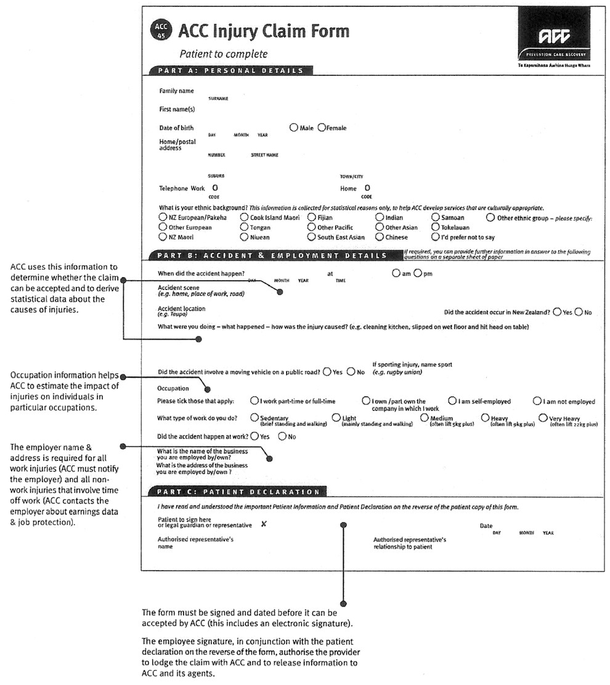

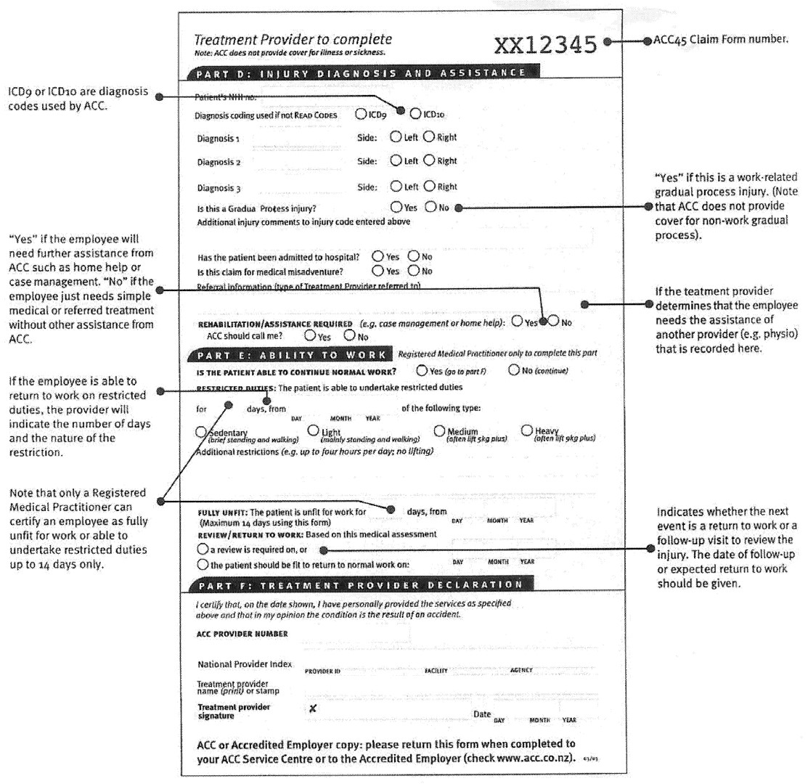

Understanding the ACC18 – Medical Certificate

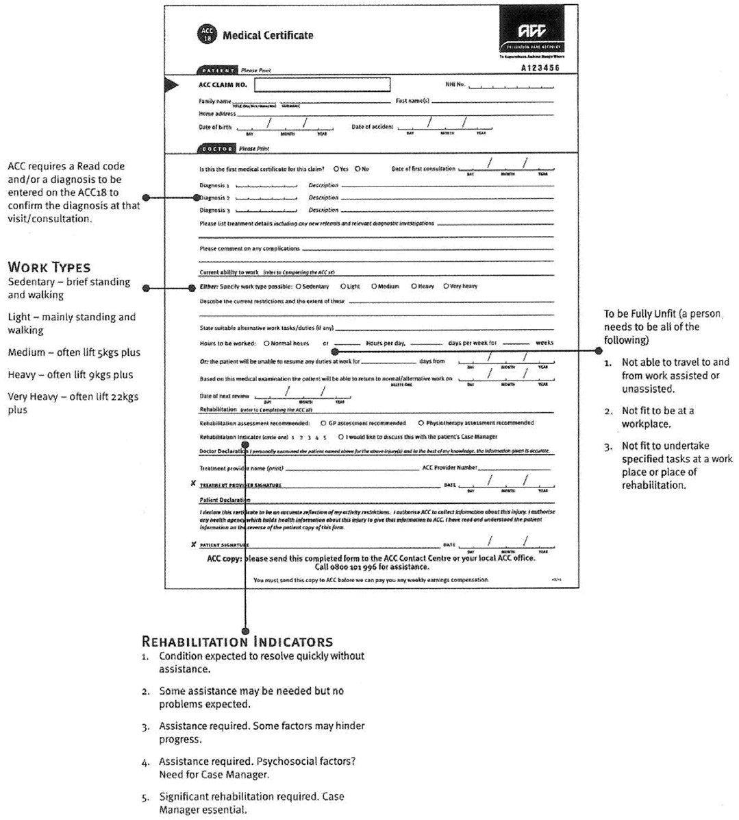

ACC5285 Updated December 2010

