Adding an Incident via “The Portal”
To add an incident, go to otago.ac.nz and select Staff
The window below will open.
Select Health and Safety
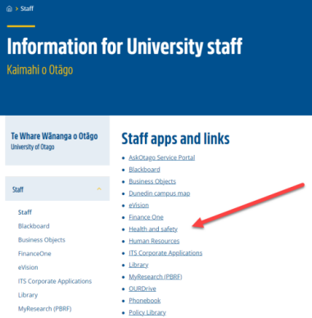

Scroll down the “Health, Safety and Wellbeing” page to “Report an Incident here”
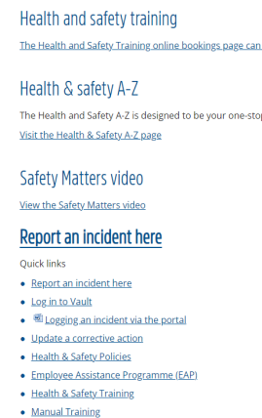
You are now in the “Portal”
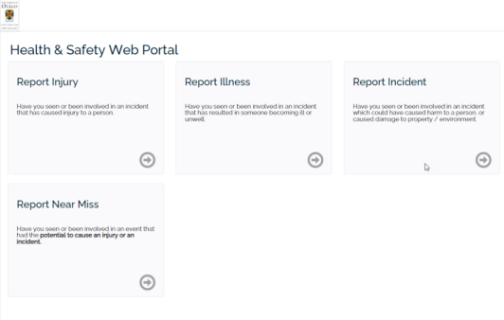
Select which area is the most appropriate for what you want to report and click on the arrow.
For this example I have selected Report Injury.
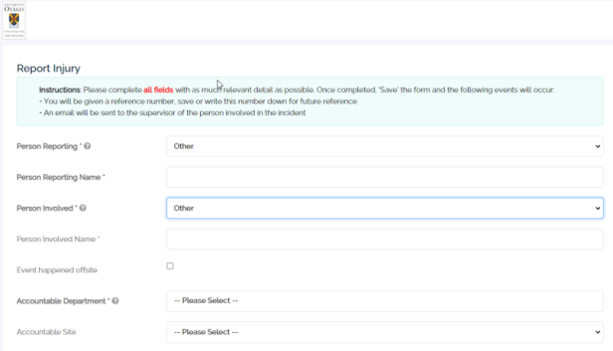
Select “Other” and free text your name in the Person Reporting area. It would be helpful if you also add in brackets whether the person is a student, staff, contractor or a visitor.
Repeat the above for the person involved remembering to add in brackets whether the person is a student, staff, contractor or a visitor.
Follow the prompts for each area. Note those marked with an * are mandatory fields. Ensure you use the calendar and click in the Event Date and Event Time selections.
Please give as much information regarding the location and injury as you can. IT can also be helpful to have your contact phone number in the description so that if necessary we can contact the person involved. If you have any photos they can be added here.
When you are happy with what you have written remember to select Save.
Thank you, you have now submitted an incident report.
The report will be progressed by the Health and Safety team and assigned to the appropriate person for investigation.
NB: There is also an option to mark incidents as 'Sensitive Event' for matters like bullying or discrimination, or any other issue you may not feel comfortable discussing with your direct line manager but wish to report to Health & Safety (H&S). When this option is selected, the report deviates from the standard pathway and is directly forwarded to the two individuals you've chosen from the drop-down menu. They will contact you to discuss further steps, ensuring your privacy/consent before any action. Contact H&S for more details.

