“ “IS THERE AN OCEAN IN THE HOUSE?”
Level | Investigations
Topic | LIGHT
‘OITH bench-top’s | Introduction, The nature of waves. And the wave nature of light.  GTV 3.1  GTV 3.2  GTV 3.3 | Tool, (setup)  manufacturing, testing, modification.  Light sensitive pigments, extraction and use.  GTV 3.4, 3.5 and 3.6 | Tool, Qualitative vs quantitative data, sensitivity.  GTV 3.5 and 3.6  Making a tool that uses light to capture and store image information GTV 3.8 | Doing with the tool. Enquiry. Problem. Proposition.  GTV 3.9  (includes signup for practical kit to support this challenge)
Support material | Overview and  worksheets | Concept, analogy and creativity. Memory, information capture and storage, image and imagination in the Nature of science.  GTV 3.7 | Data handling, wave s and ‘fun with formulae’  GTV 3.1, 3.2, 3.3 | Review and interviews  GTV 3.10

We have looked at temperature and Ocean. We saw how heat and temperature are related and how these relate to density. This leads to our next topic -LIGHT because the main source of heat in the world Ocean is solar electromagnetic radiation. This radiation warming the planet’s atmosphere also generates pressure differentials and so energize wind: and wind across ocean surface forms WAVES.
We are aware of the wave features of ocean through our dominant sense – SIGHT, which is sensitivity to light.

Sensitivity to light(photosensitivity) and the transfer and use of energy of light is essential for our understanding of Ocean, particularly ocean life. To help us understand light it helps to investigate the nature of waves!

In this topic we will investigate the nature of waves (NOW!) and the wave nature of light. Linking these to the important ideas of memory, imaging and imagination in the Nature of Science we will also explore colour, photopigments, anthotypes, and photoimaging. At the end of this topic we extend an invitation to participate in an ‘en-lightening’ challenge!

On our journey of ‘en-lightenment’ (! ha ha) we will also meet some amazing characters in the history of science who have helped us investigate, imagine, model and explain ‘LIGHT’.

To start you will need a small ‘kitchen kit’ for
Benchtop 1, the nature of waves (GTV 3.1)
-Large, deep dish or tray e.g. roasting dish
-small board e.g. chopping board.
-pieces of brick, rock
-light
-water

Procedure:
1.place dish on a bench below light source
2.1/3 to ½ fill dish with water
3.generate a wave at one end of the dish using the board
4. observe and/or make movie in slow motion using phone camera.
5. follow the activities in GTV 3.1 to explore NOW (nature of Waves)
-transfer energy
-dissipation
-reflection
-diffraction
-interference
-refraction

“Fun with Formulae” #1
ν =ƒ x λ wave speed = frequency x wavelength
As m/s =hertz(number of waves /sec) x m
λ
λ
Amplitude

λ
ƒ=4 hertz

Time 1 second

Wave period is time (secs) for 2 successive wave crests to pass a fixed point.
For this wave the period is 0.25 secs.

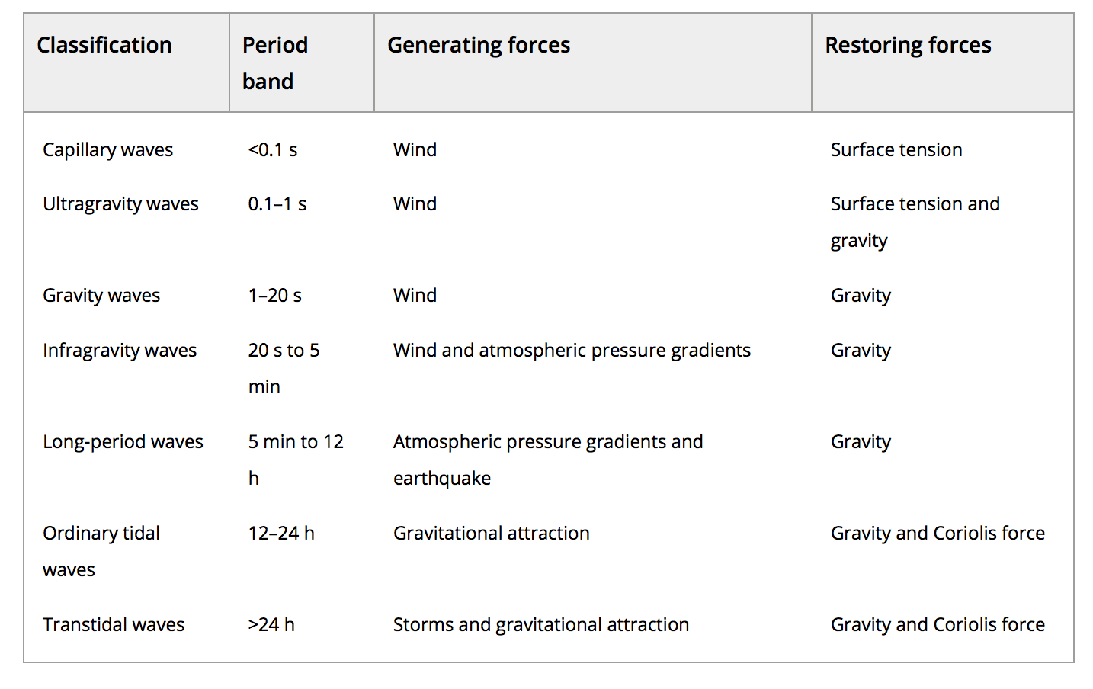
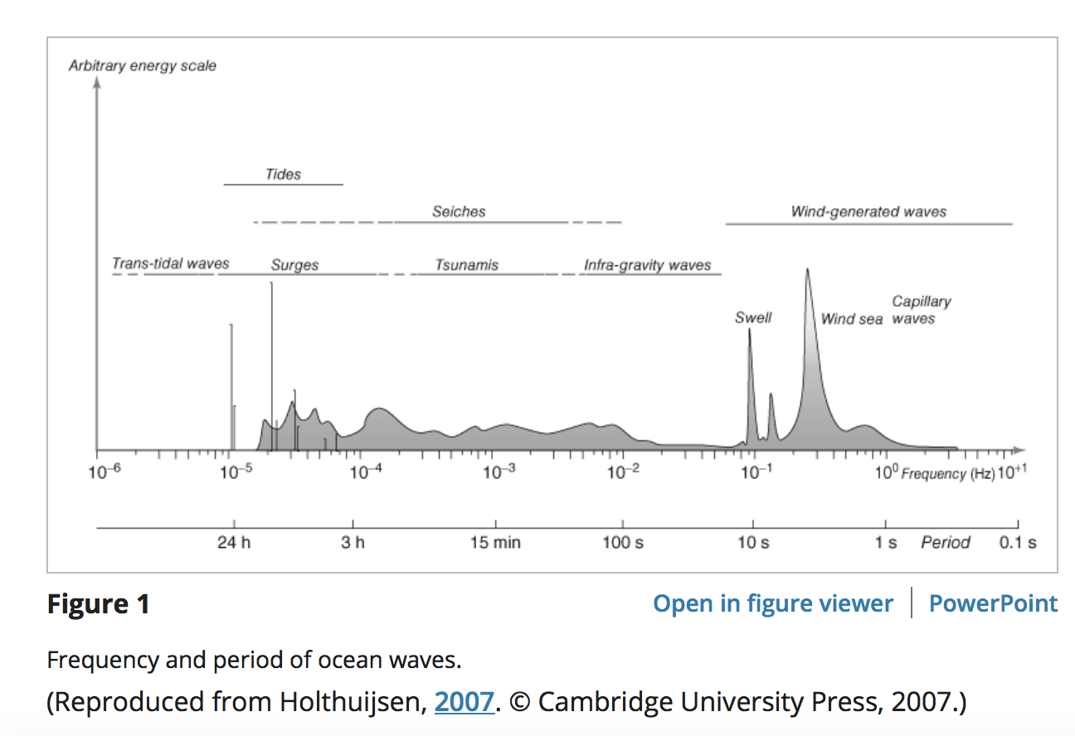
https://onlinelibrary.wiley.com/doi/full/10.1002/9781118476406.emoe077

