WORKING AT HOME - WORKSTATION CHECKLIST
Complete and Scan
Staff member keeps a copy and send to manager to hold on the departments records
Worksafe information: https://www.worksafe.govt.nz/dmsdocument/53779-setting-up-a-healthy-workstation-when-working-from-home/latest

Name: |  | Manager:
Department:  Role: | Hours of Work:  full time  part time  Time in Current Position: | Is this supported by the manager?  Yes No
Work Area | Requirements | Comments
What is the type work you do? e.g., data entry, documents, processing. | Other part time work, study, etc.: | Privacy and Confidentiality is this required?
Separate office & desk  Designated work area in room  Dining Table  Bedroom | Separate area if possible, or designated area is best practice  Add a photo of the area
Chair – adjustable chair does it adjust up and down and back?  Yes No | Add a photo of the chair | Chair requirements:
Is other equipment required:  Separate keyboard & mouse or screen  Footrest  Document holder  Other | Working on a laptop only is not recommended you either need a mouse and keyboard or screen so your head is kept at the correct angle | 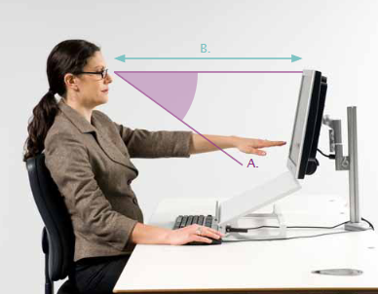
Environment  Is this a safe environment to work | Staff have you any concerns or questions? | Managers comments
Desk Type & Height  Fixed desk greater than 700mm  Fixed under 700mm  Sit Stand  Dining Table  Bench  Other furniture | Height under 700mm if taller this may need to be higher  Top thickness less than 30mm  Chair able to go high enough for shoulders relaxed
Do you have Pain or Discomfort? Yes No | If yes location & nature of discomfort and pain: | Refer to ohn@otago.ac.nz for follow up
Other: Any concerns you have about your set up or safety working at home |  | Any concerns you have about your set up or safety working at home
Recommendations | Manager
Comments or further assessment required ohn@otago.ac.nz

Extra equipment required

If concerns about the situation or pain and discomfort please contact the Occupational Health Nurse (ohn@otago.ac.nz) for further advice and assistance (such as a zoom workstation assessment).

