“ “IS THERE AN OCEAN IN THE HOUSE?”
Level | Investigations
Topic | LIGHT
‘OITH bench-top’s | Introduction, The nature of waves. And the wave nature of light.  GTV 3.1  GTV 3.2  GTV 3.3 | Tool, (setup)  manufacturing, testing, modification.  Light sensitive pigments, extraction and use.  GTV 3.4, 3.5 and 3.6 | Tool, Qualitative vs quantitative data, sensitivity.  GTV 3.5 and 3.6  Making a tool that uses light to capture and store image information GTV 3.8 | Doing with the tool. Enquiry. Problem. Proposition.  GTV 3.9  (includes signup for practical kit to support this challenge)
Support material | Overview and  worksheets | Concept, analogy and creativity. Memory, information capture and storage, image and imagination in the Nature of science.  GTV 3.7 | Data handling, wave s and ‘fun with formulae’  GTV 3.1, 3.2, 3.3 | Review and interviews  GTV 3.10

Image, memory and imagination: the nature of science and the science of light

We have been investigating light behavior and how some of this behavior such as reflection, refraction, dispersion can be explained by thinking of wave behavior.

Some of the earliest (18th century) attempts to really get to grips with wave behavior were done by imagining a plucked violin string vibrating. Such a visualization could freeze the wave form but also ask such questions as how do we describe the wave shape? How is the shape at one location affected by nearby locations? Can we describe the dynamic nature of the wave, its movement?
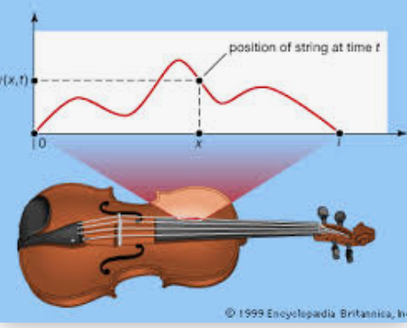

The result of this was D’Alembert combining the work and ideas of Newton, Hooke and Bertoulli into the wave equation

$\frac{∂^{2}u}{∂t^{2}}$ =$c^{2}\frac{∂^{2}u}{∂x^{2}}$ where u is displacement, with respect to time t, with respect to space x

And c is speed. $∂$ is the partial derivative which is a mathematical tool to help us ‘look’ at very small segments in a changing (dynamic) system. And what it tells us is that the acceleration (change in speed) of a small segment of the wave is proportional to the average displacement of neighbouring segments.
It predicts that the string will move in waves and can be used in any system in which waves occur. It led to big advances in our understanding of water waves, sound waves, earthquakes and the interior structure of the earth and it contributed to the idea of electromagnetic waves later on.

To understand what the wave equation does imagine yourself in the middle of the ocean, as the waves pass by, you bob up and down. As time passes at your location the rate at which your height changes (with respect to time) is a derivative of your height with respect to time. To describe the shape of the ocean near you, you freeze time and work out the slope (how height is changing) of your location, you can work out a value for this slope from a derivation of wave height with respect to space. You can see that at the peak and the trough there are moments where slope, your change of height, is momentarily zero, acceleration is zero. Between peak and trough your change in height will vary reaching a maximum halfway between peak and trough. Up and down, up and down. The acceleration, rate of change, is affected by the force caused by nearby segments.
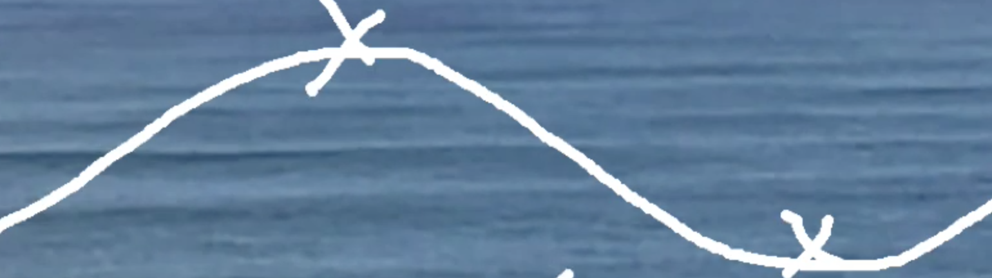
Height

Time

We can think of ocean waves, it’s very easy to see them, but how did we ever get to thinking of LIGHT as some kind of wave??

In his Traité de la Lumière (1690; “Treatise on Light”), the Dutch mathematician-astronomer Christiaan Huygens formulated the first detailed wave theory of light, in the context of which he was also able to derive the laws of reflection and refraction.

But what kind of wave?

Michael Faraday was a poor self-taught practical scientist who, amongst other things, applied the link between electricity and magnetism to invent an electric motor, an electric generator and inspired the use of electro-magnetic induction in electric telegraph which led to the invention of the telephone. But it wasn’t until James Maxwell imagined electric fields and magnetic fields as analogous to invisible fluids that equations describing and predicting the interaction of electricity and magnetism, in such devices, were developed (19th century).

In its simplest form, with no wires, metal plates and in a vacuum, this equation is:
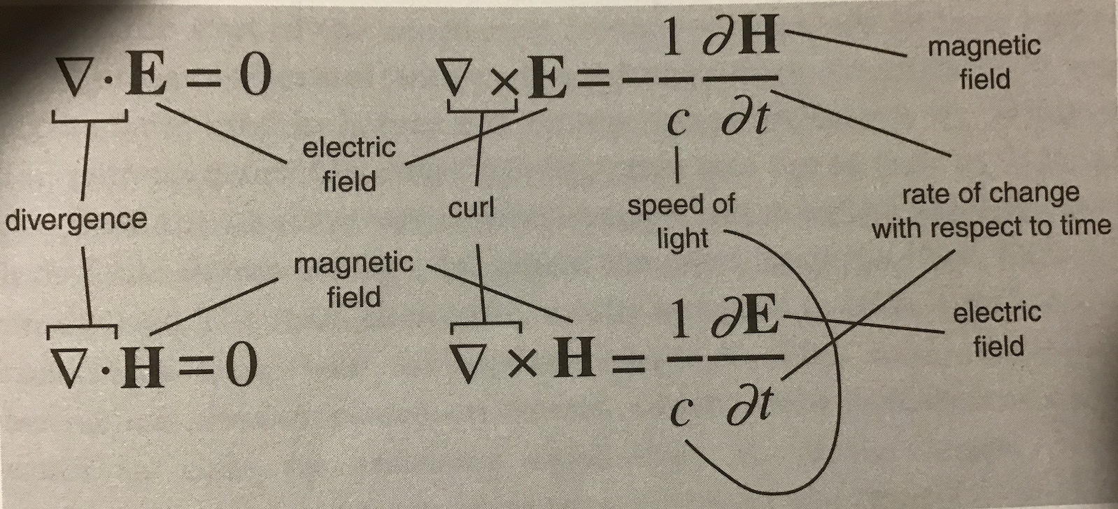
This solution predicted that the electric field and magnetic field simultaneously supported a wave. It is easier to visualize as 2 interactive waves. And that both waves travel at the speed of light. From this the implication was that light is an electromagnetic wave.
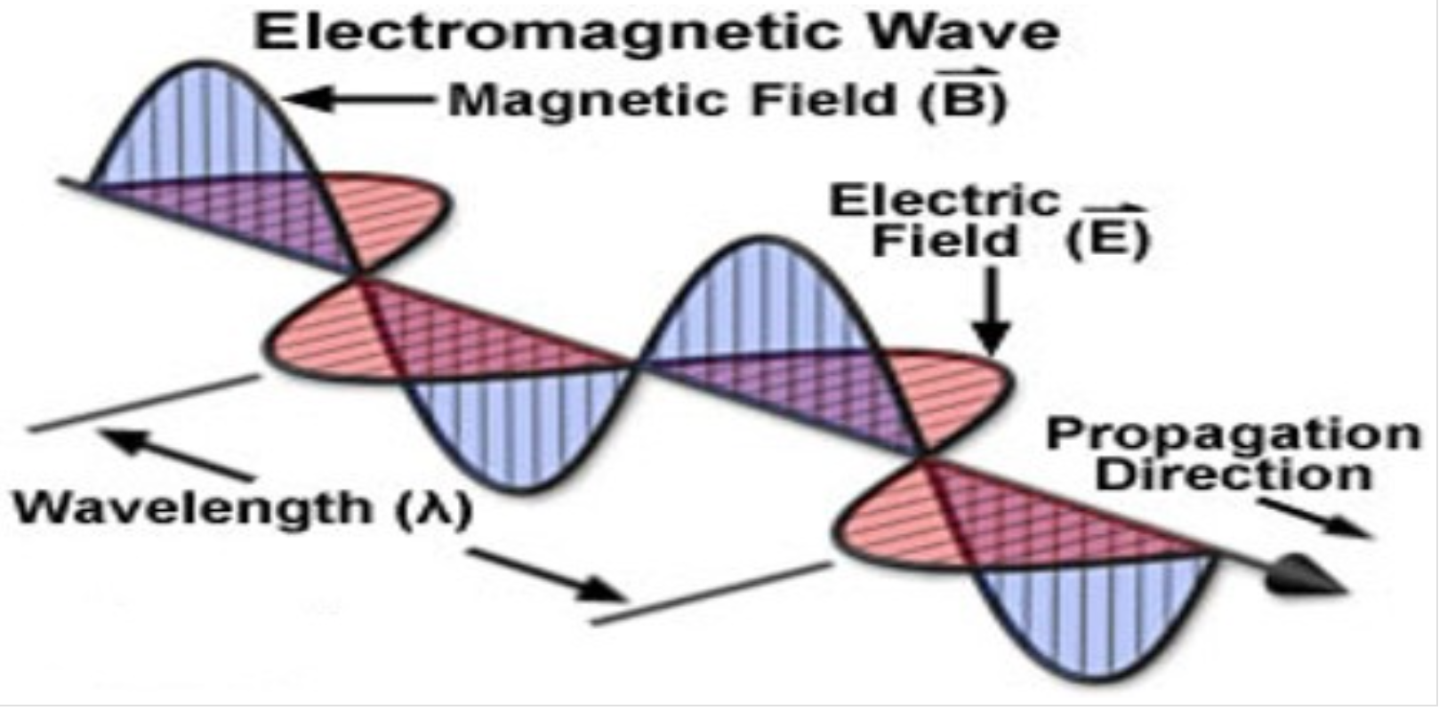

Now there had been no reason before Maxwell’s equations to imagine this fundamental link between Light, electricity and magnetism so now experimentalists could imagine and search for new electromagnetic energies as yet undiscovered – radio waves, microwaves, x-rays.

Using his imagination Maxwell was able to reach a new improved description of reality and this new understanding inspired new ways to think about light.

In his lecture “Solutions of Maxwell’s equations in free space” Richard Feynman pointed out that
Science makes huge demands on the imagination, not only that it requires us to use imagination but that science also requires us to do so in a very careful responsible way. Whatever we are allowed to imagine, whatever imagining we use in science must be consistent with everything we know.

Feynman asks
“Can we imagine beauty we cannot see? Everybody says “Ooh a rainbow”… we experience as we see it as beautiful. Is the graph of the electromagnetic spectrum beautiful? Do we have enough imagination to see in the spectral curves the same beauty?”

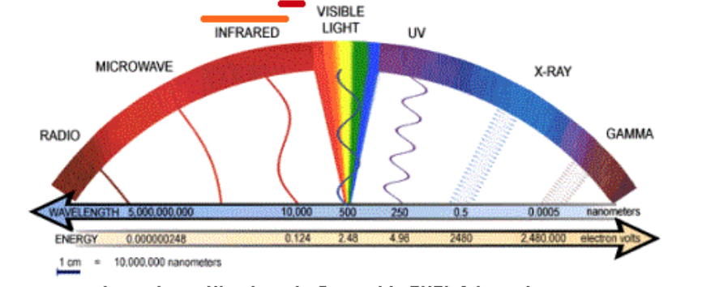
In 1979, in his NZ lecture series, Feynman stated that science is about synthesis. It is about both theory and phenomena. An example of such a synthesis is Maxwell’s electromagnetic wave that helped explain the phenomena that Faraday explored and revealed. Theoretical and practical building together.

The problem often is to fit theory to explain reality. This synthesis often takes us into realms of reality we cannot directly see, realms we cannot experience on our human scale. And as we explore deeper into the extremely small sub-microscopic and explore further into the vast expanse of the supra-telescopic we find huge demands on our scientific imaginations.

Starting with Rutherford’s experimental work leading to a new visualization of the atom as being mostly empty with a dense nucleus and sparse electrons; there was a struggle to synthesize phenomena with theory when Maxwell’s wave theory of electromagnetism did not fit the observed interactions of light and electrons. Einstein’s Nobel prizewinning work on the photo-electric effect supported the idea of a particle nature of light.

https://aklectures.com/lecture/photoelectric-effect-compton-effect-wave-particle-duality/photoelectric-effect

Now, in a modern scientific synthesis, we have come to the point where we need to imagine light as particles, photons, operating in a probabilistic quantum reality (20th century), and within the framework of the new standard model the photon is the boson (energy carrying particle) for electromagnetic energy. ( https://home.cern/science/physics/standard-model )
The theory that now synthesizes this with real world phenomena is Quantum Electro Dynamics (QED) which brings relativity, probability, and quantum mechanics together to describe and predict almost everything we experience (except radioactivity and gravity). It describes how light and matter interact. It is weird, I don’t understand it, but it is beautiful.

How then does our experience of the ‘classical’ world emerge from an underlying quantum one?

A ray of light hits the surface of a smooth sea. In the ‘classical’ world we construct from our experience the reflected rays bounce off at the same angle as the incoming rays, some rays may be refracted through the air/water interface, some are absorbed, some scattered. BUT this is NOT what happens in the real (quantum) world.

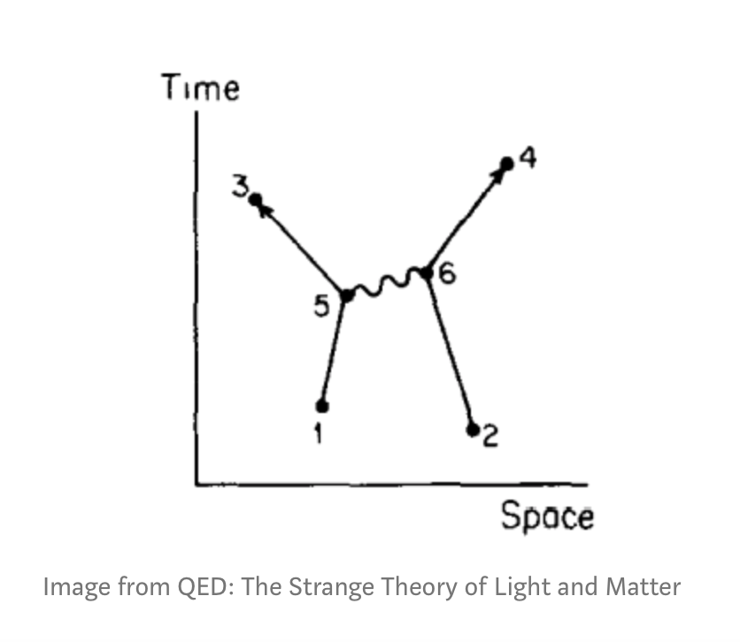
Visualize the ray of light as tiny quanta of energy, photons travelling all possible paths that you can imagine, at extreme speed (the speed of light!!) each photon is absorbed and reemitted by the electrons of the matter they encounter. Feynman illustrated these events with what are now called Feynman diagrams, such as this one to the right. Where straight line path is an electron and wiggly line is a photon. These events can happen in all possible ways, in all possible directions (in time and space!!) but if you superpose all these possible events the overwhelming proportion of emitted photons travel pathways at angles that allow us to measure the truth of our macroworld experience: angle of reflection =angle of incidence, and angle of refraction is a function of the relative refractive index of the material encountered.
Similarly, these photon-electron interactions at the quantum level result in the observed colours of pigments and the chemical processes involved with vision,
photosynthesis and photography.

QED is the most precise and accurate descriptor of reality that we know of at the present time.
The Synthesis of this theory with measured phenomena is remarkable. The latest values I could find (21st century)
are-*Experimental measure of strength of magnetic moment of the electron =1.00115965218085
QED calculation predicting strength of magnetic moment of the electron =1.001159652182032

This is like measuring the circumference of the world within an accuracy of the width of a single human hair! Feynman called QED “the jewel of physics!” And I see what he means!

Vision is our dominant sense. Seeing stuffs our lives with experiences, ideas and meanings. The built-in pattern seeking, metaphor making, of our Pleistocene brains doesn’t always make coherent sense of it all. Human science operates as best it can in this framework.

Our remarkable capacity to imagine enables us to create new images, new tools, new understandings. But, without synthesis with a verifiable memory, without care and integrity, accuracy and precision, aligned with observable and tested evidence within a shared understanding; we can lose ourselves in the fog of a fictional fabrication hungry, or angry, to be true.

In a time of global pandemic, in a time of unprecedented climate change, now, more than ever, we need to look to science and the long memory that science gives us to see what is happening to our ocean world and to imagine a safe and sustainable future.

*references
Theory (calculated)
T.Aoyama, T. Kinoshita, M. Nio (2018) Revised and improved value of the QED tenth-order electron anomalous magnetic moment. High energy physics.

Experimental (measured)
B. Odom, D. Henneke, B. D’Urso, G. Gabriele (2006) new measurement of the electron magnetic moment using a one-electron quantum cyclotron. Physical review letters 97(3).

Other reference material
Ian Stewart: 17 equations that changed the world

Ottaviani and Myrich: Feynman, a graphic biography
Feynman’s New Zealand lectures. What the universe looks like!!
electromagnetic spectrum (Light), science is synthesis
https://www.youtube.com/watch?v=LPDP_8X5Hug&list=PL01619985657950A3&index=1
QED: behaviours of photons and electron interactions. QED describes and predicts based on the dynamic particle nature of matter)

https://www.youtube.com/watch?v=hHTWBc14-mk

