How to apply for Late Paper Addition in eVision
If it is past the formal last day to add papers for a semester you will need to request special permission to enrol in papers. Approval for enrolling in a paper late is at the discretion of the teaching department and may not be permitted. For more information about academic key dates please visit here.
Follow the steps below to request for late paper addition through your eVision student portal:
- Log into your eVision student portal. Go to “Programmes and Papers.” You will see a screen displaying your current programme.
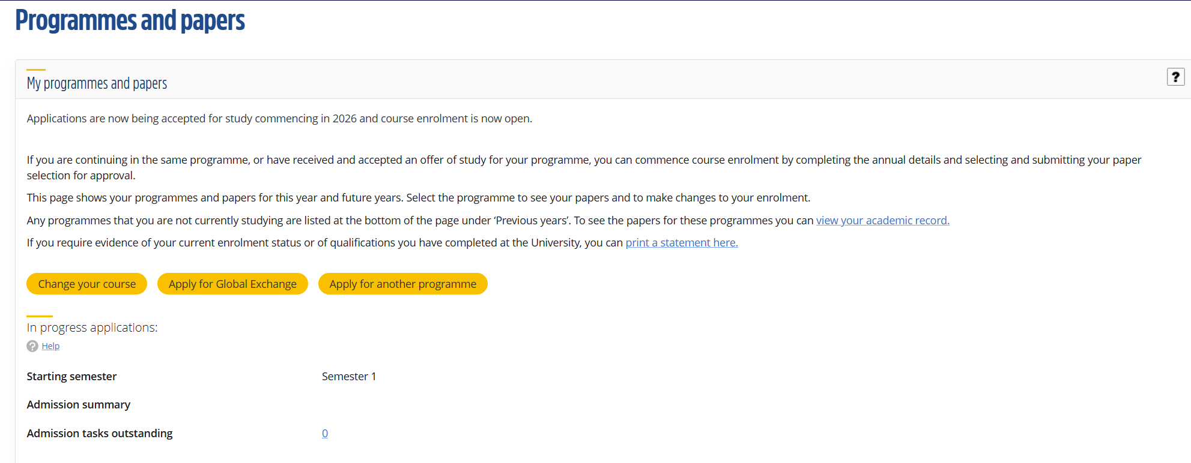
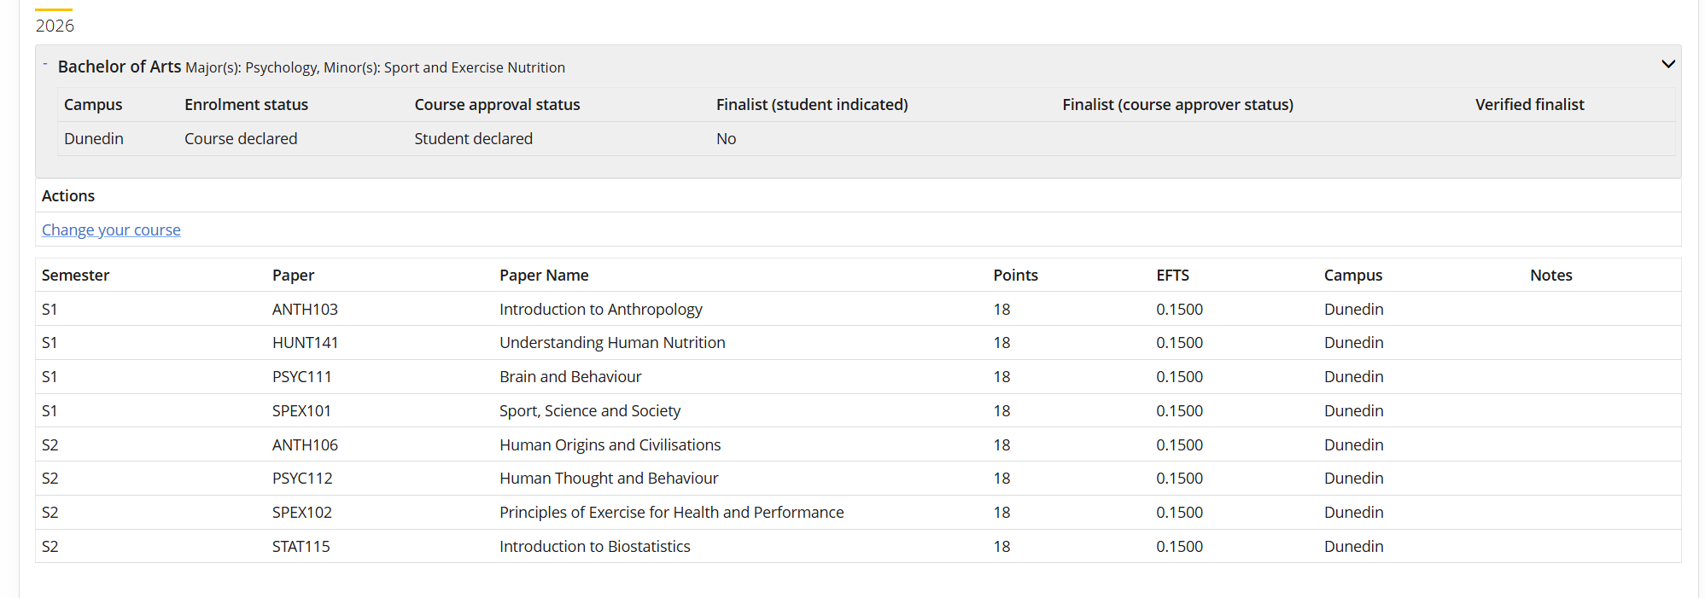
- Click on the grey box of the programme you are currently studying. When you do this, blue links will appear. Click on the one that labelled “Course enrolment” or “Change your course”. The link that appears will depend on whether you are course declared or not.
It will take you the page below displaying deadlines for changing papers. Click continue
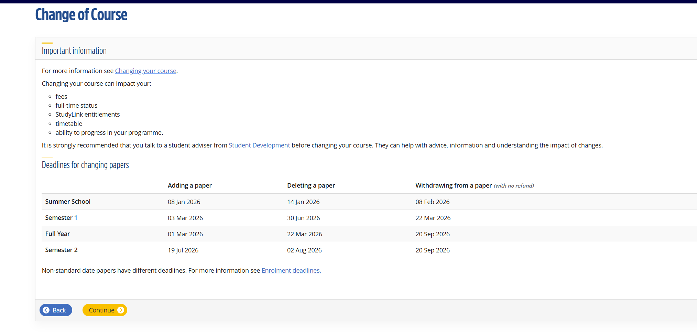

- Click on the yellow button directly to the right of Add or Delete papers section
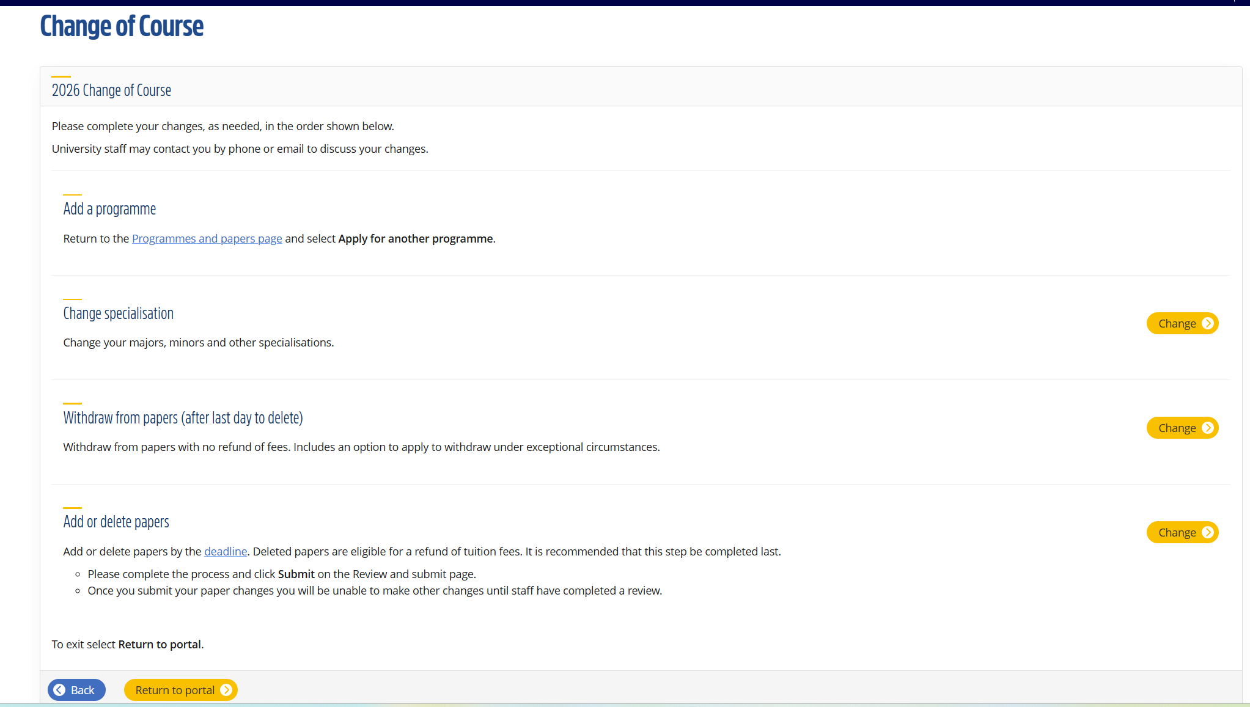
It will take you the screen below - click continue.
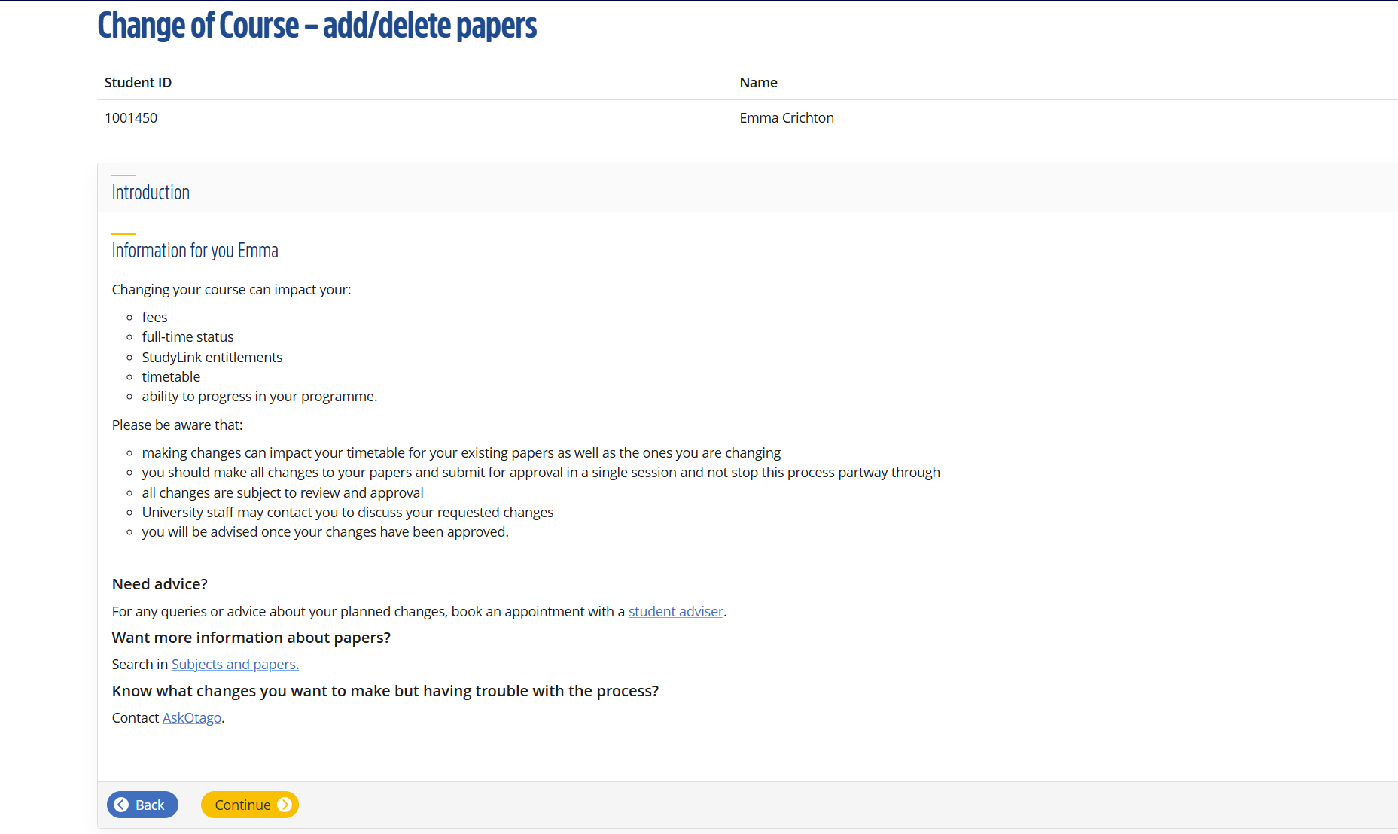

- Click the yellow button that says, “Add/delete papers.”
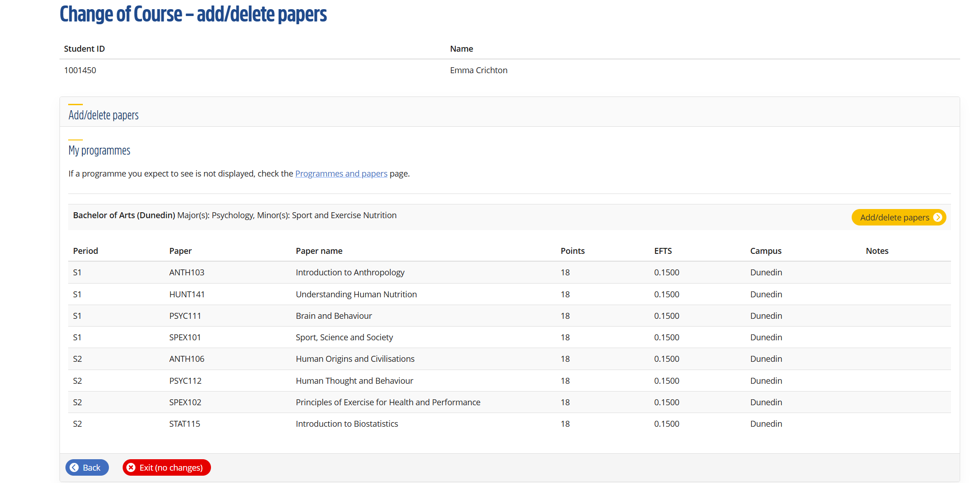
- Even if no papers are listed, click on the yellow button that says, “Confirm Papers.”
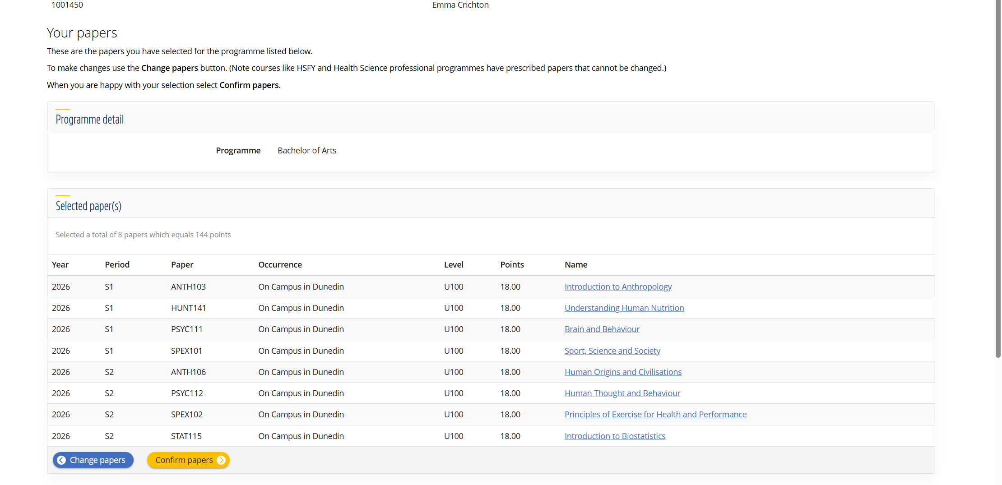

- This will bring up the scheduler. The scheduler will load (this may take up to a minute). Do not close your browser while it loads. Click continue when loading is complete.
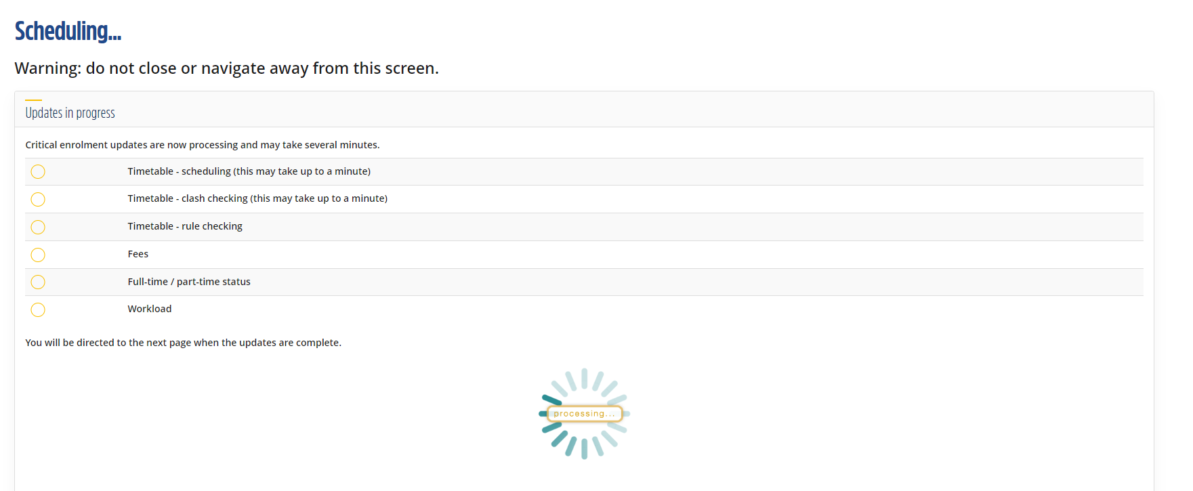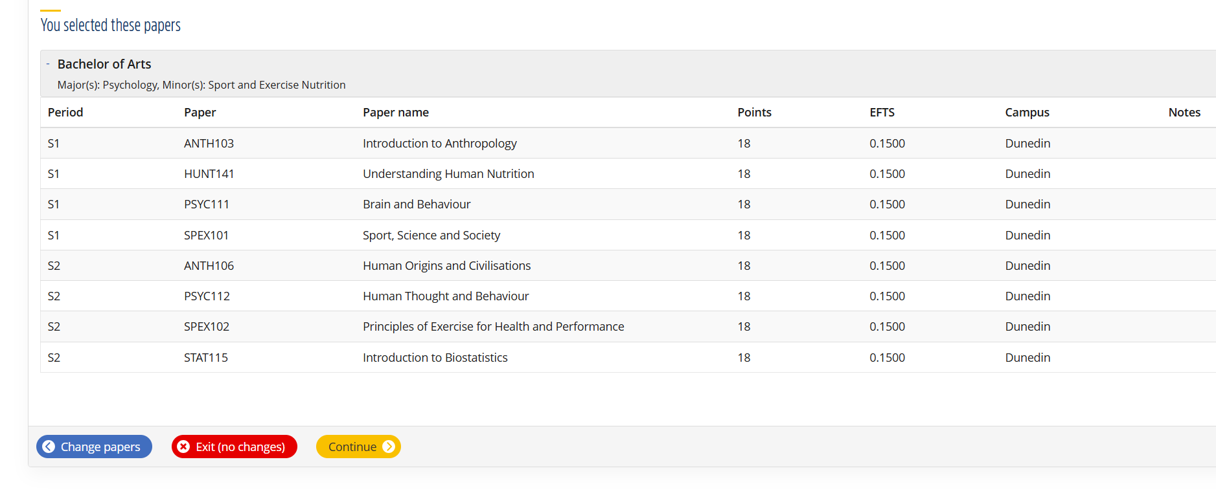

- Click on the yellow button labelled “Request Special Permission.”
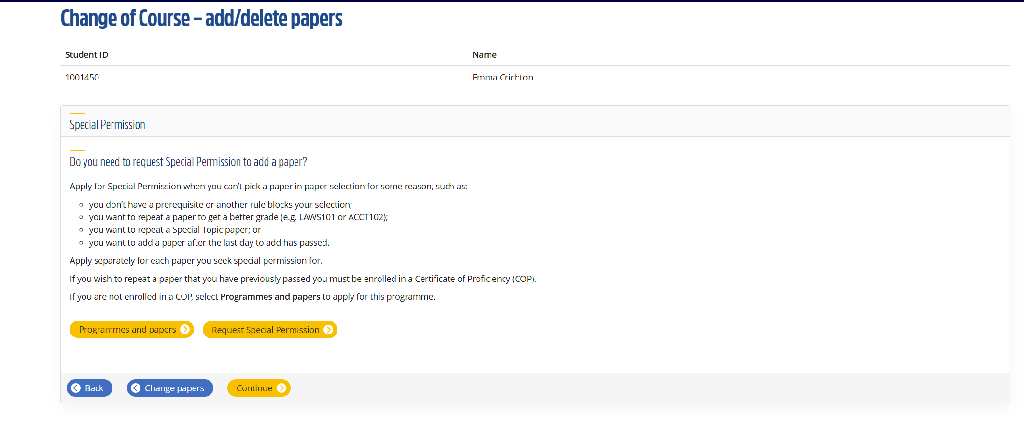
- Click the yellow “Continue” button.
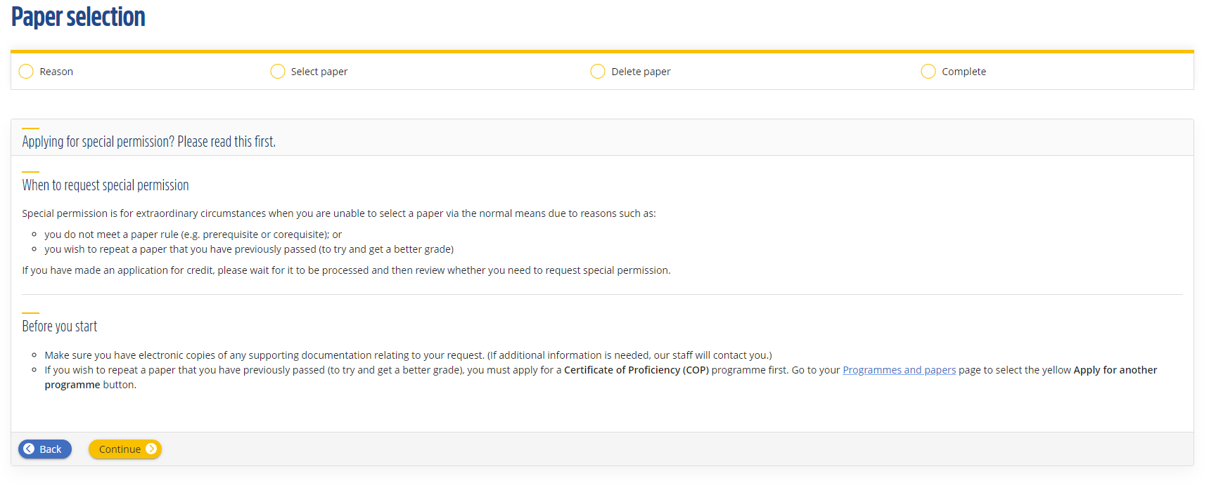
- As it is past the deadline to add papers, the paper will not appear in any search boxes unless you select the yellow button that says “Request late paper addition”.
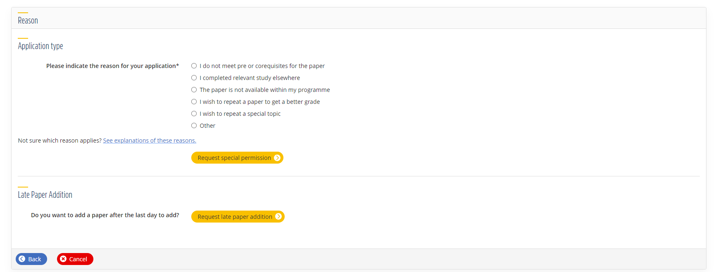

- If you selected Request late paper addition, click the yellow continue button. Please note, if you had selected “Request special permission,” you will not see this screen.
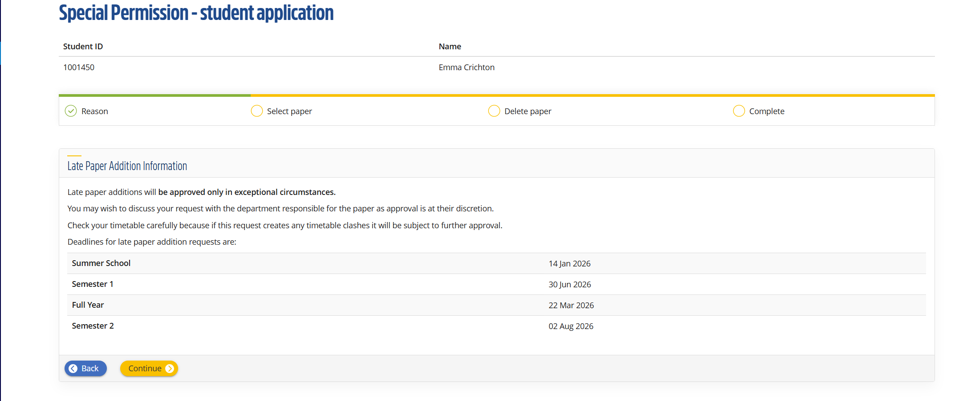
- Search for the paper in the top search box. You will need to provide information to support your request, including providing documents like transcripts if needed. You’ll be asked for more information on the next page.

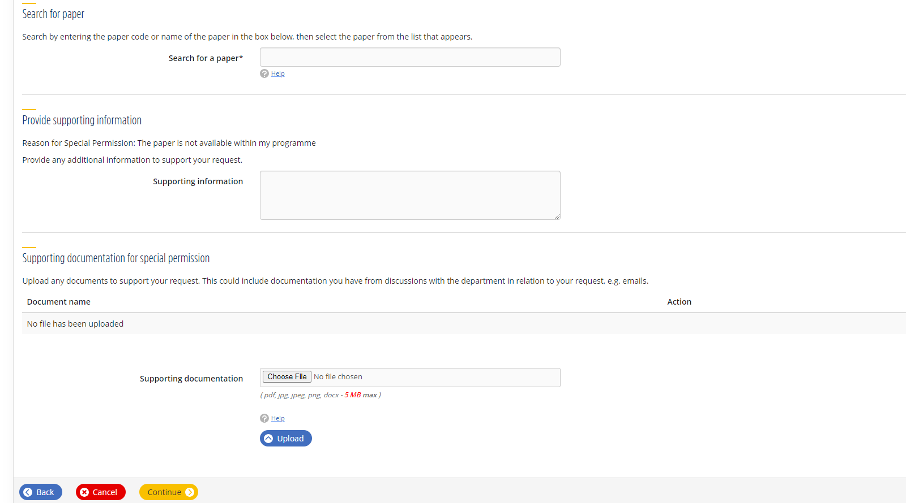

- Next you’ll need to let us know:
- Why you could not add the paper by the deadline
- Why you need to enrol in the paper
- How you plan to catch-up on missed content.
If you have spoken to teaching staff about joining late and/or have been attending lectures, please add this detail including the name of the staff member you spoke with.

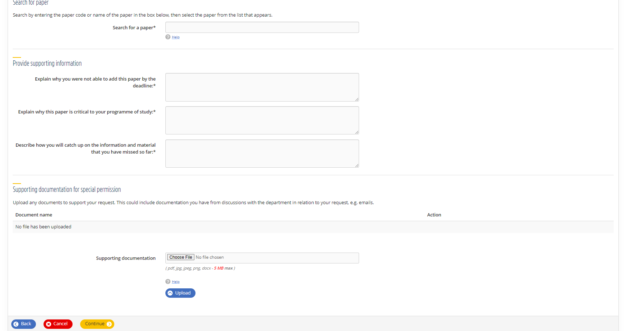
- Select which degree you want to add this paper to.
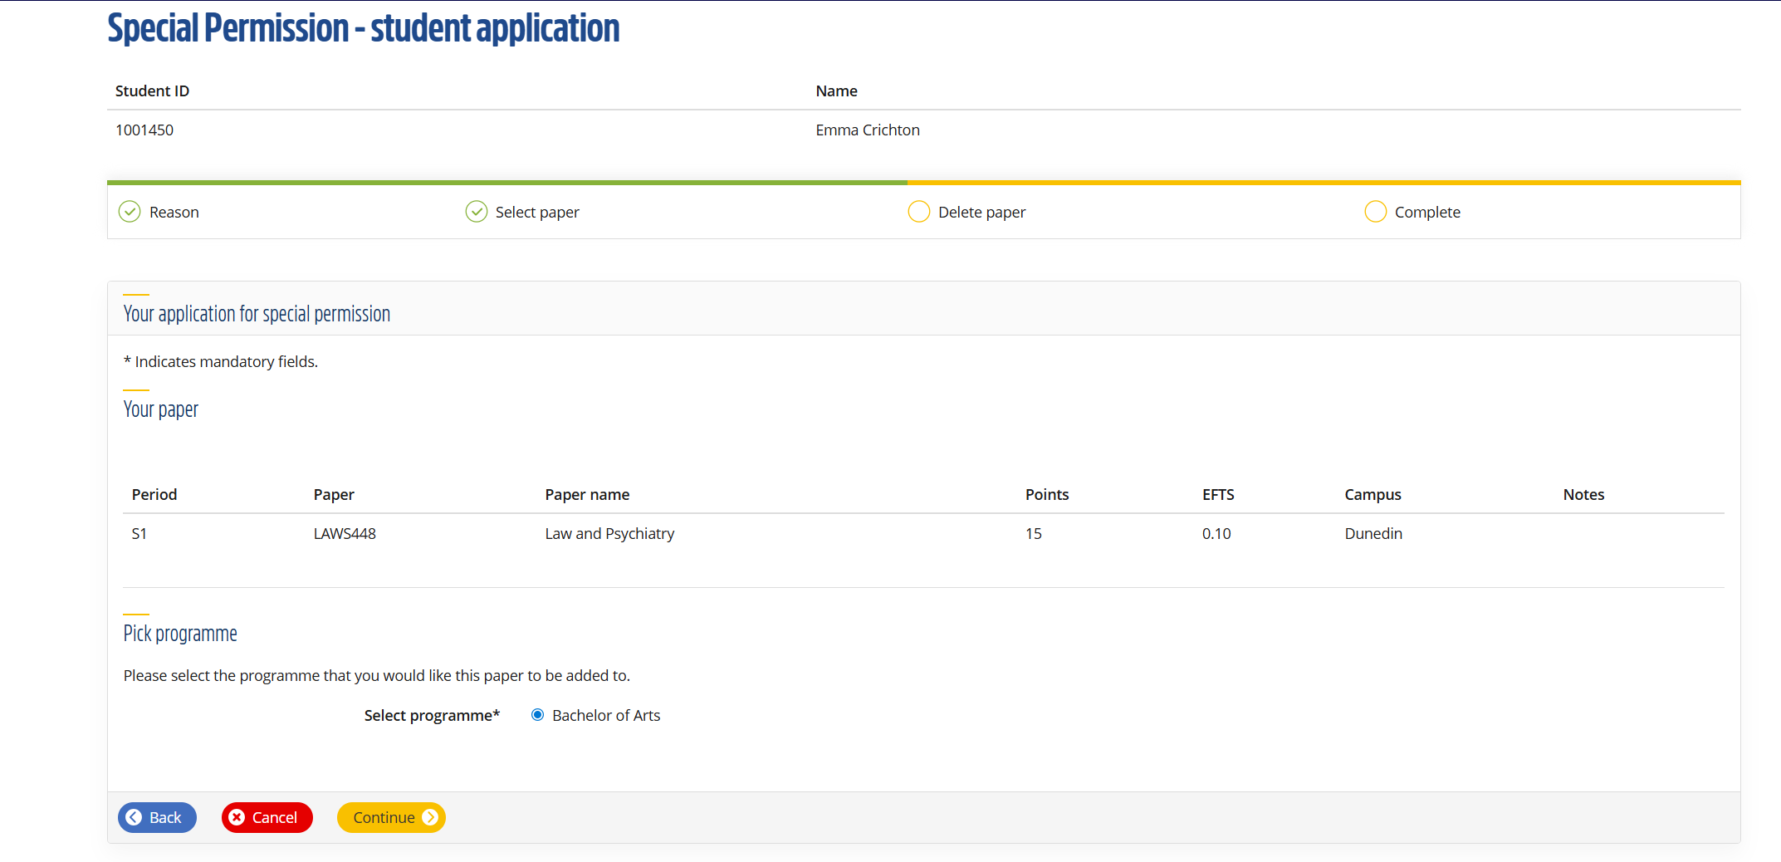

- After this you can review your request and submit by pressing the green “Complete request” button. This is not the final step though, you need to keep going.

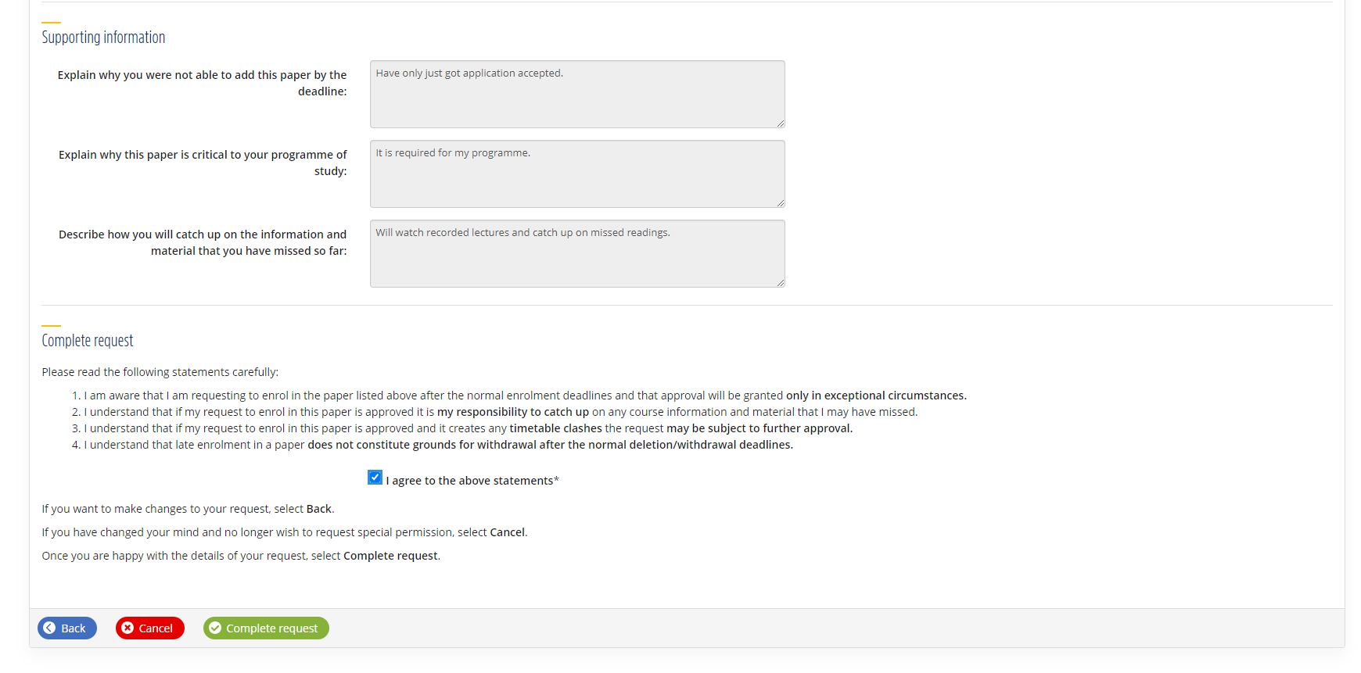

- Once you’ve submitted your late paper addition request, you’ll need to also submit your overall course for approval. Click continue.

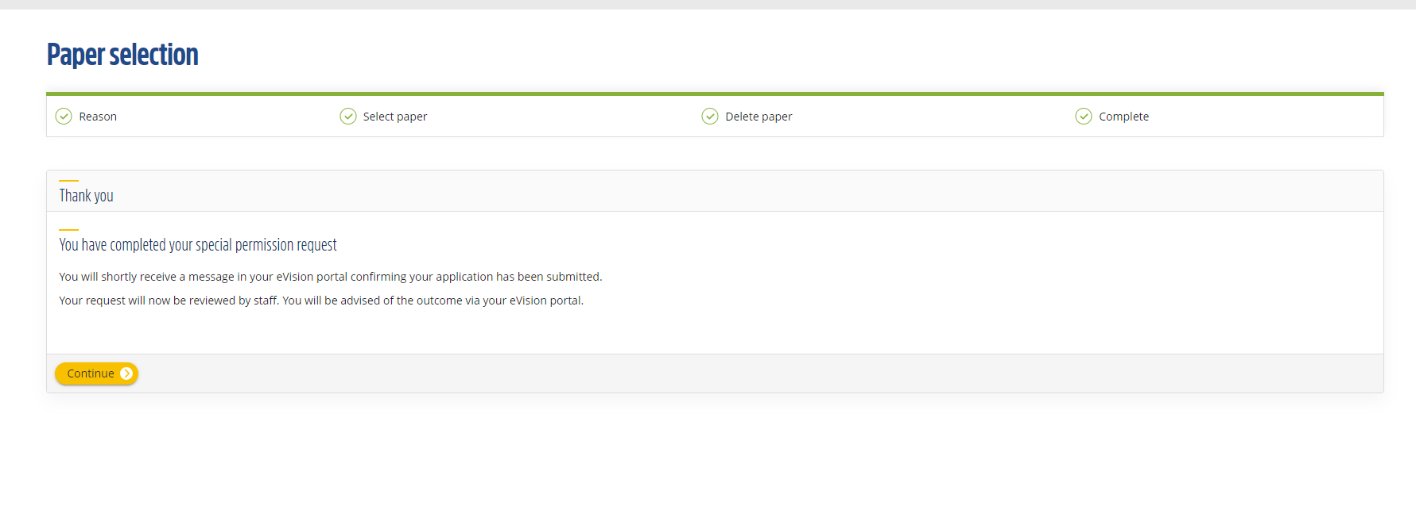

- If you need to request late paper addition for more than one paper, repeat the process above. Make sure to click the final green ‘Submit button’ to submit your request to us.
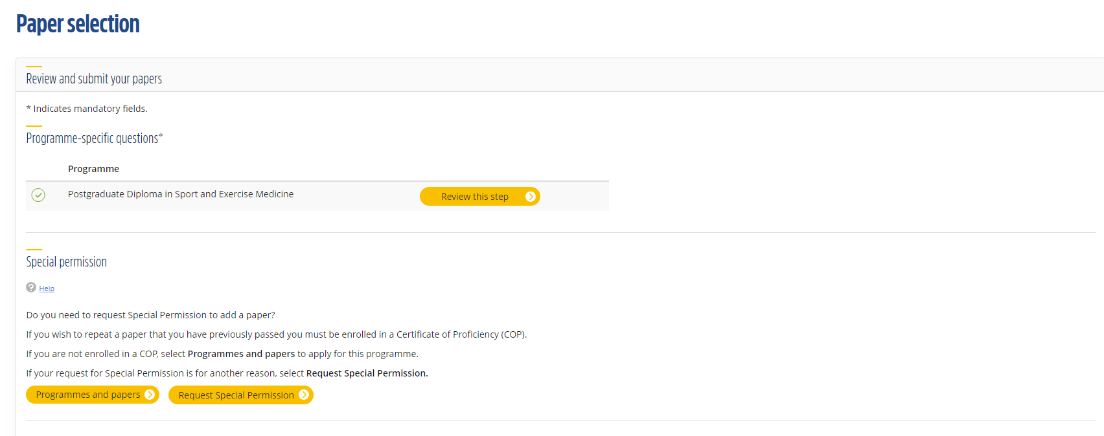

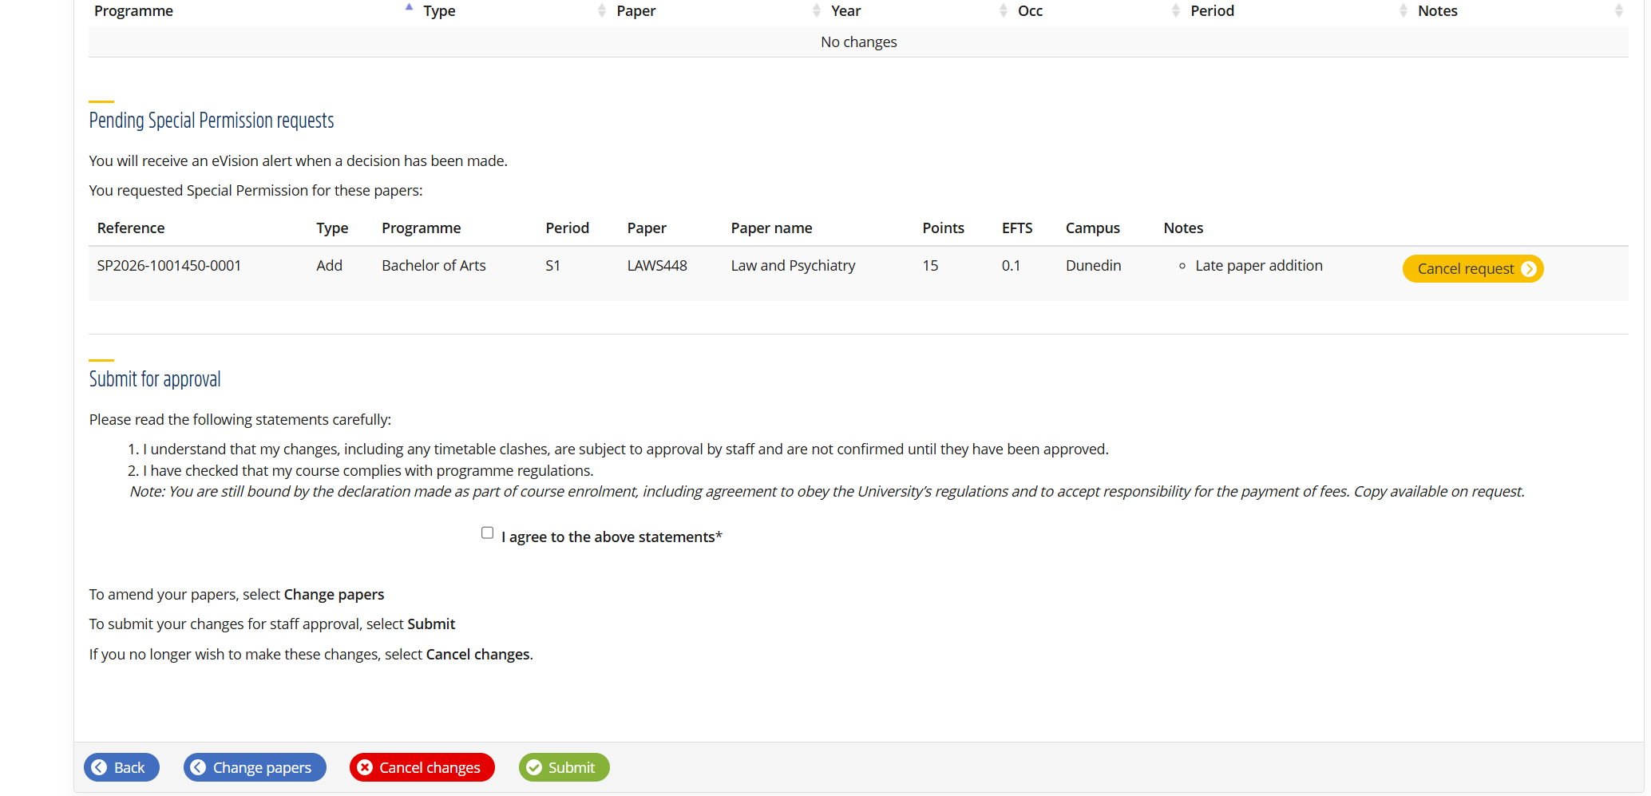

Do not close your browser until you see a screen saying your course has been submitted for course approval or that your change of course is being reviewed by staff.
- When the course approval request for Late Paper Addition has not been submitted, it will appear as shown below. The course approval status will indicate student started paper selection. Note that the paper selection button will be unticked.
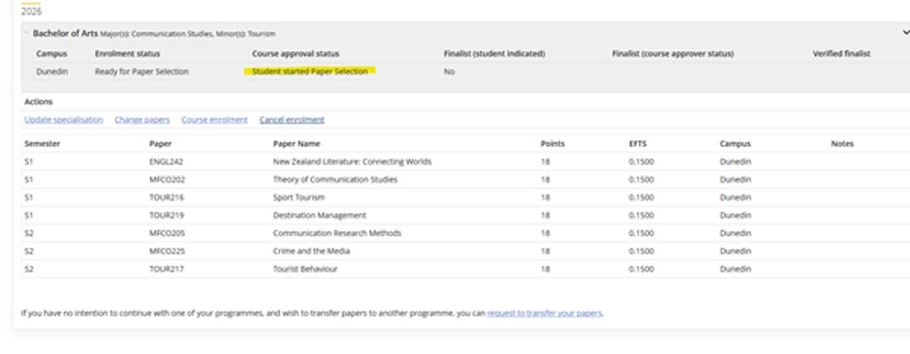
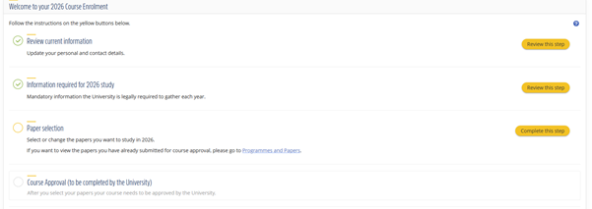

The screen will look like this when you have successfully submitted a request for late paper addition for course approval
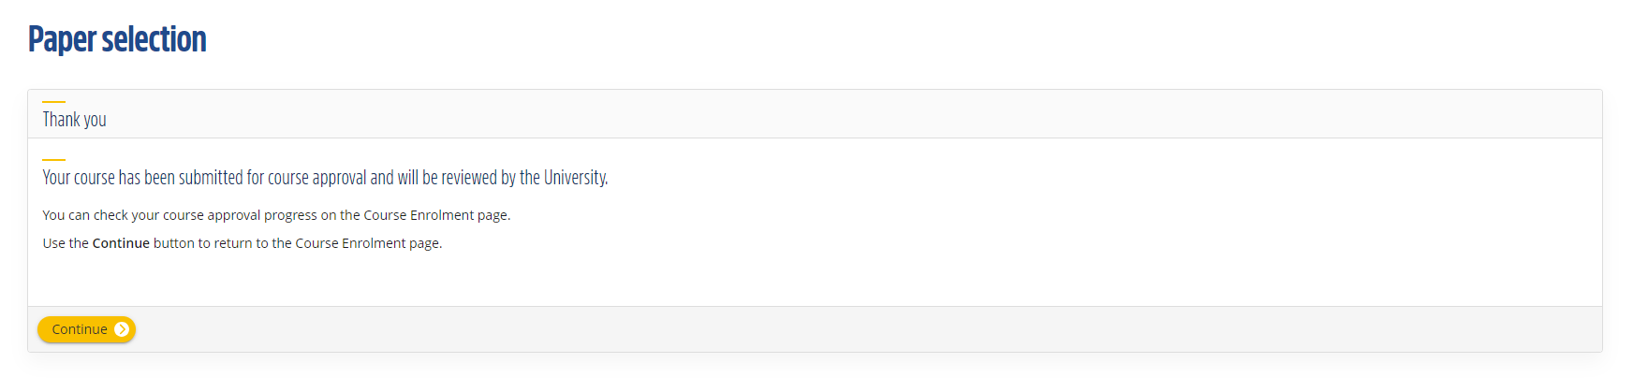

- If your Change of Course request for late paper addition has not been submitted, it will look like this. 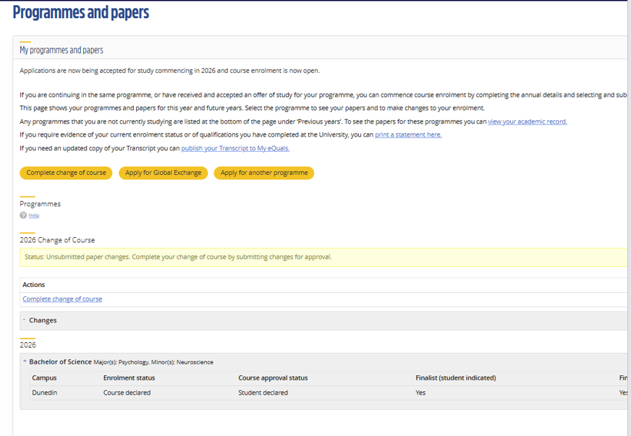

This is what the screen will look like when you have successfully submitted a request for late paper addition through change of course.

