“ “IS THERE AN OCEAN IN THE HOUSE?”
Level | Investigations
Topic | Temperature
‘OITH bench-top’s | Introduction, Definitions, changing. The nature of water.  GTV 2.1  GTV 2.2 | Tool, (setup)  manufacturing, testing, modification.  GTV 2.2, 2.3 and 2.4 | Tool, standardization and calibration, issues of range and sensitivity. (and more system error.)  GTV 2.5 and 2.6 | Doing with the tool. Enquiry. Problem. Proposition.  GTV 2.7 and 2.8
Support material | Overview and  worksheets | Concept, analogy and creativity | Data handling, conversions. Graphing, (recording and statistical error)  GTV 2.3 and 2.9 | Review  GTV 2.10

Heat and temperature in oceanography: A review and fun with formulae # 2 and #3

Temperature is a thermodynamic property of a fluid as a result of the movement of molecules and atoms in the fluid. (GTV 2.1 and GTV 2.2)
The more the movement (energy) the higher the temperature so temperature is a measure of this energy.

When the molecular energy is zero, no movement, the temperature is absolute zero on the Kelvin scale.
Temperature units used in oceanography are degrees Celsius. For heat content and heat transport calculations the Kelvin scale should be used.
For temperature change and calculations of heat flux over normal time and space degrees Celsius can be used as 1 degree Celsius = 1 degree Kelvin. (worksheet 3 and GTV 2.9)

How is temperature measured in oceanography?
In this topic we made homemade reversing alcohol and water thermometers (GTV 2.3, GTV 2.5 GTV 2.6 and GTV 2.7). Oceanography uses:
a/ reversing alcohol thermometers
but for high sensitivity there are 2 instruments:
b/ reversing mercury thermometers invented by Negretti and Zamba in 1874. Accuracy is
0.004 C (+/-) and precision is 0.002 C (+/-).
c/ electronic thermistors which vary considerably but the best have accuracy of 0.002 C and
precision of 0.0005 to 0.001 C

Because temperature effects density in a known relationship (thermal expansion), an increase of 1 degree C relates to an increase of 4m/sec change in speed of sound through seawater,
d/ acoustic tomography and acoustic thermometry have been used.

Because sea surface radiates heat in proportion to sea surface heat content, temperature can be measured:
e/ by satellite sea surface infrared radiometry
f/ by satellite sea surface microwave radiometry
(we will look further into this in Level 2, Explorations. Topic, physical ocean structure and dynamics.)

Heat is a measure of total particle motion in a given volume of a known material.
Temperature and heat are related through concept of specific heat.

Specific heat is unique to a particular material (types of molecules, atoms) and is the amount of thermal energy needed to raise 1 unit of mass of the material by 1 unit of temperature.
The scientific international standard (SI) for specific heat is Joules (energy)/ ⁰K (unit of temperature) kg (unit of mass).

For pure water specific heat is =4182 J/K kg
For seawater at 35 ppt specific heat =3850 J/K kg

You will probably be familiar with the calorie as a unit of energy. 1 calorie is equal to 4.184 Joules simply because it is defined as such. The original definition of a calorie is the amount of energy needed to raise one gram of water by 1 degree Celsius, but this is variable based on starting temperature or pressure, so 1 calorie was just defined to be exactly 4.184 Joules.
(The Joule is a derived unit where one joule is the amount of energy exerted when a force of one newton is applied over a displacement of one meter. One joule is the equivalent of one watt of power radiated or dissipated for one second.) So we see distance, time and force intersect with energy, heat and temperature!!
Fun with Formulae # 2 !!
Change in heat of a known mass is calculated from specific heat x temperature change x mass

For example from the topic experiment (GTV 2.7 and GTV 2.8 and GTV 2.9): 50L (50 kg) of water increased from 10.4 to 13.6 degrees C (in first 2 hrs. of the experiment).
Heat change = 50kg x 4182 J/⁰K ( 0C) kg x 3.2 ⁰C (⁰K)(converted from ‘humbod’ degrees)
= 668823.08 J
Heat flux, the change in heat over time, is Joules /time which is Watts. This is expressed in relation to surface area across which heat change is occurring so heat flux is watts/m².

For example from the topic experiment: in first 2 hrs. of the experiment. 50L (50 kg) of water increased from 10.4 to 13.6 degrees C. (NOTE: unlike the ocean where there is only the surface area of sea to consider the total surface of the 50L tub needs to be regarded as a heat flux surface!!).

Heat flux = heat change (J) / time (seconds) / surface area (m²)
= 668823.08 J /7200 / 0.667
=139.2 W

Fun with Formulae # 3 !!
It is clear that as mass increases the rate of temperature change decreases. However as mass increases total heat capacity increases so heat flux as a proportion of heat capacity decreases with increase in mass thus large ocean masses act as large thermal stores. (GTV 2.7, GTV 2.8, GTV 2.9)This has consequences for holding and caring for marine organisms, for adaptation and survival in different parts of the world’s ocean and for Ocean life in a time of global rise in temperature. (see interviews GTV 2.10a and GTV 2.10 b)
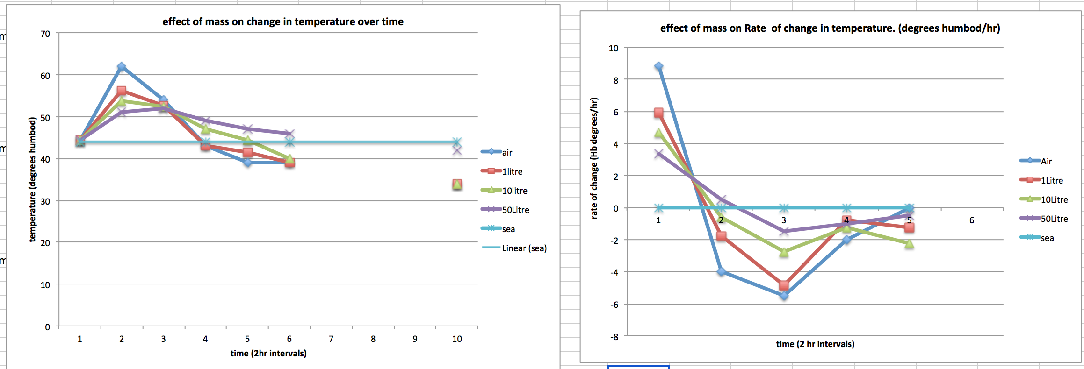

In the Ocean where mass is unknown but volume is known,
Heat flux = ((density x volume) x specific heat x change in temperature)/ time/surface area
Where density of seawater at 35 ppt is given as 1025 kg/m².

Fun with formulae challenge
Calculate heat flux for two of your containers in your thermal mass experiment and compare.

Relate this to heat flux for ocean water where a surface of 1 square km (1000m x 1000m) and average depth of 2m increases by 3 degrees C over 100 days.
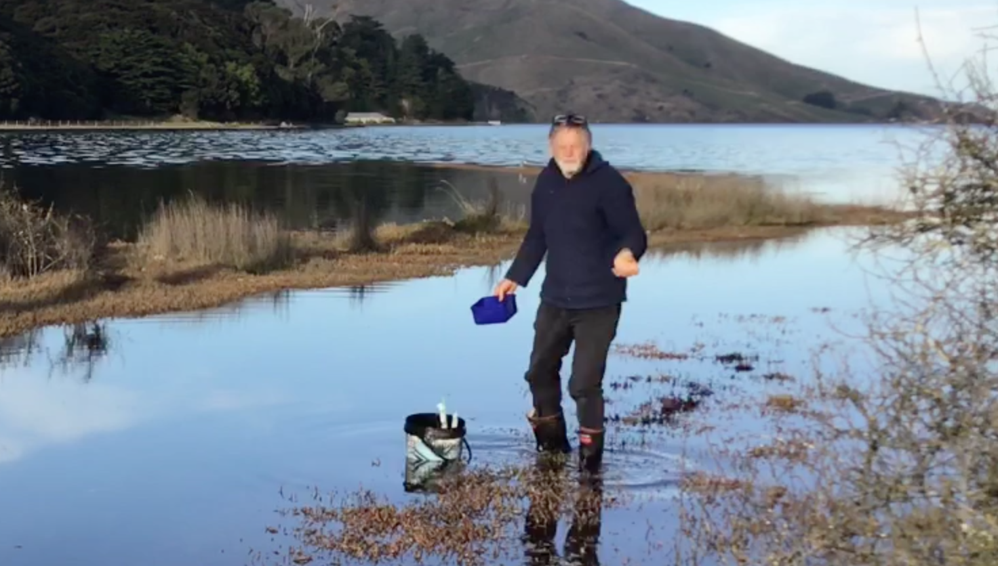

Compare total heat capacity of one of your experimental containers at a given temperature and compare with the total heat capacity of the body of seawater given above at the same temperature.

For total heat capacity ⁰K have to be used in the formulae:

Total heat = specific heat x temperature (⁰K) x mass (where ºK = ⁰C + 217.15)
(Answers in next topic, topic three, Light!!)

Answers to salinity topic FWF challenge. If you do the calculations for the other salinities you will discover that f_{b} stays the same as density of the medium changes. Try the calculation for our 100ppt ‘sea’ with density of 1099kg/m³.

