Adding training in Course Scheduling
Using Course scheduling it is possible to add a group of people who will be or have attended a training course.
Please note that if there is an individual certificate to be added you will still be required to use the Manually Add Training selection to add their certificate. This can be done after this step.
It is important that the Training course that you require is already added into Vault.
You will find Course Scheduling under the people tab
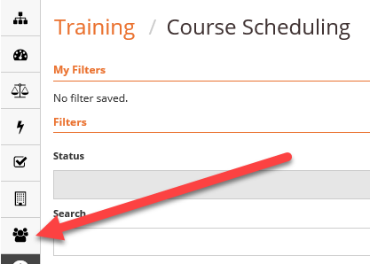
Select Add at the top right hand corner.
This will open a new window
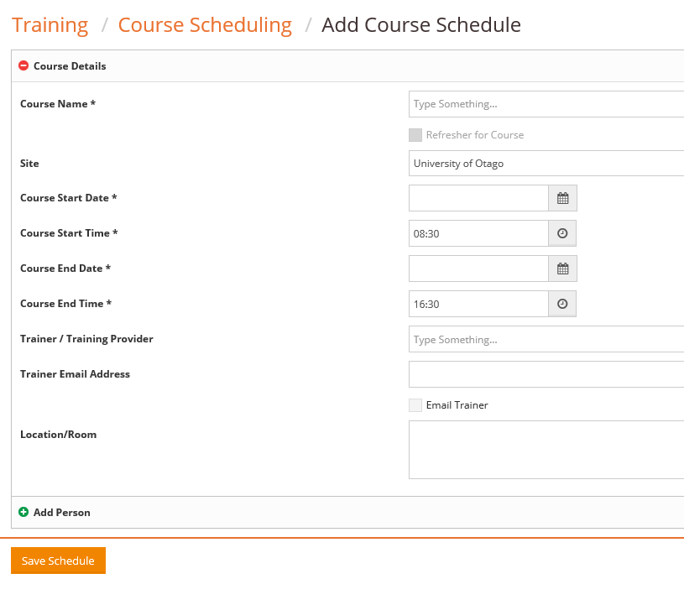
To find the correct training course, start entering the course name. If you are unsure of the exact name try something more generic e.g. First Aid. All of the courses containing the words First Aid will then appear. Select the correct course.
Enter the Course Date and times. It is not essential to add the Course Provider. A window will appear when you select save asking whether you want to save the course or delete it.
After selecting Save, your course will appear in a list of other courses.
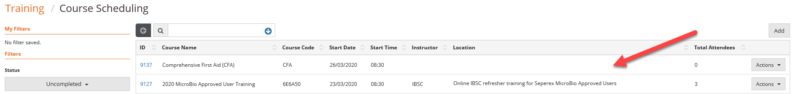
Go to the Actions tab at the right of the correct course and select edit.
At the bottom of the page is a green + with Add Person. Select the correct person type from Worker, Student or Contracted Worker.
In the search area start to enter the person’s name. When found click the box to the left of their name and then add.
Keep doing this until all of those who are attending or have attended the training course appear. If you add a wrong person, they can be removed by using the Actions button and selecting remove person.
Once your list is complete you can Print out an Attendance register or Pass all of the attendees.

As always if you have any questions phone Karen Bonney 6216 or e-mail me karen.bonney@otago.ac.nz.

