Standing to Work

There has been growing interest in standing desks. There have been a number of published articles about the health benefits of these desks. A recent article 'A systematic review of standing and treadmill desks in the workplace' by MacEwen et al in Preventive Medicine 70 (2015) 50–58 reported that:

"Standing and treadmill desks show some utility for breaking up sitting time and potentially improving select components of health. At present, however, there exist substantial evidence gaps to comprehensively evaluate the utility of each type of desk to enhance health benefits by reducing sedentary time".

The review did not address musculoskeletal conditions which may be influenced by standing or treadmill walking for extended periods of time.

As with any computer related work, the desk cannot be considered in isolation, and other factors must be considered:

- Physical comfort
- Visual comfort
- Stress
- Fatigue
- Individual factors
- Psychosocial factors
- Work organisation
- Work layout and awkward postures
- Task invariability
- Loads and forceful movements
- Environmental issues

The ACC/DOL Guidelines for using computers November 2010 includes a section on standing to work which is reproduced below.
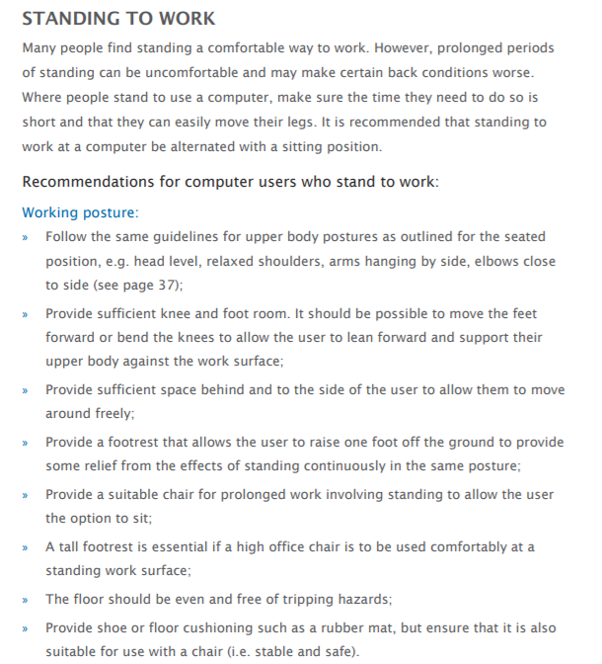

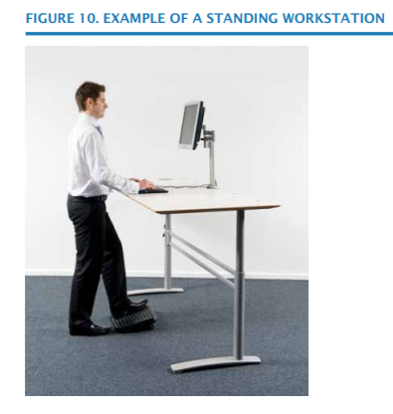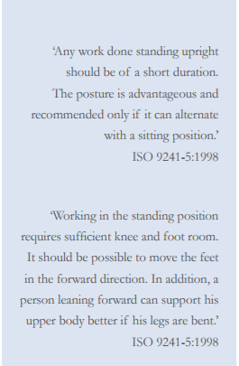

For those wishing to have a standing desk it is suggested that a temporary standing option should be tried first. Such stands are available commercially for about $30 or contact H&S who have one available for trial periods.

The price of standing desks varies a lot. A desk that has the option to be either standing or sitting is recommended as it means that the user can alter the height easily at any time. A power operated desk enables the change to be made at the push of a button. In all situations, the option of sitting for some time should be provided.

The University's Occupational Health Unit does not provide letters of support for people wishing to have one of these and does not fund them as they are a departmental cost.

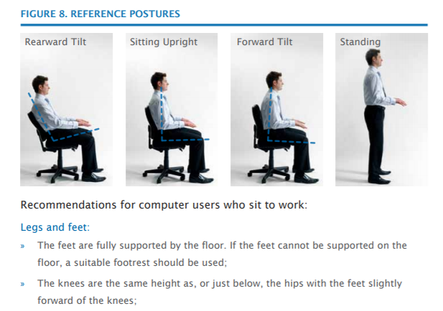

For further information and assistance, please contact the Occupational Health team.

December 2017 Occupational Health Team.

