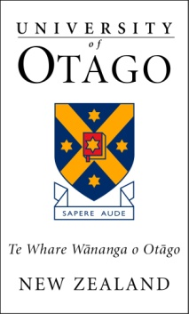

Working Group to Review the Admissions Process for the Master of Metallurgy Degree
Meeting to be held on Tuesday 3 March 2015
10:00am, Committee Room North

Agenda

Apology: Mr G L Green

- Notes of Meeting of 2 February 2015
For confirmation. Pages 1-3

- Department Admissions Group Review Report

To receive a report prepared by the Departmental Admissions Group, dated 23 February 2015. Page 4-16

- Scholarship and Alumni Office Report

To receive a report prepared by the Scholarships and Alumni Office, dated 22 February 2015.
Pages 17-25

To note that this report was also submitted to the 2 March 2014 meeting of the Division of Sciences’ Scholarships Committee for noting.

- Summary of Working Group Progress

For discussion.

- General Business

- Next meeting
Friday 10 April 2015 at 2.00pm in Committee Room North.

Distribution:

J Rain (Convener)
R A Brown
VA Grey
L A McKenzie
J I Power

A B Smith
G H Twin
M A Wilson
L Brown (Administrative Support)

