“ “IS THERE AN OCEAN IN THE HOUSE?”
Level | Investigations
Topic | LIGHT
‘OITH bench-top’s | Introduction, The nature of waves. And the wave nature of light.  GTV 3.1  GTV 3.2  GTV 3.3 | Tool, (setup)  manufacturing, testing, modification.  Light sensitive pigments, extraction and use.  GTV 3.4, 3.5 and 3.6 | Tool, Qualitative vs quantitative data, sensitivity.  GTV 3.5 and 3.6  Making a tool that uses light to capture and store image information GTV 3.8 | Doing with the tool. Enquiry. Problem. Proposition.  GTV 3.9  (includes signup for practical kit to support this challenge)
Support material | Overview and  worksheets | Concept, analogy and creativity. Memory, information capture and storage, image and imagination in the Nature of science.  GTV 3.7 | Data handling, wave s and ‘fun with formulae’  GTV 3.1, 3.2, 3.3 | Review and interviews  GTV 3.10

We have seen in GTV 3.3 how internal refraction can result in dispersion of different light frequencies showing us different colours that inform our world view. This was a peek into the diverse nature of ‘Light’ and the idea of a spectrum. It also gave us some ‘insight’ into how we ‘see’ the world

In GTV 3.4, GTV 3.5, we investigate the extraction of natural chemicals that interact with these differences in light energies in different ways such that absorbance, transmittance and reflection result in photo-chemical reactions that power, propagate, and ‘paint’ all life: including Ocean life.

In GTV 3.6 we use some of these pigments to make anthotypes we can use as a simple qualitative tool for investigating light intensity and duration and use our imagination to capture the photo reactive response of these pigments in memorable images.

Bench top 3, part 1. Chromatography (GTV 3.4)
-seaweeds, red, green, brown -leaves, various green -alcohol, from pharmacy, vodka
-wide glass jars -thick absorbent (watercolour) paper
-scissors -cardboard -pegs
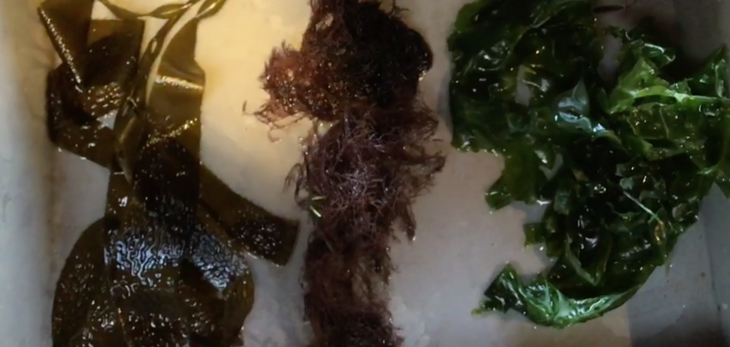
Procedure
- Cut strips of absorbent paper (2-2.5 cm wide)
- Check length in jar and cut to length
- 1 cm from end of paper strip rule a pencil line (NOT PEN!)
- Use an end of pencil, chopstick etc to hammer pigment from seaweed, leaf into the paper at the pencil line
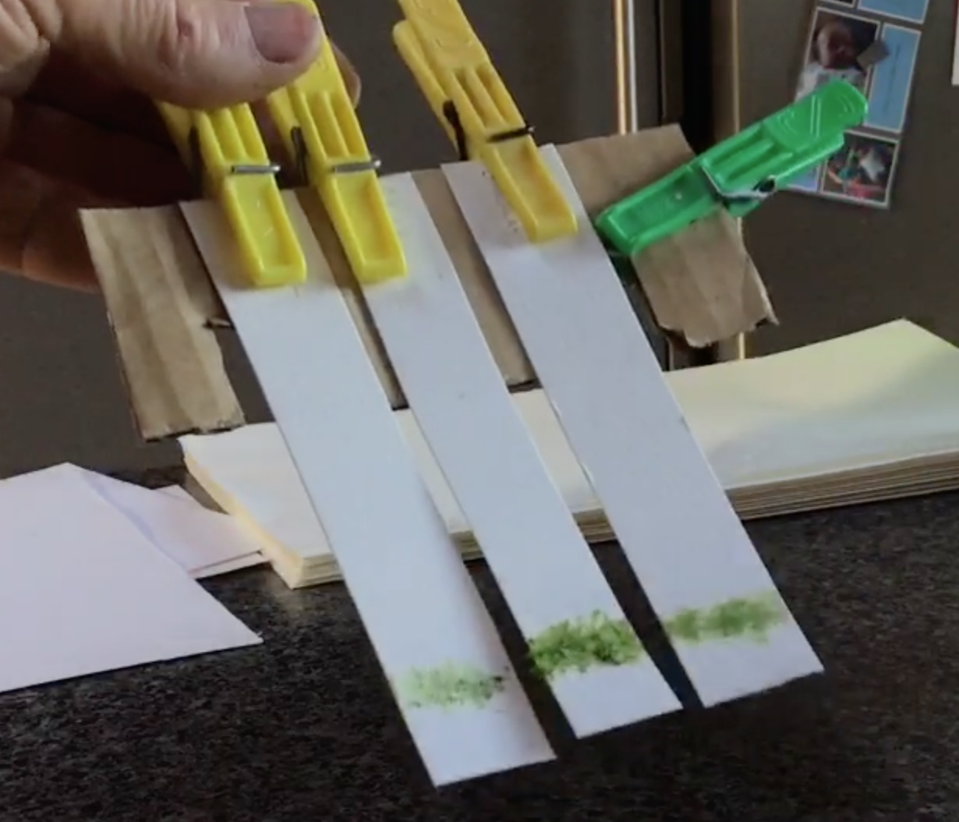
- Peg the paper strips to cardboard support so they will just touch the bottom of the jar pigment line at bottom end
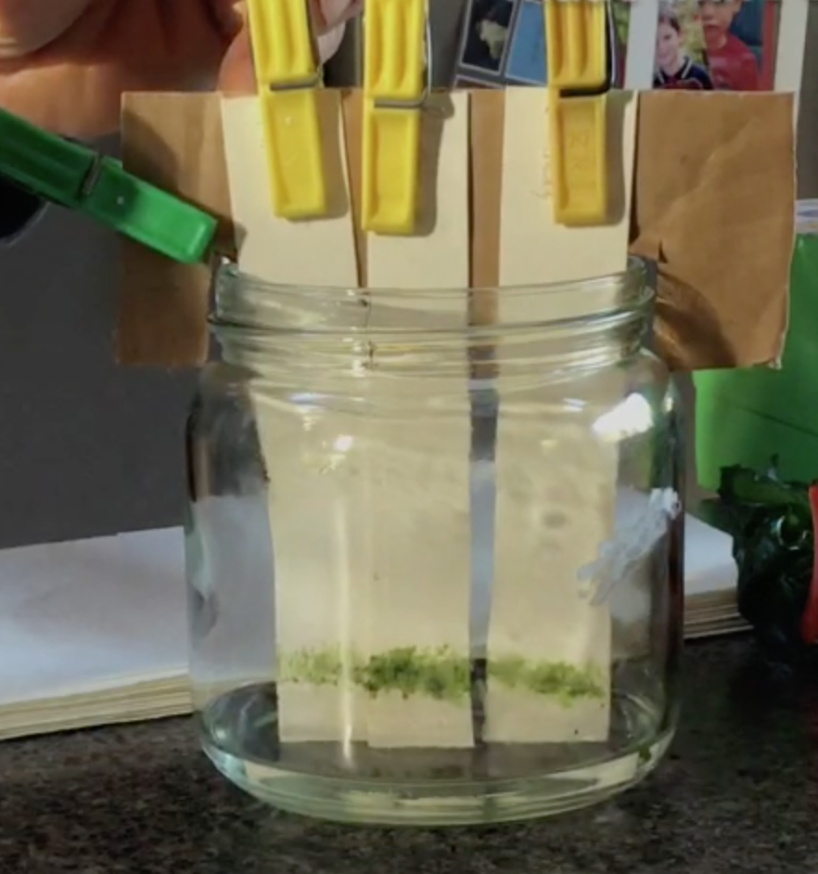
- Before placing strips in the jar, Pour alcohol into jar about half cm deep
- Place card across top of jar with strips just in the alcohol . make sure the pigment line is above the surface of the alcohol.
- Watch and wait as alcohol separates out and carries different pigments up the paper strip.
- Identify the different photosynthetic pigments
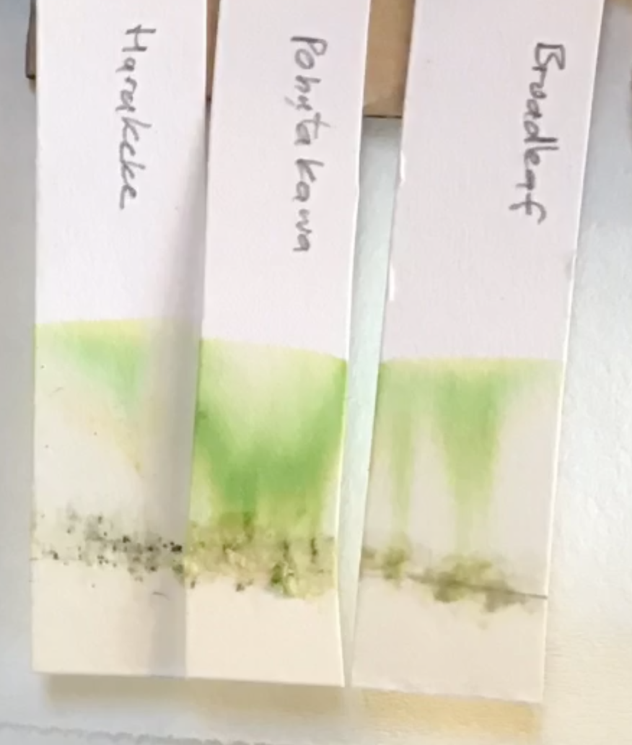
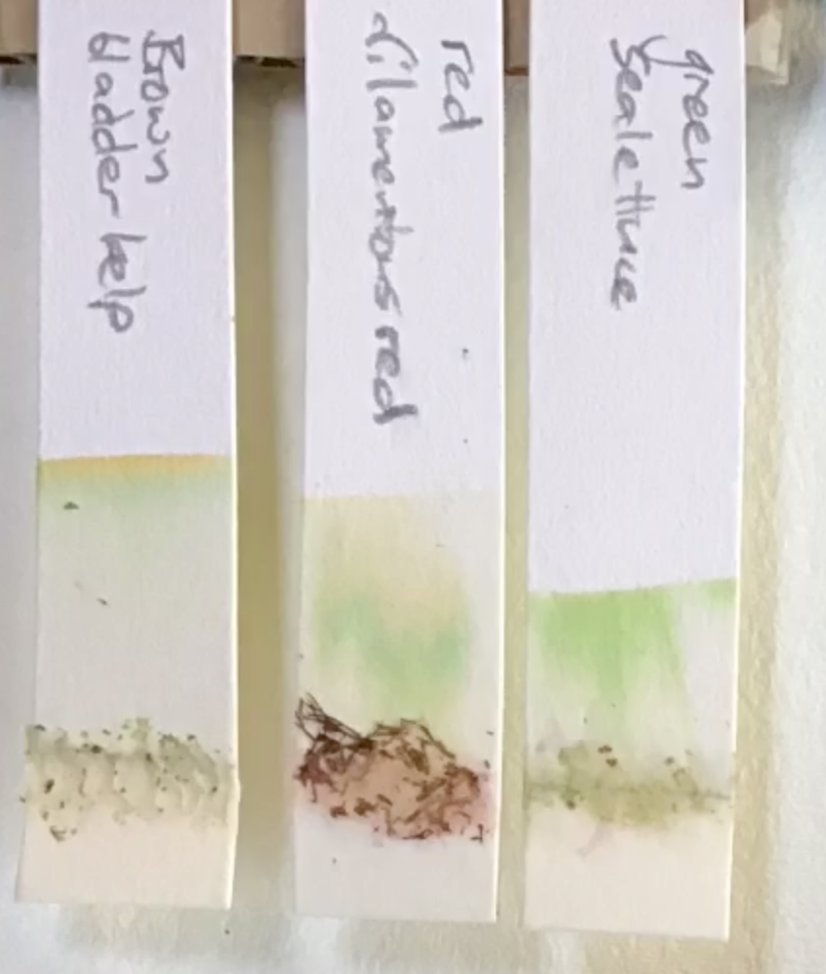

Carotenoid

Xanthophyll

Chlorophyll a

Chlorophyll b

All the colours of the natural world are the result of absorption and reflection of different wavelengths by different chemicals. We often refer to these chemicals that induce colour as Pigments. The colours we perceive are the wavelengths the pigment/s have reflected or transmitted. The colours we don’t see are those wavelengths that have been absorbed.
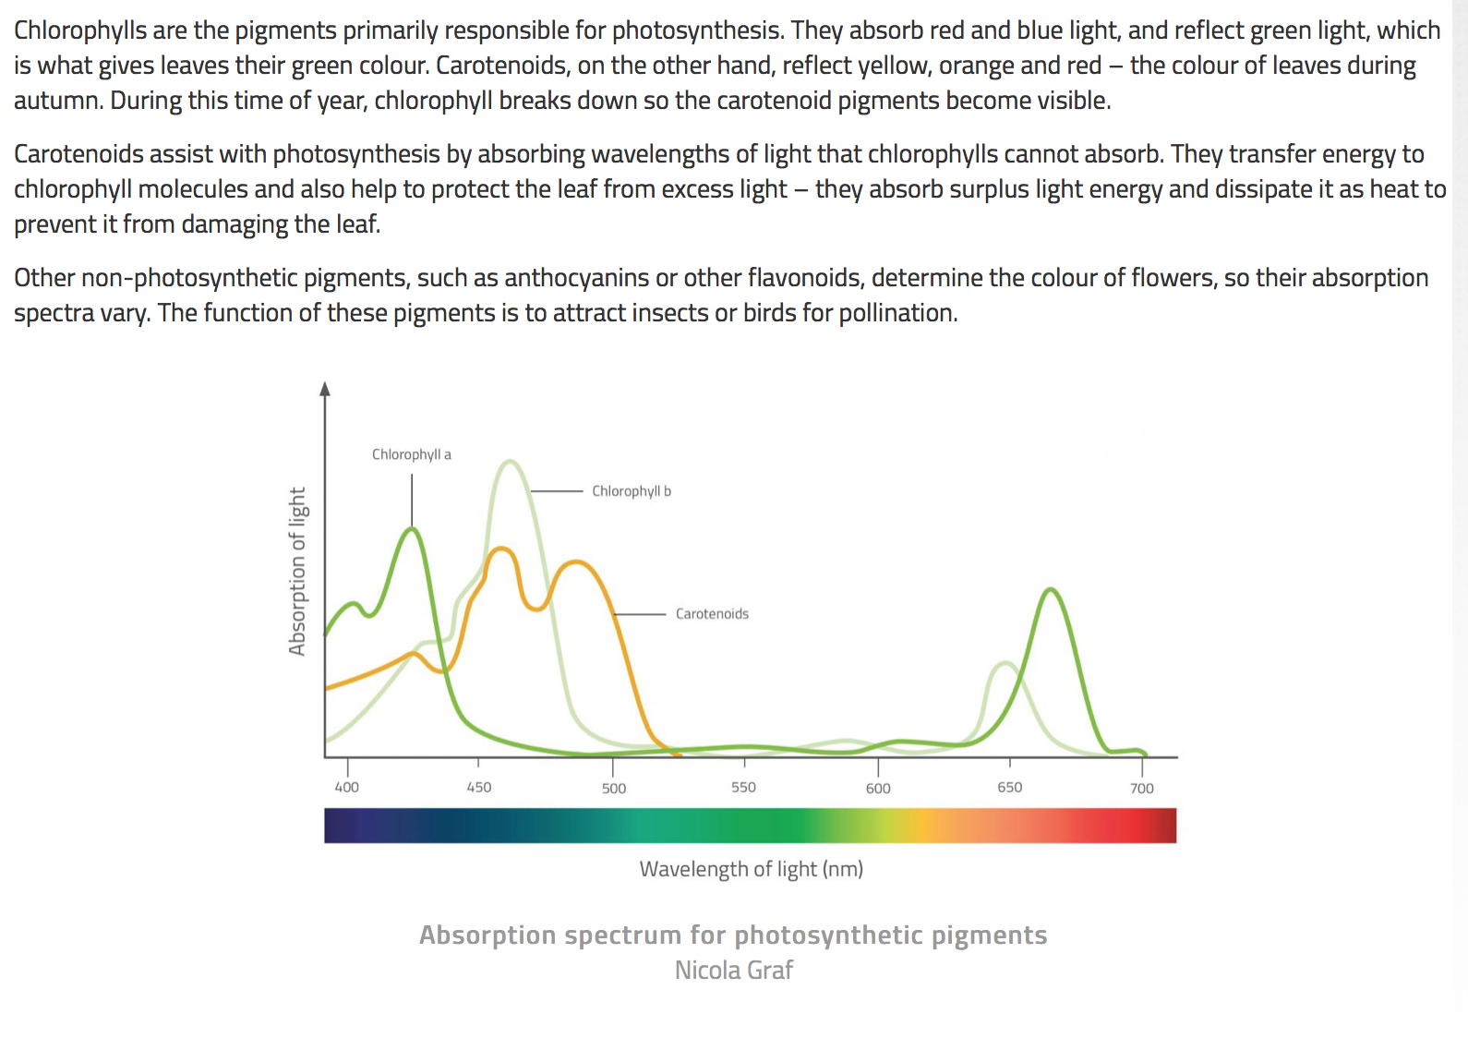
Of course, there are limits posed in the Ocean due to wave length absorption differences with depth. Blue and green penetrate further as we saw at the end of GTV 3.3
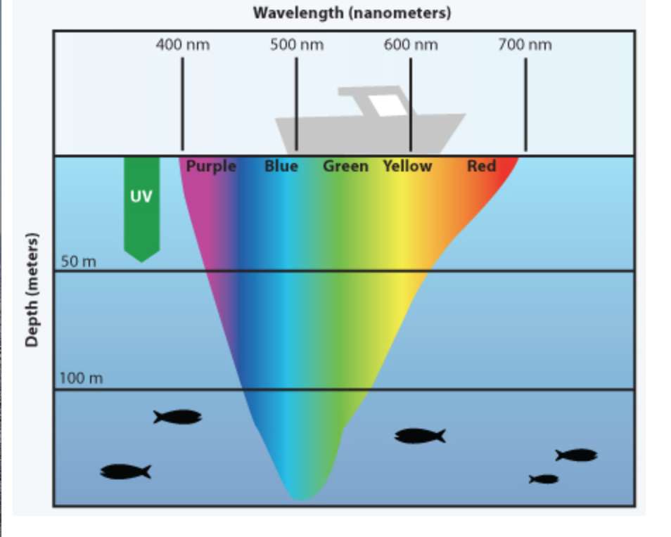

For more see:

https://manoa.hawaii.edu/exploringourfluidearth/physical/ocean-depths/light-ocean

and

https://opentextbc.ca/conceptsofbiology1stcanadianedition/chapter/5-2-the-light-dependent-reactions-of-photosynthesis/

https://www.ncbi.nlm.nih.gov/books/NBK22535/

Bench top 3, part 2. Pigment extraction and anthotypes (GTV 3.5 and 3.6)
-Brightly coloured plant material (e.g. Seaweeds such as filamentous red, sea lettuce, flowers such as chrysanthemum, poroporo, puriri, mellow, rose, fruits such as blueberry, rosehip, black peach or dark plum, roots such as beetroot, spices such as turmeric. Tea, coffee)
-water and /or alcohol -pot and stove -shallow bowls, plates -sieve
-tissues or absorbent paper towels to use as filters
-thick absorbent paper e.g. Watercolour paper
-scissors, cool dark space to dry papers.

Procedure
- Collect plant material
- Decide on water or alcohol extraction (solvent)
- Prepare plant material and mix with chosen solvent
- Prepare papers
- Soak papers in solution, or cover papers in plates with filtering tissues and pour solutions over.
- Dab off excess liquid
- Hang in dark to dry
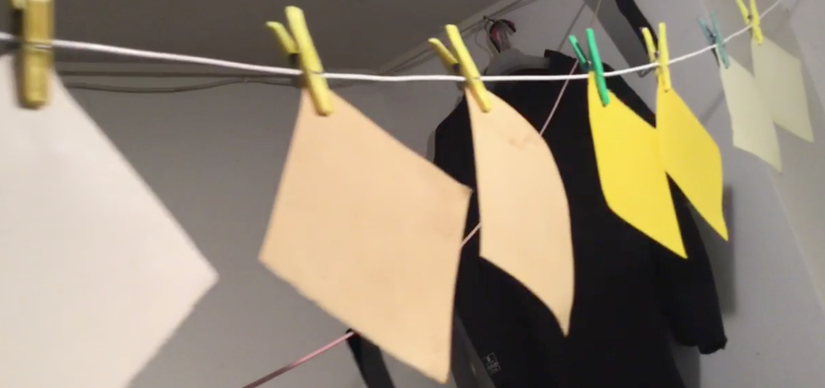

Using anthotype as Qualitative indicator of light intensity and duration. (GTV3.6)
- Choose some strongly pigmented papers and place between 2 glass sheets if you have them. If not tape to inside of a window.
- Either expose/tape up different samples of the same pigmented paper at different times over a time sequence (such as 1 day, 2 day, 3 day 4 day , 5 day, 6 day) and compare effect of light on pigment fading for different exposure times (try to control for intensity by only putting up for known amount of time at similar light intensity (weather))
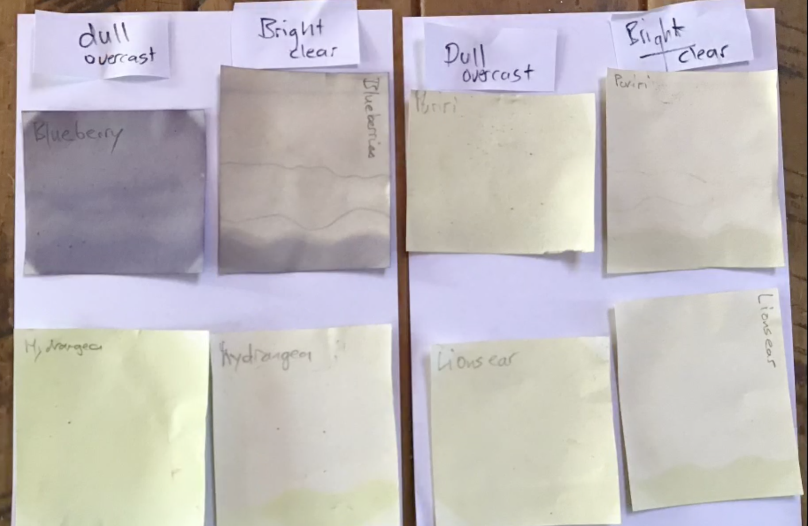
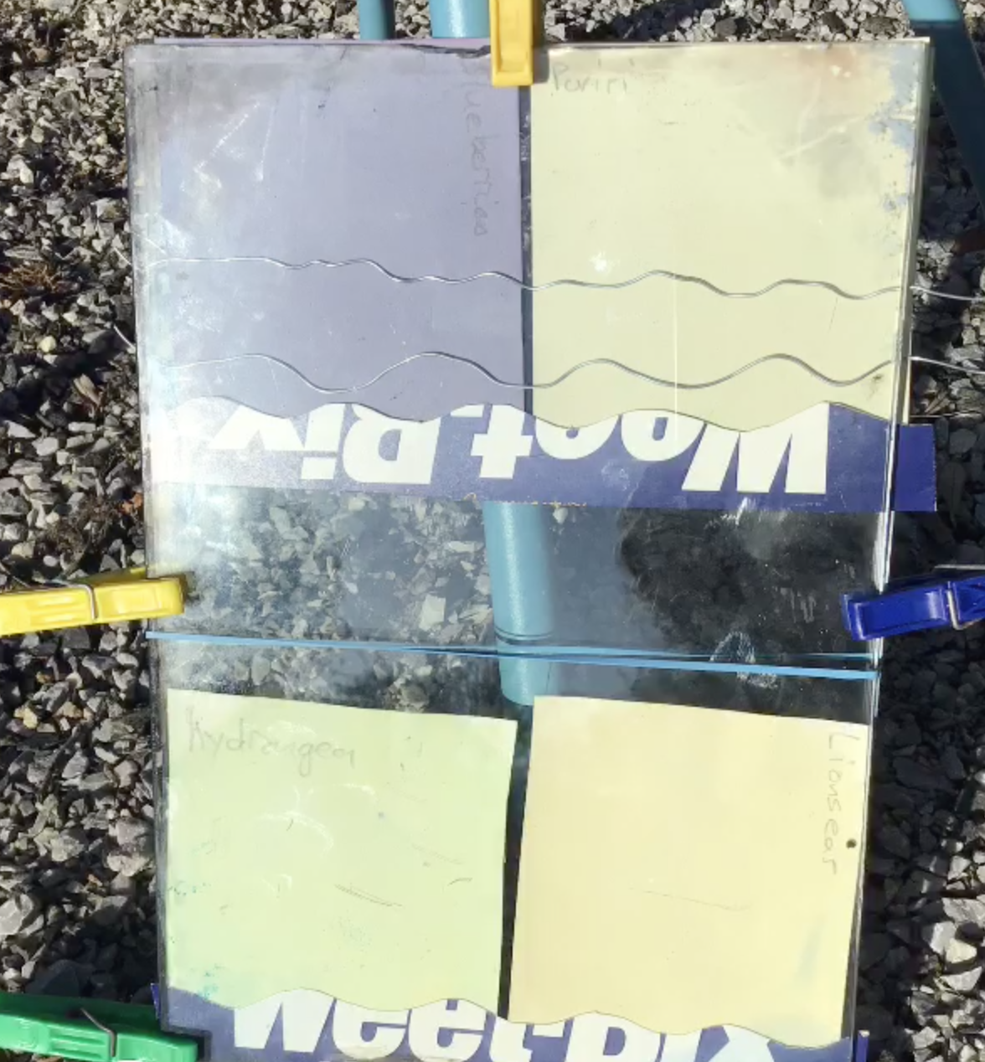

Making a simple black and white transparency for Solar imprinted anthotype. (GTV3.6)
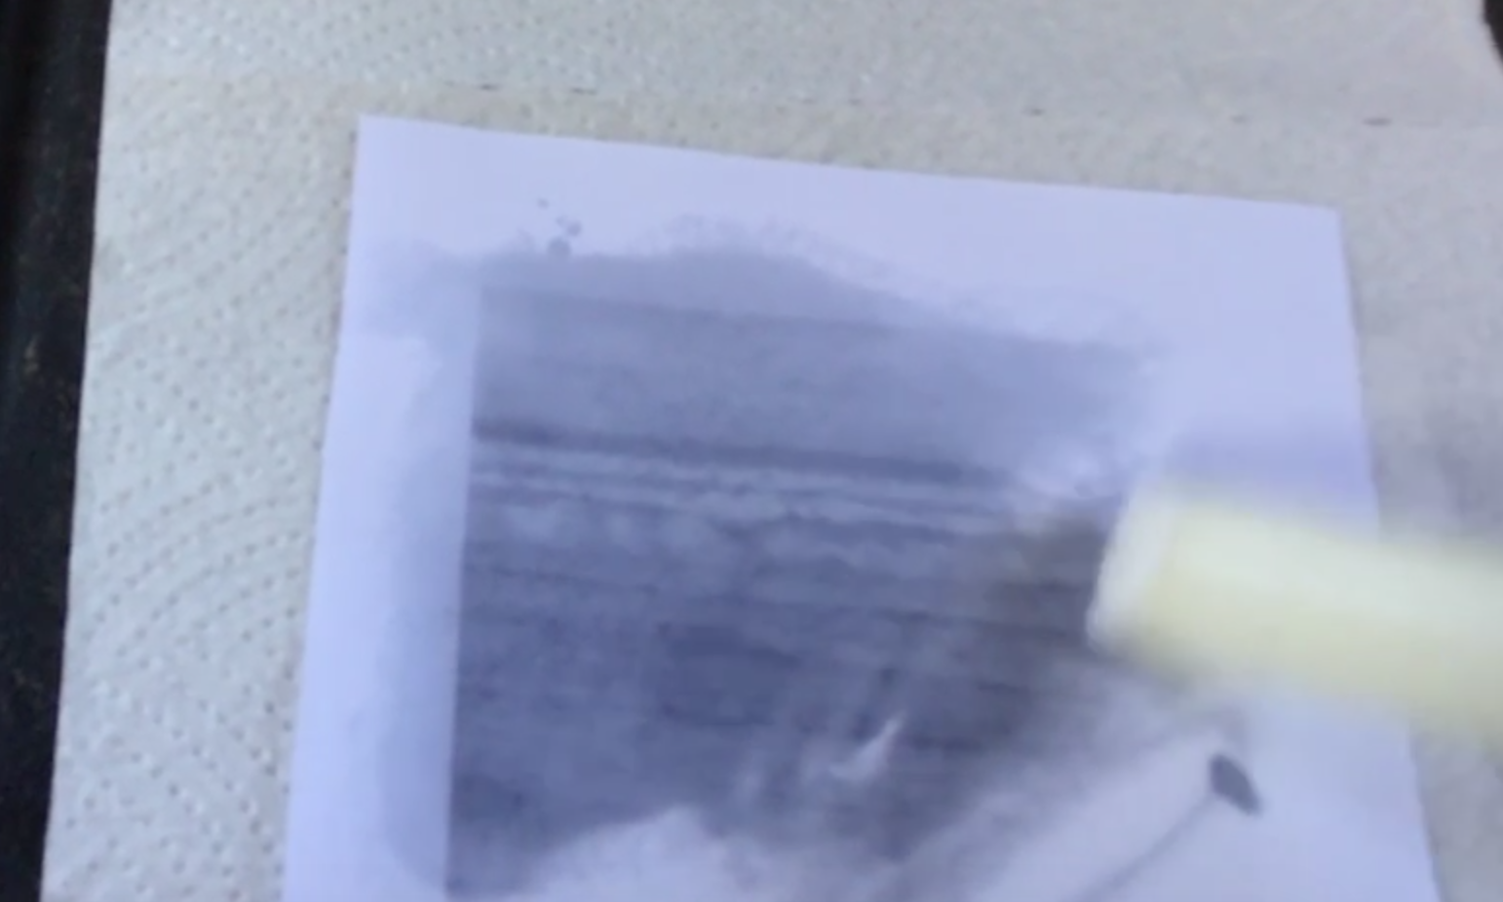
- Copy a black and white image onto an A4 piece of paper -thinner is better and an image with strong black contrast and multiple grey tones is best, (in GTV 3.6 you will see I used an image taken on a phone camera of waves )
- Warm up a hot plate, place a paper towel over the hot surface, place your black and white print face down on the paper and either rub with olive oil or rub candle wax over it till the image comes through clearly.

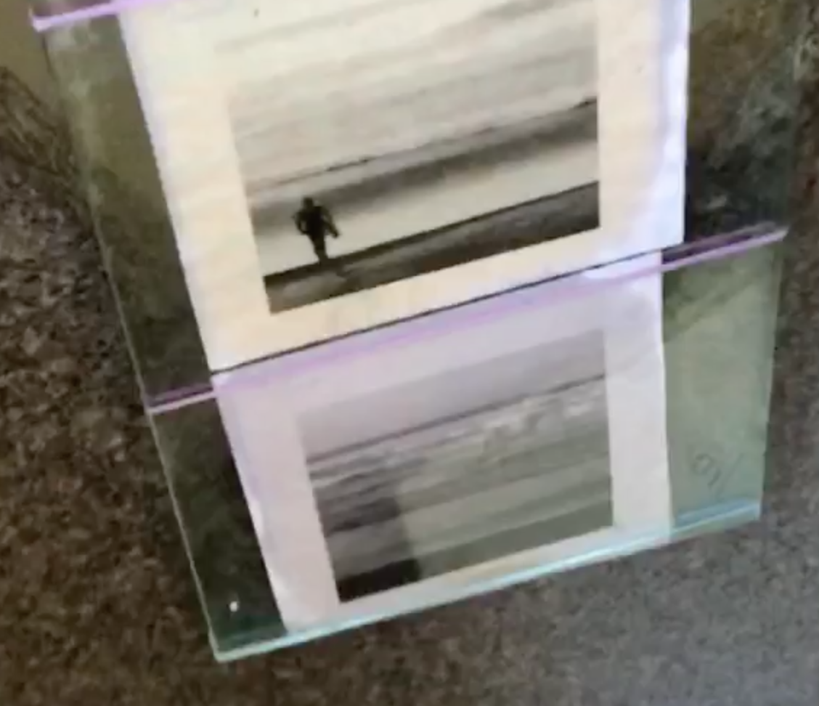
- Cut transparency to desired size , place over chosen pigmented paper and place both with a black paper backing on a glass sheet
- Place glass sheet on top and rubber band together
- Place in window in north facing sunny position and leave for a week or 2!

This is photo-imaging in one of its simplest forms.
Photo-imaging is defined as the process of forming an image by the use of LIGHT.
“Surfing the Light”

The photo-imaging process we are most familiar with is our own sight! This enables us to collect information about our world, we can store this information as retrievable perceptions, we can link new and remembered memories to fresh observations, we can access other people’s visualizations or graphic representations of the world, we can do all this and come up with new insights, views, imaginings. You can see that this photo-imaging is hard-wired into our language, our describing and making meaning of our Ocean world and our everyday life!!

In GTV 3.7 we will explore how image and imagination are a critical part of the Nature of science and to do so we will focus on the science journey that has bought us to our present day understanding of light.

EXTRA!!

Solar irradiance is a measure off total photon output by the sun
Solar irradiance at a particular location is a measure of photon output received from the sun at that place in time and space and is given as photon energy /m²/second

The unit of power is the watt so 1000W/m²/hr is 1000 kilowatt-hours

https://www.nasa.gov/mission_pages/sdo/science/solar-irradiance.html

https://www.3tier.com/en/support/solar-online-tools/what-are-units-solar-irradiance/

While irradiance is objective, measured independent of human sensory systems and processing,
Lux as a measure of illuminance is subjective.

Lux values are adjusted according to the spectral sensitivity of the human eye. In other words, when calculating illuminance, 1 W/m2 of red light doesn’t equal 1 W/m2 of green light, because the human eye is more sensitive to green. Thus, illuminance is designed to convey information about how well a human being could see under certain lighting conditions. It is still a measure of photon energy /area. A measurement of 1 lux is equal to the illumination of a one metre square surface that is one metre away from a single candle.

https://www.allaboutcircuits.com/technical-articles/understanding-illuminance-whats-in-a-lux/

