Adding Training
People can be found using this tab
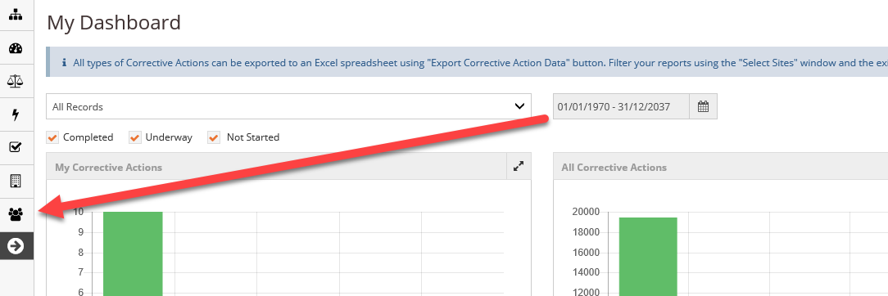
Listed under this tab you will find
- Contracted workers
- Third party/Visitor
- Training
- Workers
- Student Register
To add training to a worker, select Worker then Worker Register.
A new window will open. Using the search button you can search for an individual using several different methods
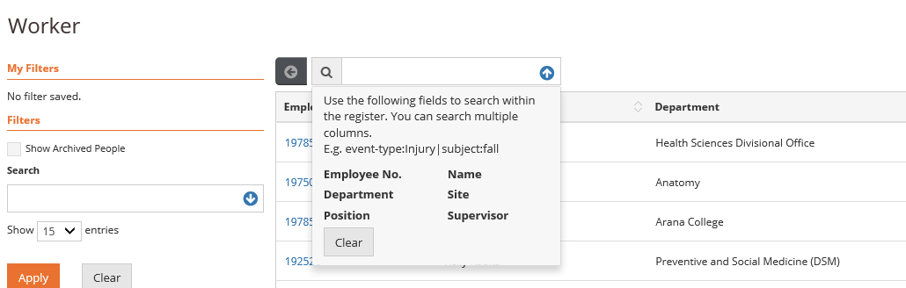
Once the correct person has been found select the Actions button and select what you would like to do. In this instance select Edit
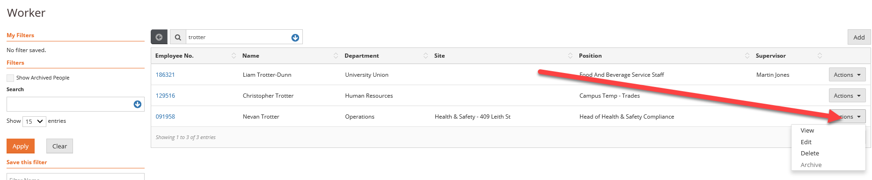
Followed by add
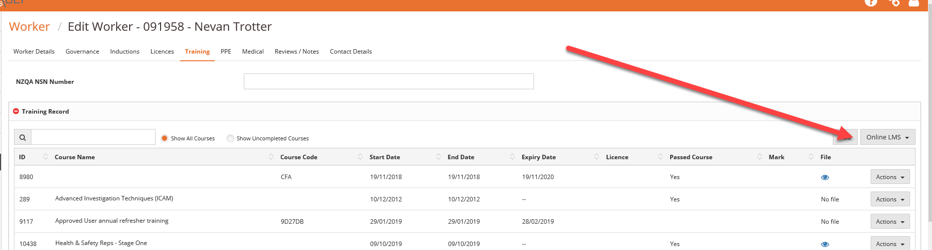
Again a new window will appear
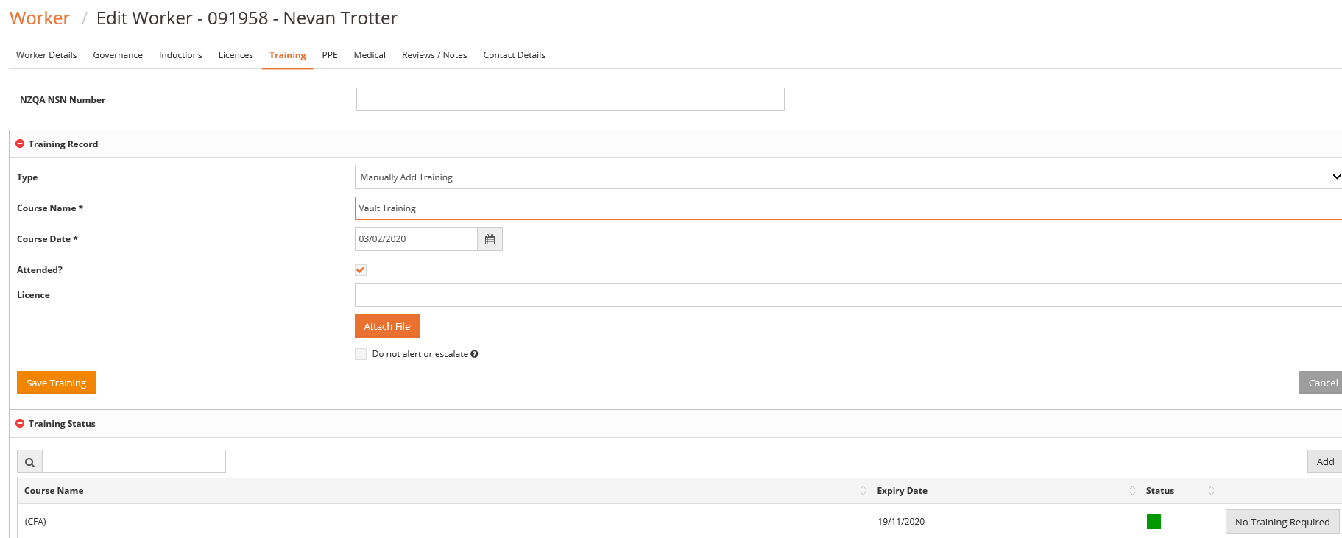
Under type keep it as Manually Add Training for now.
Start typing in the course name, name suggestions of courses will appear as you type, select the correct course. Add the course date and add a certificate if available under Attach file.
Then select save at the bottom left of the page.
The Course and certificate will now be saved against the appropriate person.

