Checking whether you have any overdue events to investigate
Log into Vault.
Vault will automatically open in your Dashboard.
Click on the Dashboard tab on the left of your page
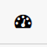
Select My Assignments.
You can now filter through your assignments using the filters at the left of your page
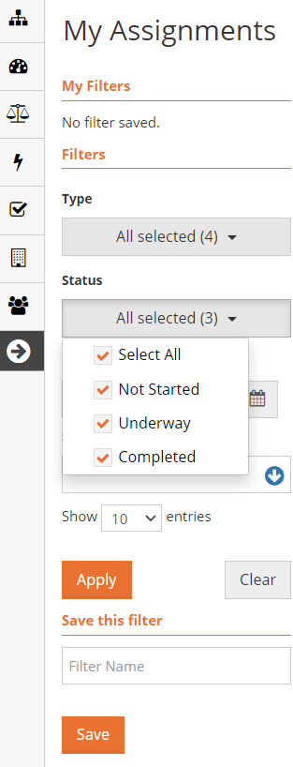
Select Underway and Not Started, then click Apply.
Any events that you have been assigned to will now appear
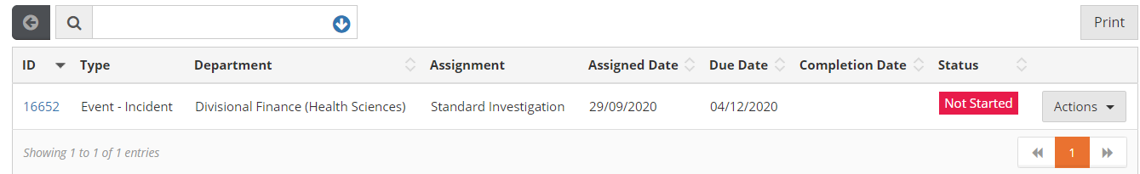
You can click on the ID showing and you will be taken to the event. If you have investigated the incident please complete it. If you still have work to do, change the due date to a later date.
Select Actions and Edit to change anything in the event.

How to change a due date in Vault
Log into Vault.
To find an event,, click on the lightning bolt on the left of your open Vault page.
Select Events.
Find the appropriate event by either scrolling or using the search bar at the top of your page.
Click on Actions to the right of the correct event and select EDIT, the event will now be open for editing.

Click on the Standard Investigation tab at the top of the page.
You will see the date the event was assigned and the current due date.
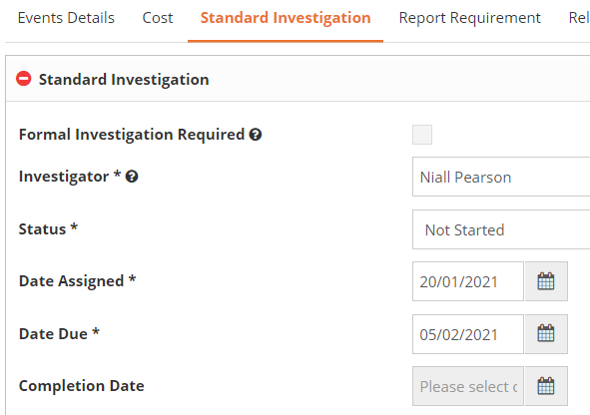
Select another date for the due date and Save to Events by clicking on the button at the bottom of the page.

As always if you have any questions please phone Karen Bonney 6216

