“IS THERE AN OCEAN IN THE HOUSE?”
Level | Investigations
Topic | Salinity
‘OITH bench-top’s | Definitions, making, changing, measuring.  GTV 1.1  GTV 1.2 | Tool, (setup)  manufacturing, testing, modification.  GTV 1.2, 1.3 and 1.4 | Tool, calibration and system error.  GTV 1.5 and 1.6 | Doing with the tool. Enquiry. Problem. Proposition.  GTV 1.7 and 1.8
Support material | Overview and  worksheets | Concept, analogy and creativity | Graphing , statistical  GTV 1.3 and 1.9 | Review  GTV 1.10

We have now made our ‘Ocean in the House’ and have a range of ‘Sea’ samples based on valid, real world, salinities. These have been made with as much precision and accuracy as our equipment has allowed.

Now we are ready to investigate salinity and density further by manufacturing a tool to measure specific gravity which is based on relative densities. This is possible because density effects buoyancy. The more dense a liquid (or gas for that matter!) the more buoyant an object will be (i.e. less submerged).

If we can construct a tool that can show us different buoyancy in different densities then we can calibrate it using our standardised sea samples of known salinity to be able to measure the salinity of an unknown sample.

This procedure, of calibration of an instrument with standardised samples, is used every day in the world of science; you will come across it again and again. If we use standards that relate to real world examples it supports the validity of our measurements and, combined with an understanding of precision and accuracy, it underpins the reliability of or data.

You can find out more about these relationships and their uses with extension into the following links, but you might like to leave this till after we have made our tool:
Density and specific gravity: links and extensions

https://www.khanacademy.org/science/physics/fluids/density-and-pressure/v/specific-gravity

https://oceanservice.noaa.gov/facts/plimsoll-line.html

https://www.wikihow.com/Calculate-Buoyancy

‘Bench top’ 2 and 3 (GTV 1.4)
Making and calibrating a tool for measuring salinity
Kit
- A kitchen, including the kitchen sink!
- Our many “seas”: 0 ppt to 100 ppt
- 1 measuring jug, preferably to 1 litre
- 1 set kitchen scales, to 1 gm accuracy
- A 1.5 L plastic bottle
- 2 or 3 drinking straws (preferably clear plastic)
- A candle and matches (or surf wax!)
- Assorted small screws and nails around 2 -3 gms each.
- Paper and pencil, pencil sharpener
- Scissors or knife (to cut top of the plastic bottle)

Benchtop 2 Procedure: Making the tool (GTV 1.4)
- Choose a clean , clear, narrow, drinking straw
- Use either surf wax or candle wax and soften, or melt some into what will be the bottom end of our tool.
- Screw in a small screw or press in a small nail
- Keep working or melting in wax to seal the screw/nail in and add a small amount of weight.
- Test in pure water in home-made ‘cylinder’ cut from 1.5L bottle. (It doesn’t matter if it tilts a bit but it doesn’t want to be too deep as we are adding more).
- Mark up paper with small sharp pencil at mm intervals marking every 3rd line longer and every 6th even longer.
- Cut the strip of paper so rolled up it will slide into the straw. (You can roll it around a chopstick to get a good start).

Benchtop 3 standardization and calibration (GTV1.5)
- Slip paper into straw and float in test water(pure water = 0 ppt.( If it sinks to hit bottom you will need to remove some wax from the end carefully)
- Let tool settle and then carefully note where surface is (bottom of meniscus) by holding with fingers at that height or by counting marks.
- Take out and remove paper and at the mark write 1.000, this is Density of pure water. (Make sure it is clear which mark it is! Maybe red?
- Place paper strip back in straw and retest in the water. You can hold straw and slide paper up or down till the surface is exactly at 1.000. You have now Standardised the tool to the reference solution -pure water of 0 ppt salinity.
- 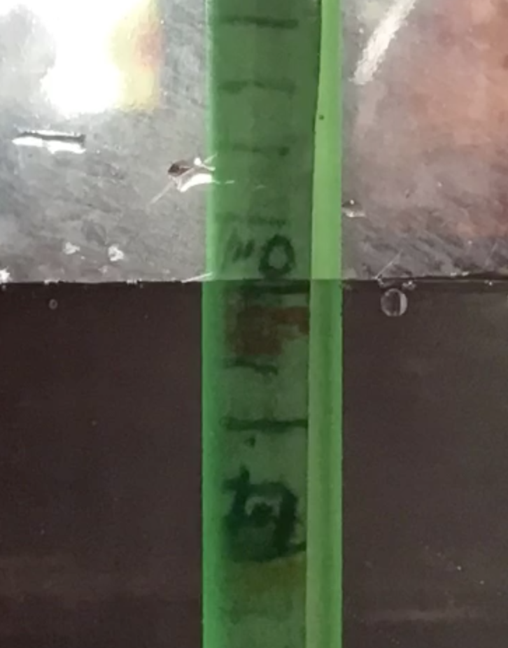
- Because the reference density is that of pure water we can use the tool to compare densities to this.
- Relative density is called specific gravity.
- This tool is called a hydrometer as it helps us measure specific gravity with reference to water.
- We are now ready to calibrate our hydrometer using the reference solutions we have made up. (GTV 1.5)
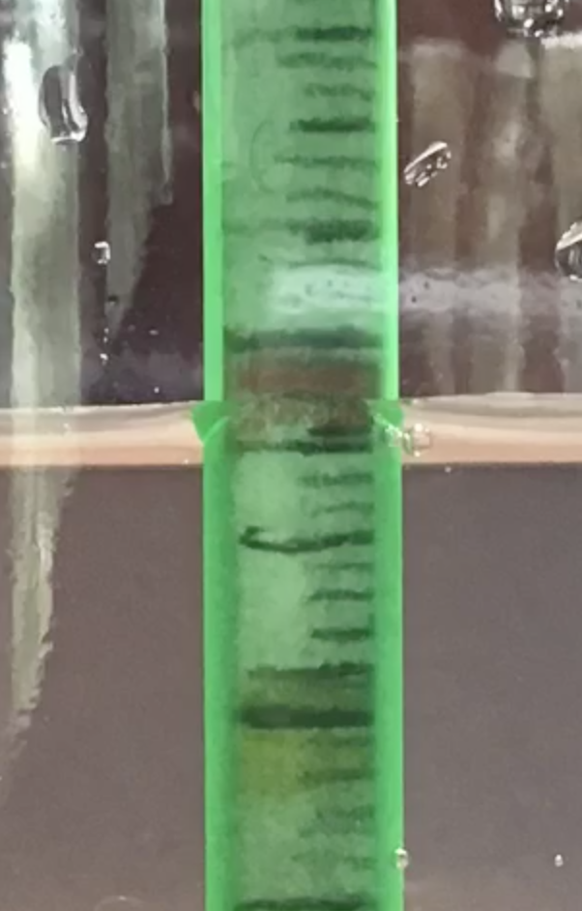

1.0 mark =0ppt

Blue line = bottom of meniscus
1.035, between 3 and 4 marks

Down from 1.0

1.1 mark = 100ppt

This is our 35ppt “sea”

Understanding system error see GTV 1.6

Now we are ready to do some science with our instrument!!

What is science?

See GTV 1.8 for a wee intro to the nature of science: it’s a more natural way to learn about the world than you might think!!

See GTV 1.7 for some ideas and GTV 1.9 for drawing up a conversion table for your instrument

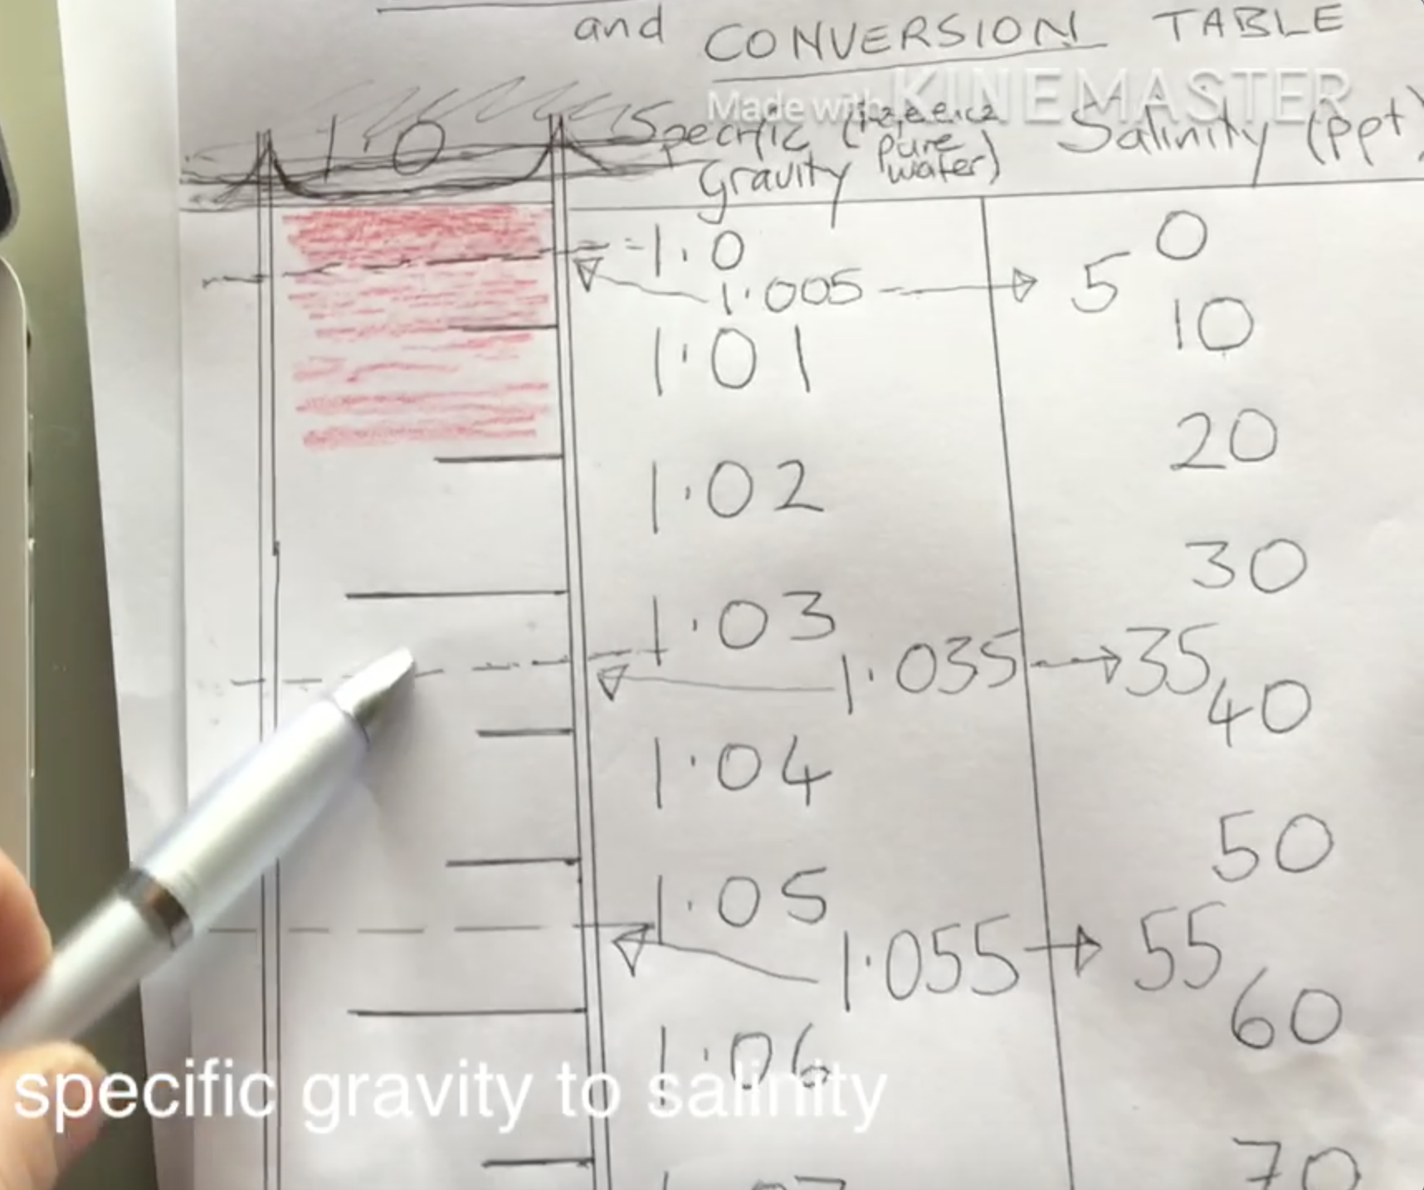

Want to get a quick overview of this topic see GTV 1.10!!

Want to find out about the things we have dealt with in this topic in the daily lives of marine scientists? View GTV 1.10 or Connect to the full Marine Science Covid-chat zoom interviews with Linda, Jess and Tamlyn.

Thanks for your engagement; see you at topic 2 - Temperature.

Nga mihi
Steve C.

