“ “IS THERE AN OCEAN IN THE HOUSE?”
Level | Investigations
Topic | Temperature
‘OITH bench-top’s | Introduction, Definitions, changing. The nature of water.  GTV 2.1  GTV 2.2 | Tool, (setup)  manufacturing, testing, modification.  GTV 2.2, 2.3 and 2.4 | Tool, standardization and calibration, issues of range and sensitivity. (and more system error.)  GTV 2.5 and 2.6 | Doing with the tool. Enquiry. Problem. Proposition.  GTV 2.7 and 2.8
Support material | Overview and  worksheets | Concept, analogy and creativity | Data handling, conversions. Graphing and interpretation  GTV 2.3 and GTV 2.9 | Review  GTV 2.10

Designing and carry out a valid and reliable scientific investigation. (GTV 2.7 and GTV 2.8)

Now that we have made our ‘humbod’ thermometers and we have standardized and calibrated and drawn up conversion tables to centigrade we can design and carry out an investigation into the effect of mass on temperature change, and heat capacity.

Science is a way of thinking and a way of doing and there are some frequently used terms that enable us to share our doing and thinking to build valid and reliable understanding.

As we saw in GTV1.8 Science is based on curiosity which is not an uncommon trait in many animals.
We have also seen that taking care and consistency are important in making observations and measurements and that the context and congruency with known science are essential for framing our enquiries and interpretations. Critique of ourselves and others work and shared communication are essential; before conscious constructs of comprehension are developed and applied.
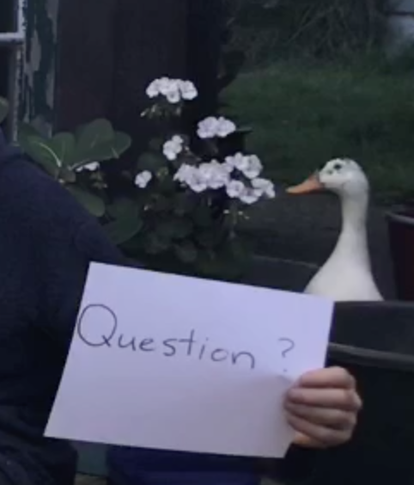
How do these essentials translate into the design of our investigation?

Curiosity means asking questions and building background.

E.g. “What effect does mass have on the temperature changes in water?”
“What effect does mass have on the ‘heat-holding’ capacity of water?”

Care and Context means building background that includes relevant real-world reference, the related science and other’s work. This includes a statement you think holds maximum truth value with what we know so far. This statement is the scaffolding for our experimental design and is usually refered to as a hypothesis (it is a tentative working tool).

e.g. “that as mass increases the rate of change in temperature decreases”
“that as mass increases the heat flux and heat capacity increases for any given temperature increase”. Thus
“the greater the mass the more stable the temperature over time”

Here is a useful checklist for making sure you have a sensible and operational hypothesis (H¹):
- Is it a statement?
- Does it have a subject? (e.g. water, ocean)
- Does it clearly state the independent variable (IV) (e.g. Mass)
- Does it clearly state the dependant variable (DV) (e.g. temperature)
- Is it a prediction of a relationship? (e.g. between mass and temperature change/heat)
- Can you sketch a graph of this (not essential but very helpful to visualize)
- Does it have an explanatory cause? (E.g. particle nature of matter and definitions of heat and temperature).

Context and congruency are all about validity. Here is a helpful checklist for validity.
- Does the independent variable vary in real world and do the treatments proposed make sense or are scalable to make sense with reference to real world?
- Can a sufficient number and range of distinct and discrete treatments be set up?
- Is the dependant variable measurable or able to be scaled to provide information relevant or scalable to context and congruent with known science?
- Is the hypothesis (IV and DV relationship) a reasonable statement in context of real world experience?
- Is the hypothesis a reasonable statement and is congruent with known science at present time?

In practice for our investigation here this translates to:
- We decide on 2 or more treatments (more is better) that are sufficiently different that they do not overlap .
- GTV2.8 shows 4 (1Litre, 10 Litre, 50 Litre and the open sea.)
- Temperature has a solid scientific history of being measurable and scalable. We use the ‘humbold’ thermometers and convert to centigrade to allow discussion and calculation relevant to conventionally accepted and known science.
- Yes we have observed the cooler air while sea stays comparatively warmer and warmer air with comparatively cooler water. Some of us will have noted a cup of water cooling quicker than a bowl of water and we noted that the larger volume thermometers made took longer to stabilize a shift in temperature than the smaller ones
- Yes, the particle nature of matter and the definition of heat suggests that an increase in temperature relates to increase in energy of molecular motion throughout a mass.( More particles moving more = lots more heat than a few).
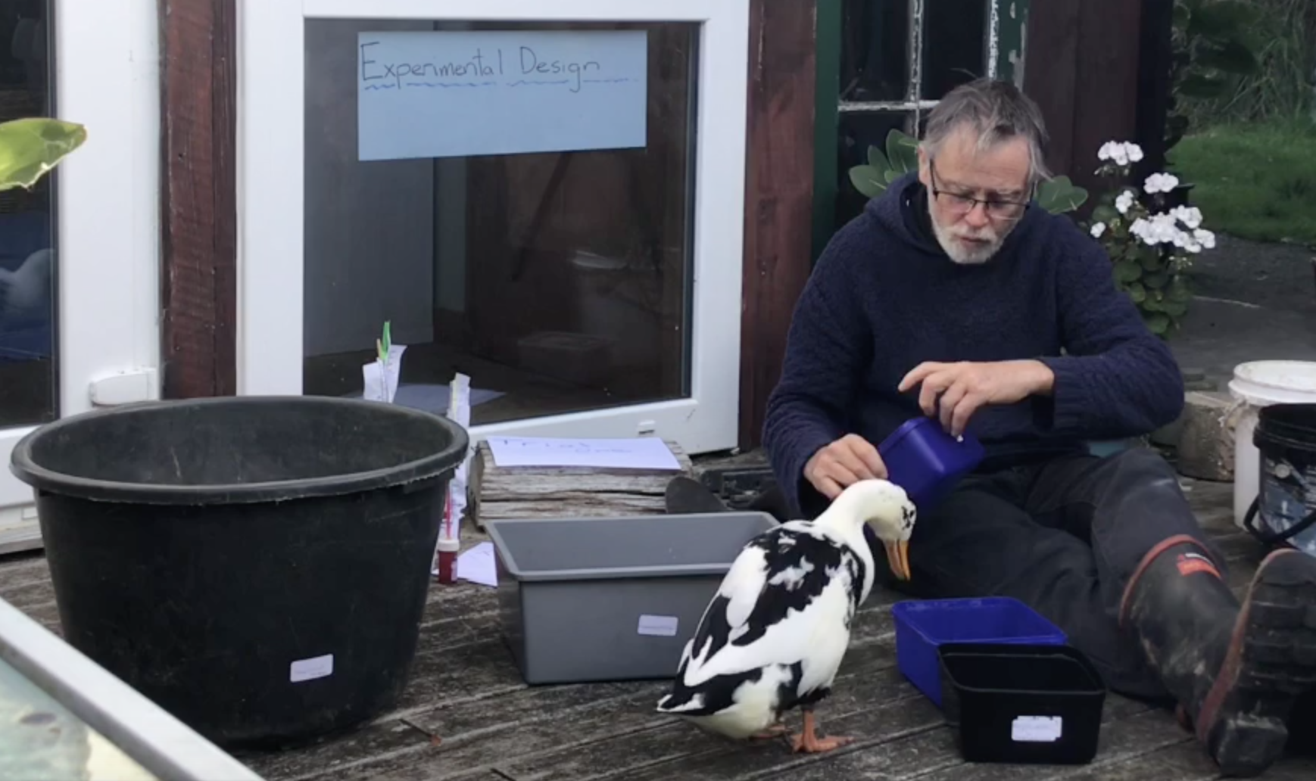

Care, consistency and critique are all about Reliability. Here is a helpful checklist for reliability.
- Overall ask the question-is the experimental design and practice such that the data collected is a most dependable and fair representation of the possible actual relationship under investigation?
- Have all sources of system error (see GTV 1.6 for detail)or bias been identified , minimized, measured or accessed, recorded managed and reviewed?
- Have all confounding variables been identified, defined, eliminated, measured, recorded and managed?
- Is the protocol for each trial maintained as exactly the same as possible?
- Is the sample size (replicates)the maximum that time , space and resource allow?
- Is a repeat of the investigation carried out where possible?
- Does the experimental design take into account the appropriate statistical analysis?
In practice for our investigation here this translates to:
- 4 different mass treatments monitored for temperature every 2 hrs, when possible over 24 hrs of ambient temperature changes.
- Thermometers have been calibrated against consistent reference standards, multiple thermometers used and cross referenced, Volumes of water measured. Same person doing the readings. Sufficient time for thermometer stabilization considered and managed.
- Exposure to sun is considered and movement to compensate. Time periods same for each trial and treatment. All dark containers re energy absorption. Water consuming animals kept out of experimental area. Same location and time period for all treatments.
- Temperature measurements begun and finished within 20 minutes either side of the designated time period etc.
- We managed 3 replicates (sample size of 3 ) for 1 litre but only 1 for all other masses.
- No, but you can!

Care, communication and conscious construct of comprehension means recording all data and operational observations precisely and as accurately as possible. (being honest and truthful!)

Temperature (degrees ‘humbod’)
treatments | air | 1 L (x3) |  |  | 10 L | 50 L | sea
Time 0 hrs
2
4
6
8
10
18

Note: spreadsheets shown in GTV 2.9 show collection of data from multiple individual identified thermometers.

Then….

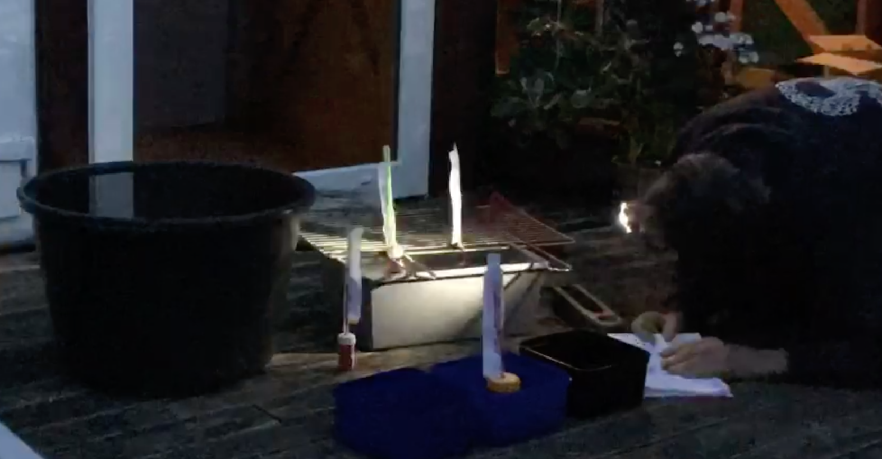
Precision
Patience
Perseverance

Followed by appropriate tabling, graphic representation, and statistical analysis and calculation if needed.

