- Annual Report Template

Cancer Society of New Zealand Research Grant Annual Report Template and Guidance

Annual Report Guidance

Section 1: Grant information
Fill in the grant information in the template below.

Section 2: Lay summary
A brief summary for a lay audience (maximum one page) of all research outcomes, describing how this research may benefit people affected by cancer, and future plans for the research. If you have any diagrams or images that simply and visually demonstrate your research outcomes please include these here. This section of your report may be used, either in the form you submit, or in edited versions, to inform the public about the work we support.

Section 3: Scientific Progress
See below the Gantt chart you submitted as part of your application (and/ or the most recent version submitted to the Cancer Society). Please confirm whether you are on track with these timelines.

 |  | 2020 |  | 2021 |  |  |  | 2022
 |  | Q3 | Q4 | Q1 | Q2 | Q3 | Q4 | Q1 | Q2
Objective 1 | Task 1
 | Task 2
 | Milestone 1
Objective 2 | Task 3
 | Task 4
 | Task 5
 | Milestone 2
Objective 3 | Task 6
 | Milestone 3
 | Task 7
 | Milestone 4

If you are not on track with the above timeline:
- Please explain why you are not on track
- Describe the impact this will have on the overall project
- Submit a revised Gannt chart with adjusted timelines until the end of the grant period

Section 4: Budget
See below the budget you submitted as part of your application.
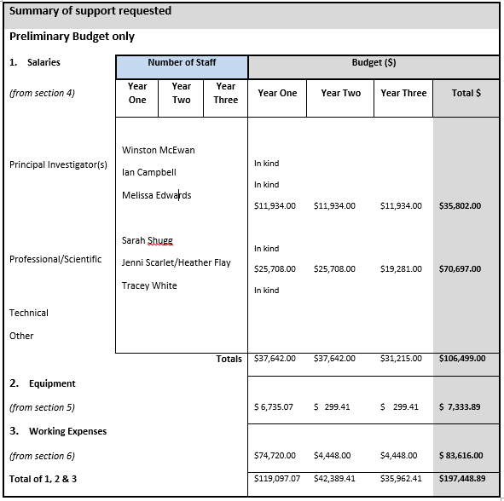
Example

Please confirm whether you are on budget. Please request a financial summary report from your Research Office, showing the overall expenditure to date for this grant (see example below) and include it as part of your report.

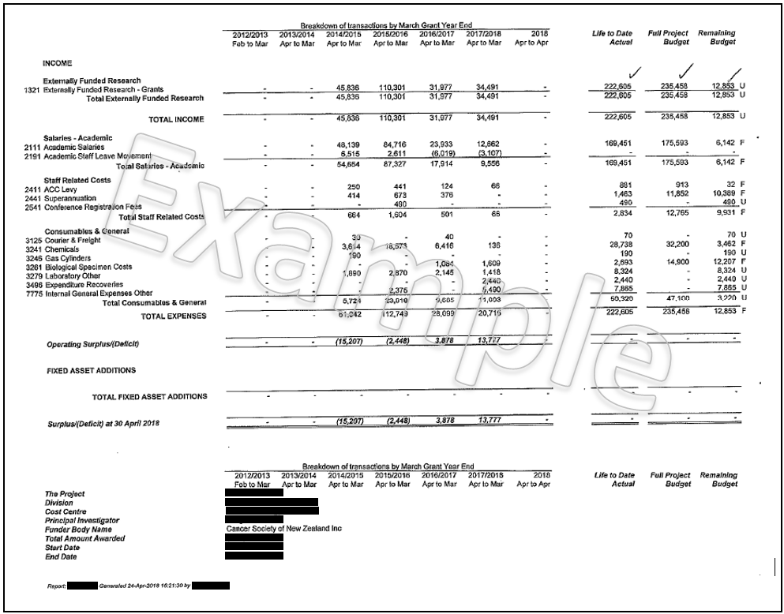
If you are not on budget:
- Please explain why you are over/ under budget
- Describe the impact this will have on the overall project
- Describe how the remainder of the grant budget will be spent between now and the end of the grant period

Section 5: Research impact
For this section please consider the following questions:

What have you, or your team, produced through this research?
Please include the key outcomes/ findings of your research to date. Please list full bibliographic citations for any published papers or meeting abstracts arising from the grant and enclose one electronic copy of each published paper.

How have you, or your team, shared the knowledge gained through this research?
Please include details of any presentations at conferences, public talks or other outreach activities that have resulted from your work.

How have you contributed to developing the cancer research workforce through this research?

Section 6: Contribution to Māori health
Please describe if your research to date has contributed to reducing inequity between Māori and non-Māori.

Annual Report Template

Section 1: Grant Information
Grant reference:
Principal investigator:
Project title:
Award type (research project/ PhD scholarship/ grant in aid):
Commencement date:
Grant duration:

Section 2: Lay summary

Section 3: Scientific progress

Section 4: Budget

Section 5: Research impact

Section 6: Contribution to Māori health

- Final Report Template

Cancer Society of New Zealand Research Grant Final Report Template and Guidance

Final Report Guidance
Section 1: Grant information
Fill in the grant information in the template below.

Section 2: Lay summary
A brief summary for a lay audience (maximum one page) of all research outcomes, describing how this research may benefit people affected by cancer, and future plans for the research. If you have any diagrams or images that simply and visually demonstrate your research outcomes please include these here. This section of your report may be used, either in the form you submit, or in edited versions, to inform the public about the work we support.

Section 3: Scientific progress
See below the Gantt chart you submitted as part of your application (and/ or the most recent version submitted to the Cancer Society). Please confirm whether you have achieved the objectives and milestones listed below. If you did not achieve the objectives and milestones below please explain why these were not achieved.

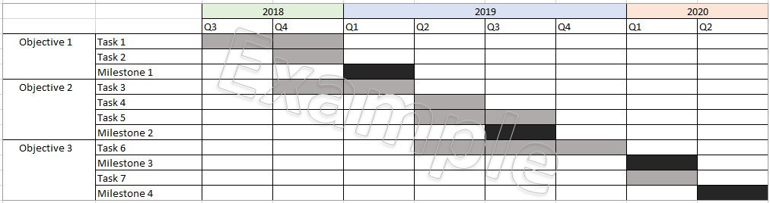

Section 4: Budget
See below the budget you submitted as part of your application.
Example

Please confirm whether you finished the project on budget. Please request a financial summary report from your Research Office, showing the overall expenditure to date for this grant (see example below) and include it as part of your report.

Please note, if you are under budget the Cancer Society will retain the amount remaining on the grant.

Section 5: Research impact
For this section please consider the following questions:

What have you, or your team, produced through this research?
Please include the key outcomes/ findings of your research. How will the research findings benefit people affected by cancer? Please list full bibliographic citations for any published papers or meeting abstracts arising from the grant and enclose one electronic copy of each published paper.

How have you, or your team, shared the knowledge gained through this research?
Please include details of any presentations at conferences, public talks or other outreach activities that have resulted from your work.

How have you contributed to developing the cancer research workforce through this research?

Section 6: Contribution to Māori health
Please describe if your research has contributed to reducing inequity between Māori and non-Māori.

Final Report Template

Section 1: Grant Information
Grant reference:
Principal investigator:
Project title:
Award type (research project/ PhD scholarship/ grant in aid):
Commencement date:
Grant duration:

Section 2: Lay summary

Section 3: Scientific progress

Section 4: Budget

Section 5: Research impact

Section 6: Contribution to Māori health

