Gut Symptom Investigation Te Waipounamu

Gut disease is a major cause of morbidity and mortality. Diagnosis can be challenging. Treatments, including medical and surgical options are often more effective when commenced earlier. However, before investigation and any treatment can begin, patients need to recognise and report their symptoms. The South Island of New Zealand/Te Waipounamu has some of the highest rates of gut disease in New Zealand, and in some cases, the world, with a number of specific issues evident. Firstly, there are very high rates of colorectal cancer, inflammatory bowel disease, coeliac disease and functional gastrointestinal disorders. Secondly, the outcomes for gut cancers are poor in New Zealand compared to other countries. Thirdly, Māori present at a later stage and have higher mortality than non-Māori for colorectal cancer.

To date, research concerning the presentation of people with gut symptoms has been defined by their disease. However, patients present with symptoms rather than diseases, therefore, it is important to understand how patients experience, interpret and report their gut symptoms regardless of aetiology. Our research strategy focuses on understanding how patients experience, interpret, report and have their gut symptoms managed. By doing so we plan to develop health promotion activities that can be evaluated and can improve access to and the effectiveness of health delivery. The project consists of four stages. Phase one was funded by the Health Research Council of New Zealand and Phase Two by the Gut Foundation.

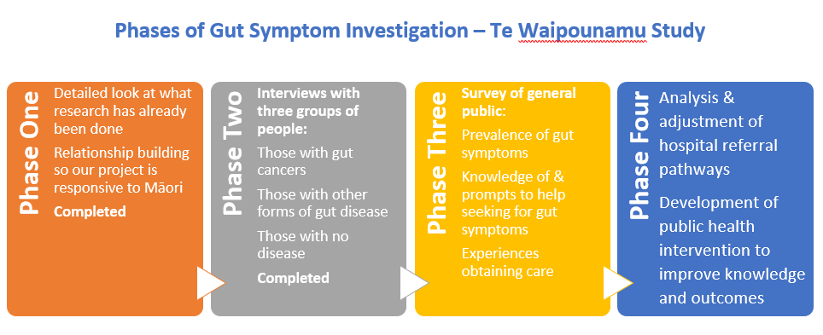

Study outputs to date:

