Howden Care NZ
University of Otago
Claims Management Manual

March 2023

Table of contents
1. INTRODUCTION 1
2. COMMITMENT STATEMENT 1
3. INJURY MANAGEMENT PROGRAMME INFORMATION 1
3.1 Kaimahi-staffawareness 1
4. ROLES AND RESPONSIBILITIES 2
5. CLAIM LODGEMENT AND COVER 3
5.1 Claim lodgement 3
5.1.1 Lodging a claim 3
5.1.2 Receipt of claim and registration 3
5.2 Cover decisions and timeframes 3
5.2.1 PICBA claims 4
5.2.2 Complicated claims 4
5.2.3 Accepted claims 4
5.2.4 Declined claims 4
6. CLAIMS MANAGEMENT 5
6.1 Claim triage and risk classification 5
6.2 Initial needs assessment 5
6.3 Action plans 5
6.4 Referrals for assessment and/or treatment 6
6.5 Privacy and Consent 6
6.5.1 Privacy Act 2020 and Health Information Privacy Code 2020 6
6.5.2 Privacy 6
6.5.3 Consent 7
6.6 Claim contents 7
6.7 Claim transfers 8
6.8 Claim closure 8
7. ENTITLEMENTS 9
7.1 Assessment of entitlements 9
7.2 Medical rehabilitation 9
7.3 Social rehabilitation 10
7.4 Vocational rehabilitation 10
7.5 Weekly compensation 11
7.5.1 Medical certification 11
7.5.2 Calculating weekly compensation 11
7.5.3 Abatement 12
7.5.4 Weekly compensation and abatement assessment responsibilities 12
7.5.5 Order in council 12
7.6 Lump sum compensation 13
7.7 Accuracy of entitlements 13
8. REHABILITATION 14
8.1 About rehabilitation 14
8.2 Rehabilitation process 14
8.3 Rehabilitation plan 14
8.4 Developing the Rehabilitation Plan 15
8.5 Monitoring and review of rehabilitation 15
8.6 Non progressive rehabilitation 17
9. Vocational Independence 18
10. COMPLAINTS AND REVIEWS 19
10.1 Introduction 19
10.2 Code of claimant rights 19
10.3 Complaints 19
10.4 Reviews 20
10.5 Mediation 20
10.6 Review applications and hearings 20
10.6.1 Review process 20
10.6.2 Withdrawal of review application 20
10.6.3 Review hearing 20
10.6.4 Appeal 21
10.7 Evaluation of complaints and reviews 21
11. DATA REPORTING AND ADMINISTRATION 22
11.1 Data collection and reporting 22
11.2 Retention and Disposal of Claim Files 22
11.3 Fraud 22
11.4 Liaison with ACC 23
11.4.1 Sensitive, serious injury and fatal claims 23
11.4.2 Key personnel changes 23
11.5 Monitoring the injury management programme 23
12. APPENDICES 24
12.1 Appendix 1 – Claims overview 24
12.2 Appendix 2 – Summary of AEP timeframes 25
12.3 Appendix 3 – Claims transfer process 27
12.4 Appendix 4 – Weekly compensation & abatement process 28
12.5 Appendix 5 – Complaint process 29
12.6 Appendix 6 – Review process 30
12.7 Appendix 7 – Fraud process 31
13. Glossary 32

INTRODUCTION
This manual describes and documents the processes and procedures in place to manage work injury claims under the Accredited Employer Programme. The processes and procedures focus on early reporting and intervention, rehabilitation and return to work strategies to assist the injured Kaimahi-staff make an early and safe return to work.

COMMITMENT STATEMENT
University of Otago is committed to ensuring a safe and healthy environment for all our people. However, should work related injuries/illness occur, University of Otago‘s effective injury management systems ensure our people return to full health and fitness wherever possible, and to resume their normal work activities in a safe and timely way. We are also committed to supporting rehabilitation and return to work programmes for employees who experience non-work-related injuries and illness. Alternative duties and reduction of hours will be provided wherever possible.

INJURY MANAGEMENT PROGRAMME INFORMATION
University of Otago offers an Injury Management Programme that is based on best practice rehabilitation processes and is delivered in conjunction with Howden Care. The programme is delivered within the following framework:
  - Accident Compensation Act 2001
  - Accredited Employer Programme Accreditation Agreement
  - Accredited Employer Programme Standards
  - Code of Claimant Rights
  - Privacy Act 2020
  - Health Information Privacy Code 2020

3.1 Kaimahi-staff awareness
Employees are advised about how we manage workplace injuries in different ways:
- All employees are issued with information to explain that University of Otago is an Accredited Employer, and what this means for any injury claims.
- The information includes what to do if they are injured at work and contact details for Howden Care. This is done initially at induction and with an annual reminder.
- Information is posted about work injuries and how to access support can be found at https://www.otago.ac.nz/health-safety/management/acc-accredited-employer-programme/. For additional information, please contact the Occupational Health Nurses ohn@otago.ac.nz
- We meet with managers, and Kaimahi-staff and union groups, and hold safety and wellbeing committee meetings to explain the Accredited Employer Programme, claim lodgement and management processes, and the rehabilitation support available.
- We run rehabilitation training workshops and discuss how we manage injury and or illness issues at management meetings.
- Howden Care website provides information about the programme, the claims process and forms on their website: https://www.howdengroup.com/nz-en/Howden-care-new-zealand

ROLES AND RESPONSIBILITIES
Role | Responsibilities
Injured  Kaimahi-staff | - Get medical treatment.  - Advise treatment providers that University of Otago is an Accredited Employer and that claim documents and invoices should be sent to Howden Care  - Report the accident/incident and complete a work injury report. Enter your incident in Vault at: https://otagouni-00.vaultgrc.com/kiosk/index?id=ytdulz6yd8cxhwk2n421inw2n7hy5dwz9r19o0gryi9rkdfbjsiyxbk7zrnq6w01&cid=OTAGOUNI  - Maintain regular contact with Case Manager  - Provide your Line manager and Case Manager with ACC claim form and medical certificates for any incapacity.  - Participate in rehabilitation, medical reviews and other referrals as requested.  - If a return to normal hours and/or duties is not possible, participate in modified return to work duties in line with medical advice and as agreed with Case Manager and line manager.  - Take responsibility and actively participate in their own rehabilitation
Line Manager | - Maintain regular contact with the injured employee.  - Provide return to work duties.  - Be involved and support the employees’ rehabilitation.  - Assess the employee’s workplace for any hazards.  - Participate in rehabilitation and monitoring meetings with the Kaimahi-staff and Case Manager
Union/Kaimahi-staff representative | - Support the injured Kaimahi-staff as requested.  - At the injured employees request take part in the rehabilitation planning and monitoring meetings  - Assist with the identification of return-to-work duties
Howden Care | - Work with University of Otago to provide administration on all work injury claims.  - Manage for the University of Otago all medical fees claims.  - Liaise with University of Otago on all cover and entitlement decisions on medical fees claims.  - Meet the AEP audit requirements for data reporting, claim and rehabilitation requirements as outlined in Appendix 2 AEP Timeframe summary and as documented in this manual.  - Ensure leave and absence management procedures are in place to support continuation of claims management.
Occupational Health and Wellbeing Coordinator/Occupational health team | - Oversees the Injury Management Programme  - Management of all work-related lost time and serious/complex claims  - Develop and review rehabilitation procedures as necessary.  - Develop and review rehabilitation objectives annually.  - Oversee the management of complaints, reviews  and other concerns or disputes.  - Resourcing the programme
Director, Health and Safety | - Complaints Manager  - ACC liaison  - Provision of cover for Occupational Health and Wellbeing Coordinator.

CLAIM LODGEMENT AND COVER

5.1 Claim lodgement

5.1.1 Lodging a claim
If an Kaimahi-staff suffers a work-related illness or injury they need to:
  - Get medical treatment.
  - Notify their manager.
  - Complete a work incident report – enter here relevant details of reporting system.
  - The medical treatment provider will complete an ACC45 claim form. Work Related Gradual Process or Infection and Mental Injury claims must be lodged by a doctor.

5.1.2 Notification and registration of claim
University of Otago will notify Howden Care of the claim within two working days. This could be via sending the work injury report, an email or phone call, or emailing a copy of the ACC45 and related documents to Howden Care.
Howden Care can receive the ACC45 claim form from a number of sources:
  - From the injured employee
  - From the treatment provider
  - From ACC
  - From University of Otago
Prior to registration Howden Care will check that the claim relates to a paid Kaimahi-staff of University of Otago, with the employer within 2 working days. If not a University of Otago claim, the claim will be transferred to the correct employer, their third-party administrator or ACC using standard letters. The treatment provider and claimant will be advised in writing that the claim has been transferred. Refer to Appendix 3 Claims transfer process.
When employment status confirmed, a Vault report will be uploaded to confirm injury (OHN). The individual will be requested to complete a Vault report if not already done, and a follow up email will be forwarded to the individual and their line manager with the Vault incident portal lodging information, advising that this must be completed within 2 days for the claim to be processed.
The claim will be created in the Howden Care claims management system and assigned a unique number.
Confirmation of the unique number will be forwarded to the OHN via email. Howden Care provide a weekly reporting sheet of claims for review by the OHT.

5.2 Cover decisions and timeframes
All work-related injuries must have a cover decision issued in accordance with ACC legislation. Claims must meet the criteria set out in the Act, including the definitions for the term’s ‘accident’, ‘injury’, and ‘work-related’. University of Otago and Howden Care work together to assess claims, Howden Care provides a cover recommendation to University of Otago on medical fees claims and deemed low risk by Howden Care.
Procedures for making cover decisions are reviewed by Howden Care’s Quality Manager when there is a material change to the legislation, as advised by ACC. Procedures are also reviewed when there is a change to key personnel responsible from University of Otago for making cover decisions.
All cover decision recommendations will be made by a person with more than 12 months’ claims management experience.
A selection of cover decisions will be reviewed by Howden Care annually to ensure decisions are correct and comply with the relevant legislation.

5.2.1 PICBA claims
For personal injury caused by accident (PICBA) claims a cover decision must be issued within 21 days from the date the claim was lodged with either ACC, University of Otago or Howden Care. A simple PICBA claim is where there is no lost time, and the decision can be made within the 21 day timeframe. These decisions can be based on the ACC45 claim form, the work injury report and if necessary, the initial medical consultation notes. Kaimahi-staff consent is not needed for these claims.
If the claim requires more information, the 21-day timeframe can be can extended for up to four months by sending a letter to the Kaimahi-staff advising them why this timeframe needs to be extended. Following receipt of the employees’ consent, information will be requested and/or assessments arranged. The further information needed could be:
  - Medical notes
  - Information regarding how the accident occurred.
  - Medical specialist review
  - Worksite assessment
The cover decision will be based on all relevant information (see section 5.1.2 to confirm employment status and incident report).

5.2.2 Complicated claims
The following claims are considered as complicated claims under the ACC legislation:
  - Work related gradual process, disease or infection claims (WRGPDI)
  - Claims lodged more than 12 months following accident date.
  - Treatment injury
  - Mental injury claims
Cover decisions must be made within two months of the claim being lodged with either ACC, University of Otago or Howden Care. Following receipt of the employees' consent, further information will be requested and/or assessments arranged. The further information requested could be:
  - Medical notes
  - Information regarding how the accident occurred.
  - Medical specialist review
  - Worksite assessment
The two-month timeframe can be extended for two more months by advising the Kaimahi-staff in writing why this timeframe needs to be extended. If necessary, a further extension to a maximum of nine months from date of lodgement can be made with the agreement of the employee. If the Kaimahi-staff does not agree to the extension, a cover decision will be made with the information available.
The cover decision will be based on all relevant information. For med fees only claims, Howden Care recommend cover decisions. For high-risk claims, the individual may be referred to the Occupational Physician or specialist for further information for a decision to be made. In all cases, it is the responsibility of the University of Otago to make the claim cover decision.

5.2.3 Accepted claims
For all accepted claims an acceptance letter together with an entitlement fact sheet will be sent/emailed to the employee. The letter also advises people of their right to have the decision reviewed if they do not agree with it.
The claimant will be informed of where the data and related information is to be held (Figtree and MedTech), including outlining who has access to the systems. Kaimahi-staff are able to access their information on request and correct information if required. Kaimahi will be informed that their manager will be notified of the accepted claim and any required rehabilitation or workplace support.

The OHN will advise the Line Manager of the ACC accepted claim and intended management of the claim.

5.2.4 Declined claims
A claim will be declined if it does not meet the legislative requirements. Throughout the cover making process Howden Care will explain the criteria for claim acceptance.
If the claim is declined, the OHN will contact the Kaimahi-staff to discuss the reason for the decision and advise them of their right to have the decision reviewed. Reasonable attempts will be made to contact the Kaimahi-staff to discuss the decision. A decline letter will be posted or emailed to the Kaimahi-staff to explain the reason for the claim being declined and advise them of their right to request a review of the decision. The Finding Solutions fact sheet will also be attached.
The OHN will advise the Line Manager of the ACC declined claim.

CLAIMS MANAGEMENT
Work injury claims are managed according to the requirements of the Accident Compensation Act 2001 and responsibilities under the Accredited Employer Accreditation Agreement University of Otago holds with ACC. If additional claim services are provided the Kaimahi-staff will be notified that these are additional, and that ACC would not provide them if they took over the management of the claim. Appendix 1- Claims Overview provides an overview of the claims management process.

6.1 Claim triage and risk classification
All claims are triaged on receipt by Howden Care or the University of Otago. This includes the type of injury, how the accident occurred, and the length of time certified off work.
The claim risk classifications are as follows:
Classification | Description
Medical fees claim.  (Blue) – Managed by Howden Care | - No time lost and  - No serious injury noted
Serious/complex  (Amber/Red)  Managed by University of Otago, OHN | - The Kaimahi-staff requires any time off work and/or  - The diagnosis is a serious injury and/or  - Management of the claim could be complex or extended.  - Work related gradual process, disease or infection claims (WRGPDI) with or without lost time  - Other risk factors have been identified

6.2 Initial needs assessment
For all claims with lost time Howden Care or the OHN will contact the Kaimahi-staff by phone within two working days to:
  - Carry out an initial needs assessment
  - Discuss entitlements and rehabilitation support
  - Discuss the claims process
  - Discuss whether the Kaimahi-staff can return to work in some capacity, depending on medical advice
If contact cannot be made then Howden Care will discuss with University of Otago the best way to contact them and use a variety of methods available to contact, such as letter/email/text.

6.3 Action plans
An Action Plan will be developed within seven days of notification for all claims with lost time off work or work restrictions. The Action Plan documents the actions and timeframes required by the case owner, the employer and the injured employee. Ideally this is done following the Initial Needs Assessment however if contact cannot be made within seven days, then the plan will be developed and updated as needed.
While cover is pending and there continues to be incapacity the Action Plan is updated every 14 days. The Action Plan documents the actions and timeframes required of the case owner, the employer and the injured employee.

6.4 Referrals for assessment and/or treatment
Depending on the needs identified the University of Otago OHN will refer the Kaimahi-staff for appropriate assessment and treatment. This may include medical treatment or assessment, weekly compensation, social or vocational rehabilitation assessments.

6.5 Privacy and Consent

6.5.1 Privacy Act 2020 and Health Information Privacy Code 2020
University of Otago and Howden Care adhere to the thirteen principles of the Privacy Act 2020 and Health Information Privacy Code 2020. The principles can be summarised as follows:
- Only collect health information if you really need it.
- Get it straight from the people concerned.
- Tell them what you’re going to do with it.
- Be considerate when you’re getting it.
- Take care of it once you’ve got it.
- People can see their health information if they want to.
- They can correct it if it’s wrong.
- Make sure health information is correct before you use it.
- Get rid of it when you’re done with it.
- Use it for the purpose you got it.
- Only disclose it if you have a good reason.
- Only disclose outside of New Zealand if the receiving organisation is subject to the Privacy Act, will protect the information or have comparable privacy laws to the Privacy Act.
- Only assign unique identifiers (e.g. claim number) where permitted.

6.5.2 Privacy

Collection
University of Otago and Howden Care collects personal and health information required for the management of the claim. We collect the information necessary to carry out our functions and responsibilities. This means we will only collect information that we require to determine appropriate treatment, entitlements or needs in relation to a claim.

Access
University of Otago and Howden Care will facilitate access to personal and health information. We commit to providing employees with access to their personal and health information, unless an exception under legislation applies.

Correction
Under the Privacy Act, individuals have a right to seek amendment to factually incorrect information. Howden Care will facilitate such requests to consider correction or addendum to information if it is unable to be changed.

Use and disclosure
University of Otago and Howden Care will use information to assess entitlements, rehabilitation and medical treatment. Information is disclosed for the purposes of why it was obtained. Privacy checks are undertaken on files to ensure only individual claim related information is held. These checks will be undertaken at hand back, referrals to specialists, file request by the injured employee, at review or when the file is being released externally.

Storage
University of Otago and Howden Care will ensure information is stored with security against disclosure. This includes electronic protection with systems and technology and also security around physical handling of information.

Privacy risk and breach
University of Otago and Howden Care follow a specific privacy risk process, which is initiated immediately upon identification of a potential risk or privacy breach. The aim is to act with priority to ensure we either prevent the risk becoming a breach, contain a breach or minimise the impact if a breach does occur. In the event of a privacy breach, Howden Care Quality Manager provides University of Otago with details of the breach. University of Otago will provide the breach information to their ACC Compliance Advisor within 5 working days of the following month. If serious harm results from the breach the Quality Manager will notify the Privacy Commission within 72 hours of the breach being identified as notifiable.

6.5.3 Consent
The ACC45 claim form gives consent for information to be provided regarding the initial consultation for the injury. Before obtaining further information to assess and manage the claim, signed informed consent will be requested from the employee. We discuss the consent with the injured Kaimahi-staff at the Initial Needs Assessment and the Authority to Collect Information form is accompanied by a fact sheet, which provides information about informed consent. Signed consent is updated annually for all ongoing claims.

6.6 Claim contents
Howden Care establishes an individual electronic record for each claim received. It is identified by:
  - Employee’s name
  - Individual claim number
  - Date of injury
Each record will contain (where applicable):
  - Claim summary information
  - ACC45 and other medical certificates
  - Initial needs assessment and action plan
  - Decision letters
  - Injured employee's written consent
  - Rehabilitation plan
  - Weekly compensation calculations
  - Entitlement information
  - Treatment provider referrals and reports
  - Records of all correspondence
Claim records contain information relevant only to the management of the individual claim. Any claim information held by University of Otago will be kept in a separate injury management file from the employee’s personnel or HR file. Howden Care establishes entitlements based on identified injury needs and legislative eligibility, other factors such as known Kaimahi-staff work performance issues, cooperation with management or fraud are not allowed to influence these decisions.

6.7 Claim transfers
Claims may need to be transferred to ACC or another accredited employer if:
  - The claim was sent in error (e.g., non-work injury, wrong employer)
  - A claim is reactivated after the end of the agreed claims management period
  - The claim is open at the end of the agreed claims management period
  - Medical evidence supports the liability of the claim sits with ACC/another Accredited Employer
  - The claim is for a sensitive, serious injury or accidental death, as agreed with ACC
The process for transferring claims will conform to any guidelines and directives issued by ACC and is found in Appendix 3 Claims transfer process. Howden Care is responsible for the transfer of claims with the agreement of University of Otago. The Kaimahi-staff and other interested parties will be advised of the transfer.
Claims not requiring transfer at the end of the claims management period are securely held by Howden Care and are accessible to ACC on request.

6.8 Claim closure
A claim is closed for the following reasons:

Claim type | Closed when
Medical fee only claims | There are no other actions expected.
Non-serious/Complex claims | The injured Kaimahi-staff has returned to full time work or completed their rehabilitation.  There are no other actions expected.

At claim closure, any correspondence held by University of Otago will be amalgamated onto the master claim file held by Howden Care.
Claims can be re-opened to process late payments or if further entitlements are required.

ENTITLEMENTS

7.1 Assessment of entitlements
The University of Otago OHN will complete an Initial Needs Assessment on all claims with time lost from work or an interruption to their normal working duties within two working days of receiving notification of the claim. This assessment considers the injured employee’s medical, vocational and social needs. The Kaimahi-staff and providers can also ask for entitlements to be considered.
The University of Otago OHN will continuously reassess entitlements during the rehabilitation process through regular contacts, weekly monitoring feedback and formal meetings.
The University of Otago OHN will consider entitlement decisions based on the requirement of the Act. A decision letter will be provided to the Kaimahi-staff for all entitlement decisions and the letter will advise the person of their right to have the decision reviewed.
If an entitlement cannot be approved the University of Otago will contact the Kaimahi-staff to explain the decision and advise them of their right to have the decision reviewed. Reasonable attempts will be made to contact the Kaimahi-staff to discuss the decision. Treatment provider(s) will also be advised in writing.
The University of Otago will cover any surcharges related to the injury treatment.
Howden Care process these payments on behalf of the University. All treatment costs must be approved by a member of the OHT.
In some instances, University of Otago may provide additional entitlements that exceed the statutory minimum allowed for in the Act. The injured Kaimahi-staff will be advised of the provision of statutory entitlements in writing with relevant review right. If discretionary entitlements are being paid the Kaimahi-staff will be advised in writing and made aware that these:
  - Are not available if ACC manages the claim, and
  - Will not continue if it the claim is transferred to ACC for ongoing management

7.2 Medical rehabilitation
Medical rehabilitation is treatment and interventions provided to help an injured Kaimahi-staff recover from their injury.
The following criteria apply to medical rehabilitation:
  - The treatment provided is necessary and appropriate for the particular injury, according to nature and severity.
  - The treatment provider is an ACC-registered provider, and usually provides that service.
  - The number of treatments they provide is necessary to treat the injury.
  - The treatment is cost-effective and will achieve the desired outcome.
If a registered medical provider, including a physiotherapist, osteopath or chiropractor, provides treatment, University of Otago will allow up to 6 initial treatments and then another 3 if required treatments without prior approval, even if the claim is pending. After this initial set, the treatment provider can request in writing approval for further treatments.
For medical treatment such as surgery and non-acute dental treatment, employees must get prior approval before having the treatment. An opinion may be sought from a relevant specialist to confirm the treatment is the most appropriate form of treatment for the injury.

7.3 Social rehabilitation
Social rehabilitation refers to a range of entitlements aimed at helping the injured Kaimahi-staff to recover outside the workplace. These entitlements are identified and assessed where an injury is affecting the employee’s ability to carry out everyday functions. This is done:
  - During the initial needs assessment and throughout the rehabilitation process, or
  - Upon receiving a verbal or written request from the injured employee, their support person or a treatment provider
The university of Otago OHN:
  - Will assess the request against the ACC guidelines and legislation
  - Where required, will arrange a formal assessment to an ACC-approved assessor to provide advice on the most effective options to support needs
Social rehabilitation may include:
Assistance | The injured Kaimahi-staff may be eligible for this type of assistance if
Home help | They were responsible for the home help task at the time of the injury or have become responsible since the injury, due to changed circumstances.
Childcare | They are the primary caregiver of one or more children under the age of 14, with whom they have a parent-child relationship.
Attendant care | They are unable to perform basic self-care due to the injury.
Aids and appliances | An appropriate professional has assessed and recommended these items.
Transport to treatment | They require assistance to get to and from treatment if the injury is preventing them from using their usual means of transport.

7.4 Vocational rehabilitation
The purpose of vocational rehabilitation is to help the injured Kaimahi-staff to:
  - Stay at work
  - Get work, or
  - Re-gain or acquire vocational independence
Vocational rehabilitation is provided to support injured employees to:
  - Remain at work, or
  - Return to work in their pre-injury role as soon as practicable
The University of Otago OHN will assess entitlement to vocational rehabilitation:
  - When a need is identified through the Initial Needs Assessment and throughout the rehabilitation process
  - After receiving a verbal or written request from the Kaimahi-staff and/or treatment provider
Once a request is received, the University of Otago OHN will:
  - Assess the request according to the individual’s needs and consideration of the ACC guidelines and legislation, and then
  - Arrange the services directly, or
  - Arrange a formal assessment from an ACC-approved assessor to provide advice and support on the most effective options to support needs.
When assessing whether to provide vocational rehabilitation, The University of Otago OHN will consider the
following:
  - Is the injured Kaimahi-staff entitled to weekly compensation?
  - Is vocational rehabilitation appropriate, cost-effective and likely to achieve the desired outcome?
  - Is it appropriate under the current circumstances?
  - Will it achieve its purpose under the injured employee’s rehabilitation plan?
  - Will it help the Kaimahi-staff return to work sooner, reducing the cost of weekly compensation?
  - Will vocational rehabilitation help the injured Kaimahi-staff to:
  - obtain work in other areas, taking into account their education, skills, training and experience, or
  - regain or acquire vocational independence, taking into account their education, skills, training and experience?

7.5 Weekly compensation
Weekly compensation covers loss of earnings due to incapacity following a covered injury. Assessments are calculated according to the ACC legislation. An injured Kaimahi-staff will be entitled to weekly compensation if their work their work-related injury or illness has cover, and they:
  - Hold employment at the date of first incapacity (DOFI) or at date of subsequent incapacity (DOSI)
  - Have been an earner immediately before the incapacity
  - Are certified for longer than one week of incapacity for this injury/illness
  - Are unable to return to work on their normal full-time duties due to this injury/illness
  - Have provided medical certification to support the incapacity

7.5.1 Medical certification
If the injured Kaimahi-staff loses any time from work, beyond that noted on the ACC45, they must provide an ACC18 medical certificate for the period they can’t work. This certificate must clearly show their work capacity and activity restrictions. The OHN Case Manager can approve short periods of incapacity of up to seven days without a medical certificate.

7.5.2 Calculating weekly compensation
To receive compensation the injured Kaimahi-staff must provide medical evidence showing that they are unable to work (ACC forms), and the University must approve the incapacity. Any secondary earnings are considered in weekly compensation and abatement calculations.
The University of Otago pay 100% salary for work related ACC compensation claims. This differs from the required ACC 80% compensation rate.
Howden Care complete the weekly compensation calculations, based on information provided by the OHN. The required information is the ACC incapacity certificate, and the completed pre-injury earnings past 4 and 52 weeks requested by the OHN Case Manager from Payroll. The OHN is responsible for identifying any additional earnings, including secondary employment, with the claimant and to notify Howden Care.
Weekly compensation is calculated as follows:
Days | Weekly compensation calculation
1–7 | The employer pays for the first seven days off work based on 80% of earnings.
8–35 (short term) | Earnings are calculated based on the four weeks gross earnings before the first day off work. The figure is divided by 4 to get a weekly average. The weekly compensation rate is 80% of this figure.  However, the University of Otago pays 100% salary compensation
36 until Return to Work (long term) | Earnings are calculated using the 52 weeks’ gross earnings before the first day off work. This figure is divided by 52 to get a weekly average. The weekly compensation rate is 80% of this figure. However, the University of Otago pays 100% salary compensation.  Note: If the Kaimahi-staff started employment within the 52-week period, their earnings are divided by the number of weeks they worked.
Notes | Earnings include work from all employment.  Refer to Appendix 4 Weekly Compensation and Abatement process

*University of Otago has chosen to fund 100% loss of earnings for their injured employees for all weekly compensation.

7.5.3 Abatement
Abatement payments will be calculated for injured employees who return to work in a reduced capacity and/or continue to receive taxable income from a secondary employment source. This is calculated as per ACC legislation.
Refer to Appendix 4 Weekly Compensation and Abatement process

7.5.4 Weekly compensation and abatement assessment responsibilities
The injured Kaimahi-staff will:
  - Provide medical certificates for incapacity due to the injury.
The claim owner will:
  - Approve the weekly compensation entitlement and the medical incapacity.
  - Confirm the First Date of Incapacity (DOFI) and any Date of Subsequent Incapacity (DOSI)
  - Approve and confirm abatement periods.
  - Provide salary information (4 weeks and 52 weeks period)
  - Advise if there is any secondary employment.
The technical claims/payment officers will:
  - Ensure the medical certificate covers the relevant period of return-to-work duties.
  - Calculate the injured employees’ short- and long-term entitlement.
  - Apply changes due to Order in Council
  - Advise the Kaimahi-staff in writing of
    - Their weekly compensation rates and abatement calculations
    - That the University of Otago pay more than the ACC legislated amounts, and that ACC will not pay the higher amount if the claim is returned to ACC for management.
The Payroll Office will:
  - Complete the salary declaration when requested by the OHN.
  - Continue salary payments at 100% for the claimant.

7.5.5 Order in council
Where ACC advise of changes required due to indexation, the weekly compensation rates (and other entitlements where applicable) will be adjusted accordingly. Injured employees are advised of the change in payment level in writing.
Indexation will be applied to injured employees who have:
  - Been entitled to receive weekly compensation continuously since 31 December before the indexation date, or
  - Received weekly compensation for any 26 weeks or part weeks in the 52 weeks before the indexation date.

7.6 Lump sum compensation
Injured employees may be eligible for a one-off payment for a life-long injury. ACC manages this process for accredited employers. The injured Kaimahi-staff lodges an application with Howden Care to start this process who will forward it on to ACC.
ACC will assess eligibility where the injury is likely to result in a permanent disability or impairment. This will generally be 24 months after the injury, and/or when the employee’s injury status is considered medically stable and unlikely to improve further. To qualify, the injured employee's total impairment must be assessed as greater than 10 percent.

7.7 Accuracy of entitlements
To ensure the accuracy of entitlement decisions a selection of claims will be reviewed, at least annually, to make sure decisions are correct and comply with the relevant legislation. The review will consider whether:
  - The entitlement is one that can be provided under the Act.
  - The entitlement has been assessed correctly.
  - Weekly compensation and abatement entitlements are calculated correctly.
The findings from these checks will be discussed at the regular meetings with University of Otago and Howden Care and any necessary changes implemented as a result of these.

REHABILITATION

8.1 About rehabilitation
A fundamental principle of best practice rehabilitation management is that it should support the injured Kaimahi-staff to return to work safely and as soon as possible after their injury. Good work is good for you. There is clear evidence that the longer someone is away from the workplace, the longer they will take to recover, and the less likely they are to return to work successfully in any capacity. The best practice approach to rehabilitation management is that the person will recover faster and more sustainably if they maintain as much contact as possible with their usual workplace duties, routines and colleagues, in a safe and managed way.

8.2 Rehabilitation process
  - University of Otago with Howden Care aim to help injured employees recover fully and return to work through appropriate assessment, planning, implementation and monitoring of rehabilitation services.
This requires:
  - Liaising with medical practitioners and other treatment providers about diagnosis, prognosis, treatment, incapacity and guidelines and recommendations for rehabilitation support
  - Ensuring all stakeholders, including the injured employee, are able to contribute to the rehabilitation process.
  - Co-ordinating meetings or case conferences with all appropriate parties, e.g., Injured person, GP, managers, support person, union/Kaimahi-staff representatives, etc.
  - Discussing and documenting agreed, time-specific, cost-effective and outcome focused individual plans for rehabilitation and return to work.
  - Monitoring rehabilitation and return-to-work programmes to ensure they are achieving the right outcomes.
  - Monitoring work environments to ensure they are compatible with any medical guidelines or restrictions.
  - Proactively assessing for issues that could impact recovery and rehabilitation and putting strategies in place to manage these.
Vocational rehabilitation will be provided in accordance with the relevant sections of the Act. We will base rehabilitation on the employee’s assessed needs, focusing on returning them to their pre-injury role.
If returning the pre-injury role with University of Otago is not possible then consideration is given to:
  - Same employer, different job
  - Different job, same employer
  - Different employer, same job
  - Different employer, different job

8.3 Rehabilitation plan
Rehabilitation plans document the agreed steps in the rehabilitation process. A Rehabilitation Plan will be developed:
  - Within 7days of a claim being accepted for cover where there is ongoing incapacity from their role, this may be where a person is fully unfit for work or fit for selected duties. There should be no gap between the Action Plan and the development of the Rehabilitation Plan
  - With new incapacity and before known periods of incapacity such as planned surgery.
Rehabilitation plans will include the following information:
  - The rehabilitation goal, outcomes and expected timeframes.
  - Actions agreed with the injured Kaimahi-staff and other stakeholders to help them to return to normal activities in a safe and timely manner.
  - Interventions required to achieve the agreed objectives and outcomes.
  - Who is responsible for ensuring the interventions occur within the agreed timeframes.
  - On-going monitoring of progress against objectives and goals

8.4 Developing the Rehabilitation Plan
The Case Manager will take the following steps to develop the rehabilitation plan:
  - Advise the injured employee:
  - that a rehabilitation plan will be developed
  - how and why we are doing this.
  - they have the right to a support person at all meetings.
  - Arrange a rehabilitation meeting, with the injured employee, their manager, support person (as requested by the employee) and other key stakeholders as appropriate, e.g., occupational therapist. The meeting can take place face to face, over the telephone or by video conference.
At the meeting work through the rehabilitation plan together to discuss, agree and document the following:
  - The rehabilitation goal, outcomes and expected timeframes.
  - Actions and responsibilities to help the injured person to return to normal activities as soon as practicable
  - Date of next review
  - Who will be completing the weekly monitoring
The following people should sign the plan:
  - The injured employee
  - The manager
  - The Case Manager
All reasonable steps will be taken to get the plan signed by the injured employee, however if the plan is not signed it can be deemed as accepted by the Case Manager and a copy provided to all parties.

8.5 Monitoring and review of rehabilitation
The rehabilitation plan and return to work progress will be monitored regularly to:
  - Check that the rehabilitation is going to plan.
  - Determine if there are any barriers to the plan progress.
  - Assess any further needs or interventions.
When | Type of monitoring/review
Weekly | OHN checks in with the injured person and completes the weekly monitoring form documenting progress. The Line Manager will be advised of any issues.
Monthly | The Case Manager and employer will review the progress of all claims. The Case Manager will document any actions needed.
At the end of the agreed interventions  If further rehabilitation needs are identified  At the end of milestones | A review of progress which may involve consulting with:  - the injured employee  - their support person/union representative  - the manager  - treatment providers, as needed.  - Outcomes and actions will be documented on the rehabilitation plan
If there are concerns about lack of progress | Where there are concerns about lack of progress, the claimant may be referred to the University of Otago Occupational Physician, or Howden Care for review. This panel is made up of internal rehabilitation experts. The Panel will provide advice to the Case Manager and employer about the next actions.

8.6 Non progressive rehabilitation
A claim is non-progressive if it:
  - Continues beyond the expected recovery time
  - Is not meeting rehabilitation objectives
  - Is slow to achieve expected milestones
We identify non-progressive claims through the regular monitoring outlined above. If concerns are identified a case management meeting will be held to assess rehabilitation progress and provide recommendations regarding the next steps. This panel is made up of internal rehabilitation experts. They may consider:
  - Current medical, social and vocational activity
  - Barriers to rehabilitation such as the impact of psychosocial issues, non-compliance, non-injury related medical condition
  - Need for further support or treatment to help achieve agreed outcomes
  - Need for further assessment or referral to help achieve agreed outcomes
  - Referral for a formal medical review to assess the injured employee's recovery and ongoing work fitness
  - Referral for vocational independence assessment
If an Kaimahi-staff seems unlikely to return to work in their pre accident role, the Case Manager will:
  - Discuss the situation, process and timeframes with the Kaimahi-staff and support person
  - Document the discussion and decision in the rehabilitation plan, the plan should be signed by the injured employee, the employer and the Case Manager. All reasonable steps will be taken to get the plan signed by the injured employee, however if the plan is not signed the plan can be deemed as accepted by the Case Manager

Vocational Independence
If an Kaimahi-staff can’t return to their pre-injury tasks because of their injury, the following process will be discussed with them and the vocational independence process initiated. This process follows the steps below:
Step | Description
Initial Occupational Assessment | Identifies a range of occupations according to the employee’s education, skills and training.
Initial Medical Assessment | Establishes whether the employee’s injuries will stop them from doing the occupations identified and any rehabilitation interventions needed.
Interventions | Recommended rehabilitation interventions from the assessments will be provided. The intent is to restore capability, not to enhance skill level.
Vocational Independence Assessments | Following the completion of vocational rehabilitation, independent assessors will carry out further occupational and medical assessments in accordance with the legislation.  If the assessments show that the injured Kaimahi-staff is able to work 30 hours a week or more in the occupation/s identified, the Kaimahi-staff will be entitled to weekly compensation for three more months from the date of notification, after which their weekly compensation entitlement will end. This will be discussed with the injured employee, and they will be notified in writing and their right to a review explained. Abatement will apply to any earnings the Kaimahi-staff receives during this process.

COMPLAINTS AND REVIEWS

10.1 Introduction
There are two types of disputes:
  - The injured employees have the right to complain about University of Otago/Howden Care’s services or if they believe their rights have been breached. For more information, see the Code of claimant rights below
  - If an injured Kaimahi-staff disagrees with either a claim or entitlement decision by University of Otago/Howden Care they have the right to review this decision.

10.2 Code of claimant rights
The purpose of the Code is to meet the reasonable expectations of the injured Kaimahi-staff (including the highest practicable standard of service and fairness) about how ACC, University of Otago and Howden Care should deal with them. University of Otago/Howden Care aims to treat all employees in accordance with the Code, which outlines the following rights:
  - The right to be treated with dignity and respect, and have their views considered
  - The right to be treated fairly
  - The right to respect for their culture, values and beliefs
  - The right to have a support person
  - The right to open, prompt, effective communication, and to receive a response
  - The right to be fully informed
  - The right to have their privacy respected
  - The right to be dealt with in a cooperative and effective environment

10.3 Complaints
Concerns and complaints can be raised about aspects that are not part of the ACC cover and entitlement process. This includes service issues, privacy and consent concerns, interpersonal issues, return to work procedures or potential breaches of the Code of Claimant Rights. If an injured Kaimahi-staff is concerned about the management of their claim, they can raise their concerns verbally or in writing to University of Otago (Director, Health and Safety, acc@otago.ac.nz) or Howden Care on freephone 0800 083 227 or email info.nz@howdengroup.com. They can also talk to their line manager.
A person may raise a concern that can be quickly resolved without proceeding to a formal complaint. An example may be where a home help provider has not turned up as expected, or they have not received information that they have requested from their Case Manager. The University of Otago OHN/Howden Care will work with the person to resolve their concern quickly and to their satisfaction. If they are not satisfied, they are able to request that their complaint be formally investigated.
Where a formal complaint is raised, it will be handled promptly and respectfully and will consider the Code of claimant rights. Options to resolve the complaint through an informal resolution process will be explored. If the complaint cannot be informally resolved, Howden Care/University of Otago will determine who is best to manage the complaint investigation and resolution. In general Howden Care will manage complaints regarding the claims process and University of Otago will manage complaints relating to employee/employer issues.
Complaints will be fully investigated by the appropriate person and will consider all relevant information. Where necessary further evidence or information may be requested.
If the complaint cannot be satisfactorily resolved, the injured Kaimahi-staff can contact University of Otago Disputes Manager (ACC@otago.ac.nz) or make a complaint to ACC via the Customer Resolution Team on 0800 650 222 or email customerfeedback@acc.co.nz.
University of Otago’s Complaints Manager is:
Andrea McMillian, Director, Health, Safety and Wellbeing
Operations Group
All complaints to Howden Care will be recorded in their Quality System and reviewed by University of Otago and Howden Care each quarter. Measures will be put in place to address any issues identified from complaint investigations and outcomes.
See Appendix 5 Complaint Process

10.4 Reviews
An Kaimahi-staff has the right to formally review:
  - Any written claim decision that relates to cover and/or
  - An entitlement they receive under the Act relating to a work injury
A formal review can be raised in writing by an injured Kaimahi-staff to University of Otago/Howden Care within 3 months of the claim decision unless there are extenuating circumstances. An ‘Application for Review’ form and process documentation can be provided by Howden Care; however, this form does not need to be used and an email/letter stating the reasons for contesting the decision is sufficient.
Information regarding the Review process can be found on the ACC website https://www.acc.co.nz/contact/get-a-decision-reviewed.The Accredited Employer Programme agreement with ACC sets out responsibilities when managing formal reviews, including timeframes. Mediation is available; however, the issue can proceed directly to a formal review hearing if either party indicates that this is the preferred option.

10.5 Mediation
Howden Care and University of Otago will consider whether mediation is appropriate.
If informal mediation is agreed on, this meeting can involve:
  - The injured employee
  - A support person if requested by the employee
  - University of Otago representative
  - Howden Care representative
If formal mediation is agreed on, this meeting will involve:
  - The injured employee
  - A support person if requested by the employee
  - University of Otago representative
  - Howden Care representative
  - An external mediation agency

10.6 Review applications and hearings

10.6.1 Review process
If a written application for review of a decision is received, the steps outlined in Appendix 6 – Review Process will be followed. Throughout the review process the Code of Claimant rights will be considered, the review application will be managed in accordance with the Act and the Accredited Employer Agreement, and all relevant information will be considered throughout this process. Howden Care will keep University of Otago informed of progress of the review from lodgement to outcome.

10.6.2 Withdrawal of review application
If at any time before the review hearing is held the Kaimahi-staff indicates that they do not wish to continue with the review, Howden Care will obtain confirmation from the Kaimahi-staff that they wish to withdraw their application for review and advise the ACC independent reviewer.

10.6.3 Review hearing
The independent reviewer will:
  - schedule and conduct the review hearing with the employee, their support person or representation if requested by the employee, University of Otago and Howden Care as appropriate
  - provide a decision within 28 days of the hearing date
Howden Care and the University of Otago will action any decision recommendations.

10.6.4 Appeal
Review decisions are binding on both parties. However, either party has the right to appeal the decision to the District Court.

10.7 Evaluation of complaints and reviews
Howden Care and University of Otago will discuss all complaints and disputes as they arise and are managed to resolution. They will also be discussed at quarterly meetings between Howden Care and University of Otago. Annually a summary of all complaints and disputes will be provided by Howden Care to University of Otago for discussion. Review of complaint and dispute outcomes will take into consideration all relevant information, and any necessary changes to policy, processes, behaviour or programme direction will be implemented.

DATA REPORTING AND ADMINISTRATION

11.1 Data collection and reporting
Howden Care uses data collected from claims to:
- Report trends and costs
- To identify areas where reduction and/or injury prevention cost may be needed
Claims data is held in Howden Care’s electronic claims management system. Data in this system is kept secure (password protected), complies with the Privacy Act 2020 and the Health Information Act 2020 and is restricted to designated personnel.
Howden Care reports to ACC on University of Otago’s behalf every month via My ACC for Business. The Business Administrator is accountable for transferring data to ACC no later than the fifth working day of each month. If the Business Administrator is absent, other Howden Care staff will do this. A dummy report is created to check for any errors and correct them before the data is transferred via the My ACC for Business portal. If there are any errors found by ACC these will be corrected and re-submitted to ACC prior to the third week of the month.
The data is backed up daily by Salesforce (the vendor supplying the claims management system). Back up data is available for 90 days and can be accessed by Howden Care at any time.
Technical support of the claims management system is provided by Salesforce.

11.2 Retention and Disposal of Claim Files
Howden Care and University of Otago manage claim files in accordance with ACC’s Disposal Authority and University of Otago’s Accreditation Agreement. Claim files are not destroyed without ACC’s approval.
ACC’s directive (ACC5804) on ‘Retention and Disposal of claim files’ provides details on how long a claim file is retained and the actions required before they can be destroyed.

11.3 Fraud
University of Otago and Howden Care will be aware of and monitor each claim for potentially fraudulent activity. Triggers may include:
  - Repeated difficulty contacting the injured person
  - Significant claims history
  - Other conditions that may impact on recovery
  - Inappropriate emphasis on entitlement and blame for an injury
  - Use of a number of different treatment providers
  - Reports of activity inconsistent with medical certification
  - Identification of treatment provider behaviour suggestive of possible fraudulent activity. For example, provider invoices being submitted to both the accredited employer and ACC for payment

Do’s and don’ts when identifying and dealing with a potential fraud situation:

Do:
  - Be aware of the fraud triggers
  - Keep an open mind as to what might have happened
  - Ensure there is appropriate documentation on the file to support all claim payments made
  - Consider engaging a professional investigation service provider so as to preserve the objectivity of the process
  - Ensure your fraud investigation policies and procedures are current
  - Keep any investigation process quite separate from the injured employee’s ongoing injury and claims management
  - Get in touch with the ACC Integrity Service Team if you need advice

Don’t:
- Do nothing – ACC fraud can only be reduced through positive and appropriate action
- Predetermine – give your employees the benefit of the doubt until evidence of fraud is established
- Ignore your HR policies relating to disciplinary or dismissal procedures
- Interview an Kaimahi-staff without another staff member being present
- Investigate an allegation of ACC fraud in a manner that could jeopardise your ability to fairly remediate an outcome
If fraud is suspected, all rehabilitation will continue as per the IRP until investigations are complete. The case owner will not be involved in any investigation and there will be a separate record from the claim. University of Otago and the Howden Care Fraud Manager will manage the fraud process and if advice is needed about suspected fraud or inappropriate claims activity, they will seek early advice from the ACC Integrity Services at accintegrity.insight@acc.co.nz. The fraud process can be found here Appendix 6 Fraud Process.

11.4 Liaison with ACC

11.4.1 Sensitive, serious injury and fatal claims
If a sensitive injury, serious injury, significantly complex injury or fatal claim is made, insert title will be the single point of contact with ACC. They will ensure decisions and management follow ACC guidelines.

11.4.2 Key personnel changes
If there are changes in key personnel or the way in which University of Otago manages injury management internally, University of Otago will notify ACC as soon as possible to ensure that security changes and contact details are kept current.

11.5 Monitoring the injury management programme
University of Otago will monitor and review the Injury Management Programme’s performance at least once a year. This will be done by reviewing and analysing data and relevant key performance indicators.
The programme’s objectives are to:
  - Help employees who are injured at work rehabilitate effectively and return to work early and safely
  - Reduce work-related personal injuries and associated claim costs
  - Provide benchmarks to measure the extent and management of work-related personal injuries
  - Review and develop rehabilitation objectives
The Injury Management Programme’s performance is monitored to:
  - Ensure that outcomes are meeting the programme’s objectives
  - Identify any areas that need to be changed or improved
  - Initiate preventative measures where trends identified
Key injury management performance targets and measures are determined annually and may include, for example:
  - Return-to-work outcomes
  - Duration and cost of claims
  - Service delivery
  - Quality assurance
Where applicable, the process will also consider information provided by the injured Kaimahi-staff and/or their support person, union representative or line manager, especially where concerns have been raised about the quality of rehabilitation. This information may include:
  - Individual claimant feedback
  - Satisfaction survey information
  - Direct management or union feedback
  - Feedback about treatment providers

APPENDICES

12.1 Appendix 1 – Claims overview
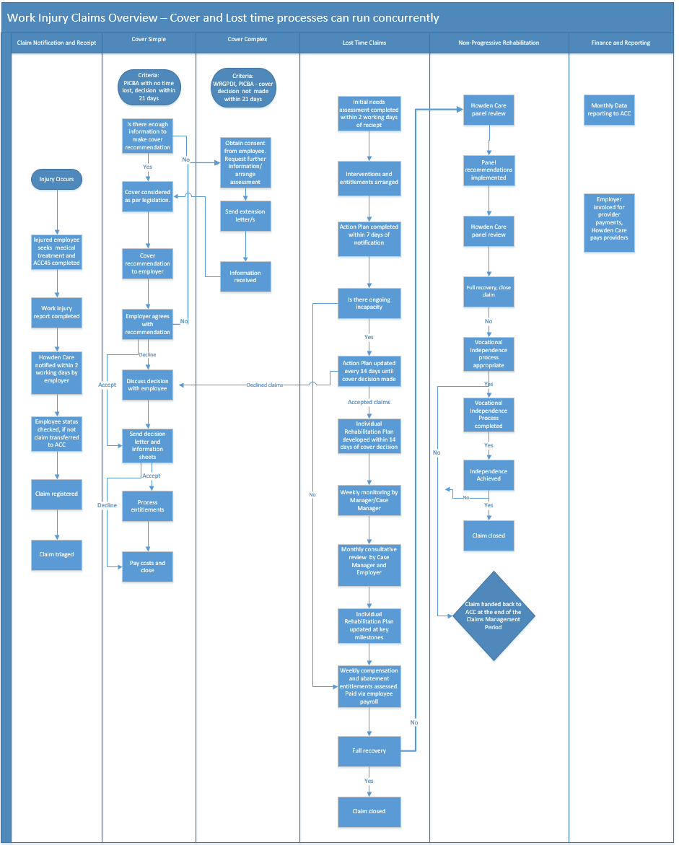

12.2 Appendix 2 – Summary of AEP timeframes
Injury Manager = University of Otago OHN Case Manager
Timeframe | Task | Action | Responsibility
2 days from treatment and ACC claim lodgement | Claim notification to Employer  Claim notification to Howden Care | Employer notifies Injury Manager  Howden Care notify University of Otago | Employer  Howden Care.
2 days from injury notification | Initial Needs Assessed for all claims with lost time or interruption to normal working activities  Vault report provided | Injury Manager contacts injured Kaimahi-staff to assess needs  Claimant and OHN | University of Otago OHN
7 days from injury notification | Action plan is completed for all claims with lost time or interruption to normal working activities | Injury Manager develops action plan | University of Otago OHN
Action Plan updated every 14 days until cover decision is made | Action Plan is updated for all claims with ongoing lost time or interruption to normal working activities | Injury Manager updates action plan | University of Otago OHN
Before any information is requested or released (except for the initial consultation notes) | Signed Kaimahi-staff consent | Consent is obtained from injured employee | University of Otago OHN
21 days | Cover decision for PICBA claims, otherwise extension needed | Cover investigation completed and decision made according to legislation  If cover decision not able to be made, send letter to injured Kaimahi-staff explaining reason and extended timeframe for cover decision | Howden Care Claims Team, or University of Otago
2 months | Cover decision due for complex claims, otherwise extension needed | Cover investigation completed and decision made according to legislation  If cover decision not able to be made, send letter to injured Kaimahi-staff explaining reason and extended timeframe for cover decision | Howden Care Claims Team, University of Otago
4 months  Simple and Complex claims  Simple =PICBA  Complex = WRGPDI, Mental Injury and claims lodged 12 months after accident date | Cover decision due for extended PICBA claims  Cover decision due for extended Complex claims, otherwise second extension needed | Cover decision must be made for extended PICBA claims  If cover decision not able to be made for Complex claims, contact injured Kaimahi-staff to discuss and send letter explaining reason and extended timeframe for cover decision | Howden Care Claims Team or University of Otago
9 months  Complex claims only | Cover decision due for extended complex claims | Cover decision must be made | University of Otago OHN
14 days after cover decision | Individual Rehabilitation Plan developed for injured employees with ongoing incapacity | Rehabilitation plan is developed with the injured employee, employer, injury manager | University of Otago OHN
Key milestones | Individual Rehabilitation Plan is updated for injured employees with ongoing incapacity | Rehabilitation plan is updated with the injured employee, employer, injury manager | University of Otago OHN
Weekly | Weekly monitoring of injured employees with ongoing incapacity | Documented weekly check in on rehabilitation progress | University of Otago OHN
Monthly | Review of non-progressive rehabilitation | If recovery has moved outside normal timeframes for injury, monthly review of claim to consider best course of action | University of Otago OHN
5th working day of the month | Data reported securely to ACC | Send data report to ACC | Howden Care Administrator
20th of the month | Pay treatment providers | Treatment provider invoices are approved and paid | Howden Care

12.3 Appendix 3 – Claims transfer process
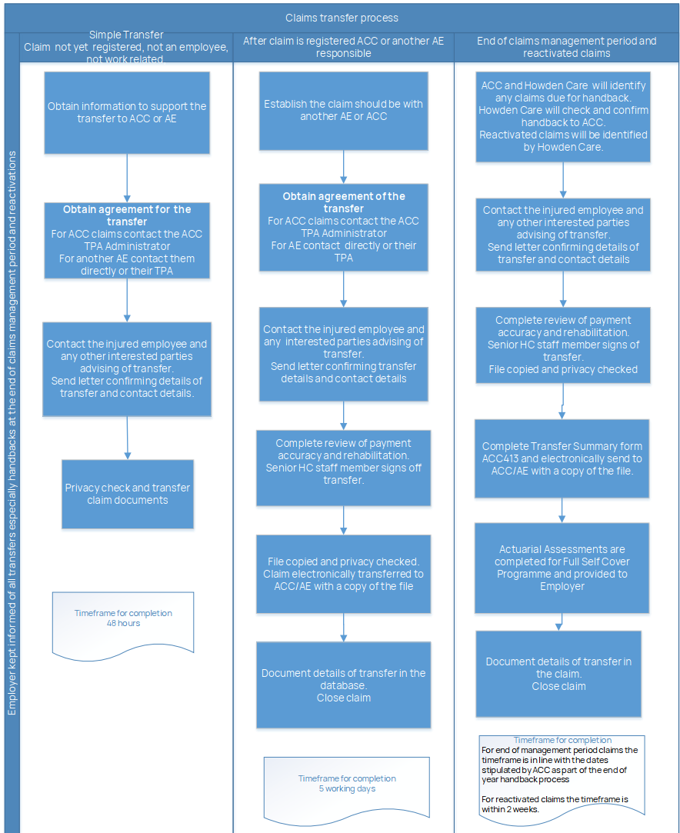

12.4 Appendix 4 – Weekly compensation & abatement process

12.5 Appendix 5 – Complaint process

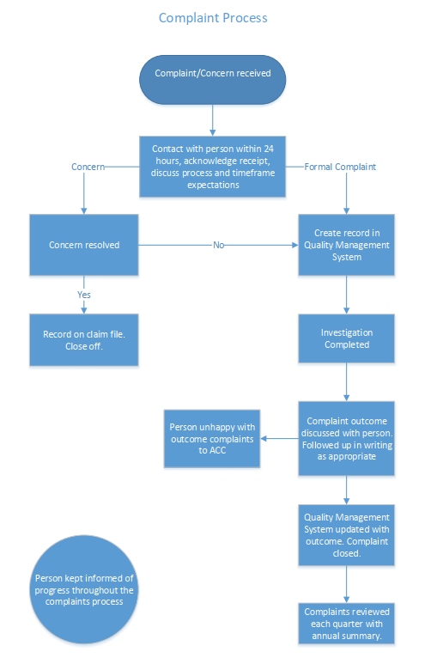

12.6 Appendix 6 – Review process
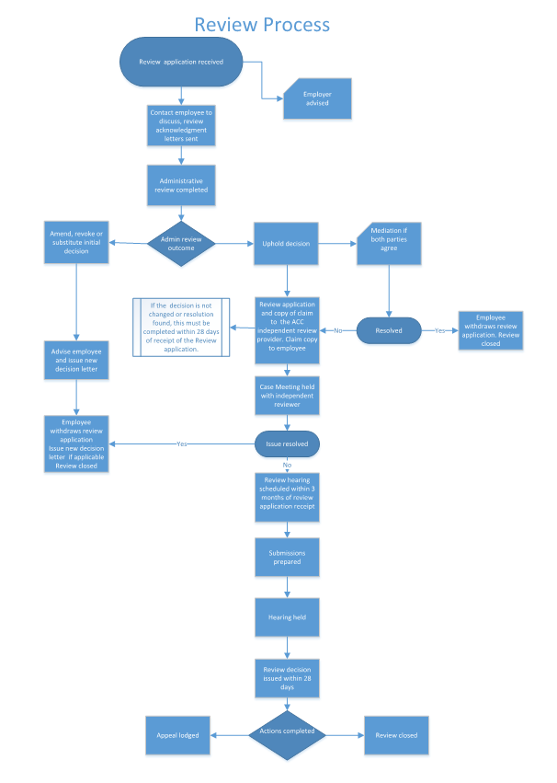

12.7 Appendix 7 – Fraud process

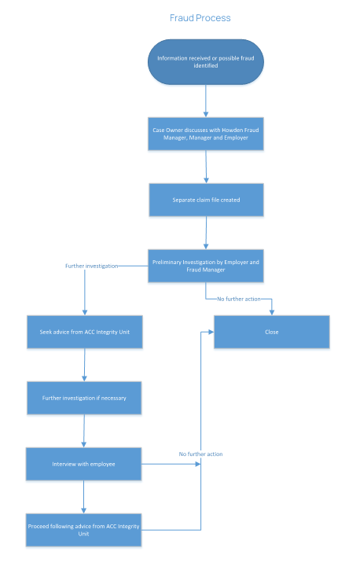

Glossary
Term | Definition
AEP | Accredited Employer Programme
AE | Accredited Employer
Act | Accident Compensation Act 2001, the legislation that governs the ACC programme
Case Owner | Person responsible for managing the claim
DOFI | First Date of Incapacity
DOSI | Date of Subsequent Incapacity (DOSI)
PICBA | Personal Injury caused by accident claim
OHN | Occupational Health Nurse
OHT | Occupational Health Team
OIC | Order in Council – Each year ACC looks at two indices and the minimum wage and advise if there is any change to the ACC statutory payment rates
IRP | Individual Rehabilitation Plan
Third Party Administrator (TPA) | Third party subcontracted by an Accredited Employer to assist them to meet their performance obligations. The overall responsibility of the programme remains between the employer and ACC
Senior HC Staff Member | Operations Partner, Quality Manager, Senior Case Manager
WRGPDI | Work related gradual process disease or infection claim
ACC18 | Medical certificate
ACC45 | The form the treatment provider completes at the initial treatment. It provides details about the claim and any initial incapacity
University of Otago OHN | University of Otago Occupational Health Nurse or member of the Occupational Health team.

