How to add a fire drill into Vault
Using the Risk menu at the top of the page, select Emergency which will take you to this page.
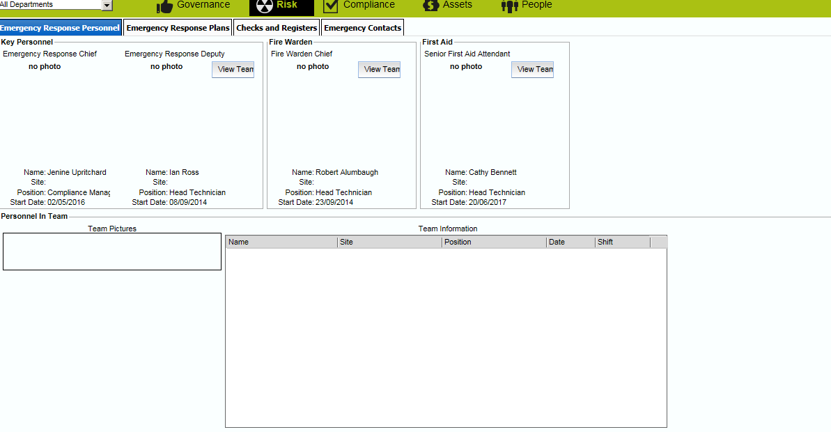
Select the Checks and Registers tab
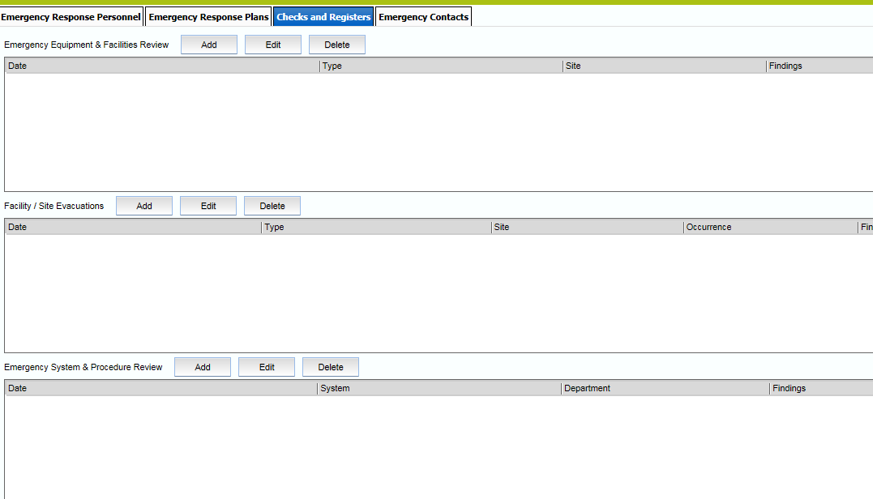
Select Add in the Facility/Site Evacuations
A new box will open up for you to fill out details of the drill.
