**Adding a Fire Evacuation**

To add a fire evacuation go to Risk

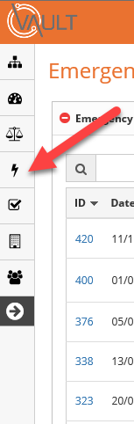

Select **Emergency** then **Checks and Registers**

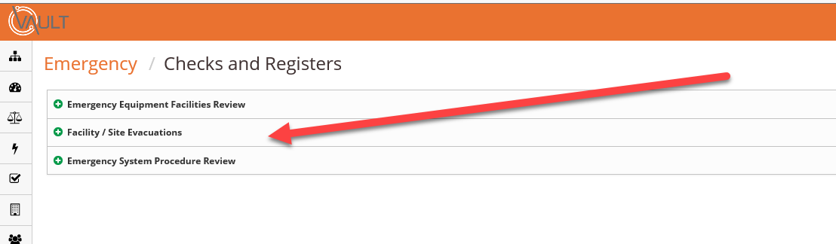

Select **Facility/Site Evacuations**

To add a new evacuation click the add button at the right hand side of the page.

A new window will open.

Under type there are 2 choices, actual and rehearsal. For a Fire Drill select Rehearsal

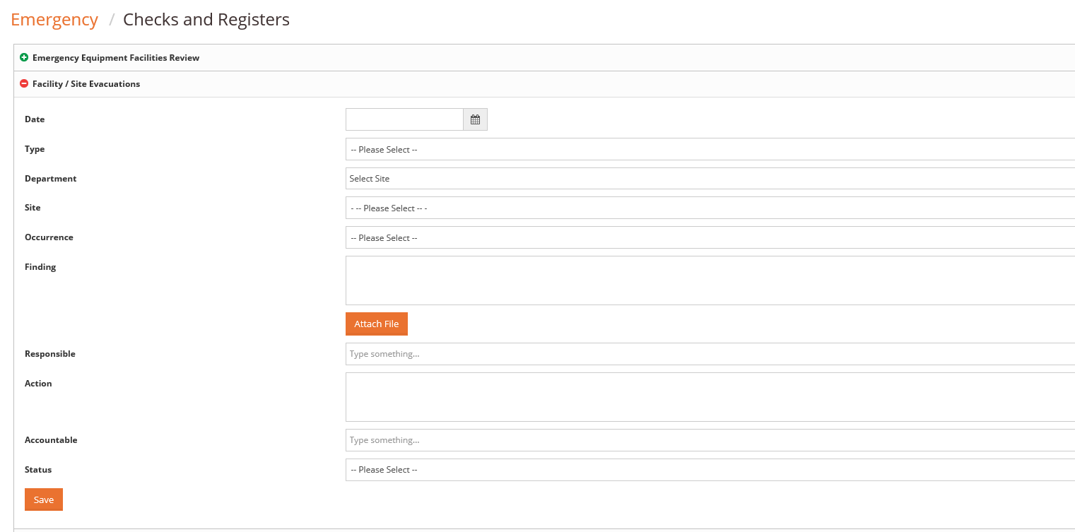

When you click on Department your options will automatically open

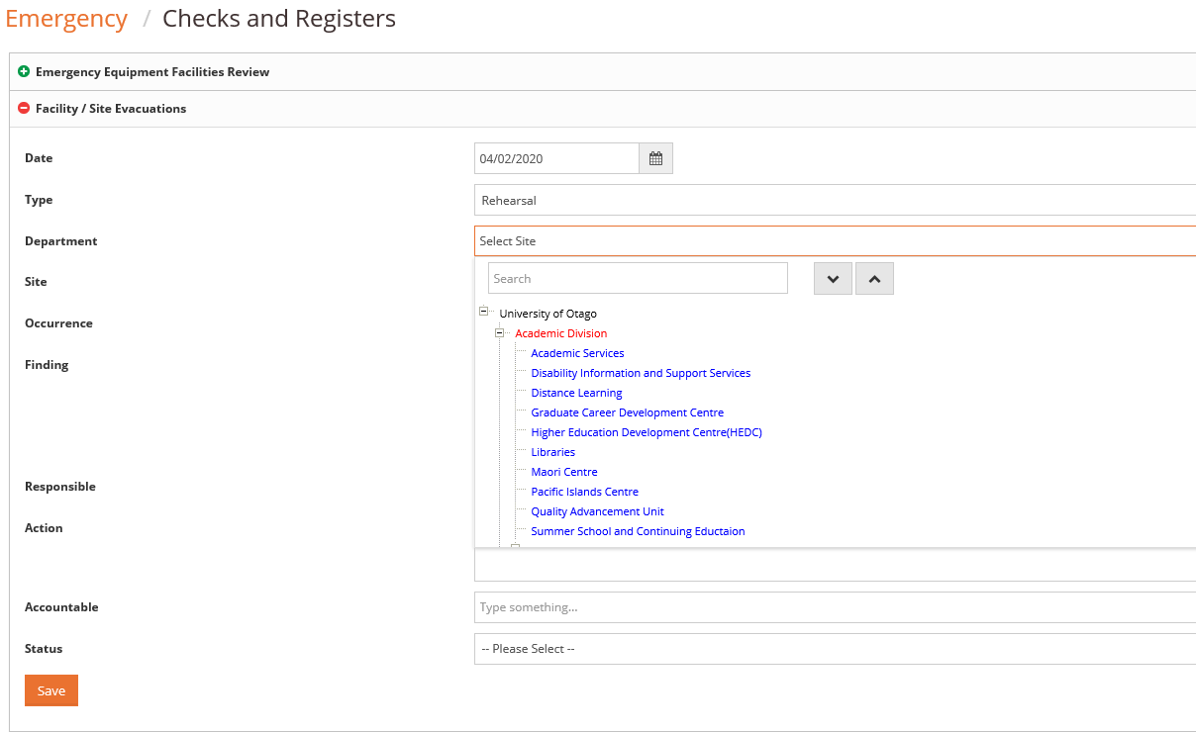

If your department has sites listed in Vault they will appear under site. If no sites are listed please contact Karen Bonney 6216 and more sites can be added.

There are several choices available under Occurrence

* Evacuation
* Fire
* Medical
* Earthquake
* Fire

For a drill select Evacuation.

Add your findings and Actions in the appropriate boxes and the status. A copy of any additional reports can be added as a file.

Remember to 