Adding an incident when logged into Vault
Risk can be found in the tabs which are on the left hand of the Vault 3 log in screen.
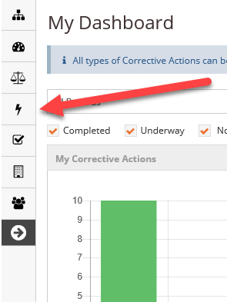
Listed under this tab you will find most of the items that you need to access the most
- Risk
- Events
- Risk Register Reviews
- Emergency
- Formal Investigation
- JSA/SWMS
- Risk Assessment
- Multiple Risk Assessment

To add an incident go to risk and select Events. The add button is on the right hand side of the page.
Select Add and another window will open
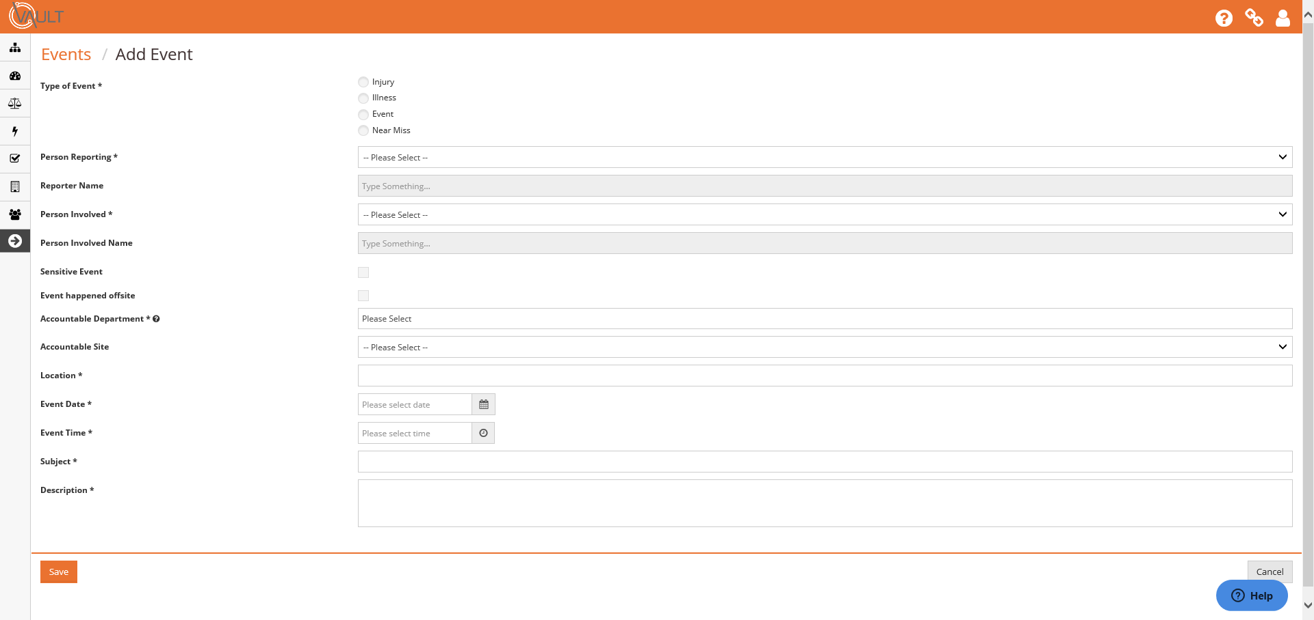
Using the titles as your guide, begin to enter the information into Vault.
When adding the Reporter and Person Involved names, name suggestions will appear as you type the name.
To add a student name you need to have Student access in your Site Selection.
If you don’t have this access I recommend that you log out and enter the incident into the portal. Alternatively contact Karen Bonney on 6216 or Karen.bonney@otago.ac.nz to have the access added.
There is a search box for the accountable department. It may be helpful to note the department which appears beside the Person Involved Name.
If the person involved is a student please make sure that you change the Accountable Department to the correct department.
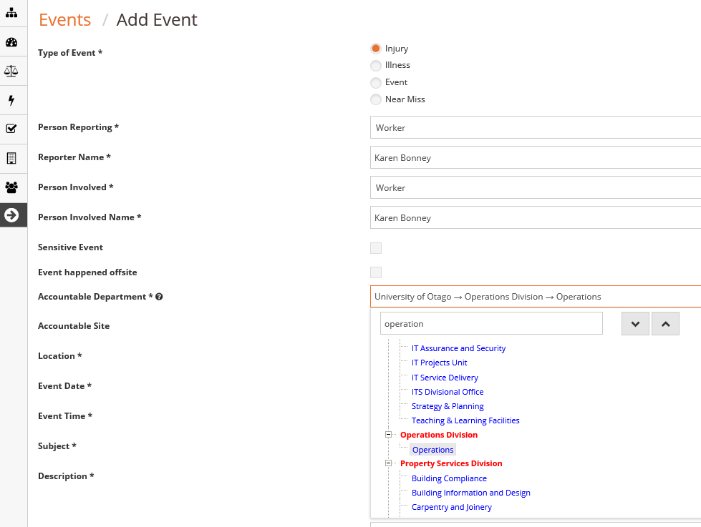
Select the appropriate Category and Severity from the drop down menus.
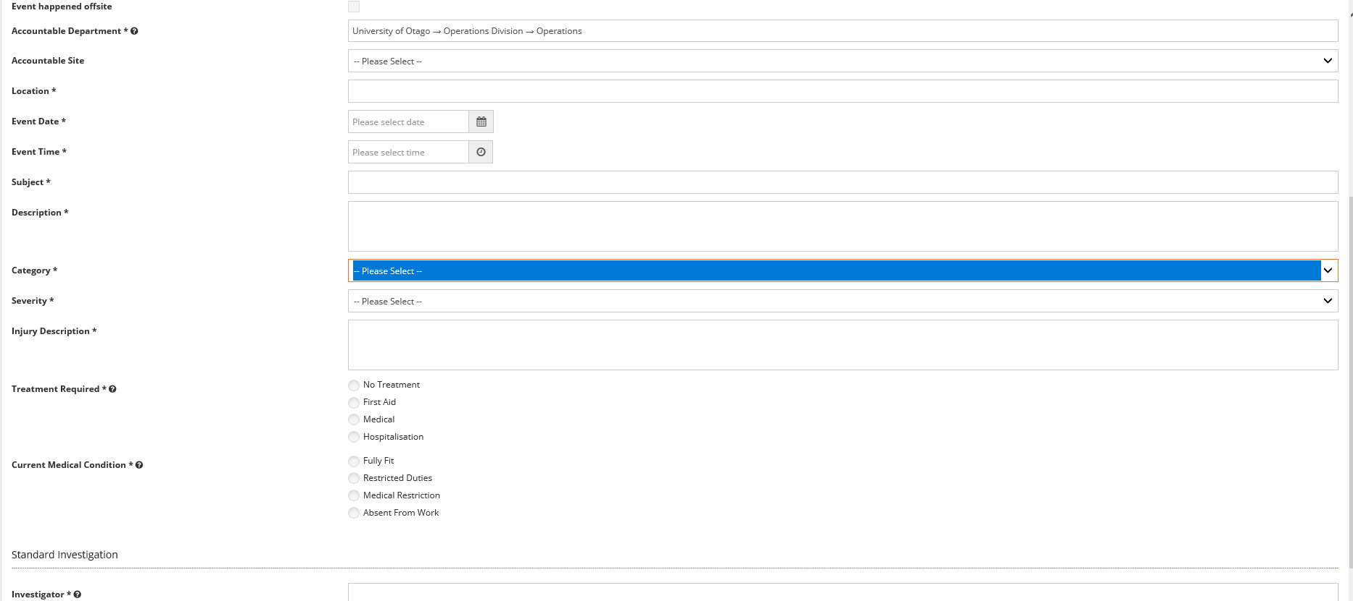
Once you have completed all of the required information, click Save (bottom left).
Once saved, the incident will open to a new page where there is a choice of Updating Pending Event or Save to Event.
Once Save to Event has been selected the incident will be added to the list of Events on Vault. Note that pending incidents will also show in this screen.
