How to call up a report of your departmental events.

Once you have logged into Vault select the Scales image from the tabs on the left hand side of your dashboard.
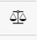
You will be given several options from this tab, click on Reports.
This will open up a large selection of available reports. In the Search bar start typing events.
For all of your events/incidents scroll down to Event Registers – All Events
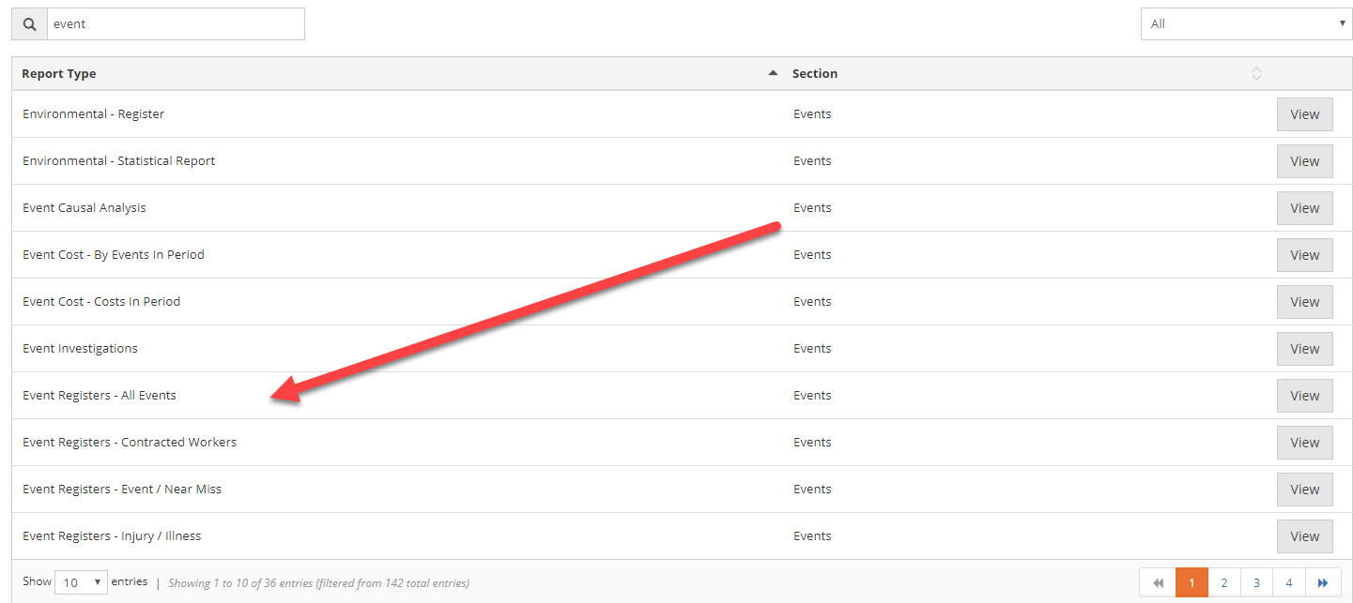

Click on the View button at the right.
This will open up a selection of options for your event report.
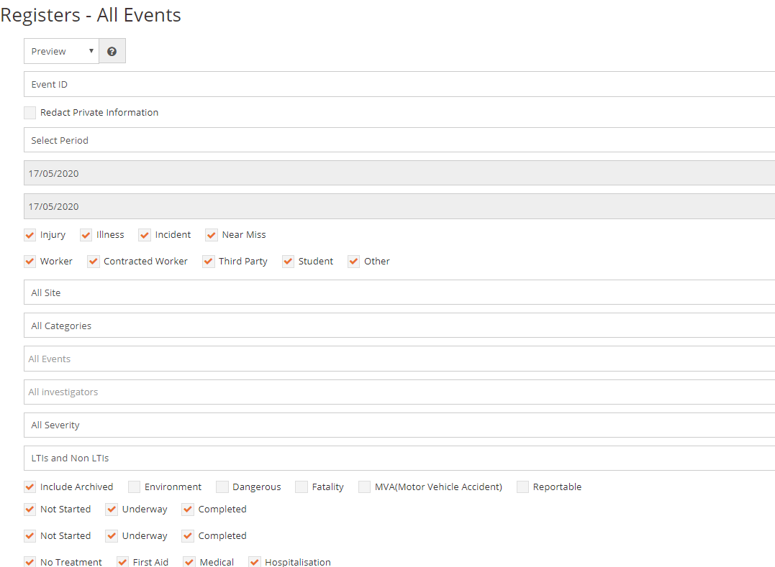
In the Output Format you have a selection of options. The report can be viewed as a preview, PDF or on a spreadsheet.
Using the Report Period you can select the timeframe for the report that you would like to view.
If you want to only look at a specific category, in the Category area when you click on the box, all of the categories will appear. Please note that if you choose to use this option only one category can be selected at a time.
Once you are happy with your selections, click on the Preview Report button at the bottom of the page.
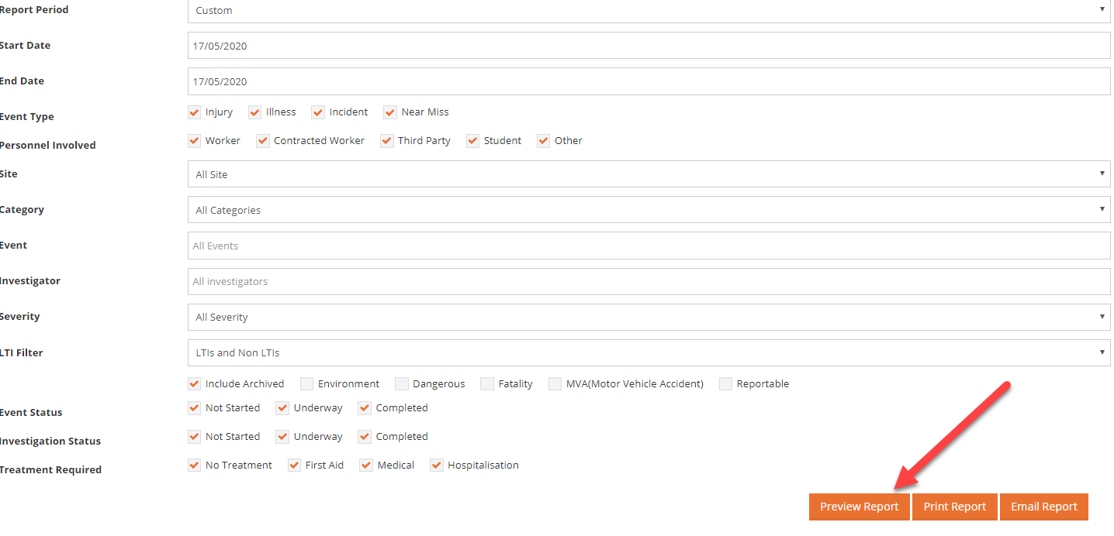
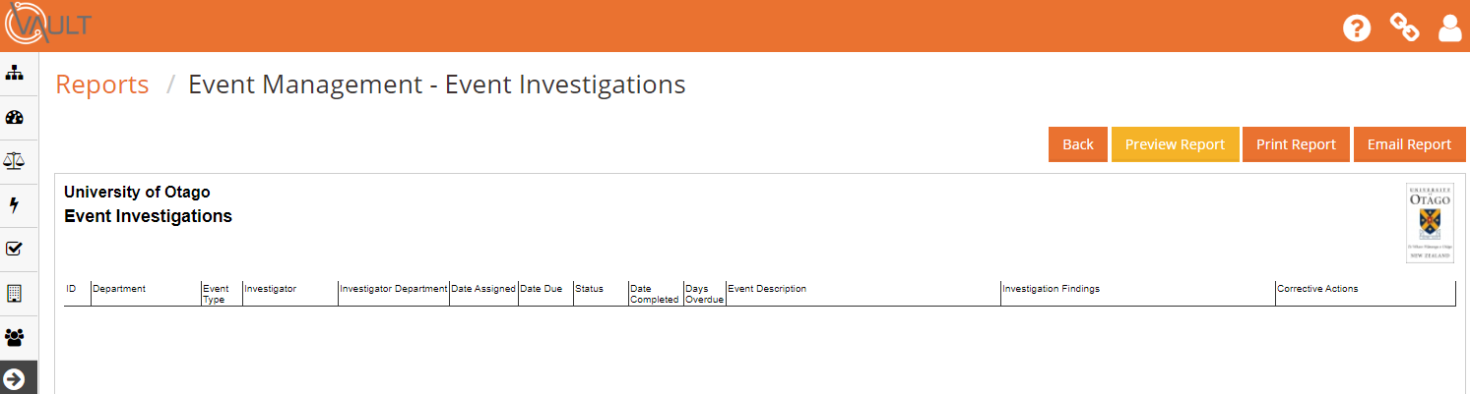

If you are happy with the report you now have the option to print or e-mail it.
As always if you have any questions please give Karen Bonney a call 4716216 or 0214796206

