University of Otago
Research Committee

Application for Humanities
Research Networks

Delete and type Name of Network

Delete and type (if applicable) Entity/group Submitting Application
Delete and type Host Programme or School
Delete and type Other Programmes / Departments / Schools involved

Closing Date: 5pm Monday 9th December 2019

Email to pvc.humanities.ea@otago.ac.nz.

About Humanities Research Network Grants

These grants, funded by the Division of Humanities, offer $10,000 per year for two years for the support of new or existing research groups that have not previously been funded as
Divisional Research Clusters or University Level Themes or Centres.

They may include members from other divisions or institutions but must be hosted by a
Humanities School or Programme.

SECTION ONE APPLICANT DETAILS

1.1 APPLICANT DETAILS
Principal applicant’s name and title
Name and title of alternative contact

1.2 PURPOSE OF THE PROPOSED NETWORK (100 WORDS)

1.3 SIGNATURES/DECLARATIONS
Signatory | Signature | Date
Principal applicant
Head of Hosting School
(name)_____________________
I confirm that if this application is approved the basic
resources to support the Network will be available, and that relevant University professional services units have been consulted and are able to provide support to the Network (e.g. finance, client services, IT, communications and
marketing, etc.), should funding be awarded.
Comments by Head of School (if any)

SECTION TWO
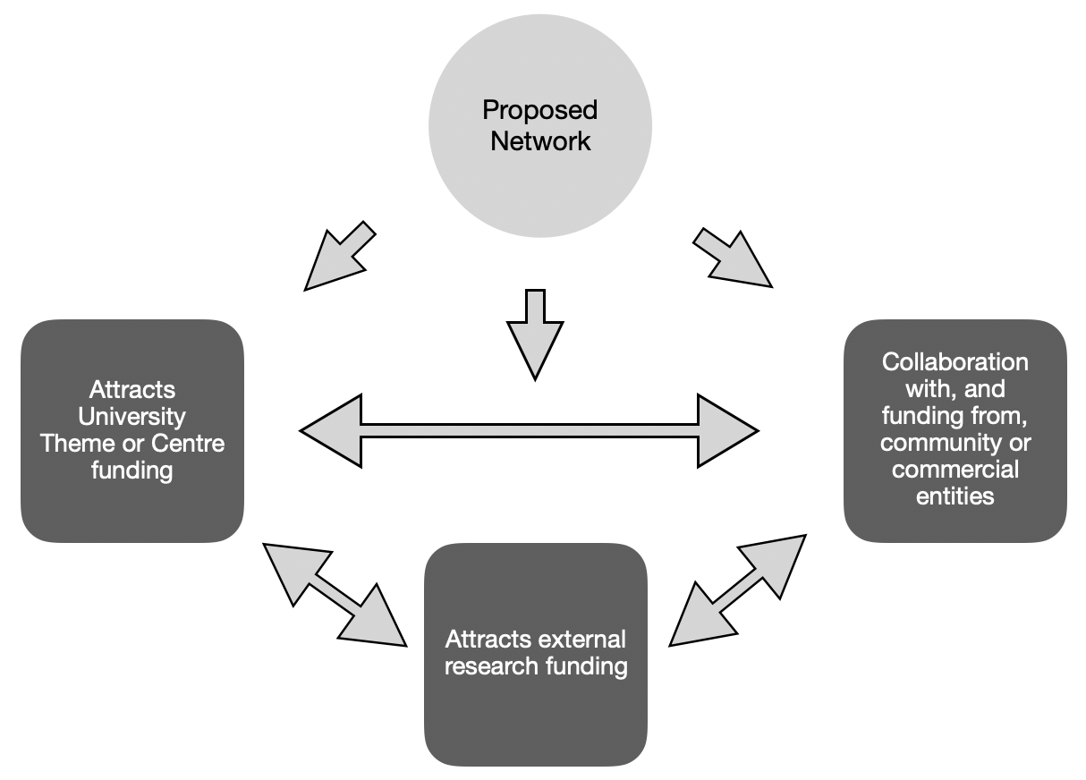
OUTLINE OF PROPOSED NETWORK
(This section should be NO MORE THAN THREE PAGES excluding references, which should be on a separate page. Font size should be no smaller than 11pt)

- Describe the area of research that will form the core of the Network’s activities. Explain its
importance/significance in relation to its inter-disciplinary field(s) and the extent to which it has relevance beyond its academic field (eg. to policy, business, health, cultural, economic,
environmental etc users).

- Describe the research strengths that the University has in the Network area. Which researchers or research areas will contribute to the Network? What are their strengths and how will they
contribute?

- Explain how a Network approach will extend Otago’s research strength beyond what is occurring already through individual, School or Divisional collaborations, workshops, co-publications etc. Note other national or international groups with which the proposed Network could collaborate.

- Describe the potential for the proposed Network to develop in future. Some possibilities are set out in the diagram above. What are the goals of the proposed Network and how will it achieve sustainability (including future funding) for this area of research by the conclusion of the grant?

- Outline the set of coherent activities that will help you achieve the goals identified in 4. Note particular research projects or outputs and/or funding applications to which the proposed
activities will contribute. This might be presented as a timeline or in table form. Note activities that will require funding (include amounts where possible).

SECTION THREE NETWORK GOVERNANCE AND RESEARCHERS

- Governance
Research Networks are not required to have a formal governance group. By agreeing to
participate, the principal investigators acknowledge their responsibility for achieving the goals and milestones set out in this application. They will be required to submit a report of the network’s activities at the end of year one and to participate in a celebratory event at which the network presents its final report.

- PRINCIPAL INVESTIGATORS (Add additional lines if needed)

Title | First Name | Surname | Department/  Programme | Research Expertise | Research Role

- ASSOCIATE INVESTIGATORS (including postdocs, PhD students, and researchers from external organisations. Add additional lines if needed)

Title | First Name | Surname | Department/  Programme | Research Expertise | Research Role

SECTION FOUR CVS

Please attach CVs of the Principal Investigators only. Use the Standard MBIE CV format (a template adapted for Network Grants is available on the Humanities Forms and Guidelines page).

