“ “IS THERE AN OCEAN IN THE HOUSE?”
Level | Investigations
Topic | Temperature
‘OITH bench-top’s | Introduction, Definitions, changing. The nature of water.  GTV 2.1  GTV 2.2 | Tool, (setup)  manufacturing, testing, modification.  GTV 2.2, 2.3 and 2.4 | Tool, standardization and calibration, issues of range and sensitivity. (and more system error.)  GTV 2.5 and 2.6 | Doing with the tool. Enquiry. Problem. Proposition.  GTV 2.7 and 2.8
Support material | Overview and  worksheets | Concept, analogy and creativity | Data handling, conversions. Graphing, (recording and statistical error)  GTV 2.3 and 2.9 | Review  GTV 2.10

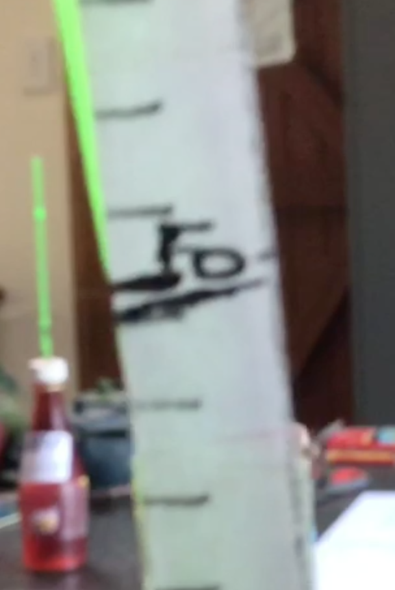
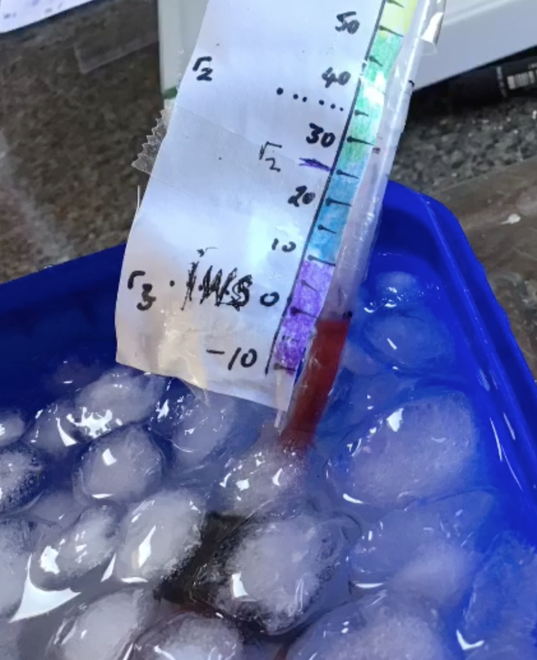
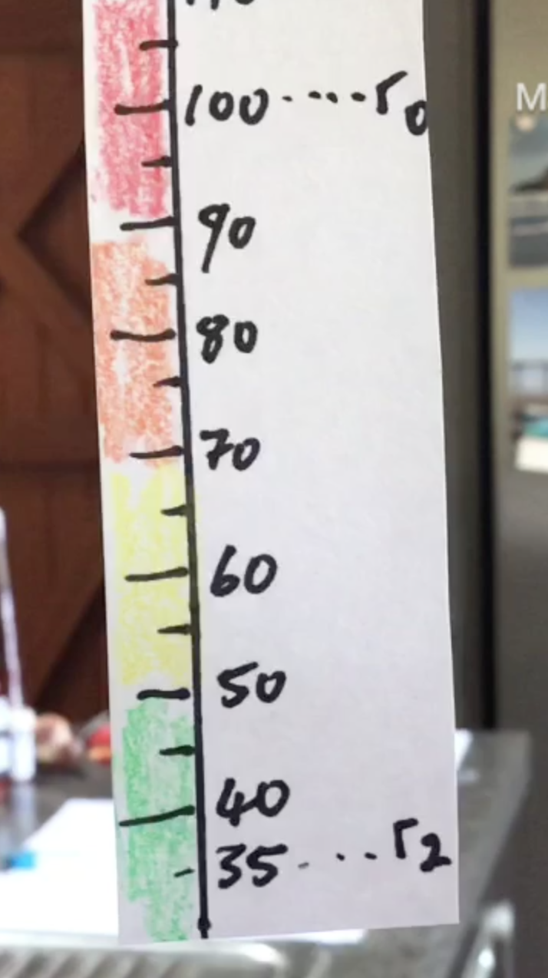

R0 (human body temperature) r3/iws (freezer/ice+water+salt) Final ‘New Scale’ (the
Shows the most consistent and provides a lower calibration ‘humbod’ scale) calculated,
Conserved values so it makes reference, less consistent or measured out, marked (100
Sense to use it as calibration conserved but workable. Degree division between
Reference standard. “Kevin” proves to be most ro and r3 and colour coded.
“Karl” has useful range dependable and have the most “Karina” is useful in upper
And sensitivity useful range as well as allow for Range but low precision.
high precision.

There are at least 8 different temperature scales !!
https://www.thoughtco.com/the-history-of-the-thermometer-1992525
http://users.telenet.be/instrumentatie/temperature/temperature-scales.html

We have utilized different historical perspectives to design, calibrate and test our thermometers.
From Fahrenheit we have used a lower reference point than ice and copied his ice, water, salt combination (though not to same precision) From Newton and Fahrenheit we have utilize human body temperature as a known point but uniquely we have set this as 100 on our scale. From Celsius we have taken the idea of 100 divisions between our zero and 100 points.
But you will now have seen that standardization and calibration need constant care and attention!! AND different instruments that are intended for the same measurement are not necessarily equally sensitive, or reliable!!
We are also the creatures of habit and the centigrade scale is one we easily understand and think about temperature with. This is the scale much of science and all of Ocean science uses.
We need to think about conversion to help us think about what we are measuring in terms of a familiar scale. This can be done by:
- a table of conversion say from Humbod to centigrade

- a graph of relationship to interpolate from one temperature (x) to other (y)

- a formulae of relationship (which can be the formulae for the slope of the graph). It is by such a formulae that conversion tools found on line use.
To graph the relationship use a table of known and measured values (I have used the thermometer ‘kevin” as all my use with this one has taught me it is most sensitive and consistent across the range of our standard references r3-r0)
From excel spreadsheet
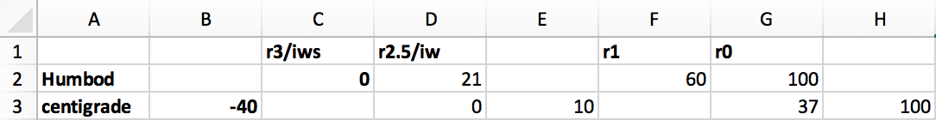

Graph with fitted trend line and trend line formulae. Conversion table using formulae

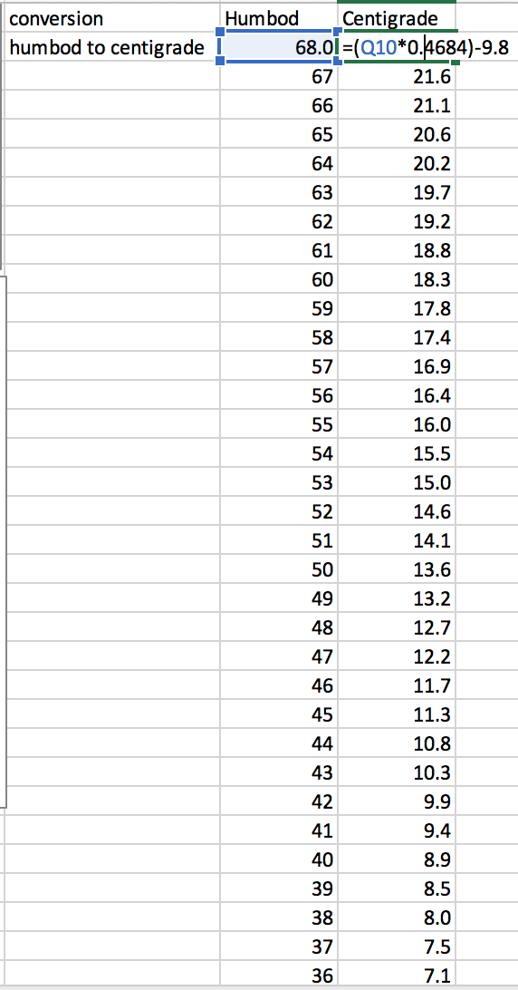
From either the graph or the conversion table
I can now work out that r1, room temperature, reference measured at 60 ‘humbod’ degrees, is about 18 degrees C.

Now I have conversion in hand I can proceed with an experimental design knowing that any results I get can be easily related to the work of other scientists and used in conventional calculations that rely on degrees centigrade as a reference scale.

