“ “IS THERE AN OCEAN IN THE HOUSE?”
Level | Investigations
Topic | LIGHT
‘OITH bench-top’s | Introduction, The nature of waves. And the wave nature of light.  GTV 3.1  GTV 3.2  GTV 3.3 | Tool, (setup)  manufacturing, testing, modification.  Light sensitive pigments, extraction and use.  GTV 3.4, 3.5 and 3.6 | Tool, Qualitative vs quantitative data, sensitivity.  GTV 3.5 and 3.6  Making a tool that uses light to capture and store image information GTV 3.8 | Doing with the tool. Enquiry. Problem. Proposition.  GTV 3.9  (includes signup for practical kit to support this challenge)
Support material | Overview and  worksheets | Concept, analogy and creativity. Memory, information capture and storage, image and imagination in the Nature of science.  GTV 3.7 | Data handling, wave s and ‘fun with formulae’  GTV 3.1, 3.2, 3.3 | Review and interviews  GTV 3.10

REFLECTION and REFRACTION are 2 properties of LIGHT that suggest a WAVE nature.
These properties connect to what we see, how we see, energies absorbed and transferred.

in BENCHTOP 2 we investigate refraction.

Benchtop 2, part 1 refraction (GTV 3.2)
-2litre ice-cream container -cardboard -scissors
-ruler -pencil -permanent marker (fine tipped)
-flexible tape (e.g. Sewing tape) -water -salinity solutions (35 ppt, 50 ppt)
-jug

Procedure
- Use permanent marker to mark a scale on bottom of ice-cream container. (3mm spacings if possible.)
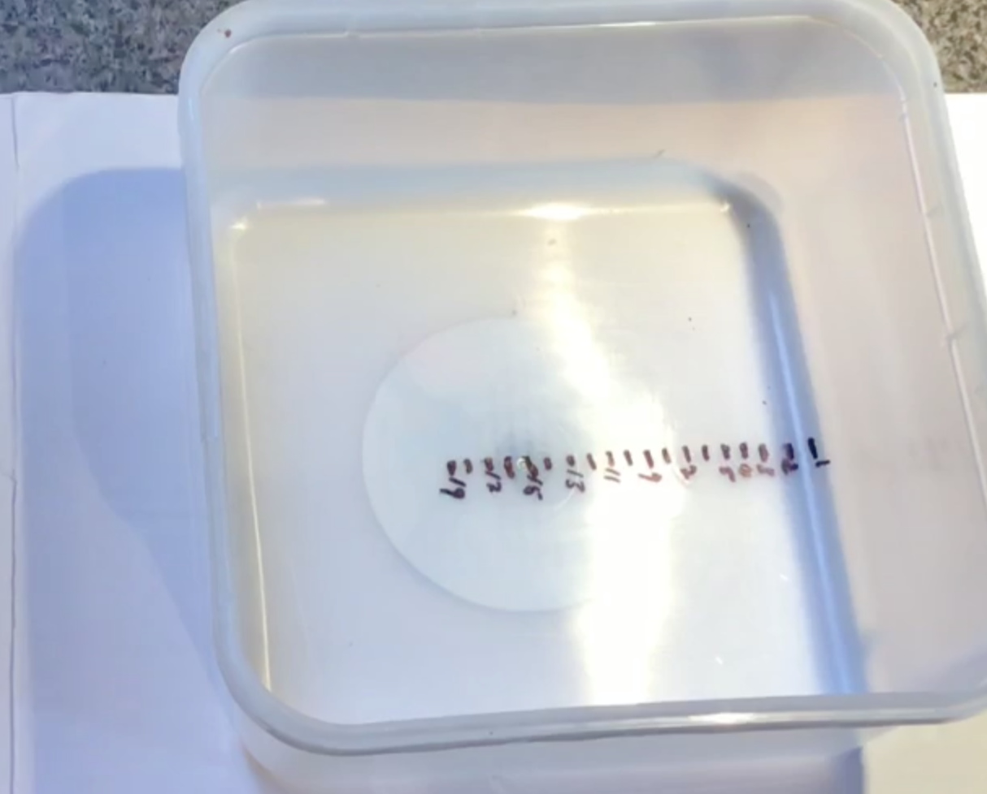
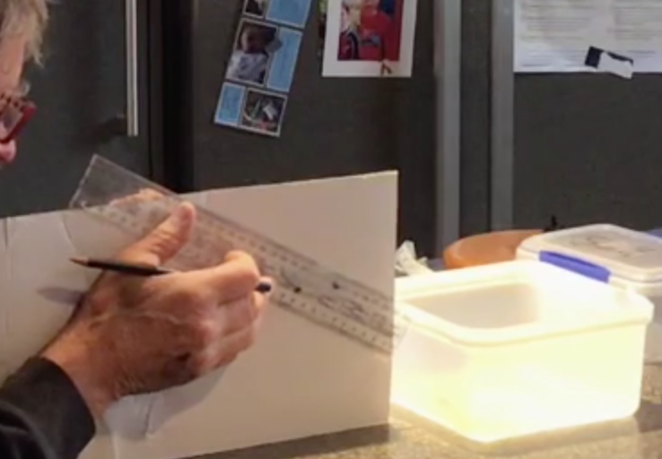

- Line-up card as shown above and in video (GTV3.2) and sighting down card to first mark on far bottom edge of empty container place ruler such that you are sighting along it and mark this sight line with a pencil.
- Cut this slope with scissors.
- Check this sight line and correct if necessary.
- Looking down this sight line pour in 2 litres of fresh water and observe what happens. Note the bottom mark (m) you can now see at end of the sight line.
- Repeat this using one of your saline solutions instead of fresh water – e.g. 35ppt or 50ppt.
- Note the difference in bottom markings you can see with different salinities (densities)
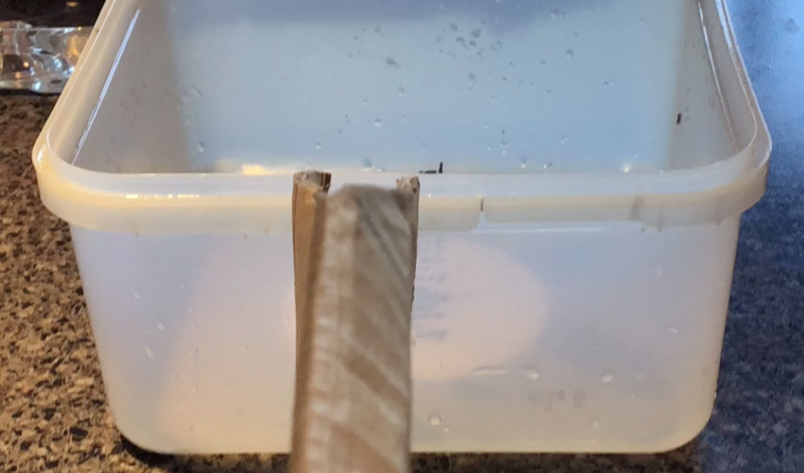
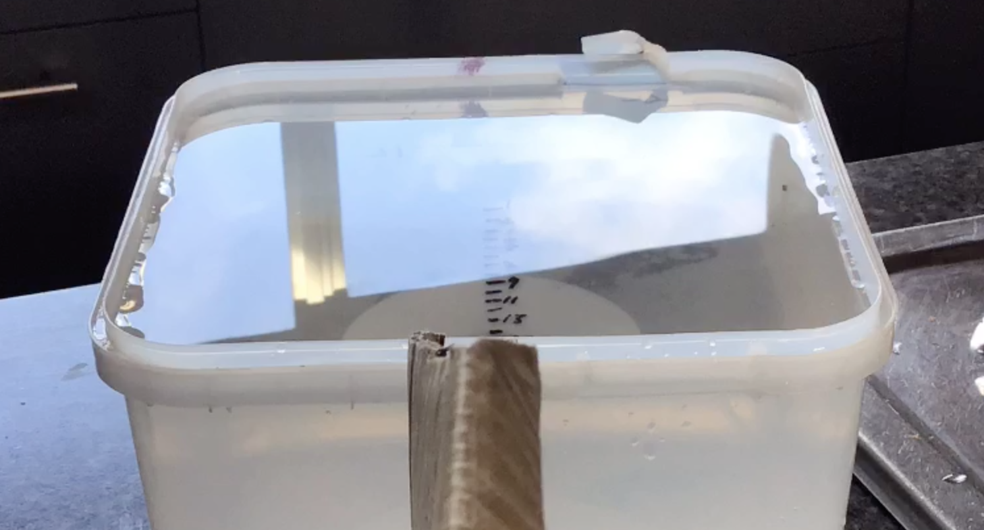

“Fun with Formulae” #2

- Use ruler and pencil to accurately mark on card the line that extends from surface of the water (horizontal black line ). Measure the distance (a) as shown in diagram below.
- Measure depth of water (b’) as shown on diagram.
- At point on bottom of container where vertical b’ meets bottom measure to mark (m), this is distance a’.
- find b and so measure and draw up these lines on a clean piece of A4 paper. Or draw up a set of lines that represent it and write in measured values.
- We can now calculate relative refractive index of air/water !

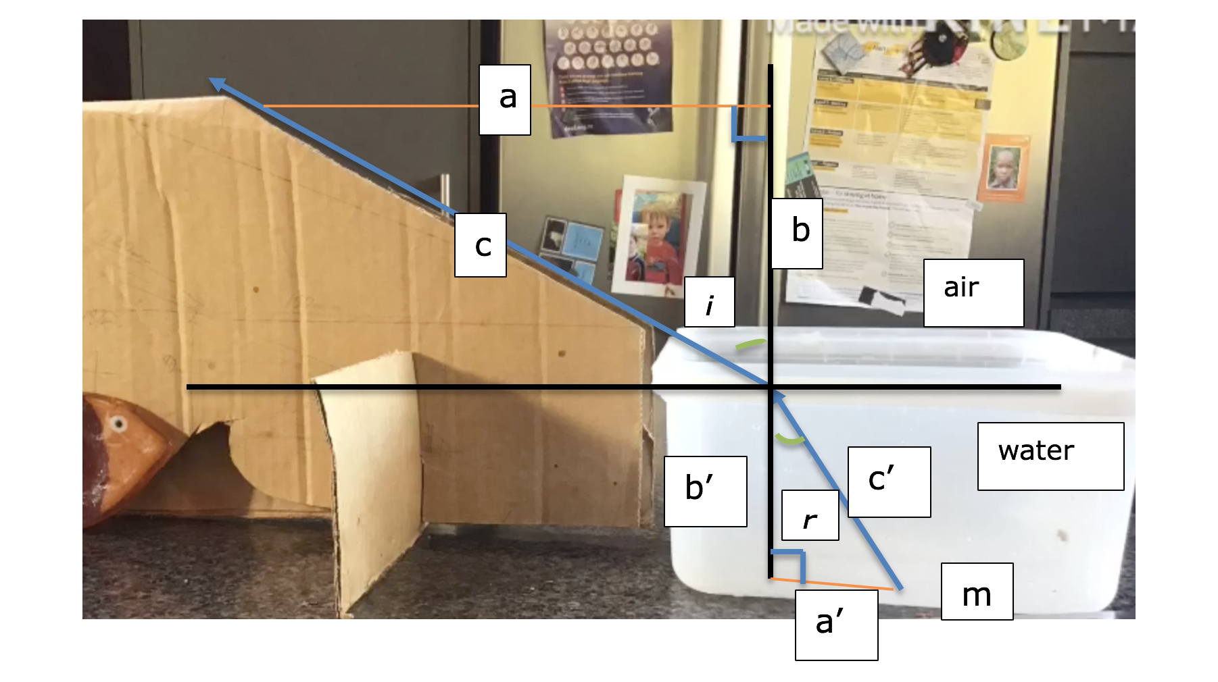
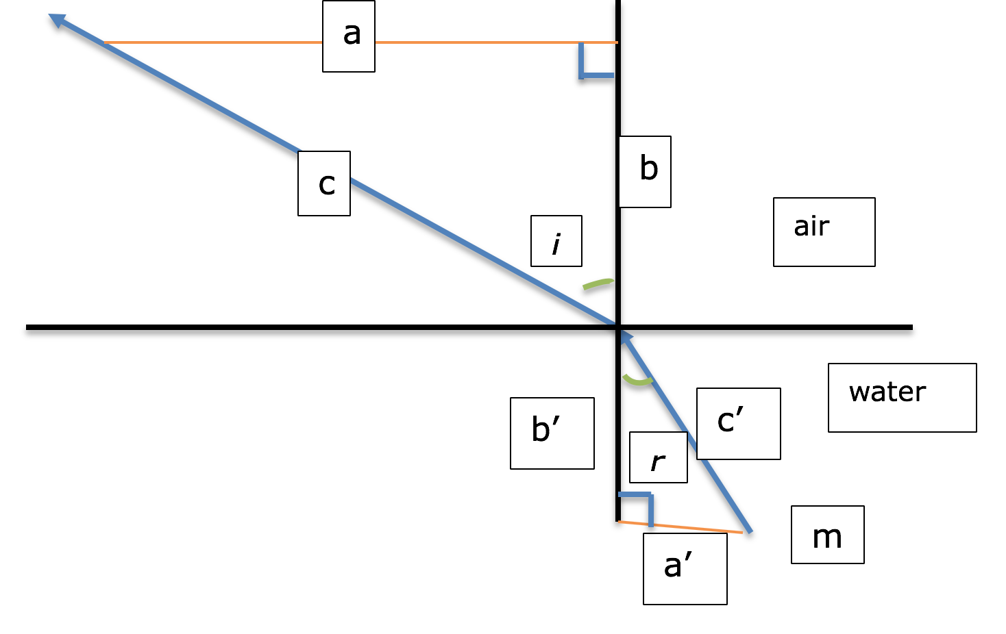

Using Pythagoras’ theorem . c²=a² +b²
Which ingeniously links geometry to algebra!

And easy online calculator
http://cossincalc.com/#angle_a=&side_a=68&angle_b=&side_b=82&angle_c=90&side_c=&angle_unit=degree

we can enter the values we now know for our angle of incidence triangle, abc, where angle opposite side c is 90 degrees .
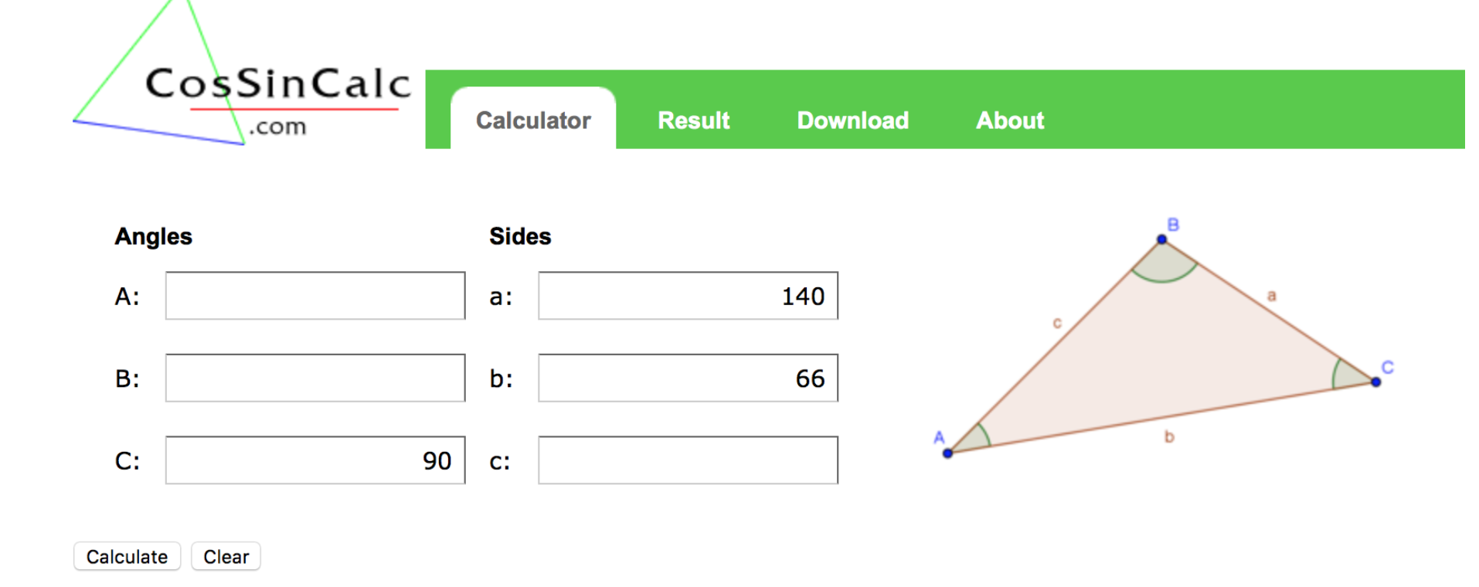

We get the following result:
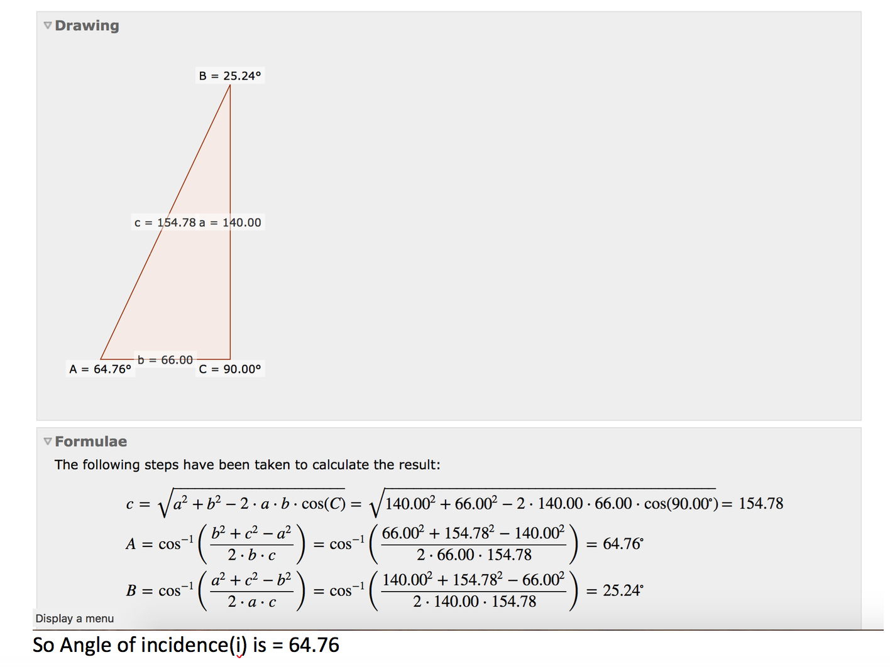

Doing similar calculations for our angle r in triangle a’b’c’
We find:
For pure water, 0ppt, Angle(A) of refraction r= ---40.49º

Similarly,’ result for seawater, 35ppt, angle(A) r = ----39.67º

relative refractive index (n) = sine i/sine r
and is a comparison of speed of light in the different media.

Using https://www.rapidtables.com/calc/math/Sin_Calculator.html
We get
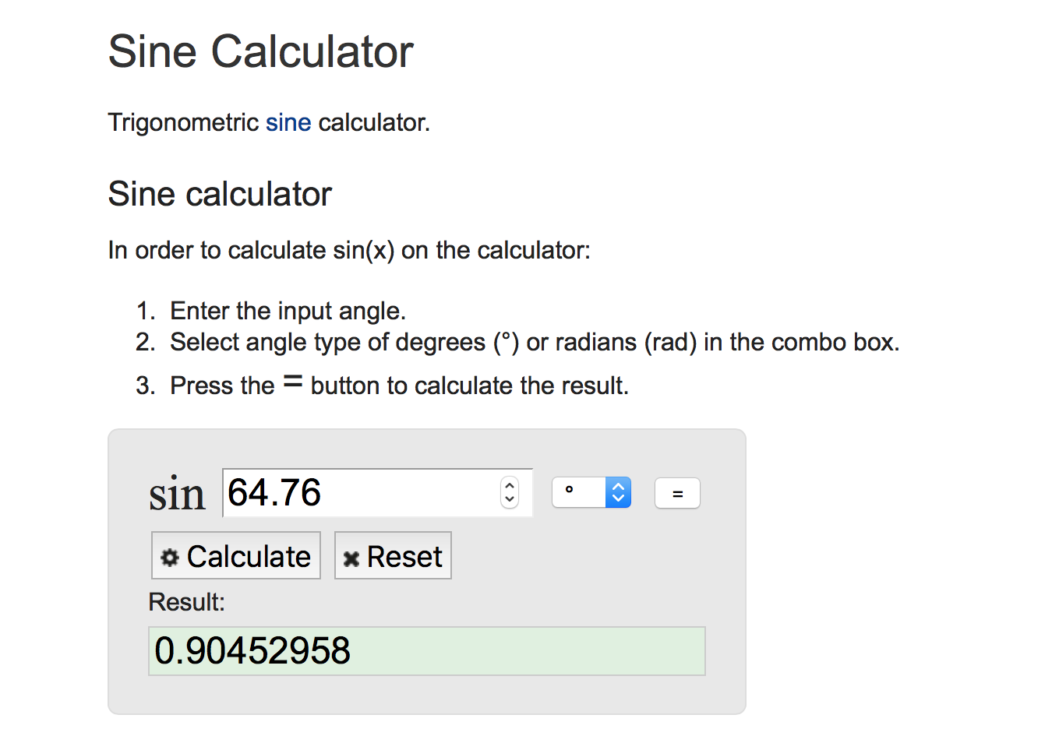

for pure water (0 ppt) n = sine i/sine r = 0.9045/0.6493= 1.393

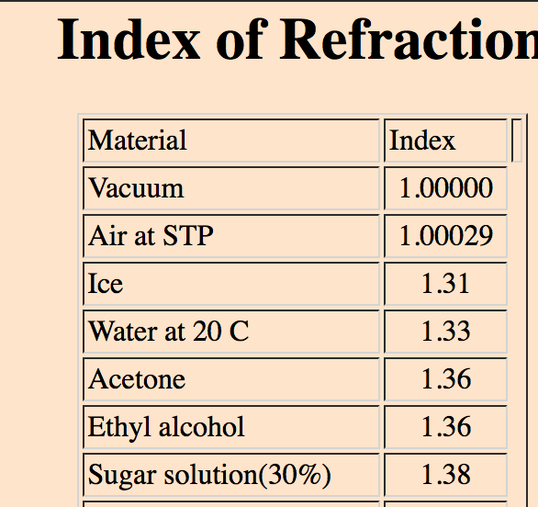
for seawater (35 ppt) n = sine i/sine r = 0.9045/ 0.63836 = 1.417

Which is not too far out from
Some referenced values!
And clearly shows seawater has
A higher refractive index than fresh.

Benchtop 2, part 2 refraction and lenses (GTV 3.3)

-round clear glass jars -cardboard -black screen (black card or card on cardboard)
-white A4 paper -scissors -ruler
-pencil -duct tape - bright torch/headlamp

Procedure
- Cut out large cardboard for screen to go in front of light, cut 2 thin slots in middle bottom to produce 2 rays of light about 2-3 cm apart.

- Cut ‘leg’ supports for this card screen and slot into to make it free-standing.

- Make black screen , preferably with side screes to make back of screen quite dark

- Place A4 paper sheet between light screen and black screen.

- Place torch behind light screen slots so 2 beams of light are formed , ix this in place with tape or blue tack.

- Place clear glass jar filled with fresh water between the screens so that the beams of light pass through it .

- Move jar back and forth until the 2 beams overlap and form 1 light line on the black screen. The refraction of the light beams through the water filled jar means they are ‘focused’ to the same position, this demonstrates the lens effect.

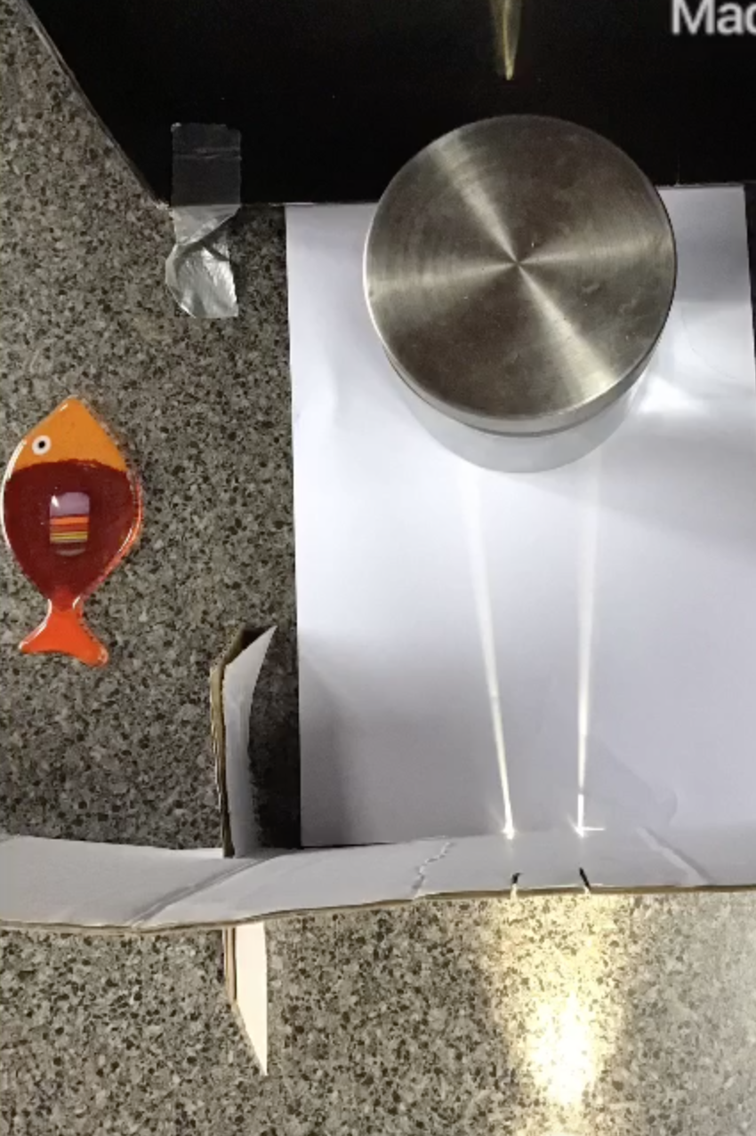
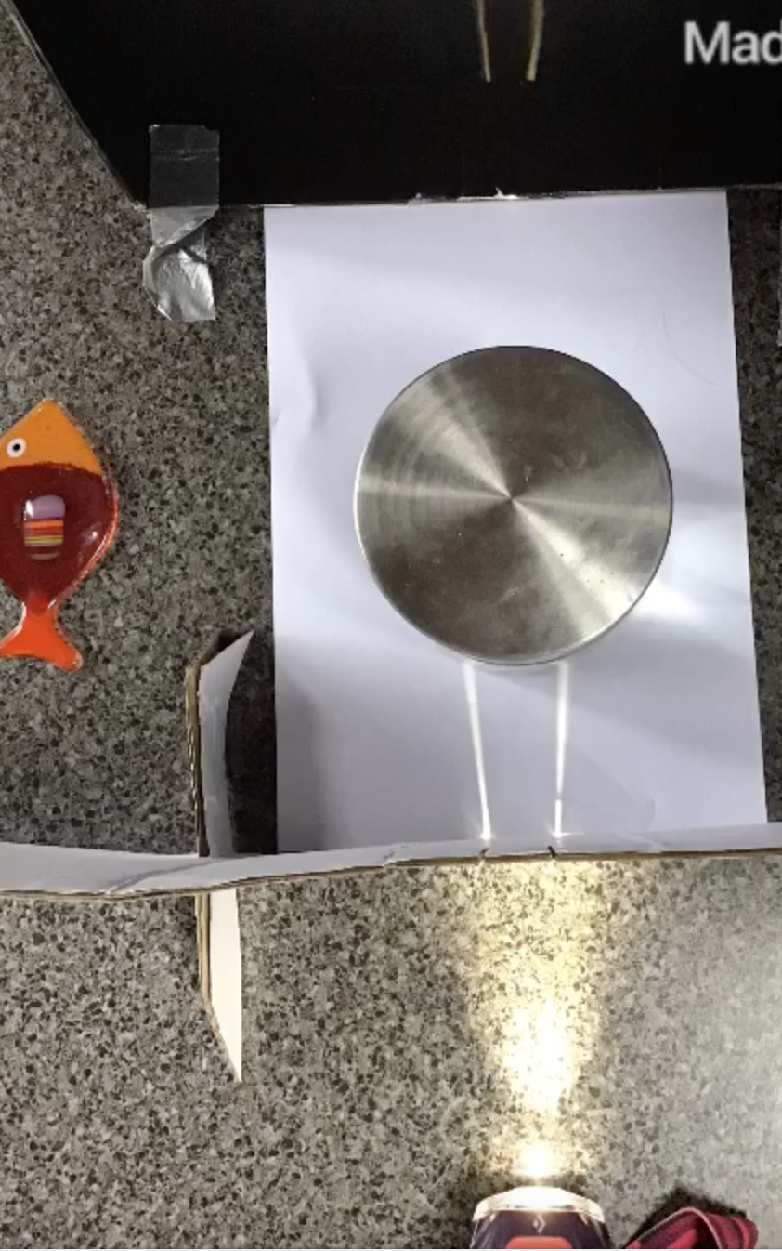
Refer to bullet point no.7
Refer to bullet point no.6

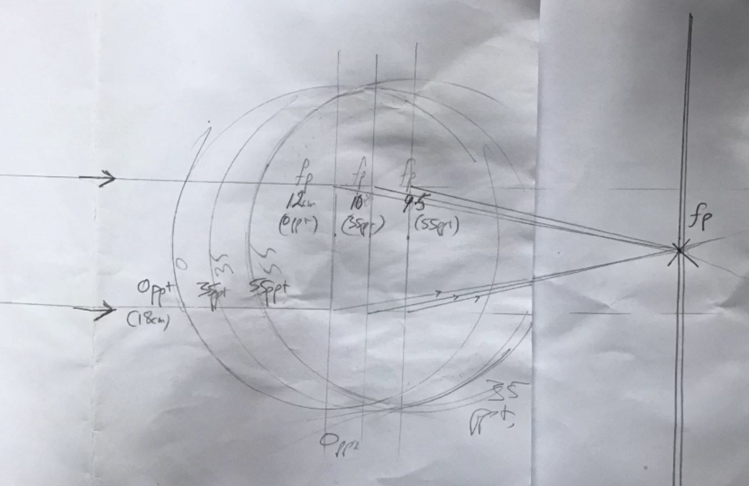
- Draw pencil outline of jar in this position. Remove jar , rule a line across jar circle at its midpoint (widest diameter) at right angles to light direction, measure distance from this line to the black screen , this is the focal distance of your “lens”.

- Repeat with jar filled with different density (salinity) water .

- You should note that as salinity increases (density increases) refraction increase and focal distance decreases.

- If you have different shaped glass containers you could explore the effect of different lens shape.

It is this lens effect that results in the pattern of rippling light and dark on the seafloor beneath a wave riffled sea.
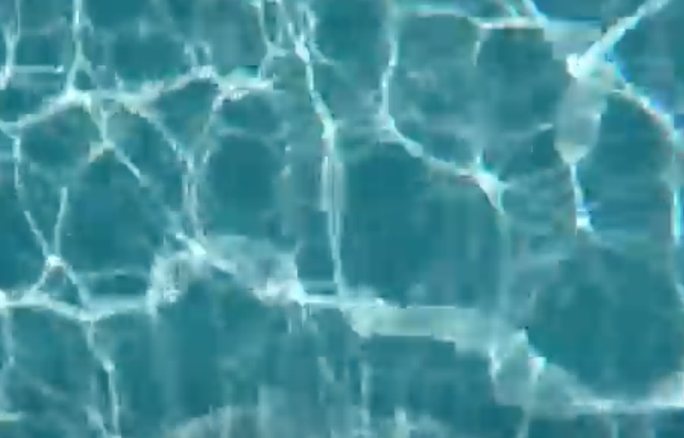

It is what enabled us to see more clearly refraction demonstrated in our homemade ‘wave tank’
shallow
deep

It is this lens effect that we all (including fish, marine mammals) rely on for forming a projected image of the outside world onto the light sensitive pigments in our retina.
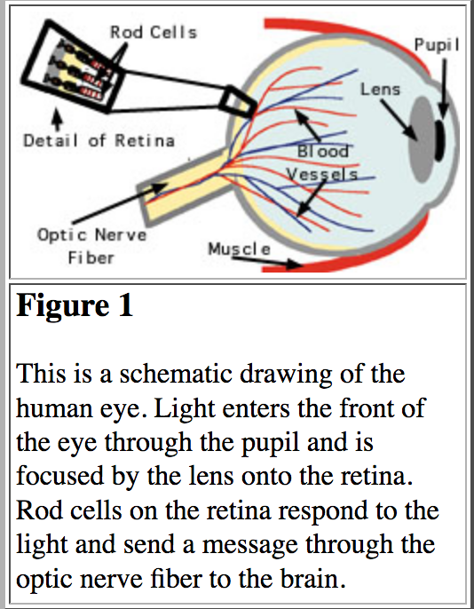
However, unlike ours, a fish eye lens is most like our jar experiment, purely spherical and fixed in shape. So, to change focus it does what we did; it moves its whole lens forward or back!! Also, its lens has a refractive index of 1.65, higher than any other vertebrates. These 2 things mean it can see in the sea much better than us!!

For a more detailed look at this, see: http://www.chemistry.wustl.edu/~edudev/LabTutorials/Vision/Vision.html

