“ “IS THERE AN OCEAN IN THE HOUSE?”
Level | Investigations
Topic | LIGHT
‘OITH bench-top’s | Introduction, The nature of waves. And the wave nature of light.  GTV 3.1  GTV 3.2  GTV 3.3 | Tool, (setup)  manufacturing, testing, modification.  Light sensitive pigments, extraction and use.  GTV 3.4, 3.5 and 3.6 | Tool, Qualitative vs quantitative data, sensitivity.  GTV 3.5 and 3.6  Making a tool that uses light to capture and store image information GTV 3.8 | Doing with the tool. Enquiry. Problem. Proposition.  GTV 3.9  (includes signup for practical kit to support this challenge)
Support material | Overview and  worksheets | Concept, analogy and creativity. Memory, information capture and storage, image and imagination in the Nature of science.  GTV 3.7 | Data handling, wave s and ‘fun with formulae’  GTV 3.1, 3.2, 3.3 | Review and interviews  GTV 3.10

The interaction of photons and electrons lays the functional foundations of the liquid oceanic planet we live on, and life itself!

Memory is essential for us to build understanding and meaning into our lives and into our knowledge of this ocean world.

Image making and visual memory are our dominant tools for making meaning.

In benchtop 4 part 1 we make a photo imaging tool, a memory maker, a camera. (GTV 3.8)

Once you have made your camera we invite you to register with us ( ) to receive a small kit that will enable you to capture, develop, and fix an image as described in benchtop 4 part 2.(GTV 3.9) The challenge is to create an image that represents some idea of the ocean, waves or light, or combination. Imagination in action. Then you send us your best image.

benchtop 4 part 1
making a pinhole camera
- Thick cardboard or cardboard box about shoebox size
- Craft knife, scissors - Black tape - Aluminium can
Drawing pin, pin - Fine sandpaper - Black permanent marker
- Board (to work on) - Ruler, with fine mm markings
- Two-sided Sellotape
- Not essential but useful to get a more accurate measure of pinhole diameter--Magnifying glass, cell phone or iPad camera with zoom.

Procedure:
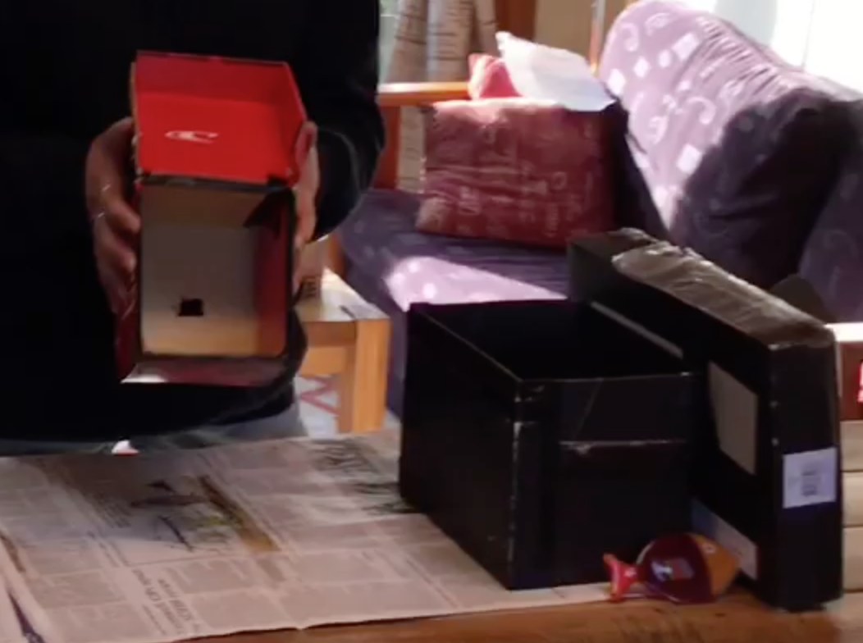
- To produce an approximately ‘normal field of view’ for your photo-image you need to make a light proof box with a lid that fits firmly over one side with the distance from pinhole (front of camera) to photo paper (the lid, back of camera) between 10 and 20 cm (this is the projection distance). A ‘normal field of view’ is roughly what we ‘see’ and to get this on your photo paper at the back of the box, the projection distance (from pinhole to the paper) , the ‘depth’ of the camera, needs to be pinhole diameter divided by 0.03679, squared. (in GTV 3.8 we make 12 cm and 18 cm deep cameras and so an example is (0.4mm/0.03679)² = 118.18mm= approx. 12cm). (However you can customize your camera, see note below)
- The minimum size for the back lid needs to be 9 cm x 13 cm (this is approx. the dimensions of the photo paper in the kit)
- Making the box is just a process of measuring, marking, cutting , folding and taping as shown in GTV 3.8.
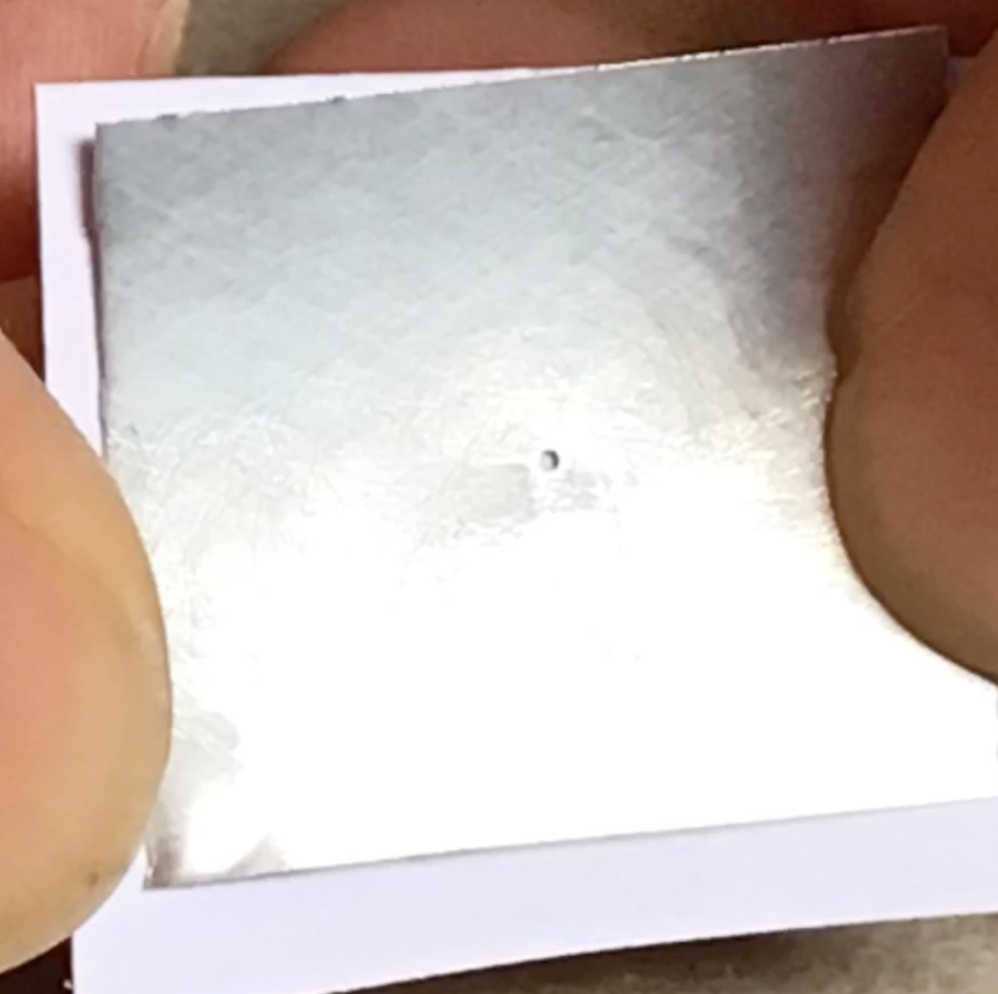
- For the pinhole you need to carefully cut out a piece of thin aluminium from a can about 3 cm x 3 cm push the pin in about halfway along the taper twirling it all the time. it is a good idea to practice making pinholes and having a few bits of aluminium to use so you can select your best one.
- Sand the back of the hole to remove all burrs, any irregularities in the hole will produce poor imaging.
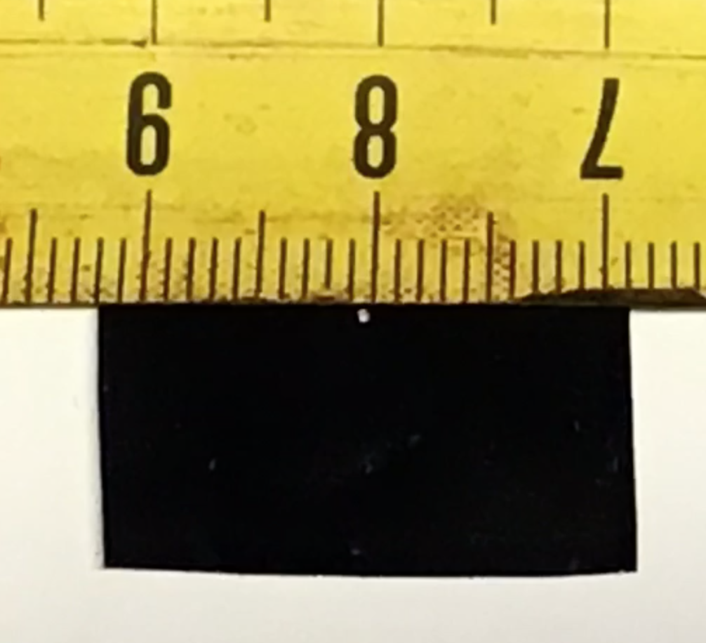
- Check the hole and measure the diameter as accurately as you can (see step 15 below). (magnify it if you can)
- Make the back surface (that will face inside the camera) of the aluminium piece black with the permanent marker.
- For a smaller sized camera box use a smaller diameter (we used an approx. 0.4mm hole for our 12 cm box and an approx. 0.5mm hole for our 18 cm box). (you can customize your camera, see note below)

- Change the size of the pinhole if you need to.
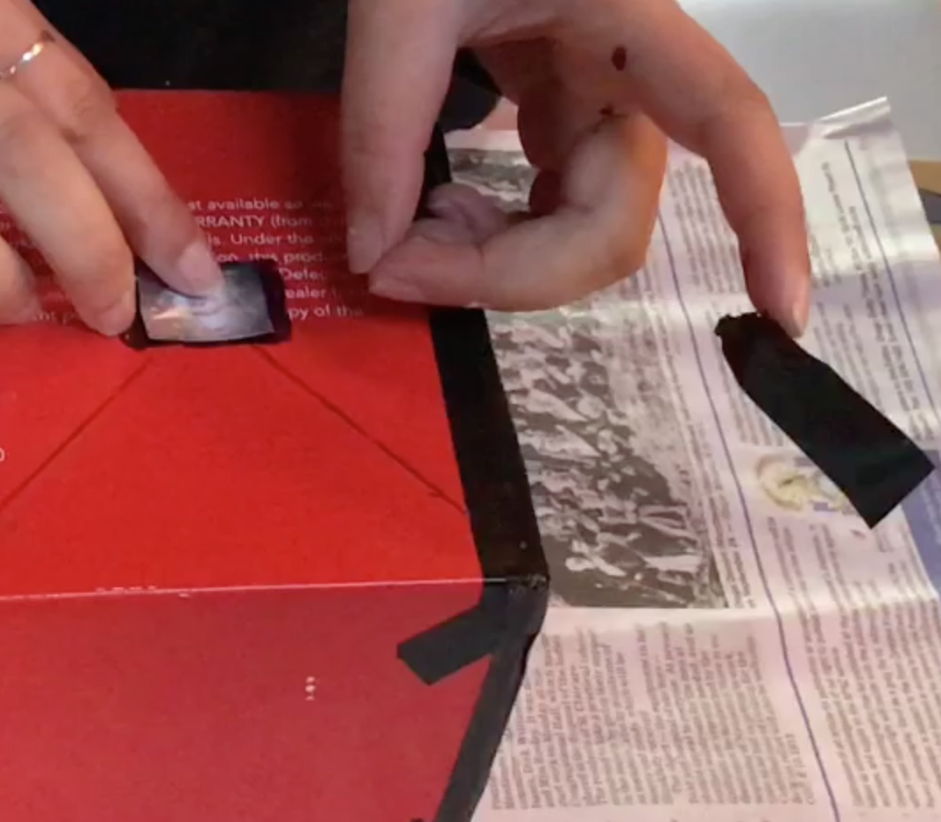
- Mark the centre of the front of the camera box by drawing diagonals and cut a hole less than the size of your pinhole aluminium piece where the diagonals cross.
- Tape the pinhole piece over the hole making sure the hole is in the centre of the front
- Now use the black tape to tape up edges, corners etc that might let light in and use the permanent marker to black out edges and corners on the inside.
- If the inside of the camera box is not black paint it black or line with black paper.
- It is absolutely essential that NO light gets in the box except through the pinhole!!
- Calculate the fstop value of your camera by dividing the distance from pinhole to the back (projection distance) by the pinhole diameter. Write this value on the top of your camera for ready reference. (E.g. for our 12 cm camera with the 0.4mm hole, 120mm/0.4mm =300; so our fstop value is 300. The smaller the fstop value the more light reaching the photo paper in any given time so this is essential for us to know when we work out how long to expose the photo paper for)
- Place double sided tape in corners of an approx. 9 cm x 12 cm space on lid, inside back, of the camera, (you can use a blank piece of paper cut to this size to help placement of these sticky corners, as shown in GTV 3.8).
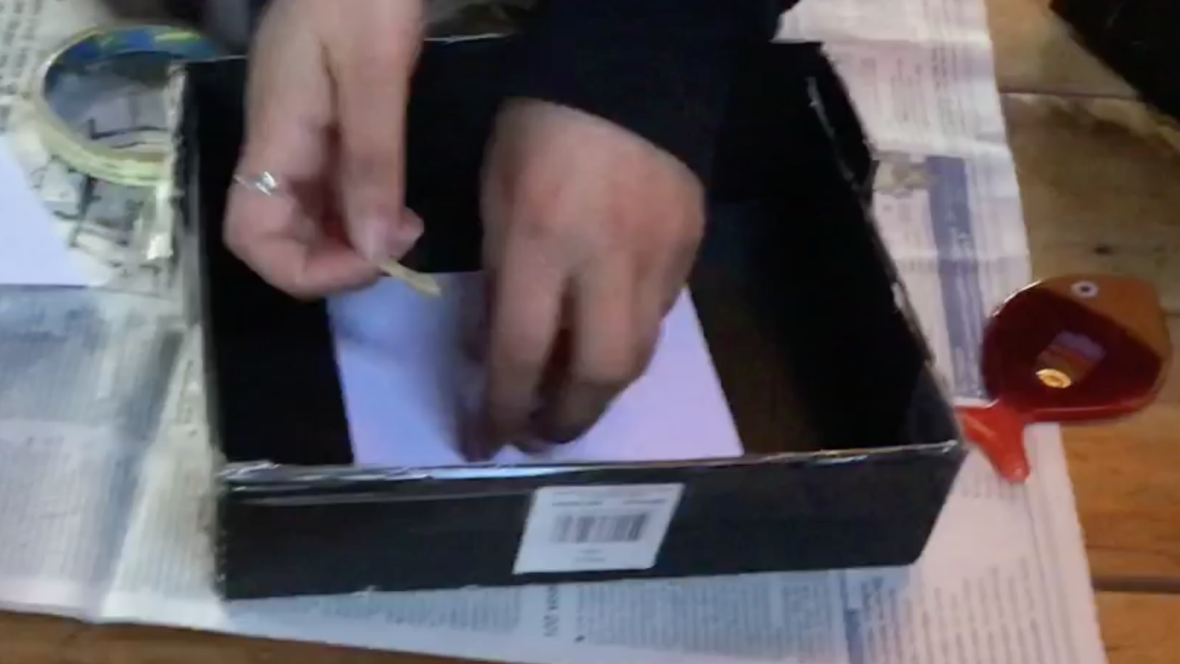

NOTE: A large hole diameter with a short projection distance makes a short depth of field (the distance range from the camera that will be in focus) and needs less exposure time to capture an image.
A small hole diameter with a long projection distance makes a long depth of field and needs longer exposure times.

Benchtop 4 part 2
Preparing a darkroom, preparing developing and fixing solutions, loading photopaper, taking a photo image and processing.

- A small room where you can take over and operate for a few days without upsetting the whanau!!
- Large sheets of cardboard - newspaper -lots of wide black tape
- 4 2Litre ice-cream containers -3-4 litre water (bucket?), or sink and tap in the room
- -a red light or red cellophane or something red to put over a light
- Scissors -Measuring cup or jug
- Teaspoon
- The full NZMSC ‘Light’ kit (see note below) OR - NZMSC photopaper pack and -instant coffee, washing soda (or baking soda), citric acid powder (see worksheet 6), tweezers, protective gloves.
- Some timing device
- An ocean scene or some scene, object, that can be imaginatively connected to the sea
- A stable flat surface (for placement of the camera when taking the photo).

NOTE: Full NZMSC ‘Light’ kit (limited availability, until stocks last):
-tweezers -protective gloves
-2 photo paper packs (ONLY OPEN IN THE DARK!! MUST NOT BE OPENED IN THE LIGHT!!)
1 pack of 3, 9cm x 12cm multiuse negative print photopaper, ISO 6
1 pack of 2, 9cm x 12 cm Harman direct positive photopaper, ISO 3
-2 vials of photo-processing-chemicals (may be opened and prepared in the light)
1 x 12ml photo developer,
1 x 12ml photo fixer

Procedure
- Make your Dark Room by covering all windows and checking for ANY LIGHT and taping up, covering, using cardboard, paper, or anything that works. It should be ABSOLUTELY DARK.
- Prepare a VERY DIM RED light making sure there is absolutely NO WHITE LIGHT SEEPAGE AT ALL!!!
- Prepare a work surface, cover in newspaper. You should be able to only just see it but your eyes will adjust to the low light after a few minutes.

In the normal Light:
- Make up the 4 processing trays by cutting, 2 Litre ice cream containers down to about half their original depth.
- Label and layout in the order -developer, first wash, fixer, second wash
- Make up the developer -If using NZMSC kit photo chemicals -12ml developer in first tray and mix in 108 ml warm (20-25 degrees C) water (a 1 + 9 mix), mix with teaspoon, then rinse teaspoon in fresh water.
- Pour water into second tray about half full.
- Make up the Fixer in the third tray-If using NZMSC kit photo chemicals – 12 ml fixer into the tray and mix in 108 ml warm water, mix with the clean teaspoon, rinse the teaspoon .
- Pour water into the fourth tray about half full.
- If you are making your own homemade developer and fixer (as per GTV 3.9) then follow recipe below then lay out in this same order, developer, wash, fixer, wash.
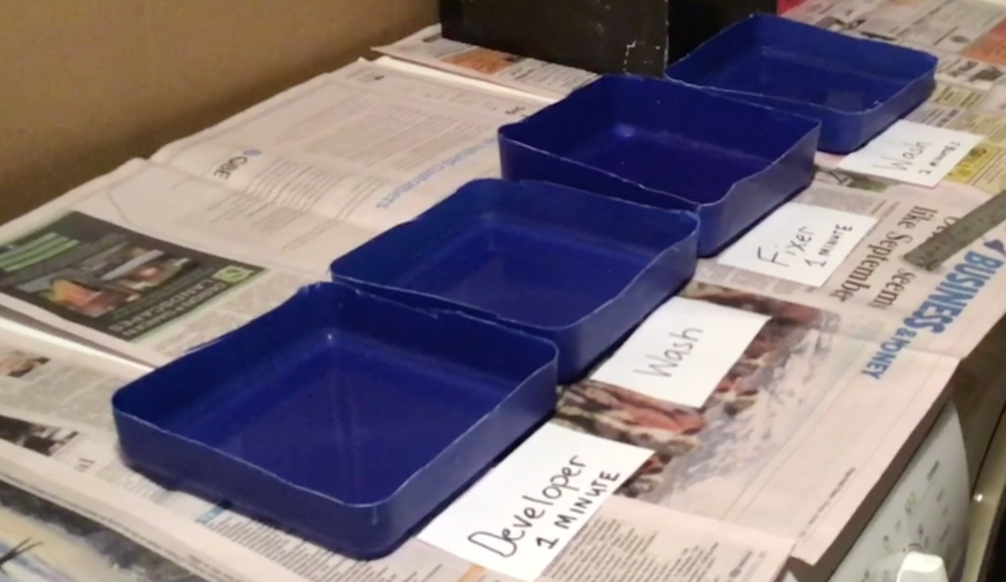

Now you are ready to capture a photo image!
We recommend that you use the 3 negative papers first as these will help you get to know your camera and practice the use of the exposure time calculator before making your final finished images with the direct positive paper. That is – experiment with the negative paper to get a feel of the process before using the fancy final finish paper.

In the dark:
- To load the photo paper in the camera you must operate in the dark with only the very dim red light.
- If you haven’t already done so cut and stick into the back of the camera, opposite the pinhole side, 4 pieces of double sided tape, where the corners of the 9 x 12 paper will need to stick, and remove the protective cover of the tape so it is ready for sticking the photo paper.
- MAKING SURE YOU ARE IN THE DARK carefully open the photopaper pack and remove ONE sheet only , lay the glossy (smooth ) side down, close pack up.
- Stick the photo paper to back of camera making sure the glossy, smooth, side faces out towards where the pinhole will be (this is the side the photo sensitive emulsion is on).
- Close back of camera up and make sure the pinhole is covered with black tape as shown in the videos (GTV3.8 and GTV 3.9)
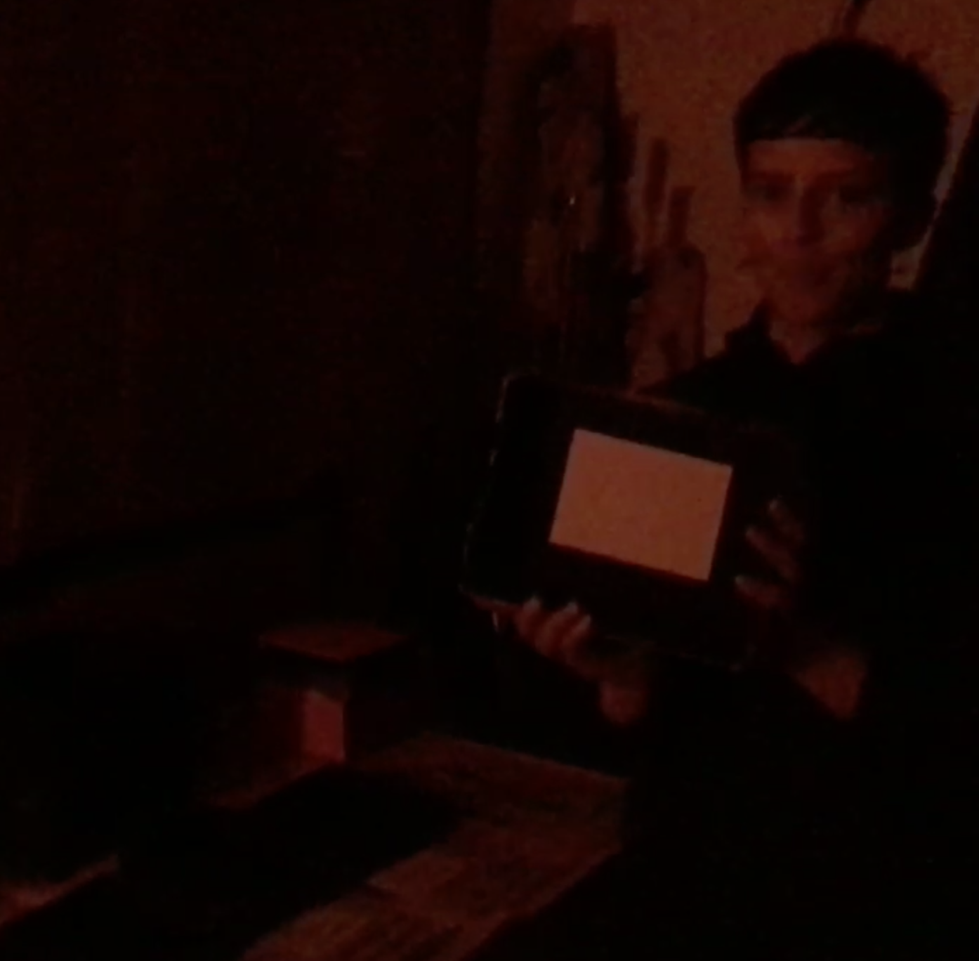
Outside:
- Select object, view to be photo imaged. Perspective, near and far objects, good dark/light tone variations and contrasts will help.
- Have a small table/ chair, solid surface for the camera to rest on so it will be completely still for minutes. A windy day doesn’t work so well.
- Have a watch, or cell-phone timer for accurate timing of exposure
- Using the rough guide table below to estimate as carefully as possible the exposure value for the light conditions.(This is an estimate of light intensity, illuminance)
- Exposure value table

EV | Descriptor of lighting situation
-3 | Rural , open spaces under full moon at Night
-2 | Rural, snowscape under full moon at night
-1 | Lit by dim artificial light
0 | Lit by dim artificial light
1 | Distant view of lighted horizon
2 | Lightening, lunar eclipse
3 | fireworks
4 | Close candle light, bright street lights
5 | Subject lit by campfire, average interior light
6 | Brightly lit home interior
7 | Under rainforest canopy during bright day , very brightly lit night-time streets
8 | Store windows lit at night, large fires, bright florescent lighting
9 | Landscapes 10 minutes after sun has set below the horizon
10 | Landscapes immediately after sun has set below the horizon
11 | Sunsets or sunrises
12 | Open shade or heavy overcast daytime
13 | Weak, light grey, hazy sun, some light grey reflective surfaces,
14 | 15 towards end of day (<2hrs before sunset) or 13 mid-day mid-summer, or mixed/changing light 13-15.
15 | Light cloudy bright light , reflective surfaces in a white day
16 | Bright sun winter, no cloud, reflective surfaces
17 | Bright sun summer –mid day, reflective surfaces
18 | Bright daylight on light coloured sand, snow or water in mid-summer, mid-day

- With the exposure value, the known sensitivity of the photopaper-ISO value (Negative paper =ISO 6, Direct positive paper =ISO 3) , and the calculated fstop for your particular camera (see step 15 in Bench top 4 part 1); use the pinhole exposure calculator table to work out the length of time you need to have the pinhole open for . (GTV 3.9)

Calculator table for pinhole camera shutter open times

ISO for photopaper |  |  | fstop
3 | 6 | 27 | f88 | f128 | f176 | f256 | f300 | f352 | f512 | f704 | f1024
1 | 0 | -2
2 | 1 | -1
3 | 2 | 0 | 512
4 | 3 | 1 | 256 | 512
5 | 4 | 2 | 128 | 256 | 512
6 | 5 | 3 | 64 | 128 | 256 | 512
7 | 6 | 4 | 32 | 64 | 128 | 256
8 | 7 | 5 | 16 | 32 | 64 | 128 | 190 | 256
9 | 8 | 6 | 8 | 16 | 32 | 64 | 96 | 128 | 256
10 | 9 | 7 | 4 | 8 | 16 | 32 | 50 | 64 | 128 | 256
11 | 10 | 8 | 2 | 4 | 8 | 16 | 18 | 32 | 64 | 128 | 256
12 | 11 | 9 | 1min | 2 | 4 | 8 | 10 | 16 | 32 | 64 | 128
13 | 12 | 10 | 30sec | 1min | 2 | 4 | 6 | 8 | 16 | 32 | 64
14 | 13 | 11 | 22 | 50 | 1min 40sec | 3 20 sec | 4 30sec | 6 | 13 | 26 | 50
15 | 14 | 12 | 15sec | 30sec | 1min | 2 min | 3 min | 4 | 8 | 16 | 32
16 | 15 | 13 | 8sec | 15sec | 30sec | 1min | 90 sec | 2 min | 4 | 8 | 16
17 | 16 | 14 | 4sec | 8sec | 15sec | 30sec | 45 sec | 1min | 2 min | 4 | 8
18 | 17 | 15 | 2sec | 4sec | 8sec | 15sec | 22 sec | 30sec | 1min | 2 | 4
 | 18 | 16 | 1sec | 2sec | 4sec | 8sec | 11 sec | 15sec | 30sec | 1min | 2
 |  | 17 |  | 1sec | 2sec | 4sec | 6 sec | 8sec | 15sec | 30sec | 1min
EXAMPLE: For a 0.4mm pinhole in a 12cm deep camera on a clear bright sunny day.

Step 1. Calculate fstop= 120/0.4 =f300
Step 2. bright sunny day in winter with a very light thin high cloud, EV 15
Step 3. Multiuse negative image paper .ISO 6
Step 4. Down ISO 6 column till we reach EV 15, Across till we reach column f256, f300 we estimate to be between this and column f352 so we get a shutter open time of between 1 and 2 minutes so we would try 1and ½ minutes to start with.

- Without any movement in the camera, open the pinhole and start the timer.
- When timing is complete , and without bumping or moving the camera in any way, cover the pinhole again.
- You are now ready to take the camera back to the darkroom and process the photo image.

Back in the dark room:
- Making sure that all light is blocked out , turn on the very dim red light.
- Put on pair of protective gloves.
- Carefully open back of camera and with tweezers or clean fingers take out the photo paper, keeping the exposed surface, glossy smooth, up.
- Place in tray 1 , the developer, and gently agitate , If the developer is at about 20 degrees C then within 1 minute you should see a negative image appear. The developer will take a lot longer if it is cool.
- When you judge the dark and grey tones have been sufficiently developed (usually between 1 and 2 minutes), take out and place in wash one and gently agitate for a minute, if there is a tap and sink handy wash under the running tap for about a minute
- Take out and place in tray 3 , the fixer, agitate gently for 1 minute. Leave in the fixer. If the solution is cool time will be longer. After 3 or 4 minutes the image should be fixed.
- Take it out and put into tray 4, the second wash, and agitate gently for 1 minute. If there is a tap and sink handy wash under the running tap for about a minute, then leave in the wash tray under the tap for a few minutes.
- You can now turn the full white light on and look at the photo image you have captured!
- If you used the negative paper the light areas will be dark and the dark areas light.
(And the way the camera works, like your eye, means the image projected on the photo paper (and on your retina) is upside down and back to front!)
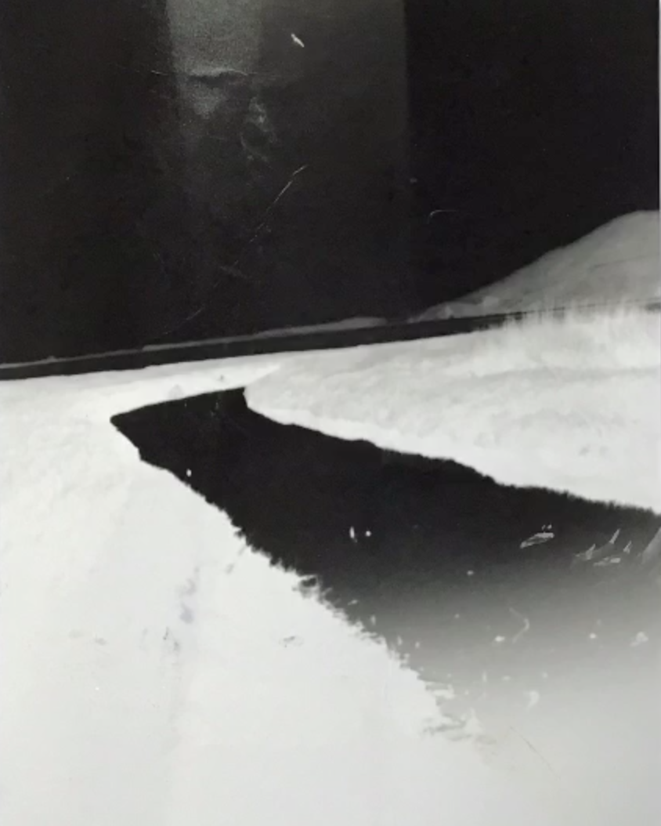
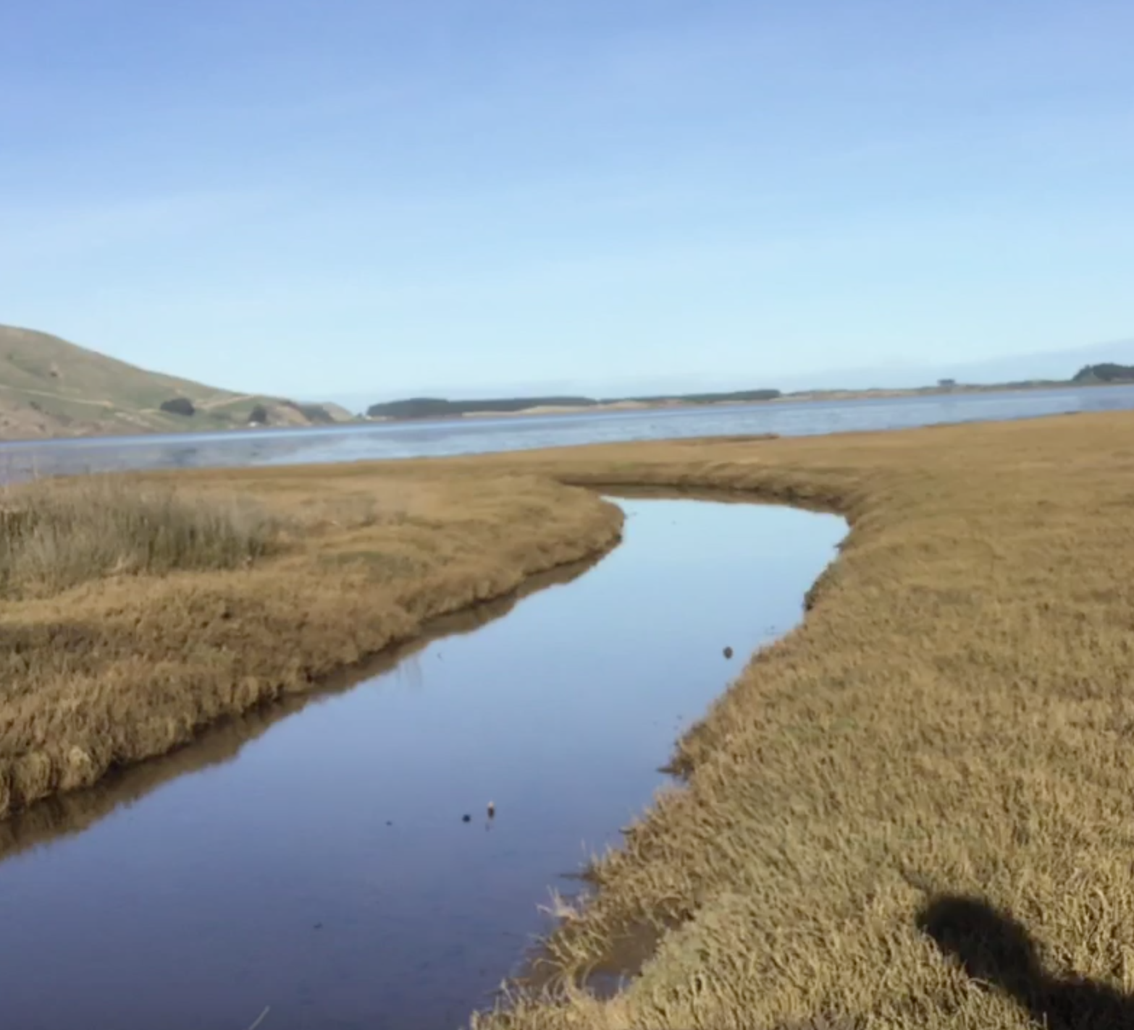

34. you would be very lucky, and skilled to get it right on the first go, if you did-congratulations!
If not -use these checks to solve some of the more common issues.

Note that these are in relation to a negative photo paper image.

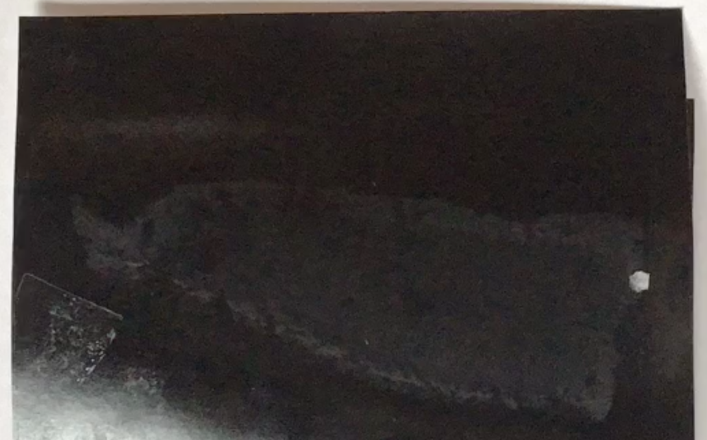
Is it all black? – this means the paper was fully exposed in loading into the camera and/or taking it out –the darkroom isn’t light proof, or you had a sneaky light on in the dark room –your cellphone?? OR too much light got in the camera. The lid might not be fitting tight and you will need to tape up the lid, camera box joins in the dark each time you load a photo paper.

Is it an image but quite dark? – this means it was probably overexposed and needs a shorter exposure time, Check your assessment of the exposure value, ISO and fstop

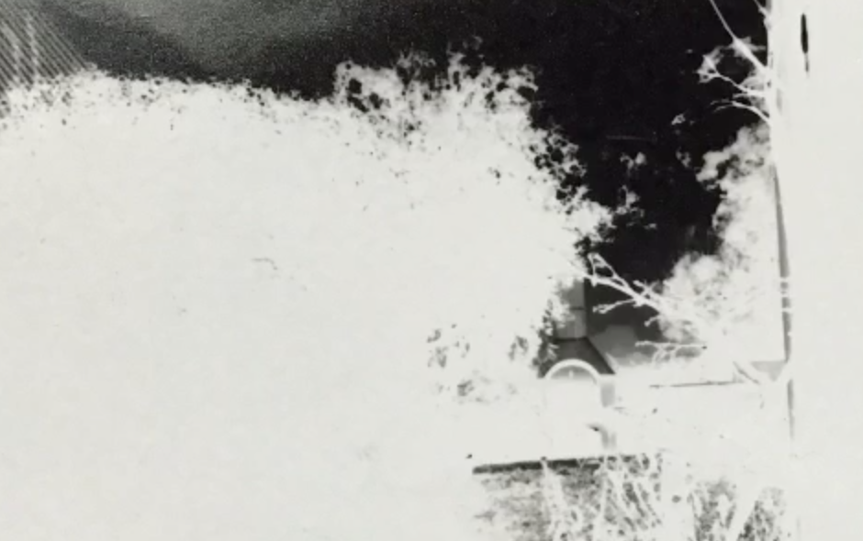
Is it a very faint image nearly all white or very washed out looking? -then it is probably underexposed and needed a longer exposure time. Check your assessment of the exposure value, ISO and fstop

Is it streaky light and dark?
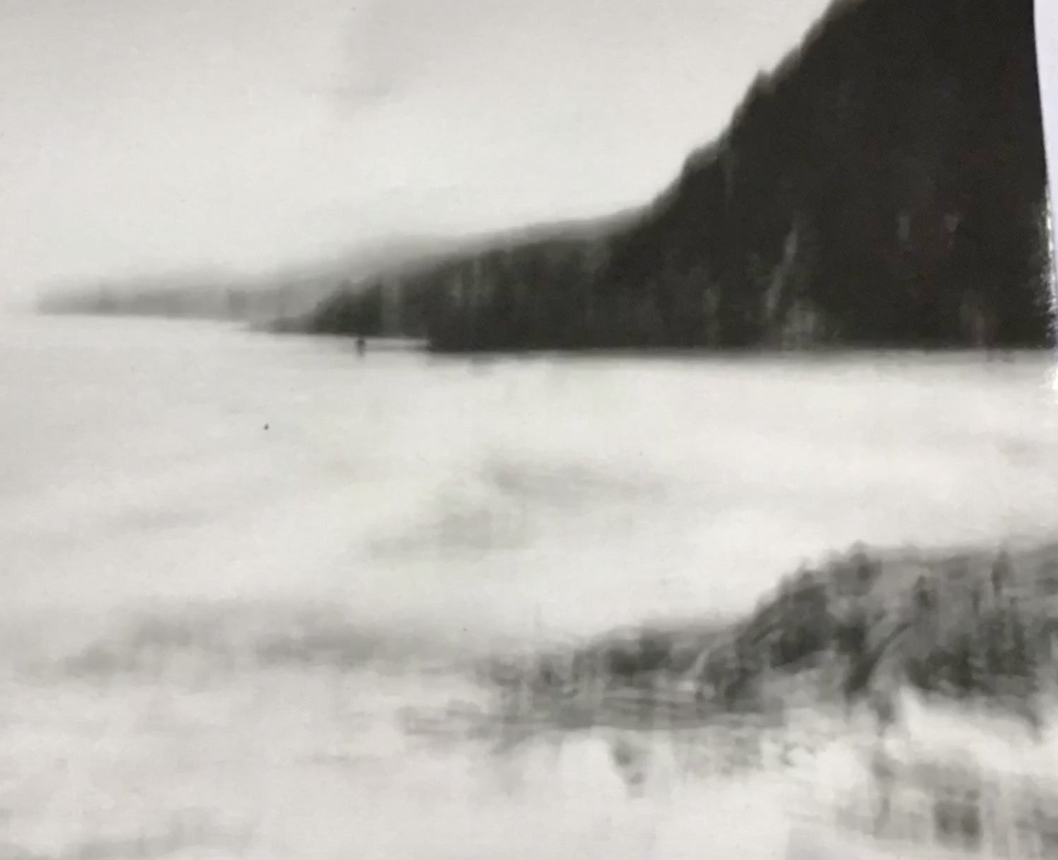
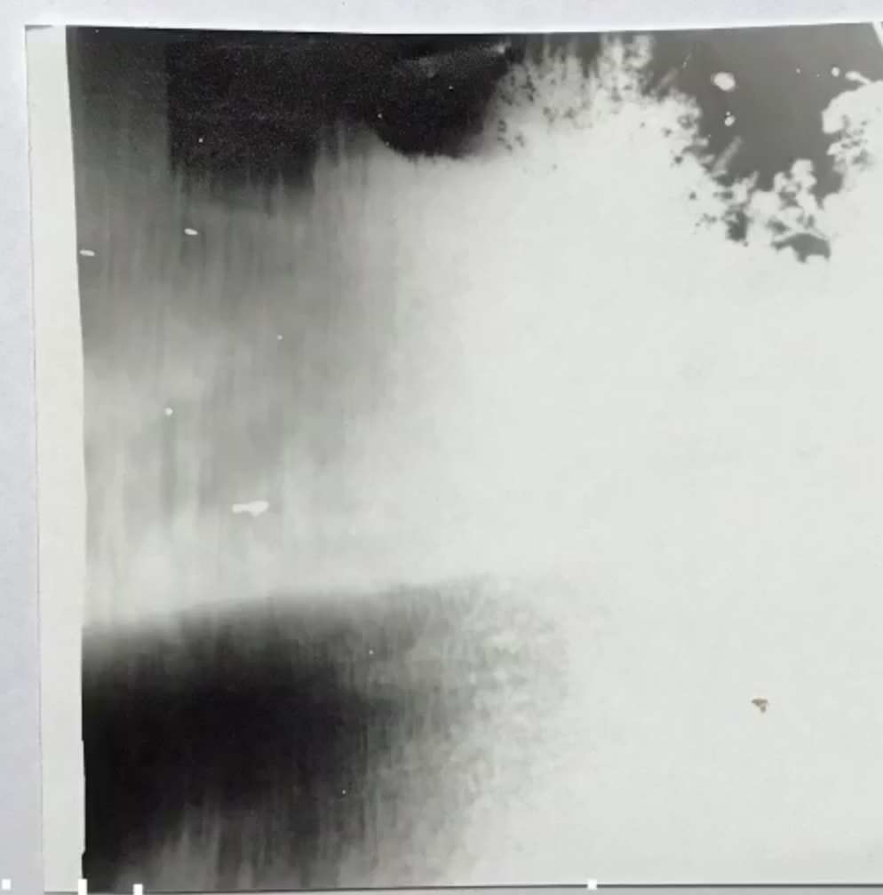
This could mean there is some light leakage into the camera. Tape up outside edges, corners, scratches etc. with black tape.

Is it well developed but a fuzzy image?
This could be that the camera moved during exposure time or the pinhole is rough edged, has a bit of dirt around it.

Does it have a dark foreground and washed out back ground (or vice versa)? This is probably a result of cloud shading the background and dark cloud shade on surfaces in the distance (or visa versa) so calculated exposure time was too short for lower exposure value of background and too long for higher exposure value of foreground (or vice versa!!). Avoid a time period when you think the cloud will come over the sun or light intensity will change significantly in some part of the image area.

When you think you have solved the issue, try another image.

Once you have done 3 negatives you should have solved most common problems.
But there will always be a lot more to learn!!

Now you are ready to plan and create your final positive image representative of some ocean/light/wave idea.
BUT remember in calculating exposure time the direct positive paper is ISO 3 so use that column on the calculator to work out exposure time (which will be longer than for the ISO 6 paper).

Select your best image, give it an imaginative title, photo graph it with your phone and send to us at ..

Image: “sea log”
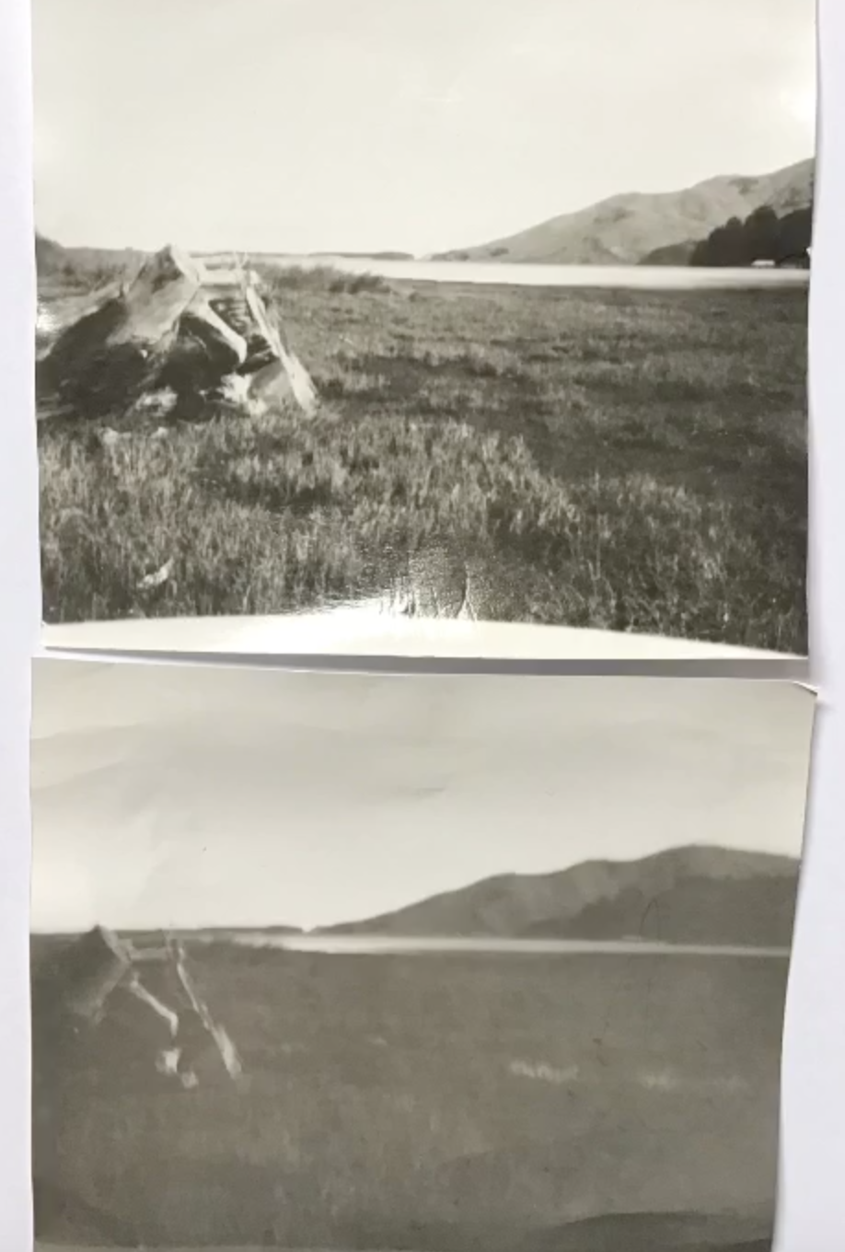
Camera: pinhole=0.5mm
Projection distance=18cm
f360

Paper: Harman direct positive ISO 3

Exposure value: 16

Top image
Exposure time 2 minutes

Commercial developer and fixer

Bottom image
Exposure time 1 minute

Image: “storm at sea”
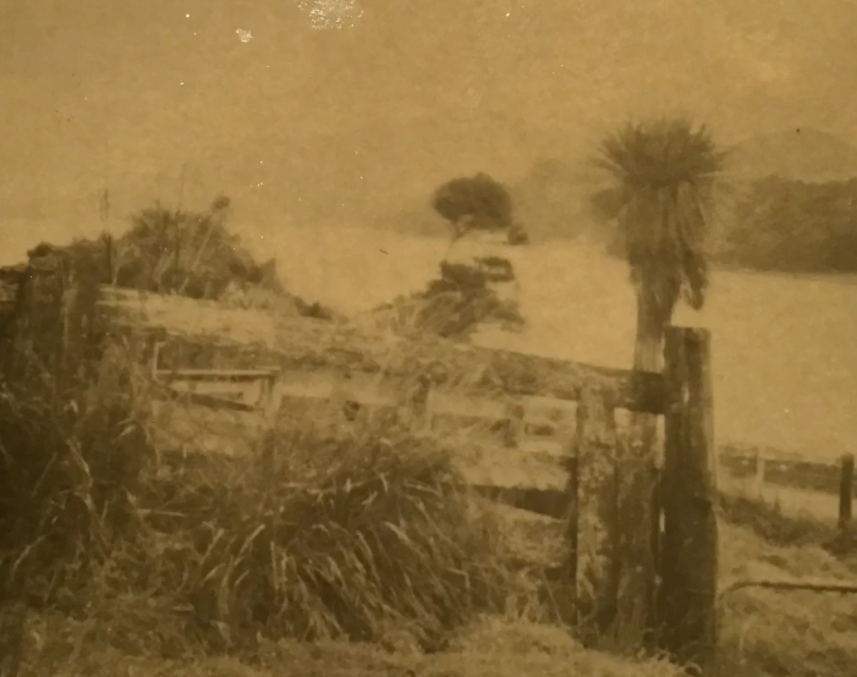
Camera: pinhole=0.5mm
Projection distance=18cm
f360

Paper: Harman direct positive ISO3

Exposure value: 14

Exposure time 6 and half minutes

Homemade caffenol developer and homemade saline fixer. (see worksheet 6)

