Maurice Wilkins Centre for Molecular Biodiscovery

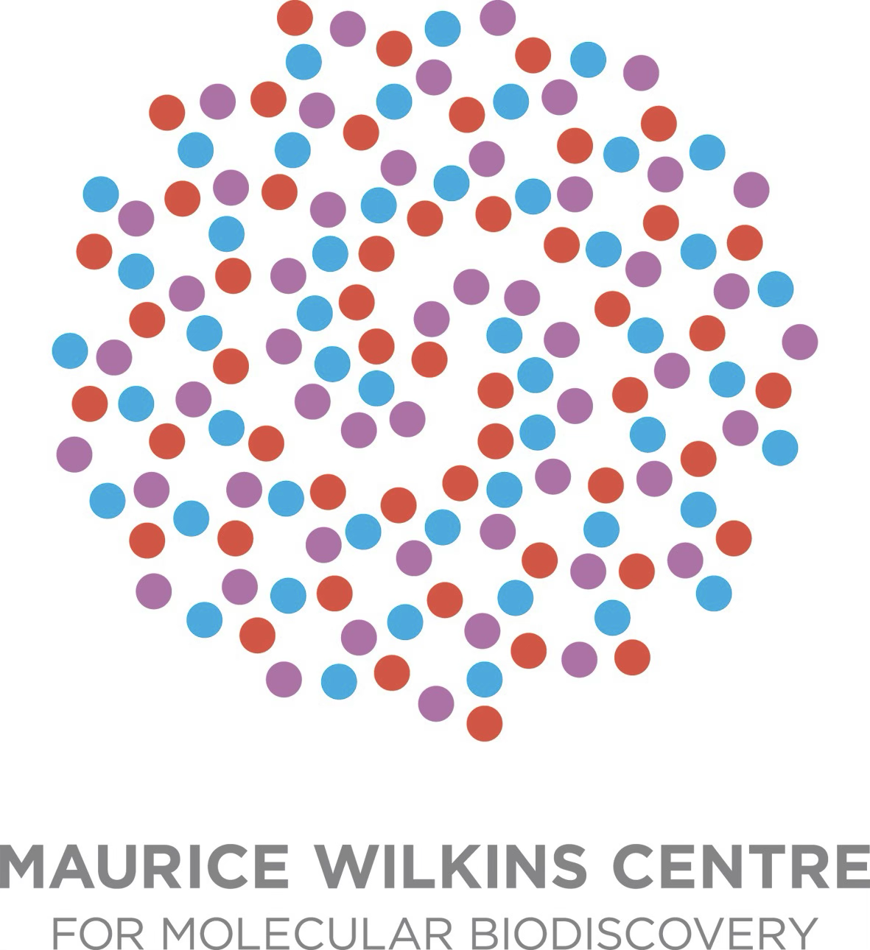

Call for applications for

High-Impact Projects in Infectious Diseases

Closing date November 12th, 2026

- Purpose of the call
The Maurice Wilkins Centre (MWC) Infectious Disease Theme invites applications for research projects that address priority challenges in infectious diseases across Aotearoa New Zealand. This call aims to support innovative, collaborative research that strengthens the translation of discovery science into meaningful health outcomes.
Proposals should demonstrate clear potential to address important infectious disease challenges and generate impact through areas such as clinical translation, commercialisation, community health, diagnostic innovation, or improved understanding of infectious diseases. Relevant projects may include clinically focused studies that improve the prevention, treatment, or management of infectious diseases; community-engaged research that addresses health inequities; or the development and evaluation of novel diagnostic tools, technologies, or platforms that enhance detection, surveillance, or timely treatment.
Projects must be feasible within a 1.5 year timeframe and demonstrate a clear pathway to meaningful outcomes within this period, consistent with the lifetime of the current MWC funding. Priority will be given to proposals that show strong potential to deliver tangible impact, such as clinical translation, improving community health outcomes, developing diagnostic capabilities, or generating data that positions the team for larger external collaborative grants or translational opportunities.
- Eligibility
Applications must be led by a researcher affiliated with the Maurice Wilkins Centre. Collaborative proposals involving MWC investigators from multiple institutions and disciplines are strongly encouraged. Early career researchers are encouraged to participate as lead investigators or key collaborators.

- Funding details
A total of $600,000 is available to support projects through the theme for a maximum of 1.5 years, starting no earlier than the 1/1/27 and finishing no later than the 30/9/28. Funding may be allocated to two or more projects, depending on the scope and quality of applications received.
Funding may be used to support research personnel, consumables, and other project-related costs, as appropriate to the proposed research.

- Assessment Criteria
Applications will be assessed based on the following criteria:
- Alignment with the Infectious Diseases Theme call priorities, including relevance to clinical translation, community impact, or diagnostic innovation.
- Scientific merit and innovation of the proposed research.
- Strength of collaboration, particularly projects that bring together complementary expertise across the MWC network.
- Feasibility and likelihood of achieving outcomes within 1.5 years.
- Potential to catalyse future research, including external grant funding, new research directions, or translational and implementation opportunities.
- Alignment to the MWC Māori and Pacific Strategies (see section 8).

- Application Requirements
Applications should be completed using the template form provided.

- Timeline
The anticipated timeline for the call is as follows:
- Call opens: 15th October 2026
- Submission deadline: 12th November 2026
- Review of projects: Mid-November
- Notification of outcomes: Early December
Applicants may be asked to provide additional information if required.

- Review Process
Expressions of Interest will be reviewed by representatives of the Infectious Diseases Theme leadership within the Maurice Wilkins Centre alongside the Kaiārahi and Pacific coordinator or their nominee(s).
Applications will be assessed against the criteria outlined above, with particular attention to alignment with theme priorities, the strength of collaboration across the MWC network, and the potential for meaningful outcomes within the eighteen month funding period.
Where necessary, external expertise may be sought to support the review process.

- MWC Māori Engagement Strategy and MWC Pacific Strategy
A major area of focus for MWC is improved long-term health for Māori and Pacific communities. The Centre has a Māori Engagement Strategy and Pacific Strategy to guide both the Centre and its investigators in supporting Māori and Pacific aspirations and advancing the impacts of health research within Māori and Pacific communities.
The full Māori Engagement Strategy document can be accessed (after member sign in) at https://www.mauricewilkinscentre.org/welcome/mwc-m%C4%81ori-engagement-strategy/
The public version of the MWC Pacific Strategy can be accessed at https://www.mauricewilkinscentre.org/sub-pages/pacific-health/mwc-pacific-strategy/

- Contact Information
For further information about the call or the application process, please contact:
Joanna Hicks (Theme Coordinator) joanna.hicks@waikato.ac.nz
or Shaun Lott (Deputy Director) s.lott@auckland.ac.nz

