Report on Tobacco Taxation
in New Zealand

Volume I Main Report

(A separate Volume II contains Appendices with some of the detailed work underlying this report.)

November 2007

One of two associated reports
commissioned by

The Smokefree Coalition and ASH New Zealand

The other report is

‘Dedicated tobacco taxes - experiences and arguments’
written by George Thomson

Report Authors and Contributors

Principal Authors:

Mr Des O’Dea¹ Overall responsibility for contents of report
Health Economist des.odea@otago.ac.nz

Dr George Thomson¹ Principal responsibility for sections and recommendations on a ‘Dedicated Tobacco Tax’.
Research Fellow george.thomson@otago.ac.nz

Contributors:

Dr Richard Edwards¹ Associate Professor, Epidemiology
Dr Heather Gifford Manager, Whakauae Research Services,
PO Box 102, Whanganui

- Employed at Department of Public Health, Wellington School of Medicine and Health Sciences, University of Otago. PO Box 7343, Wellington.

Note: Although most of the contributors are employed at the Wellington School of Medicine, the work on this report has been carried out independently of that institution. The Wellington School of Medicine bears no responsibility for any errors or omissions in this report.

Acknowledgements:

The authors express their gratitude to the sponsors of this work for their support, both financial and advisory:-
Mark Peck, Director of The Smokefree Coalition, and Dr Ben Youdan, Director of ASH New Zealand.

They also express their gratitude to those who reviewed and commented on the reports, or parts of them. Many of their suggestions have been incorporated. They bear of course no responsibility for any remaining errors or omissions.

Report on Tobacco Taxation
in New Zealand

Executive Summary

Purpose:

This report, commissioned by the Smokefree Coalition and ASH New Zealand, has the objectives of :-

- Assessing the use of tobacco taxation as a policy tool for improving the health of New Zealanders based on current and past tobacco taxation experience in New Zealand, with some reference to overseas studies.

- Making policy recommendations on tobacco taxation in New Zealand.

Both the information on tobacco taxation and the policy recommendations are summarised below, in order of the main sections of the report. The detailed policy recommendations are also brought together in Section G at the end of this report.

Some of the material requested by the clients, that on a ‘Dedicated Tobacco Tax’, has been split off into a separate report Dedicated tobacco taxes - experiences and arguments, written by George Thomson. However, for ease of cross-reference, the conclusions and recommendations in that report are also included in this report.

Also to reduce bulk, much of the more detailed analytical work has been relegated to the Appendices, in Volume 2.

Section A: The effects in New Zealand of tobacco tax rises.

Information collated:

- Current tobacco excise revenues amount to approximately $1 billion per year, and have been at that level for some years. This is just under 2 percent of total tax revenues.
- Of the approximate $1.6 billion per year retail spending on tobacco products, approximately 70 percent is accounted for by taxation, including GST as well as tobacco excises.
- Thus the average amount spent by New Zealand’s 750,000 smokers is approximately $2,135 each per year, of which approximately $1,500 is tax revenue.
- Rates of smoking prevalence, and of consumption of cigarettes per head, have dropped substantially in New Zealand in recent decades.
- The smoking prevalence rate was in 2005 23.5 percent of the population aged 15 and over, down from 33 percent in 1983, and 28 percent in 1990.
- Annual consumption was just over 1,000 cigarettes per adult (smoking and non-smoking) in 2005, including both factory-made and roll-your-own cigarettes. This compares with annual per adult consumption of about 3,200 in 1975, and 1,900 in 1990.
- There have been similar trends in other countries. Cigarette prices in New Zealand, in a 2002 survey, appear to have been higher relative to income than in other English-speaking countries, with the exception of the United Kingdom.
- The fall in New Zealand’s per capita consumption has been associated with a very substantial three-fold increase from 1985 to 2005 in the price of cigarettes relative to consumer prices in general. These price increases have to a considerable extent been driven by tax increases. However, other factors than price – such as changes in social attitudes to smoking, smokefree legislation, etc. – have also contributed to the falls in consumption and prevalence.
- The tobacco excise rate is currently adjusted on 1 December of each year for the change in general consumer prices over the previous 12 months.
- There were substantial increases in tobacco excise rates in the mid- and late 1980s, and in 1991, 1998, and 2000. There has been no real increase, however, above the annual CPI adjustment, in the last seven years.
- Econometric analyses of the New Zealand time-series data suggest a price elasticity of demand for cigarettes of about –0.50; and a price elasticity of smoking prevalence of about –0.20. These values are used subsequently in the report (Section F) to calculate the impact of tax-caused price increases. They are consistent with results found in the overseas literature.

Policy Issues and Recommendations based on Section A:

A1. Substantial ‘health gains’ can be made from the reductions in smoking prevalence which are the expected result of increases in tobacco taxation. High tobacco tax rates are a valuable tool for deterring smoking uptake and promoting smoking cessation. Therefore an explicit, planned, long term strategy of tobacco tax increases should be adopted as a key component of the tobacco control strategy in New Zealand.

A2. Tobacco taxes should be presented and justified as a public health measure, and levied in such a way as to maximise the public health benefit.

A.3. There should be substantial tax rises timetabled for at least every two or three years, but preferably annually, from 2008.

A.4. Such increases should be either of the order of ten percent annually or of the order of twenty to thirty percent every two to three years, with a provisional target of doubling the real cost of tobacco (in terms of affordability) within ten years. The objective of these increases is to contribute to the reduction of smoking prevalence to less than 10 percent within ten years.

A.5. Such tax increases are similar in size to those implemented in the 1980s and 1990s, but not seen since the year 2000.

A.6. Increases in tax rates are not the only instrument for tobacco control, and taxation should be used in a coordinated manner with other aids to smoking cessation, with particular targeting to high smoking prevalence groups such as Māori and Pacific peoples. The ‘dedicated’ tax fund proposed in the associated Thomson report would assist such coordination.

A.7. The proposed increases should be in addition to the present annual indexation of tobacco tax rates.

A.8. This indexation should in future, however, be based on annual increases in average incomes, Average Weekly Earnings (AWE) being the preferred benchmark, rather than on annual increases in consumer prices, as at present (it is anticipated this would increase prices by about an annual 1 percent extra above inflation).

A.9. The annual indexation date of 1 December is not the best date, being too near the summer holiday period, and indexation and other tax increases would be better switched to another date, such as 1 March, allowing better coordination with other tobacco control measures intended to support the effects of tax increases.

A.10. Indexation on the suggested new basis should begin from the next suitable indexation date.

A.11. Changes in the relativity of tax rates on factory-made and roll-your-own cigarettes should be urgently considered, to ensure that smokers are not continuing to smoke rather than quitting, because of the availability of cheaper hand-rolled cigarettes.

Section B: The Costs of Smoking in New Zealand.

- Updated estimates of Smoking costs have been calculated for New Zealand, drawing on earlier work by Easton for New Zealand, and the Collins and Lapsley work for Australia.
- The tangible costs of smoking to New Zealand in 2005 were of the order of NZ$1.7 billion, or about 1.1 percent of GDP. Major components are lost production due to premature mortality, lost production due to smoking-caused morbidity, and smoking-caused health-care costs.
- The intangible costs in 2005 were of the order of 62,800 life-years lost to smoking-induced premature mortality, and 19,000 Quality-adjusted Life-years lost to smoking caused morbidity.

Section C: Economic and social costs and benefits from a tobacco tax rise.

- It cannot be simply assumed from Section B that a tax-caused reduction of one-tenth in smoking prevalence would quite quickly also reduce the costs stated there by one-tenth. It would take decades for the full consequences to be apparent.
- Modelling work overseas does indicate, however, the likely benefits from a tobacco tax rise.
- One recent Californian study, assuming a 20 percent tax increase, gave results which, scaled down to a NZ population equivalent result, in an estimated QALY gain of 942 QALYs in the first year, and 5,850 QALYs per year by year 75.
- Applying even a relatively conservative value per QALY of NZ$50,000 to these numbers gives ‘monetary’ gains of NZ$47 million in the first year, and NZ$293 million per year, by year 75. In addition there would be a gradual reduction in the tangible costs estimated in Section B.

Sections D and E: A dedicated Tobacco Tax Fund

The full arguments are spelt out in the separate report by George Thomson. A brief summary is given here.
- Tobacco control measures in New Zealand are currently under-funded.
- Dedication of an appropriate share of tobacco tax revenue to tobacco control would address this problem.
- It would also help address the ethical and equity issues of using a lethal, addictive substance to raise general government revenue.
- It is evident from overseas studies that such dedication of a proportion of tax revenues, to be used to assist cessation and deter initiation of smoking, increases popular support for tobacco tax increases, including support among smokers.
- The recommended initial amount of dedicated tax revenue is $100 million, (compared to current spending on these activities of about $40 million), targeted to increase to at least $200 million within five years.
- This is in the context of proposed overall Tobacco Strategy targets of reducing smoking prevalence (including that by Māori and Pacific) to less than one percent within 20 years, and less than 10 percent for all groups within ten years.
- The dedicated funds should be subject to evaluation of effectiveness of their use, should be used to reduce tobacco-related inequalities, and should involve the devolution of power and resources to Māori and other disadvantaged groups.

Section F: Distribution of health gains, and financial burdens, resulting from tobacco tax increases, and equity and Treaty of Waitangi implications.

- The principal problem with tobacco taxation is that it bears heavily on those who do not succeed in quitting, more particularly on low-income households and individuals, quite a high proportion of whom are Māori or Pacific. Māori smoking prevalence rates are of the order of double those for the general population.
- A ‘non-quitter’ would on average pay an extra $280 a year for the ‘example’ price increase of 20 percent in Table F.9 below.
- At the same time the ‘health gains’ and ‘financial gains’ for those who are spurred to ‘quit’ by tax increases are substantial. This is apparent, for example, in the gains tabulated in the table. Thus the average person quitting will save of the order of $2,200 per year, and receive health gains on average of 2 QALYs, probably more.
- An effective tobacco-control policy should therefore continue to have as one of its main components the use of high and increasing tobacco tax rates.
- Tobacco taxation policies should be integrated where possible with overall government policies to reduce social and economic inequalities and to ensure the fulfillment of Treaty of Waitangi obligations.
- The regressive impact of tobacco tax increases on low-income households and on Māori and Pacific peoples should be ameliorated by allocation of a substantial proportion of tobacco control resources to assist smoking cessation by these populations.
- Tobacco control resources targeted at Māori and Pacific peoples should be in general used for intervention programmes designed and administered by Māori and Pacific peoples.

Conclusions

To quote an earlier report (Thomson et al 2000. Page 39)

“Tobacco taxes are a broad impact intervention. They benefit smokers who quit, reduce the consumption of tobacco and make quitting attempts move up the personal agenda of smokers who continue to smoke. They benefit non-smokers exposed to second-hand smoke, and young people who are less likely to smoke.”

All these benefits still hold. Tobacco tax increases burden those ‘tobacco-purchasing’ households who do not succeed in ‘quitting’, more particularly low-income households, quite a high proportion of whose members are Māori. Against this, those households, and individuals, who do ‘quit’ in response to a tobacco tax increase make useful financial savings in addition to the ‘health gains’ received by the ‘quitting’ individuals.

An effective tobacco-control policy should continue to have as one of its main components the use of high and increasing tobacco tax rates. The ethical and equity impacts of such a policy need to be addressed. We believe, as discussed in the accompanying report that this can be done by dedicating a substantial proportion of tobacco tax revenues to assisting smokers to quit and to preventing others from taking up smoking, particularly the young. These measures should put considerable emphasis on assisting those populations with a high prevalence of smoking, namely those on lower incomes, and Māori and Pacific populations.

Copied here from Section F of this report.

Table F.9 Gains and Losses on average for Individuals.

Tax-caused price increase of 20%.

2003/04 data. Assumed Prevalence Elasticity of –0.20
Category Number Health Gains Financial Gains/Losses
affected per year. $(2003/04) (in post-tax prices)

Pre-increase smokers of all ethnicities:
- Non-quitters 725,000 None. Loss $280 / person

- Quitters 30,200 2 QALYs per Gain $2,200 /person
person quitting
-------- permanently.
755,200

Pre-increase Māori smokers:

- Non-quitters 187,000 None. Loss $280 / person

- Quitters 7,800 2 QALYs per Gain $2,200 /person
person quitting
-------- permanently.
194,800

Financial impacts per year summed for ‘Quitters’ and ‘Non-Quitters’ :

All ethnicities: Quitters +$66.4 mn. Non-Quitters - $203 mn.

Māori: Quitters +$17.2 mn Non-Quitters -$52.4 mn

Plus value of lifetime ‘health gains’
If valued at a conservative $50,000 per QALY

All ethnicities: 60,400 QALYs of total value + $3,020.0 mn.

Māori: 15,600 QALYs of total value + $ 780.0 mn

Sources: Statistics NZ resident population estimates.
Nielsen survey smoking prevalences by ethnicity.
Expenditure estimates based on Laugesen 2005.

Report on Tobacco Taxation
in New Zealand

Table of Contents
Page

Executive Summary 3

Background and Structure of Report 18

A: The effects in New Zealand of tobacco tax rises 20

A.1 Background Statistical Information. Tax rates, revenues, prices, consumption and prevalence, and income trends. 21
Mechanism of collection

Data on revenues, tax rates, tobacco and cigarette prices
Trends in tobacco consumption, and smoking prevalence
Income trends
Selected other countries – Consumption, Prevalence, and Cost of Smoking

A.2 The purposes of a tax specifically on tobacco 32

A.3: The concept of the ‘Price elasticity of demand’ and other elasticities 33

A.4: Estimation of the ‘Price elasticity of demand for tobacco products’. New Zealand and elsewhere 36

A.5. The expected consequences of a tax rise? 43

A.6: The best way of applying Tobacco Tax increases and adjustments 44

Frequency of indexation
Date of indexation?

The indexation benchmark? Prices or incomes?
Equalising tax rates on different tobacco products
Size and frequency of tobacco taxation increases beyond indexation
What other complementary measures are needed to make tobacco tax most effective?

A.7: Recommendations 50

Table of Contents (contd.)
Page

B: The costs and benefits of smoking to various parties? 51

B.1 Methodological Framework 51

B.2 Identifying the Costs of Smoking 53
B.3 The estimated costs of smoking in New Zealand in 2005 54

B.4 Cross-checking with New South Wales estimates 55
B.5 ‘Benefits’ and Transfers 55

B.6 Where do the costs fall? 56
B.7 Evidence from other jurisdictions 57

B.8 Summary and Conclusions. 60

C: Economic and social benefits and costs from a tobacco tax rise? 61

C.1 Introduction 61

C.2 ‘Cost-effectiveness’ Results from Selected Studies 62

C.3 How far can tax increases be taken? 65

D/E: Dedicated tobacco taxes - experiences and arguments 66

F: Distribution of health gains, and financial burdens, resulting from tobacco tax increases, and equity and Treaty of Waitangi implications. 68

Introduction, and Structure 69

F.1 Smoking Prevalence among Māori, and lower-income households 70

F.2 Health Inequalities caused by tobacco – by Ethnicity and Socio-economic Status (SES) 72

F.3 The potential health gains from a tobacco tax increase. 76

F.4 The magnitude of the financial burdens of tobacco tax increases, and where they fall. 83

F.5 Policy Trade-offs. 87

F.6 Conclusions and Recommendations 91

G : Summary of Recommendations on Tobacco Taxation Policy 92

References 97

Chronology of Tobacco Taxation Changes and Related Events 103

Appendices: (Separate Volume II)

A: The Purposes of a Tax specifically on Tobacco

B: Estimation of New Zealand Tobacco Elasticities

C: The Health Costs and Economic Costs of Smoking
to New Zealand

D: Analyses of Household Economic Survey (HES) tabulations on purchases of tobacco products. 2000/01 and 2003/04.

E: Under-reporting of Spending on Tobacco Products
in Household Economic Survey (HES)

F: Supplementary Source Tables and Charts

Tables and Charts
Page

Table A.1 Tobacco Tax Revenue, including Customs Duty.
1994/1995 to 2005/06. Excluding GST. 22
Chart A.1 Real Tobacco Tax Revenues. 1994/95 to 2005/06.
June 2006 prices, excluding GST. 23
Chart A.2 Real Tobacco Tax Revenues Per Smoker.
1994/95 to 2004/05. June 2006 prices, excluding GST 24
Table A.2 Real Tobacco Tax Revenues Per Smoker.
1994/95 to 2004/05. June 2006 prices, excluding GST 24

Chart A.3 Real Cigarette Prices. Relative to All Groups CPI. 25
1975 to 2005. June 1999 = 1,000.

Chart A.4 Cigarettes delivered per person 15+. 1970 to 2005. 26
Chart A.5 Cigarette deliveries per head (15+) and real cigarette prices.
Calendar years 1975 to 2005. 27
Chart A.6 Smoking Prevalence Rates. Male and Female Adults.
1983 to 2005. 27

Table A.3 Year-on-Year changes in Real Income, and in Real Tobacco Prices. 29

Table A.4. International Comparisons. Prevalence and Consumption per adult. 30
Table A.5 International Price Comparisons – Selected Countries 31

Table A.6 Elasticity Estimates (selected) from Gallet and List 2003 Meta-Analysis paper. 37
Table A.7 ‘Best’ equations for 1975 to 2005 period for Tobacco Consumption per adult. Double-log specification. 40
Table A.8 ‘Best’ equations for 1984 to 2005 period for Smoking Prevalence of adults. Double-log specification. 41

Chart A.7 Loose Tobacco released for consumption as percentage of total

(Loose + Manufactured Cigarettes) 1970 to 2005. 48

Table B.1 Estimates of the Social Costs of Tobacco Use in New Zealand updated to 2005 54

Chart F.1 Smoking Prevalence (15+), by Ethnicity. 1990-2005 70

Table F.1 Number of Smokers - Total and Māori – Calendar Year 2005 71
Figure 1. Age standardised lung cancer mortality rates in New Zealand by ethnicity and household income, males and females (per 100,000 population). 73
Table F.2 Number of Smokers 2003/04; by Household Income Decile and Māori / non- Māori ethnicity. 76

Table F.3 Estimated reduction in number of smokers for price increases of 20 percent and 50 percent. 77

Table F.4 Estimated Quality-adjusted Life-year (QALY) gains for price increases of 20 per cent and 50 percent. 80
Table F.5 Effect of a 20 percent real price rise on tobacco purchases.
Using 2003/04 HES data. 85
Table F.6 Effect of a 50 percent real price rise on tobacco purchases.
Using 2003/04 HES data. 85

Table F.7 Decile proportions by ethnicity – Pakeha, Māori, and All. 2003/04. 86

Table F.8 Gains and Losses on average for Households. Tax-caused price increase of 20%. 88

Table F.9 Gains and Losses on average for Individuals. Tax-caused price increase of 20%. 89

Chronology of Tobacco products excise rates. 1989 – 2006. 107

Tables and Charts in Appendices (Volume II)

Appendix B: Estimation of New Zealand Tobacco Elasticities

Table B.1 Previous estimated elasticities from Deliveries data. Thomson et al (2000).
Table B.2. Data-set used for estimation of Tobacco Elasticities
Table B.3 Demand Equation estimates – 1975 to 2005
Table B.4 Demand Equation estimates – 1984 to 2005
Table B.5 Prevalence Equation estimates – 1984 to 2005

Appendix C: The Health Costs and Economic Costs of Smoking to New Zealand

Table 1 Easton’s estimates of the Social Costs of Tobacco Use.

New Zealand 1990.

Table 2. Estimated additional NSW population in the absence of smoking.

June 1999.

Table 3. Estimated additional New Zealand population in the absence
of smoking. 2005.
Table 4. Average weekly income, by gender. June Quarter 2005. New Zealand.
Table 5. Average weekly income, estimates by gender and age-group.
June Quarter 2005. New Zealand.
Table 6. Phillips et al (1992) estimates: 1989 Smoking-caused health-care costs.

Table 7 Estimates of the Social Costs of Tobacco Use. New Zealand.
Updated to 2005.

Table 8. 1998/99 NSW estimates of ‘Tangible’ Cost components converted to approximate 2005 NZ equivalents.

Appendix D: Analyses of Household Economic Survey (HES) tabulations on purchases of tobacco products. 2000/01 and 2003/04.

Chart D.1 Population percent in tobacco purchasing households. 1987/88 to 2003/04. HES Survey.
Chart D.2 Percent living in tobacco purchasing households. 1987/88 to 2003/04. By ethnicity. HES survey.
Chart D.3 Percent of HES households recording tobacco purchases. 1987/88 to 2003/04. (Assuming no change in proportion ‘not reporting’.)

Table D.1 Number of households in HES reporting purchase of Tobacco products – and numbers living in these households. 2000/01 and 2003/04
Table D.2 Number of Māori living in HES households reporting purchase of Tobacco products. 2000/01 and 2003/04
Chart D.4 Average real household spending on tobacco products (June 1999 $). All households, and households reporting purchases.
Chart D.5 Proportion of households reporting tobacco purchases. 2000/01 and 2003/04. By disposable household income decile.
Chart D.6 Average annual household spending on tobacco products, by purchasing households, by household income decile. 2000/01 and 2003/04.
Chart D.7. Expenditure on tobacco products as percent of total household pending. By household income decile. 2000/01 and 2003/04.
Table D.3 Effect of a 20 percent real price rise on tobacco purchases.
Using 2003/04 HES data.
Table D.4 Effect of a 50 percent real price rise on tobacco purchases.
Using 2003/04 HES data.
Table D.5 Decile proportions by ethnicity – Pakeha, Māori, and All. 2003/04
Table D.6 Number of smokers 2003/04. By Māori / non- Māori ethnicity and household income decile.
Table D.7 Estimated reduction in number of smokers for price increases of 20 percent and 50 percent.

Appendix E: Under-reporting of Spending on Tobacco Products
in Household Economic Survey (HES).

Table E.1 Estimates from Laugesen (2006) of Total Expenditure on Cigarettes.

Table E.2: Comparison of Laugesen Estimates with HES Estimates of Spending on Tobacco Products.

Appendix F: Supplementary Source Tables

Table A.1 Real Prices of Tobacco Products. 1975 to 2005
Table A.2 Tobacco Products Released for Consumption. Total and Per Capita (15+). 1970 to 2005. (Corrected and Adjusted)

Table A.3 Smoking Prevalence Rates (15+). 1976 to 2005. Males and Females
Table F.1 Prevalence of Cigarette Smoking (15+). By ethnicity, 1990-2005.
Table F.2 Prevalence of Cigarette smoking(%), 15+ years, by age, gender and ethnicity. 2004.
Table F.3 Age-standardised cigarette smoking prevalence (%), 15+ years, by gender and ethnicity. 2004.
Table F.4 Prevalence of Cigarette smoking(%), 15+ years, by labour force status and gender, 2004
Table F.5 Prevalence of Cigarette smoking(%), 15+ years, by household income and gender, 2004

Table F.6 Life Expectancy at Birth – 1995-97 Abridged Life Tables. All Deprivation Groups
Table F.7 Māori Life Expectancy at Birth – 1995-97 Abridged Life Tables. By Deprivation Group
Table F.8 Approximate estimate of effect of Smoking on Life Expectancy at Birth. 1995-97. By Ethnicity.

Background, and Structure of this Report

Background:

The Smokefree Coalition commissioned this report to provide evidence based answers to the following questions:

(A) What are the effects in New Zealand of tobacco tax rises? This includes:
(i) What would be the most effective strategy of tax rises for tobacco control – amounts, frequency etc?
(ii) What related fiscal, tobacco control and other measures need to be taken?

(B) What are the present cost/benefits of smoking to various parties?

(C) What are the economic and social benefits, and costs, from a tobacco tax rise?

(D) Should all or part of tobacco tax revenue be used for particular purposes (eg, tobacco control, health sector budgets)?

(E) What is the experience of NZ and other jurisdictions in gaining, keeping, and using dedicated tobacco and other taxes?

(F) What are the implications for reducing health inequalities and for Treaty of Waitangi implications of questions A-E?

Structure:

The report’s structure follows that in the list of questions above.

Section A first brings together the various statistical evidence on tobacco tax rates and revenues, cigarette prices, trends in tobacco consumption and smoking prevalence, and trends in incomes.

The purpose of taxing tobacco is then discussed. The conclusion reached is that the best reason for high rates of taxation on tobacco is that they deter smoking and give sizable health gains.

The important concept of ‘price elasticity of demand’ is discussed, and its likely magnitude for New Zealand.

Finally policy issues concerning tobacco tax rates are discussed, and a number of recommendations made (as listed in the previous summary section).

Section B discusses the costs and benefits of smoking. The costs are considerable.

Section C builds on the previous section, discussing the benefits of measures which reduce smoking prevalence

Sections D and E (combined) have now been put into a separate report, titled Dedicated tobacco taxes - experiences and arguments. The report, whose principal author is George Thomson, examines the case for ‘dedicating’ a proportion of tobacco tax revenues to tobacco control measures, concludes that the case is a strong one, and provides detailed recommendations on implementing such a policy. (These are listed in the previous summary section.)

Section F discusses the equity implications of raising tobacco taxes, given that smoking prevalence is highest for lower socio-economic status households, including many Māori. There are difficult ‘trade-offs’ here, and a large part of resources directed to tobacco control need to be targeted at helping those in these categories.

A: The effects in New Zealand of tobacco tax rises?

Summary:

This section:-

- Collates the available information on tobacco tax rates and revenues, the contribution of taxes to retail cigarette prices, changes in cigarette prices and tax rates over the past couple of decades, changes in consumption and smoking prevalence, and similar changes in selected other countries.
- Uses some of this information to calculate updated estimates of price elasticities of tobacco consumption and smoking prevalence (much of the detail is in the separate Appendix B).
- Discusses the justification for high tobacco taxes, concluding that the principal justification is the ‘public health’ argument, namely that it is the health gains from reducing smoking prevalence that justify high taxes on tobacco. (Some of the detail of this argument is in Appendix A.)
- Examines the current policy framework for setting tobacco tax rates, concludes that it is deficient, and proposes a future programme of substantial increases, plus some changes in the details of the annual tax adjustments.

The questions to which the Smokefree Coalition has requested answers is as follows –

“ (A) What are the effects in New Zealand of tobacco tax rises? This includes:
(i) What would be the most effective strategy of tax rises for tobacco control – amounts, frequency etc?
(ii) What related fiscal, tobacco control and other measures need to be taken? “

Contents of this section

1. Background Statistical Information. Tax rates, revenues, prices, consumption, prevalence, and income trends
2. The purposes of a tax specifically on tobacco
3. The concept of the ‘Price elasticity of demand’
4. Estimation of the ‘Price elasticity of demand for tobacco products’ for New Zealand
5. The expected consequences of a tax rise?
6. Policy issues
(i) The most effective strategy of tax rises for tobacco control?
(ii) Related fiscal, tobacco control and other measures needed?
7. Recommendations

A.1 Background Statistical Information

Mechanism of collection

Data on revenues, tax rates, tobacco and cigarette prices
Trends in tobacco consumption, and smoking prevalence
Income trends

A.1.1 Mechanism of collection

Taxation of tobacco has a long history in New Zealand. To quote from the article ‘Taxing pleasures’(page 661) in the 1990 sesquicentennial New Zealand Official Yearbook -

“ Throughout New Zealand’s history, there has been [an] underlying puritan ethos which has manifested itself in the tax system. The pleasures with the slightest sniff of vice about them, including alcohol, tobacco, and horse racing, have always been socially, and politically, acceptable sources of taxation revenue. “

The perils of addiction are rather overlooked in this comment. The article then, however, acknowledges some serious issues –

“ Recently, the principle that harmful pleasures, such as tobacco and alcohol, should contribute towards the extra costs they place on the health care system has seen regular increases in taxation on these substances. “

With the repeal of sales taxes at the end of September 1986, and the introduction of the ‘value-added’ Goods and Services Tax (GST) from 1 October 1986, selected goods such as tobacco products, previously liable to sales tax, became liable to excise duty instead. Goods subject to excise are manufactured in areas specially licensed under the Customs Act. Equivalent arrangements and duties are required of imported products. (NZ Official Yearbook 1990. Page 660.)

Tax Rates A table of excise rates since 1990 is given in the Chronology at the end of this report.

The current excise rate, from end-November 2006, is $361.45 per kilogram of loose tobacco, and $289.16 per 1000 manufactured cigarettes. Goods and Services tax, of 12.5 percent, applies in addition. The excise component of the total tax is a ‘specific tax’, i.e. a specified monetary amount per unit, rather than the more usual ‘ad valorem’ tax, that is a percentage tax. An advantage of a specific tax in the context of taxing tobacco products is that it applies a flat dollar amount to all brands. This discourages consumers switching to purchase of lower quality products produced more cheaply. Specific taxes do, however, require regular adjustment to keep pace with inflation.

The lower rate for manufactured cigarettes is on the assumption of 1 manufactured cigarette containing 0.8 grams of tobacco as against one gram of tobacco in hand-rolled cigarettes. However purchasers of roll-your-own tobacco could well be rolling lighter cigarettes. We return to this issue later.

The tax on one manufactured cigarette in 2007 is therefore 28.916 cents – or $5.78 per pack of 20. For the calendar year 2005, Laugesen (2006) estimates from the returns made by manufacturers that the average tax (excluding GST) per cigarette was 27 cents, or $5.40 per pack of 20, and the average retail price per pack was 46 cents per cigarette, or $9.20 per pack. That is, tobacco taxation accounted directly for 59 percent of the retail price, and GST for a further one-ninth, or 11 percent, for a total of 70 percent. Manufacturing costs and profit and wholesale and retail mark-ups make up the remaining 30 percent, the ‘trade share’.

The tax rate is high, compared with the standard 12.5 percent GST rate applying to most goods and services. This differential was criticised by the 2001 Tax Review team, as discussed later in this report.

A.1.2 Data on revenues, tax rates, tobacco and cigarette prices

Revenues

Table A.1 presents time-series information on excise tax revenues, plus ‘excise-equivalent’ customs duties, up to the year ending June 2006. In 2005/06 total tobacco tax revenues reached $981 million.

On top of these numbers would be an additional GST 12.5 percent revenue, or just over $100 million. However, GST revenue would still be received if consumption expenditure is switched from tobacco to other products, so should not necessarily be attributed specifically to tobacco consumption.

Table A.1 Tobacco Tax Revenue, including Customs Duty. 1994/1995 to 2005/06

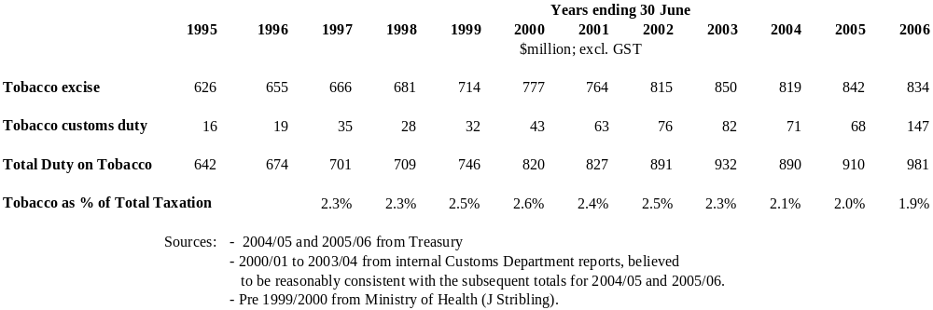

The substantial increase in customs duties received in 2005/06, to $147 million, reflects the initial stages of a close-down of a substantial part of New Zealand’s cigarette manufacturing industry, substituted for by imports of finished product from abroad.

Revenues from tobacco taxes are therefore, at almost $1 billion per year (excluding GST), substantial. Their importance to the government’s total tax-take has, however, been declining recently, falling in 2005/06 below 2 percent of total tax collected.

Real revenues, total and per capita

Total tobacco tax revenues in real terms are shown in Chart A.1, and revenues per smoker in Chart A.2. The source data is given in Table A.2. It should be noted that Statistics New Zealand has recently re-based its Consumer Price Indices, from a base of June quarter 1999 = 1000 to a new base of June quarter 2006 = 1000. The series allow for this change in the index base, and are expressed in June quarter 2006 prices.

In real terms (June 2006 prices) total tobacco taxation revenues have levelled off in the last few years at around about $1,000 million. There has not, however, been any increase in tobacco tax rates, apart from the December indexation increases, since May 2000.

Chart A.1 Real Tobacco Tax Revenues.

1994/95 to 2005/06. June 2006 prices, excluding GST.

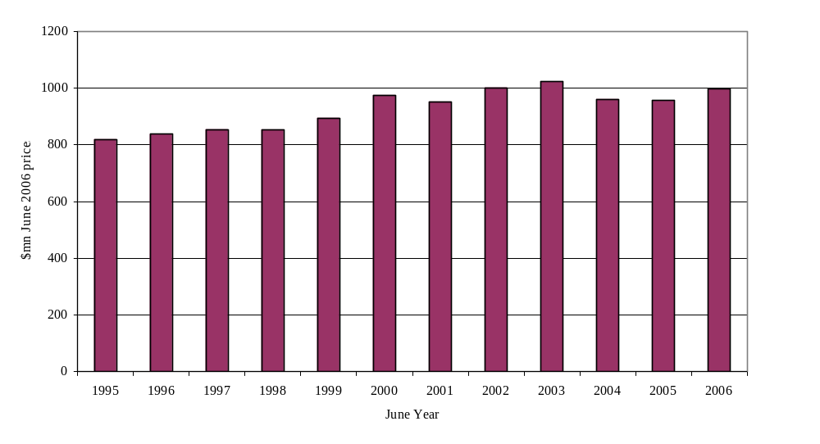

Chart A.2 Real Tobacco Tax revenues per smoker.

1996/97 to 2003/04. June 2006 prices, excluding GST

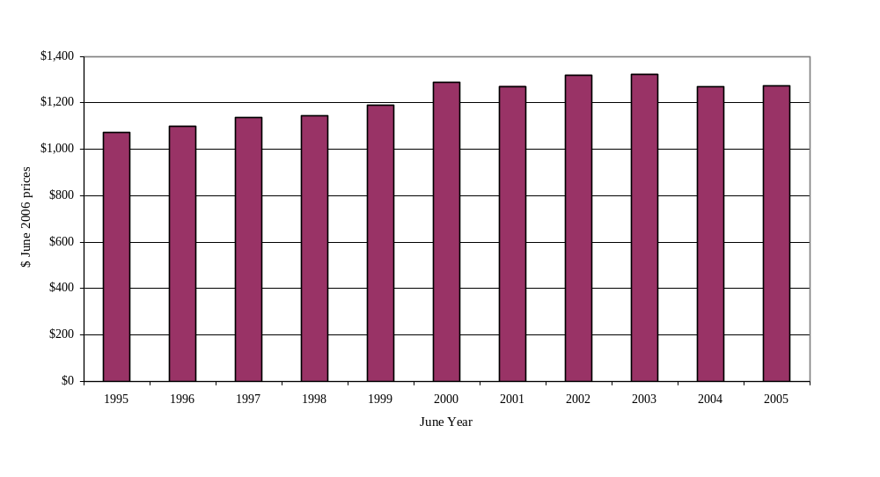

Table A.2 Real Tobacco Tax Revenues Per Smoker. 1994/95 to 2004/2005

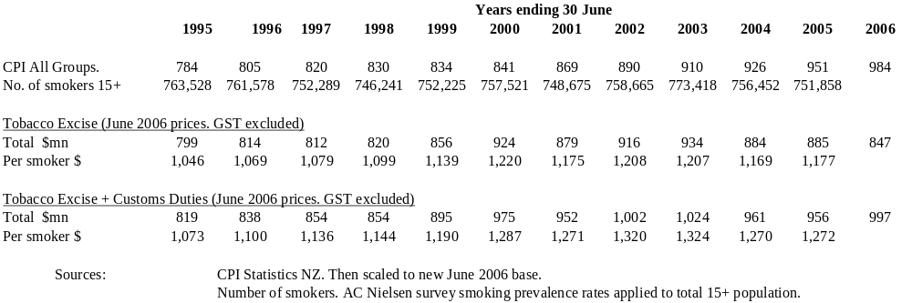

Prices of tobacco products

Official data on cigarette retail prices prior to 1975 are not now easy to locate. Charts in publications such as Tobacco Statistics 1996 demonstrate, however, that there were substantial falls in the real cost of cigarettes through the 1960s and 1970s. For instance in 1960 it took 21 minutes to earn 20 cigarettes, in terms of average hourly ordinary-time earnings (op. cit. Page 25). By 1981 it took only 11 minutes. Substantial increases in real cost commenced from the mid-1980s.

From March 1975 onwards a quarterly price index for the Cigarettes and Tobacco sub-group (series CPYQ.SE9G1) of the Consumers Price Index is available from Statistics New Zealand. This has been used to construct an index of the real price of cigarettes and tobacco relative to the average price of other consumer commodities since 1975. The index is given in Table A.1 of Appendix F in Volume 2 of this report.

Chart A.3 shows this index for the 30 years from 1975 to 2005. It can be seen from the chart that real cigarette prices have increased by a factor of more than 3 (in fact 3.3) over the thirty year period. Increases were particularly marked over the periods from 1985 to 1992, and 1996 to 2001. These in particular reflect the excise tax increases in those periods, but also include the effects of pricing decisions by manufacturers.

Chart A.3 Real Cigarette Prices. Relative to All Groups CPI.

1975 to 2005. June 1999 = 1,000.

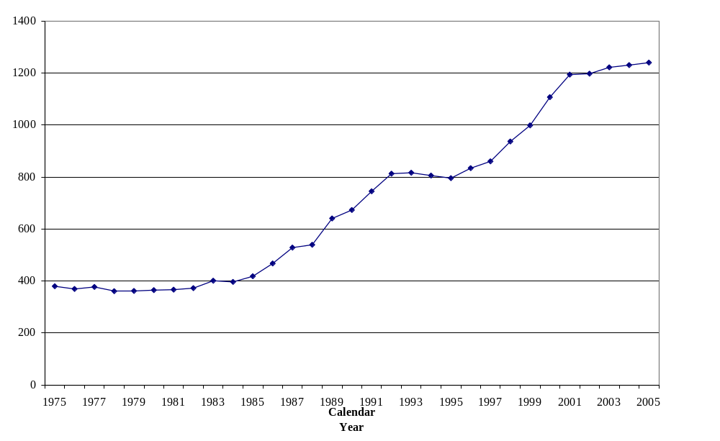

A.1.3 Trends in tobacco consumption, and smoking prevalence

Table A.2 in Statistical appendix F provides data on cigarettes smoked per adult since 1970. Chart A.4 below shows the decline in per capita consumption over the 35 years from 1970 to 2005. By 2005 per capita consumption was about one third of consumption at the start of the period.

In part this decline was a result of individual smokers cutting back their consumption. In part it was due to reductions in the number smoking, because both of former smokers quitting and potential new smokers not taking up the habit.

Chart A.4 Cigarettes delivered per person 15+. 1970 to 2005.
(Assumed 1 gm loose tobacco = 1 cigarette)

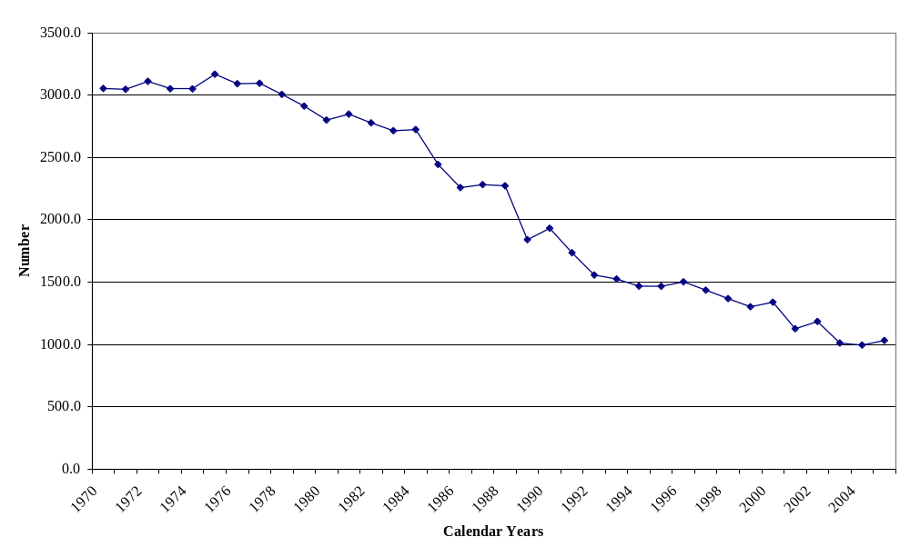
Chart A.5 plots the association between average consumption and real cigarette prices over the years since 1975. There is a strong negative association between the two series – consumption falling as real tobacco prices rise. It is to be noted, however, that cigarette consumption was already falling steadily through the period 1975 to 1985 when cigarette prices were virtually stable in real terms. Clearly factors other than price were reducing consumption, in this period at least.

Chart A.5 Cigarette deliveries per head (15+) and real cigarette prices.
Calendar years 1975 to 2005.
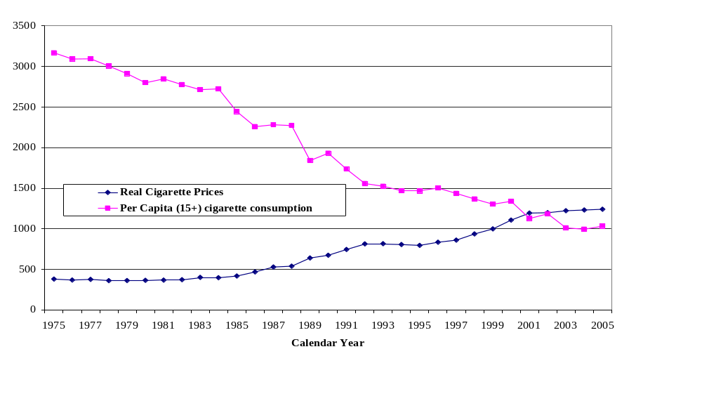
Chart A.6 shows trends in prevalence since 1983. Male smoking rates, higher in 1983, fell more rapidly in the initial period, to 30 percent in 1985, equal to the female rate in that year. Since then male and female rates have fallen about equally, to 23.7 and 23.3 percent respectively in 2005, for a combined prevalence of 23.5 percent. Other non-tax measures taken during the period covered by the chart include the 1990 Smoke-free Environments Act, banning print media advertising from December 1990 and smoking in offices from February 1991; the Smokefree Environments Amendment Act of 1997 further restricting sales and advertising of tobacco products; and the Smokefree Environments Amendment Act of 2003, making most indoor workplaces smoke-free from December 2004.

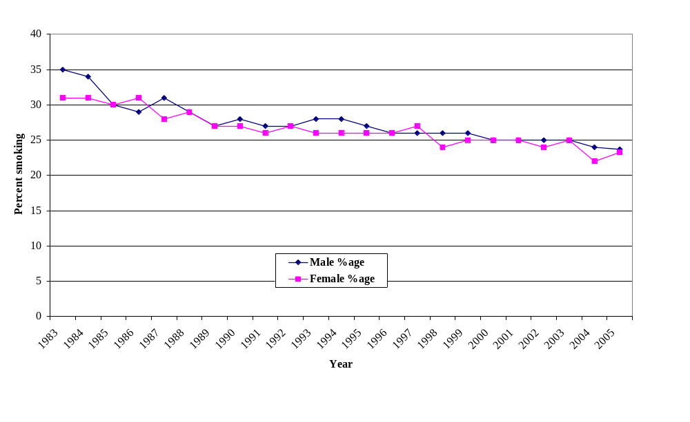
Chart A.6 Smoking Prevalence rates. Male and Female Adults.

1983 to 2005.

Summing up, cigarette consumption has fallen dramatically, but smoking prevalence less so. The greater fall in consumption is quite likely in good part due to fewer opportunities to smoke, due to bans on smoking in most work-places, in many public places, and in public transport. But increases in the real price of cigarettes will also have contributed significantly to the decrease.

A.1.4 Income trends

Tobacco excise rates are adjusted regularly for consumer price inflation, so as not to fall in ‘real’ terms. By and large the retail price of cigarettes (as measured by the Statistics NZ Cigarettes and Tobacco CPI sub-group index) appears to have increased in recent years by at least as much as the increases in the excise tax, and usually more. That is, the ‘indexation’ of tobacco excises has been accompanied by increases in cigarette retail prices at least equal to increases in consumer prices.

Over the long term, however, average incomes have increased in real terms, making cigarettes more “affordable”, as measured for example by the number of minutes of work at average wages required to purchase one packet of cigarettes (Tobacco Statistics 2000).

The income elasticity of demand for cigarettes appears to be relatively low, perhaps of the order of only 0.2 or 0.3, a lot less than unity, meaning that cigarette purchases increase by only a fraction of any increase in average incomes. There does appear to be some increase, however. (See the table in Appendix B on ‘Elasticities’; drawing on Gallet and List; 2003.)

If the aim of tobacco taxation is to reduce consumption and promote cessation, it is therefore logical that cigarettes be prevented from becoming more “affordable” in terms of the share of income required for their purchase. That is, tobacco excise rates should be ‘indexed’ not against general consumer price increases, but in terms of increases in average incomes.

We return to this proposal further on in this report. The relevant statistical evidence is provided in Table A.3. Real income increases, in excess of CPI inflation, are shown for three different income measures.

For comparison, the final column in the table shows year-on-year increases in tobacco products prices, over and above the rate of inflation (as measured by the All Groups CPI). Very substantial increases are apparent at the start of the 1990s, and then for the later years in that decade. Over the last few years from 2002, however, the annual increases have only just kept pace with increases in average earnings. These above-inflation increases are the result, however, of pricing decisions by manufacturers, importers, and retailers.

Returning to the three income measures, they show rather different rates of increase, year-on-year and over longer periods. The average annual rate of increase for the last five years is shown at the foot of the table. The real GDP per head measure is probably too broad in its compass (including in particular the ‘profit’ component of income), and too subject to later revision, to be used for indexation purposes. Of the ‘average earnings’ and ‘average income’ measures, the former has the advantage of already being used for indexation purposes, being an input to annual adjustments of NZ Superannuation pension payments. It shows a lower average annual rate of increase over the last few years (perhaps because of increases in part-time employment) of 0.9 percent per year. If that rate of increase were maintained, using average earnings as an indexation measure would imply an additional increase in revenues each year, cumulating, of the order of $9 million x ( 1- price elasticity), or about $4 million net each year, for the price elasticity value of 0.5 assumed subsequently in this report.

Table A.3 Year-on-Year changes in Real Income, and in Real Tobacco Prices

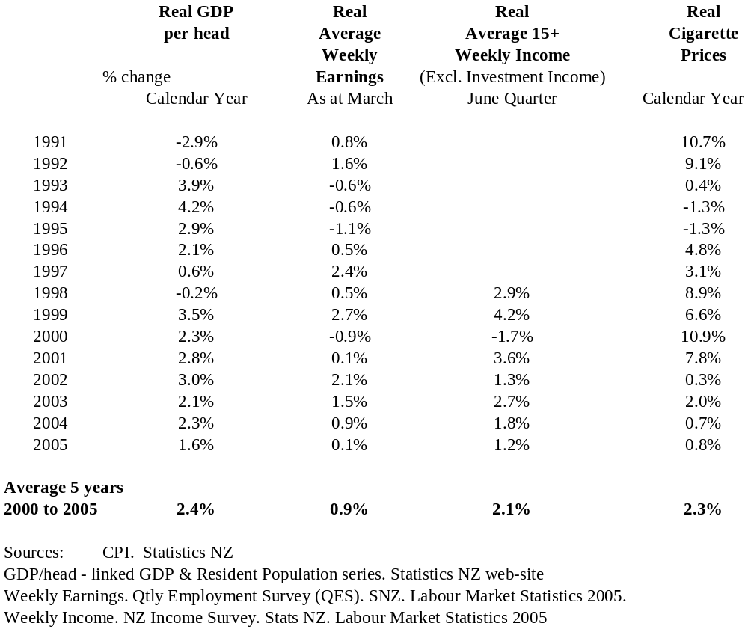

A.1.5 Selected other countries – Consumption, Prevalence, and Cost of Smoking

Other countries are facing the same tobacco control problems as New Zealand. We give here a very brief comparative survey of data for selected English-speaking and/or Pacific region countries. The data below are from Shafey et al Tobacco Control Country Profiles (Second Edition 2003).

Consumption and prevalence.

Table A.4 International Comparisons.

Prevalence and Consumption Per adult.

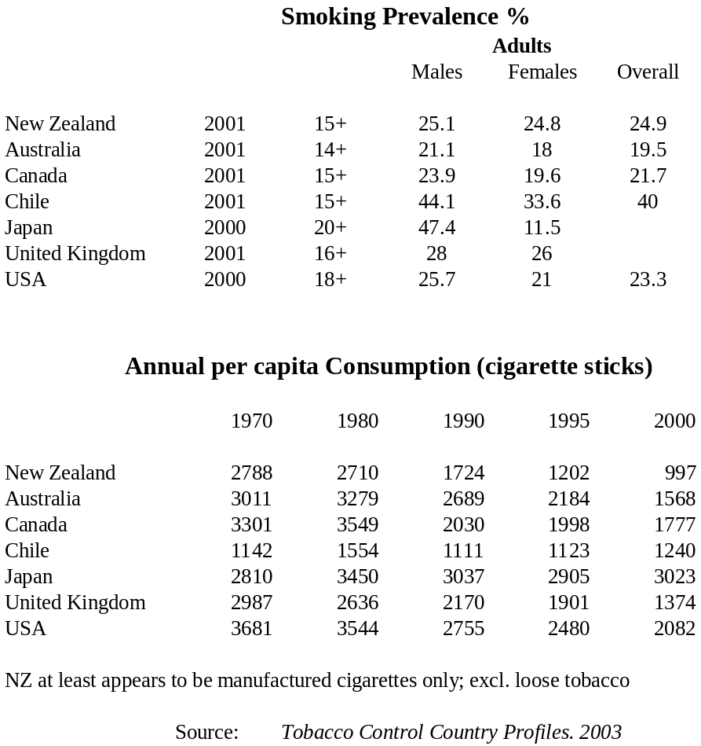
Smoking prevalence for New Zealand is noticeably higher than the prevalences tabulated for Australia and Canada, especially for females, but lower than the United Kingdom (the differences in age-range could influence these comparisons). The United States of America and New Zealand have a similar smoking prevalence for males, but the USA female prevalence is significantly lower. Japan and Chile have clearly different prevalence and consumption patterns.

Consumption per head has dropped very substantially in all the English-speaking countries over the three decades 1970 to 2000. New Zealand shows the greatest proportionate drop and New Zealand had the lowest per capita consumption of the countries shown. This, however, could be because of the apparent omission of roll-your-own cigarettes from the New Zealand statistics.

Price and affordability.

The next table compares retail prices, converting Local Currency Units (LCUs) to US$, as collected in a survey by the Economist Intelligence Unit, London, in 2002. These are then, as a rough measure of ‘affordability’, standardised for this report by comparing the annual cost (domestic brand) of a ‘pack-a-day’ habit with GDP per capita.

Table A.5 International Price Comparisons – Selected Countries

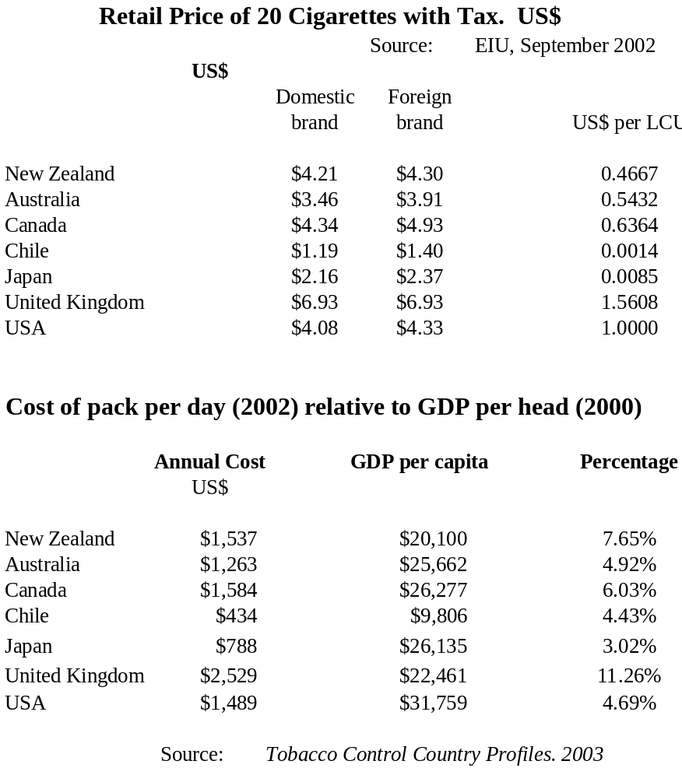

In US dollar terms the cost of cigarettes in New Zealand, Canada and the United States was more expensive than in Australia, but significantly cheaper than in the United Kingdom. In ‘affordability’ terms, measuring cost relative to GDP, the retail price of cigarettes in New Zealand in 2002 was appreciably higher than in all other countries in the table, with the exception of the United Kingdom. It appears that the cost on this basis is approximately 50 percent higher in the UK than in New Zealand.

The tabulated data are some years old, and as discussed elsewhere in this report there has been no real increase in tobacco tax rates in New Zealand since the year 2000.

A.2 The purposes of a tax specifically on tobacco

There are several motives for high taxes on tobacco. They are:-

- The Revenue motive
- The ‘externalities’ argument – tobacco tax as an instrument for making smokers meet the full social costs of their smoking
- The ‘public health’ argument – tobacco tax as an instrument for reducing the unwanted adverse consequences of smoking; thereby improving the public’s health.

Against these are the arguments that heavy taxation of tobacco violates the principle of ‘consumer sovereignty’; and the ‘equity argument’ that the burden of the tax falls most heavily on those least able to afford it.

These various arguments are reviewed at more length in Appendix A. The conclusions reached are as follows:-

- A revenue rationale for levying tobacco taxes is unsatisfactory, indeed unethical. It in effect has governments sharing purposefully in the profits from consumption by its citizens of an addictive and toxic substance.

- The ‘consumer sovereignty’ argument against interfering with consumers’ choices by singling out tobacco for especially high tax rates should, however, be rejected. It does not take account of the significant ‘market failures’ in the market for tobacco products. These are, first, that young people take up smoking with imperfect knowledge of the consequences. Secondly, the addictive properties of nicotine make it difficult to reverse the original choice on becoming better informed. Thirdly, smoking imposes ‘external costs’ on the rest of the community, in the form of the additional publicly-funded health-care costs caused by smoking, and also the additional health-care costs resulting from ‘passive smoking’, plus, for the latter, other costs in terms of lost income from increased sickness, and increased premature mortality.

- Nor are ‘external costs’ a sufficient rationale in themselves for high tobacco taxes. It appears certain that smokers contribute considerably more in taxes than the net ‘economic costs’ to the rest of the community caused by their smoking. And that the ‘non-economic external costs’, such as morbidity and mortality caused by passive smoking, are sometimes better addressed more directly by means other than taxation, for example smoke-free legislation.

- The best rationale for high tobacco taxes is simply the ‘public good’ or ‘public health’ argument. Namely that, in addition to helping meet external costs, they deter smoking and hence promote the public good by improving the public health. High taxes reduce smoking prevalence and consumption, and thereby reduce not just external costs but also the ‘internal costs’ of smoking borne by the smokers themselves. In particular they reduce the increased illness and mortality caused by smoking.

- The greatest objection to tobacco taxation at the present level, and to further increases in tax rates, is that the tax is inequitable. It falls particularly heavily on persons in low-income households. It falls disproportionately on Māori also.

- A partial solution is to ensure that a growing proportion of tobacco taxation revenues is made available specifically to aid smokers in quitting, with a substantial part of these resources being directed to helping Māori and low-income households.

A.3: The concept of the ‘Price elasticity of demand’ and other elasticities

An especially important parameter for tobacco taxation policy guidance is the so-called ‘price elasticity of demand for tobacco”. Another important parameter is the ‘price elasticity of smoking prevalence’. In this and the immediately following sections the ‘elasticity’ concept and its relevance to policy are explained. The elasticity values found in the overseas literature are discussed, as also are past estimates of New Zealand elasticities. Next the New Zealand elasticities are re-estimated using the available annual data for the period from 1975 to 2005 (details of the estimation are given in Appendix B). Finally values are selected which seem consistent with the evidence and suitable for policy guidance in New Zealand.

A:3.1: Definition of Elasticity

In economics the term ‘elasticity’ is used as the label for ‘responsiveness’.

The ‘price elasticity of demand’

In particular, the responsiveness of the quantity purchased of a commodity to a change in its real price (inflation-adjusted) is labelled the ‘price elasticity of demand’ for that commodity. The formula for this elasticity is –

e = percentage change in quantity demanded
percentage change in price

Because of the ‘law of demand’- that “quantity demanded decreases as price increases” for almost all commodities - the ‘e’ in the above formula will have a negative sign. For convenience, however, the negative sign is often omitted.

As an arithmetical example, if the price of cigarettes were to rise, relative to prices of other commodities, by 10 percent, and the quantity bought were then to fall by 4 percent, then the price elasticity of demand for cigarettes would have a value of -0.40.

The price elasticity is further categorised as: –

- price-inelastic if the value (ignoring the minus sign) is less than 1.0
- price-elastic if the value (ignoring the minus sign) is greater than 1.0

The influence of the level of price elasticity on tobacco expenditure and tobacco-related government revenues is discussed further below.

Other elasticities

Although the ‘price elasticity of demand’ is the most important application of the elasticity concept, at least for the purposes of this report, there are many other applications of the elasticity concept, of which the following are the most relevant here:-

- ‘Price elasticity of smoking prevalence’. Namely the responsiveness of the population prevalence of smoking to changes in the real price (inflation-adjusted) of tobacco products. For example if there was a rise of, say, 100 percent in the real price of cigarettes, and the proportion of adults smoking dropped, say, from 25 percent to 20.0 percent, or by one fifth, then this elasticity would have, at the postulated values, a value of 0.20.

It can be seen that the change in prevalence in response to a change in price contributes to the overall change in quantity demanded. The remaining contribution is from the reduction in average demand of those consumers who continue smoking but consume a smaller quantity.

- Price elasticity of supply. Namely the responsiveness of the quantity supplied to the market to a change in real price.

This elasticity has a positive value for most commodities. A common assumption for tobacco products, in particular, is that the supply elasticity is very large, or ‘infinite’. What this means is that tobacco companies can supply whatever quantity of cigarettes or tobacco consumers are willing to purchase, at a constant cost per packet or per unit weight of loose tobacco. The assumption seems a reasonable one, given the large-scale production technology available to the tobacco companies, so that production can be readily expanded or contracted in response to changes in consumer demand. The assumption also simplifies considerably the econometric analysis required to estimate the price elasticity of demand.

- Income elasticity of demand.

This measures the responsiveness of demand to a change in income. For ‘normal’ goods demand increases with income. For tobacco products, it could be expected that an increase in income over time will increase demand, and the statistical evidence does tend to support this expectation. For cross-sectional data, however, demand for tobacco is in general lower at higher income levels (though the elderly tend to smoke less). Experience from New Zealand and most other developed countries is that smoking becomes highly concentrated in low income and disadvantaged populations due to a variety of factors. These include, for example, a poorer knowledge of the scale of health risks, strong social and cultural influences which normalise tobacco use within these communities (Gifford 2003. Pages 295+), and less easy access to smoking cessation support and quit aids.

Distinction between ‘short-term’ and ‘long-term’ elasticities

A further point to note is that the measure of an ‘elasticity’ can vary with the period of time over which it is measured. For example the short-term price elasticity of demand for petrol will tend to be lower than the long-term elasticity, because consumers have more time to adjust their transport mode in response to the price changes. It appears from the literature (Gallet and List 2003) that this holds for tobacco products also. That is, the long-term price elasticity is higher than the short-term elasticity.

A.3.2: Relevance to effects of a price rise on government revenues

The consequence of the price elasticity of demand being ‘inelastic’ is that if the price goes up, say as the result of a tax increase, the amount spent on the commodity also goes up. For example, if the price of cigarettes increases 10 percent, and the price elasticity is -0.40 (that is ‘inelastic’ because 0.40 is less than unity), then the quantity of cigarettes purchased will fall by 4 percent. This leaves, however, a net increase in consumer expenditure of approximately 6 percent (in fact 5.6 percent, as 1.10 x 0.96 = 1.056). Tax revenues would rise by approximately the same amount (the amount will be influenced by the degree of the price rise which is attributable to the tax increase).

An equally important implication is, for the same parameter values, that spending by smokers will also increase by approximately six percent, on average, because quantities purchased have fallen only 4 percent, against the 10 percent price increase.

A.4: Estimation of the ‘Price elasticity of demand for tobacco products’. New Zealand and elsewhere

The previous discussion shows the importance of the value of the ‘price elasticity of demand’ for estimating the effect of tobacco tax rises on tobacco consumption, and on government revenues. There have been therefore many papers overseas attempting to estimate as precisely as possible the numerical value of this elasticity. By far the most common method for doing this is so-called least squares regression analysis. This assumes that demand for tobacco products can be modelled by an equation (or perhaps a number of equations) of the form

Y = a + b₁ * X₁ + b₂ * X₂ + …

Where Y is the ‘dependent’ variable, in this case either the demand for tobacco products, or smoking prevalence, to be explained.

The X_{i}s are the ‘explanatory’ or ‘independent’ variables, in this case for example the price of cigarettes, average income, advertising expenditure, perhaps age-group and/or gender of the consumer, etc.

The coefficients b₁, b₂, etc are the measures of the contribution of the independent X_{i} variables on the dependent variable Y.

The coefficients are then estimated by least squares regression – namely those values are found for which the equation best fits the actual data available. This is in terms of minimising the sum of the squared differences between actual data values and the values predicted by the equation.

The equation above is ‘linear’ in the X_{i} variables. It is often convenient to take logarithms of these variables, giving a ‘log-linear’ equation, and also of the Y variable as well, giving a ‘double-log’ equation. The particular advantage of the latter is that the values of the coefficients are then the values of the ‘elasticities’ with respect to the given variables, assuming the elasticities are constant over the data-set.

The above description omits many sophisticated modelling and estimation techniques available to the investigator.. The statistical and econometric literature on such matters is huge. A good guide in the current application is Wilkins et al; 2001.

A.4.1 Estimated values in other countries.

A convenient summary of results is that provided in Gallet C.A. and List J.A. 2003 . ‘Cigarette Demand: a meta-analysis of elasticities’ Health Economics 12: 821-835. Gallet and List reviewed tobacco elasticity estimates from 86 papers, containing 523 estimated price elasticities and also income and advertising expenditure elasticities for tobacco demand. The estimates made use of a wide range of data-sets in different countries, either at country aggregate or sub-national level, used a range of models for tobacco demand, and used also a number of different econometric estimation techniques. The purpose of the paper was to examine the extent to which these differences might contribute to differences in the resulting estimates.

Some of the more interesting results from the Gallet and List paper are given in the following table.

Table A.6 Elasticity Estimates (selected) from Gallet and List 2003
Meta-Analysis paper.
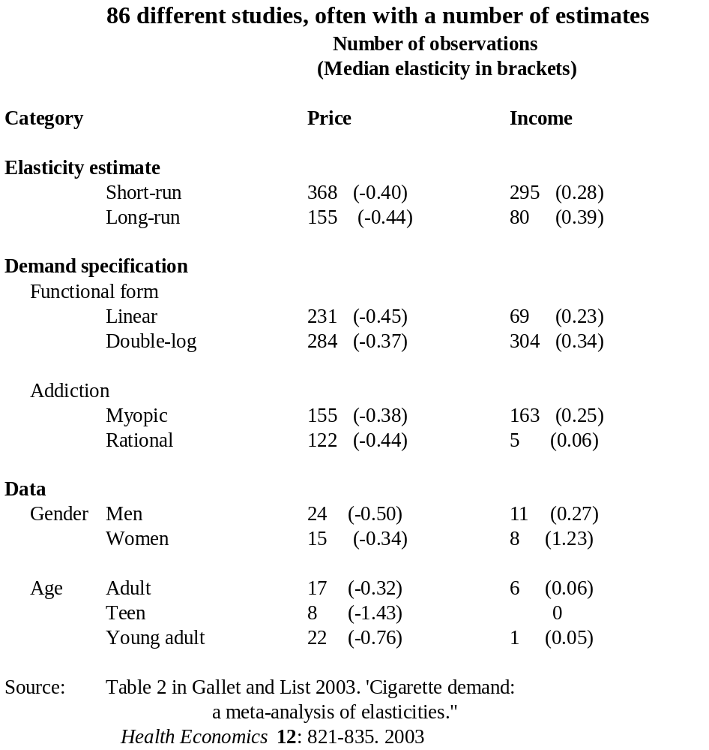

So far as Gallet and List’s objectives went, they noted -

“ … several factors significantly influence the price elasticity estimates. First, the price elasticity is larger when cigarette demand is estimated jointly with alcohol demand. Second, price elasticity is lower when demand is modeled as an almost ideal demand system. Third, … estimating a double-log specification of demand within a rational addiction framework tends to increase the price elasticity. Fourth, ….. women (teens) tend to be less (more) sensitive to price, as indicated by the larger (smaller) price elasticity estimate.”

Of equal importance from the viewpoint of this report are the reported mean and median values. Thus –

“ Due to the refinement of econometric techniques and the growing availability of data, it is not surprising to find significant differences in elasticity estimates across studies. For instance, while the mean price elasticity across the 86 studies is -0.48, suggesting that cigarette demand is generally inelastic, the standard deviation is quite large (0.43), as is the range of estimates (-3.12 to 1.41). Coupling these results with the fact that … income elasticities display similar variation (i.e. the mean income elasticity is 0.42, with a standard deviation (range) equal to 0.49 (-0.80 to 3.03); …. the difficulty of properly synthesizing these results becomes readily apparent. “

Thus the mean of the price elasticity estimates in these studies is –0.49, and of the income elasticities is 0.42. The median price elasticities given in the table are short-run –0.40 and long-run –0.44. That is,

“ … following received wisdom, the demand for cigarettes tends to be more inelastic in the short-run than in the long-run (i.e. ceteris paribus, the short run estimates are higher than the longrun estimates). “

Another important feature of the estimates in the table is that the negative (median) price elasticities are substantially greater for teenagers and young adults than for adults. In other words, younger people are more responsive to tax and price increases. The number of studies calculating elasticities by age-group (and by gender) is, however, relatively small.

A.4.2 New Zealand estimates

Past New Zealand estimates have suggested rather low price elasticities (Salter 1981; Evans and Meads 1991). In her substantial 1981 paper Salter estimated elasticities from data for the 1961-78 period, using both annual and quarterly data. As an income proxy she used retail sales data. She tested both linear and log-linear specifications, using ‘lagged consumption’ as a ‘habit’ or ‘addiction’ variable, and also for estimation of long-term elasticities. Her results using annual data were the more robust. In brief her preferred results might be summarised as

Short-term price elasticity = -0.08 (t-statistic –0.87)
Short-term income elasticity = 0.46 (t-statistic 2.90)

Long-term price elasticity = -0.26 (t-statistic -0.87)

These price elasticity values are relatively low. A possible cause is that her study-period was one in which real cigarette prices were tending to fall, and consumers might well have been relatively insensitive to price changes of the magnitude seen in the 1960s and 1970s.

In Thomson et al (2000) O’Dea estimated a value of –0.75 for the period 1987/88 to 1997/98; but a lower value of –0.43 for the longer period 1982/83 to 1997/98.

An econometric analysis of New Zealand tobacco market data for the years since 1975 up to 2005 has been carried out for this report. The data, results and conclusions are given in Appendix B on ‘Estimation of New Zealand Tobacco Elasticities’. Summary results are given below.

The models used were single-equation double-log. For these analyses the time-series variable used as a proxy for income was ‘private household consumption per capita’. It became apparent during the investigation that ‘income’ does not make a statistically significant contribution to tobacco demand, either because this is genuinely so, or more probably because of deficiencies in the proxy series. Multi-collinearity was also a significant problem, with real cigarette prices rising steeply over the period since 1985 whilst at the same time ‘social’ factors (e.g. smoke-free environments, social attitudes) were driving down both cigarette consumption and smoking prevalence. In other words it is difficult statistically to disentangle the different influences because they are highly correlated over the period of study. Analysing “differenced” data, that is year to year changes, is one way of addressing this problem, and both ‘un-differenced’ and ‘differenced’ results are given below.

Tables A.7 and A.8 pick out the best of the various equations estimated in Appendix B. Deciding the ‘best’ is to some extent a value judgement, but aided here by requiring the coefficient on the ‘income’ proxy variable to be greater than zero. Because these are ‘double log’ equations the coefficients on the variables are in fact estimates of the respective elasticities. 95% confidence intervals are given in brackets.

Table A.7 ‘Best’ equations for 1975 to 2005 period for Tobacco Consumption per adult. Double-log specification.

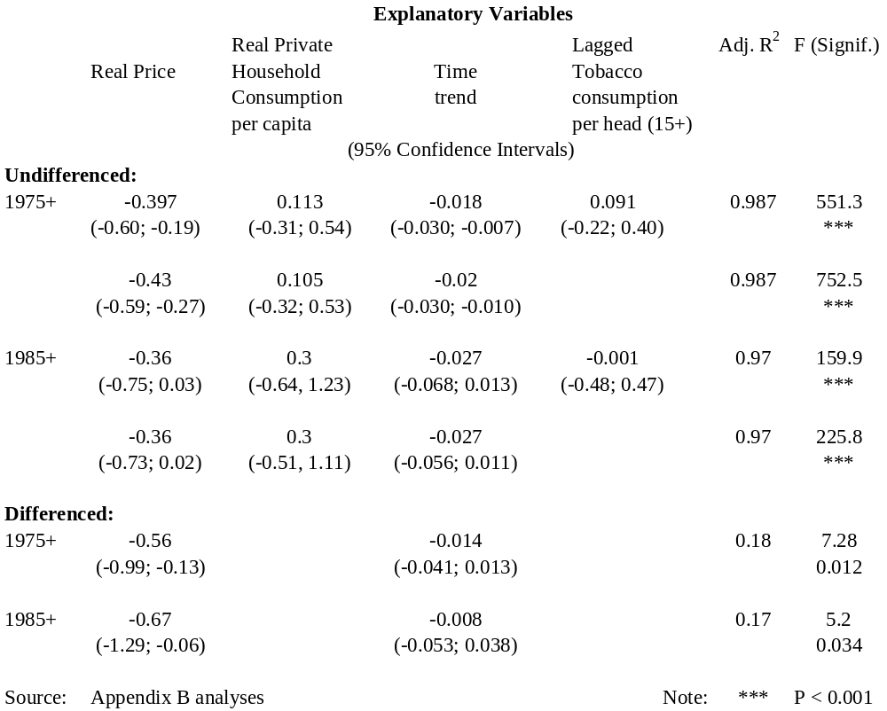
Table A.8 ‘Best’ equations for 1984 to 2005 period for Smoking Prevalence of adults. Double-log specification.

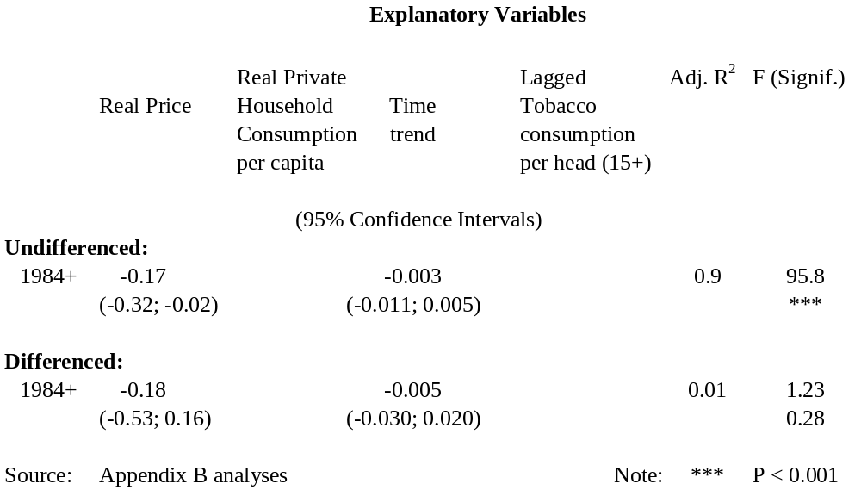

On the basis of this evidence the following conclusions were reached.

- demand elasticities
The results are consistent with a long term price elasticity of demand of about –0.45, with a short-term elasticity perhaps somewhat lower at about –0.40. These values are statistically significantly different from zero. This figure is more or less identical to the mean and median price elasticities tabulated by Gallet and List. The ‘income’ variable makes in general a very poor contribution to overall fit, with the best estimate of the income elasticity of demand being about 0.12, but this is not statistically significantly different from zero.

Equations with only the price variable as an explanatory variable give higher price elasticities, of around –0.80. But these elasticities will be over-estimates as there were undoubtedly other factors, such as smoke-free legislation and changes in social attitudes to smoking, driving down consumption in addition to the increases in the real price of smoking. The addition of a time trend to try and account for these other factors yields lower values for price elasticities (though for the ‘differenced’ data still as high as –0.56 and –0.67). On the available data it is not possible to completely separate the effects of price increases from the effects of ‘social’ trends.

- prevalence elasticities
The results here are rather more robust and consistent. They point to a ‘price elasticity of prevalence’ of about –0.20. This is also the ‘central’ value for the ‘elasticity of smoking participation’ used in the simulation modelling for California by Kaplan et al (2001).

A.4.3 Possible variations for different sub-populations

One result, already mentioned in discussion of the Gallet and List paper, seems well established in the literature. Namely that price elasticities are considerably higher for adolescents than for the total population. In other words adolescents are sensitive to tobacco prices and high tobacco taxes deter them from smoking.

It would be of considerable policy importance also to establish the extent to which the elasticities differ between ethnic groups and by household income and other measures of socio-economic status. Unfortunately it has not proved possible with the available data to identify such differences. A priori it might be expected that price elasticities would be higher for low-income persons and households.

A.4.4 Values of price elasticities of demand and prevalence assumed in remainder of this report.

For calculation purposes the following values of elasticities have been assumed in the remainder of this report -

- Price elasticity of demand of -0.50
- Price elasticity of prevalence -0.20

It can be shown that this is equivalent to the ‘price elasticity of consumption by continuing smokers’ having a value of -0.30

Note that this elasticity is for only those who continue smoking.

A.5. The expected consequences of a tax rise?

From the assumptions just above it is now possible to set out the expected consequences of a rise in the tobacco tax rate.

- The effect on cigarette prices.

From the material in Section A.1, the excise tax plus GST accounts for approximately 70 percent of the retail price of a pack of cigarettes. Of the remaining 30 percent probably about a third, or 10 percent of retail price, is the retailer’s margin. It seems likely that retailers would be able to, and seek to, maintain this margin following a tax increase. Thus the percentage price increase in retail price is likely to be at least 80 percent of any percentage increase in the tax rate.

A further assumption here is that manufacturers have the ability to pass on, and would pass on, the full amount of any tax increase, using the occasion to recover any increases in real costs they have undergone.

In brief any percentage increase in tobacco tax will probably result in a like percentage increase in retail price.

- The effect on quantity consumed

Assuming a price elasticity of –0.50, and a full passing on of a tax increase so that the tax content of the retail price is unchanged, quantity consumed will be reduced approximately by the product of the percentage tax increase and the elasticity. For a tax increase of 10 percent, this amounts to a quantity reduction of 5 percent.

- The effect on consumption expenditure and tax revenue

For a tax increase of t percent, on the same assumptions, both consumer spending and tax revenues will increase by a factor t.(1 – e). For t = 0.10 and e = 0.50 this amounts to a five percent increase.

- The effect on smoking prevalence

Supposing the prevalence elasticity equals -0.20, then for a 10 percent price increase the reduction would amount to 2 percent of the original prevalence. Supposing an initial prevalence of 25 percent the reduction would be to a new prevalence of 24.5 percent.

- The effect on disposable income
This is discussed in the later Section F on ‘equity’.
A.6: The best way of applying tobacco tax increases and adjustments

On the basis of the discussion in preceding sections, the authors of this report believe that tobacco taxes should be increased in real terms because –

- i) To lower taxes, or to allow them to erode in real terms, would result in an increase in tobacco consumption and smoking prevalence and therefore damage the public health;

- ii) Maintaining the current real price of tobacco through index-linked tax increases would have no effect on reducing tobacco consumption or smoking prevalence and would mean that an effective opportunity for reducing the burden of morbidity and mortality due to smoking was being missed;

- iii) Further real increases in taxation are justified by the potential health benefits from more smokers quitting or smoking less, and fewer ‘potential smokers’ taking up the habit.

Tax increases do, however, bear heavily on less well-off households, including many Māori households. These equity implications are discussed further in Section F.

There are also worrying ethical implications associated with punishing smokers financially for their addiction, while at the same time generating sizeable government revenues. This concern has helped motivate recent interventions ensuring that services are provided to assist smokers to quit. For example, the provision since 2000 of nicotine replacement therapy and cessation support through the Quit Group.

However, there is indicative evidence that the resources provided to market and provide these services are still inadequate, and that Government’s timing in ensuring the availability of these resources to meet increased demand is not always good. (See the accompanying report by G Thomson on a Dedicated Tobacco Tax.) There is a strong case for devoting a substantially larger part of the revenues generated by tobacco taxation to smoking prevention and cessation measures and also for ensuring that real tax increases are applied as a deliberate public health intervention, with accompanying measures to ensure maximum impact (e.g. accompanying smoking cessation campaigns, increased Quit Line marketing, and other support services). This case is made in later sections, as also is the case for setting up a dedicated agency for administering such funds.

There is little dispute now about two ingredients of current tax policy. The first is that tobacco taxes should be ‘specific’ rather than ‘ad valorem’ (or ‘percentage’); in order that a consumer shift to cheaper tobacco products not be encouraged. The second, a consequence of the first, is that the specific tax rates need to be adjusted regularly, in order not to be eroded by inflation and increases in income. That is, an appropriate level of ‘indexation’ of tobacco tax rates is a necessary first step, before considering the question of tax increases in excess of indexation.

Questions which remain to be decided are: –

- How frequently should indexation take place?
- At what date(s) in the year should it take place?
- Should ‘indexation’ be in terms of consumer price inflation, or should it also allow for real income growth over and above price inflation? Put another way, should indexation be in terms of “affordability” to the average consumer?
- How large and how often should real increases in the rate of tobacco tax, above that necessary to maintain constant ‘affordability’, be?
- What else should be done to maximise the public health impact of tobacco tax increases?

Frequency of indexation

The current policy is that tobacco tax rates are adjusted annually, on December 1, by the amount of the increase in the All Groups Consumer Price Index for the year up to the preceding September quarter.

There appears no good reason for the indexation occurring more frequently, say six-monthly as in the early 1990s, or less frequently, such as every two or three years. The larger increases for the latter option might have more ‘shock’ impact on smokers, but less frequent indexation could lead to increases becoming ‘discretionary’ rather than automatic.

Date of indexation?

As pointed out in Laugesen (2003), December 1 is not the ideal time of year for tobacco tax increases. People, including smokers, are preoccupied with the approach of Christmas, and it is not a good time of year for cessation service providers to build up staff resources in anticipation of an increase in demand.

A better date would be 1 March, with the population in general back from summer holidays, New Year resolutions waiting to be implemented, and the initial weeks of the year available for providers to get ready for the extra calls on their services.

The indexation benchmark? Prices or incomes?

Since the late 1980s the general policy for changes in tobacco tax rates has been for there to be substantial real ad hoc rises in the tax rates every few years – since 1986 and 1988-89, in 1991, 1998, and 2000. Between these have been the ‘indexation increases’ in which tax rates have been adjusted upwards in line with increases in the Consumers Price Index (CPI). These increases have been applied annually, in 1 December of each year, from 1995, and more frequently in the earlier 1990s. The effect is that tobacco tax rates, and tobacco prices, have been maintained in real terms.

However, real incomes have also been increasing in recent years. That is, average incomes have been increasing at rates on average higher than increases in consumer price inflation. Cigarettes have been becoming more ‘affordable’. This in itself is likely to lead to some increase in consumption of tobacco products, though possibly only a small increase if the income elasticity of demand for cigarettes is low, as it seems from the quantitative evidence.

A table in the earlier section A.1.4 showed year-on-year real increases in three different measures of income change: GDP per head, Average Weekly Earnings, and Average Income from all sources, excluding investment income.

Over the past five years two of these measures have increased in real terms at over two percent per annum, whilst real Average Weekly Earnings (AWE) have increased at just about one percent per annum.

Of the three measures real AWE is the one to be preferred. It is readily available, and not unduly subject to later revision. It is also already used in a policy context, as one of the bases for adjustment of national superannuation rates. Its slower rate of growth could be due in part to the inclusion in the average of part-time as well as full-time workers, with part-time proportions increasing with the economic expansion in recent years.

We consider that in future the annual indexation of tobacco tax rates should be based on movements in average weekly earnings (AWE) as calculated from the Quarterly Employment Survey, including male and female, full-time and part-time workers.

AWE has increased over the last five years by about 1 percent per year on average in excess of consumer price inflation. Assuming this real increase continues, on current total annual revenues of $980 million, and with a price elasticity of about 0.50, the extra amount of Tobacco Tax revenues would be approximately $5 million each year. The additional revenues, assuming a continuing real income increase of 1 percent per annum, would cumulate under this policy; $5 million in the first year, $10 million approximately in the second year, and so on.

It is unnecessary perhaps to be too precise here about the details of implementing this recommendation. But it could be applied from the first convenient ‘indexation date’, for example 1 March 2008. A retroactive element to the initial increase should be avoided. Because of annual fluctuations in real earnings increases it might be advisable to work in terms of a moving three-year average of annual movements or the like, starting initially with an assumed real increase of one percent per annum.

Equalising tax rates on different tobacco products

Tax rates on loose tobacco (‘roll-your-own’ and pipe tobacco) were increased sharply in 1995. This was to discourage substitution away from ‘Factory Made’ (FM) cigarettes to cheaper ‘rollies’.

Excise rates on Manufactured Cigarettes are expressed usually as $ per 1,000 cigarettes. Rates on loose tobacco are expressed as $ per kg of tobacco. The 1995 change increased the tax rate on loose tobacco by 38 percent. This made the $/kg rate on loose tobacco 25 percent higher than the $/1000 rate on manufactured cigarettes. (In early 2006 $349.35/kg versus $279.40/1000.) The 25 percent differential has been maintained for the past decade.

The implicit assumption behind this differential is that one manufactured cigarette contains 0.8 grams of tobacco; and that one roll-your-own cigarette will also use 0.8 grams of tobacco. Hence the tax rate per kg of loose tobacco needs to be 25 percent higher to equalise the tax burden on the two products.

It has been since argued (Laugesen 2003) that the equalising increase in the tax rate on loose tobacco was insufficient, in that ‘roll-your-own’ smokers are economising by rolling thinner cigarettes.

Laugesen, in his two reports (with associated spreadsheets) to the Ministry of Health (2005 & 2006), drawing on manufacturers’ returns, provides background information. The ‘tax content’ in 2005 of a manufactured cigarette is 27 cents, and of 1 gram of tobacco 34 cents. This gives equality for a hand-rolled cigarette using 0.8 grams of tobacco. If, however, only 0.6 grams are required, the tax cost per hand-rolled cigarette becomes 20.4 cents. That is, 25 percent lower than the tax cost of a manufactured cigarette.

Such a differential would provide a powerful incentive to switch from manufactured to hand-rolled cigarettes. Chart A.7 shows deliveries of loose tobacco as a proportion of total deliveries since 1970. Note that the calculations for this chart assume one gram of tobacco per hand-rolled cigarette. An alternative assumption of 0.8 or less grams would shift the plotted curve upwards but would not affect the general picture. At the start of the 1980s the hand-rolled proportion had been falling steadily for decades. It can be seen to have bottomed out about 1985 at less than 10 percent of the total. It then started to rise steadily and then, in the early 1990s, rapidly, to nearly 20 percent by the mid-1990s. This certainly implies that smokers were seeing some price advantage to hand-rolled cigarettes.

The temporary impact of the 1995 increase in loose tobacco excise rates is clear. From 1997, however, the share of loose tobacco again began a steady rise, to the current proportion above 25 percent. Again this implies that many smokers see some advantage in smoking hand-rolled cigarettes, presumably a price advantage, though this could possibly be a perceived rather than actual advantage.

There is no current evidence as to whether in fact the average tobacco content of ‘roll-your-owns’ has fallen, say from 0.8 grams to 0.6 grams of tobacco or lower; or whether the 1995 assumption of 0.8 grams was correct. (There is a discussion of the issues in the Canadian ‘Win-Win’ submission.) The ongoing increase in the market share of loose tobacco does suggest, however, that many smokers do perceive a saving from smoking roll-your-owns. If the use of RYO encourages smokers to continue smoking, when otherwise they may find it easier to give up, then there is a definite argument for increasing the tax on RYOs in relation to manufactured cigarettes.

Chart A.7 Loose Tobacco released for consumption as percentage of
total (Loose + Manufactured Cigarettes) 1970 to 2005.

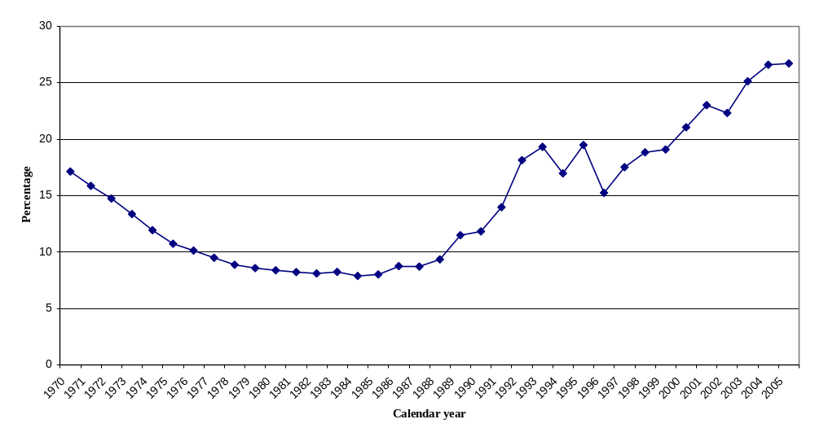

At present there is perhaps not quite sufficient evidence on which to base a recommendation for changing the relative tax rates of different types of tobacco, unless a ‘precautionary’ approach is taken. The issue does, however, deserve further investigation. This should be carried out with some urgency. A simple first step would be to collect evidence on the actual average weight of a ‘roll-your-own’ cigarette.

Size and frequency of tobacco taxation increases beyond indexation

The central argument of this report is that increases in taxation are above all justified by the health benefits – to both active and passive smokers - of cessation, or reduction in consumption, or by not taking up the habit in the first place.

Ideally one would set targets for tax increases in terms of the contributions they would make to targets – short and long-term – for reductions in smoking prevalence and tobacco consumption. For instance policy targets might be to reduce present smoking prevalence levels, for all ethnic and socio-economic groups, to less than ten percent within ten years, and to effectively zero within 20 years. Price increases would be set so as to make these policy targets achievable. There is too much uncertainty, however, about current values of ‘prevalence’ and ‘price’ elasticities to have excess confidence in the exactness of calculations based on them. Also it would be dangerous in any case to extrapolate current values too far into the future, as the nature of the diminishing smoking population changes.

A more ad hoc, if less ‘scientific’, approach is needed. For example one might set an initial target of doubling real cigarette prices over a 10-year period, and combining this with other tobacco control measures as necessary to achieve the desired prevalence and consumption targets. As better evidence became available policy settings could be modified.

A doubling of real cigarette prices over 10 years would be achieved, for example, by an increase each year of 7.2 percent, or by 4 increases over the 10 years, each of 18.9 percent. A question in the latter case is whether such increases are politically possible, and possible also without unacceptable increases in smuggling and theft. The answer is that they are very likely possible, because historically there have been such increases (though in percentage terms rather than absolute value terms). In the last two decades there have been two real price increases in the range of 25 to 30 percent, in 1986 (though associated with the introduction of GST at 10 percent) and in 1988/89. There have been a further three increases in the 15 to 20 percent range, in 1991, 1998, and 2000.

Should tobacco control policy aim for smaller, but still substantial, increases in real tobacco policies every year, or larger increases every two or three years? A problem either way will be the temptation for retailers and consumers to stockpile in anticipation of increases. An advantage of larger but less frequent increases is their possibly greater impact on desire to quit, and also that the longer intervals give tobacco control agencies more time to digest the outcomes and lessons from the previous increase.

However, whether an annual or two—or three-yearly approach is taken, the essential matter is to have a tobacco tax strategy – a medium or long term plan of how tobacco tax will be used, what the intended effect should be, and what the associated government activities need to be.

What other complementary measures are needed to make tobacco tax most effective?

The complementary measures needed are a build-up of prevention and cessation infrastructure in anticipation of the increased demand for such services following a large tax increase. Such resource commitments should be announced at the same time as the announcement of tax increases. There is good evidence, as discussed in a later section, that such announcements make tobacco tax increases more acceptable, to smokers as well as non-smokers.

A.7: Recommendations
From the above discussions

A.1 That government adopt a tobacco tax strategy as a significant and integral part of its tobacco control strategy.

A.2 That tobacco taxes should be explicitly presented and justified as a public health measure, and levied in such a way as top maximise the public health benefit.

A.3 That as part of a medium or long term tobacco tax strategy there should be further continued substantial increases in tobacco taxation, justifiable in terms of the health benefits to be expected, and the fact there has been no real increase in tobacco tax rates since the year 2000.

A.4 That such increases should be either of the order of ten percent annually or of the order of twenty to thirty percent every two to three years, with a provisional target of doubling the real cost of tobacco (in terms of affordability) within ten years. The objective of these increases is to contribute to the reduction of smoking prevalence to less than 10 percent, for all ethnic and socio-economic groups, within ten years.

A.5 That the first such increase take place in 2008.

A.6 That prior to any such increases, appropriate additional resources be in place ready to help the expected increase in quit attempts, and that the availability of such resources be announced at the same time as the announcement of the tax increases and accompanied by health promotion campaigns to promote quitting.

A.7 That the proposed increases be in addition to the present annual indexation of tobacco tax rates.

A.8 That this indexation should in future, however, be based on annual increases in average incomes, Average Weekly Earnings (AWE) being the preferred benchmark, rather than on annual increases in consumer prices, as at present (it is anticipated this would increase prices by about an annual 1 percent extra above inflation).

A.9 That the annual date at which indexation increases, and tax increases in general, take place should be changed from 1 December, which is too near the summer holiday period, with the preferred date being 1 March.

A.10 That indexation on the suggested new basis should begin from the next suitable indexation date.

A.11 That changes in the relativity of tax rates on factory-made and roll-your-own cigarettes should be urgently considered, to ensure that smokers are not continuing to smoke rather than quitting, because of the availability of cheaper hand-rolled cigarettes.

B: The costs and benefits of smoking to various parties?

For better readability, much of the detail of the calculation for this section of the New Zealand costs of smoking is placed in Appendix C: Estimates of the Health Costs and Economic Costs of Smoking.

Summary:

Estimates of the costs of smoking are useful in indicating the potential gains from reducing smoking prevalence. In this section the costs of smoking are estimated for New Zealand in 2005. The approach used is the so-called ‘prevalence’ approach, comparing the current situation with a ‘counterfactual’ scenario in which there has been no consumption of tobacco in the lifetimes of persons currently living. This allows estimation of the numbers of persons who would be currently alive, were it not for smoking.

The approach builds on earlier work for New Zealand by Easton (1997), and makes use of the work by Collins and Lapsley for New South Wales (2005), and earlier for Australia as a whole (2002). Much of the detail of the analyses has been placed in Appendix C.

The estimates have two main components – the ‘tangible costs’ e.g. health-care costs, lost production from tobacco-caused premature mortality and morbidity, etc., - and the ‘intangible costs’, the lost life-years from premature mortality and lost Quality-adjusted Life-years (QALYs) from this and also tobacco-caused illness.

B.1 Methodological Framework

The meaning of ‘cost’
The economist’s standard definition of cost is based on the concept of an alternative use for scarce resources (Single et al. 2003. Page 18). This is the opportunity cost concept. Its measure is the benefit which would be derived from the best alternative use of a particular resource. Major examples in the health sector discussed below are the costs of health-care provision, and the loss in production from smoking-caused premature mortality and morbidity.

In ‘cost of illness’ or ‘burden of disease’ studies such as this, it is common to extend the definition of ‘costs’ to include ‘health costs’ or ‘health consequences’; in particular the lost years of life from premature mortality, and the reduced quality of life, or additional pain and suffering, caused by increased morbidity. These are the so-called ‘intangible’ items in the tables below, though as Drummond et al (2005. Page 24) point out they are not strictly intangible in that they can often be measured and valued, for instance through ‘willingness-to-pay’ methods.

The point here is that these ‘intangible costs’ are not linked to any component of GDP, and so should not be expressed as a ratio to GDP, whereas that is appropriate for opportunity costs.

Recent approaches to counting the costs of smoking
The topic of the estimation of the costs, and benefits, of smoking, has in recent years developed a reasonably substantial literature. Much of this is a sub-set of the general health economics literature on “Cost of Illness” or “Burden of Disease” studies. These studies fall into two main categories.

- Studies measuring costs arising in the current year, including losses caused by death and illness in previous years. This is the ‘prevalence’ approach.

- Studies measuring costs and losses to the current population, in the current year and also in future years as a result of future deaths and illness to the currently existing population. This is the ‘incidence’ approach. Future costs need to be discounted to the present day, using an appropriate discount rate.

The discussion in this section is based on the ‘prevalence’ approach. As Collins and Lapsley (2005) remark, “One major advantage of the demographic approach is that the need for arbitrary selection of a discount rate is avoided.” (Page 5.) Collins and Lapsley appear to use the labels ‘human capital’ and ‘demographic’ as close synonyms for ‘incidence’ and ‘prevalence’.

The ‘incidence’ approach does have advantages, however, in allowing predictions of the future time profile of benefits over time. Bridge and Turpin (2004), in their lively and substantial report on the cost of smoking in British Columbia (discussed further below) point this out in an Appendix on the choice between approaches. They acknowledge, however, “The main problem with the incidence-based approach is that it is far more complicated.”

There is a substantial recent literature on estimating the costs of smoking. Both Easton (1997) and Collins and Lapsley in their various Australian studies are major contributors in the field, and contributors also to the WHO publication by Single et al (2003) providing general guidance on ‘cost of substance abuse studies’.

B.2 Identifying the Costs of smoking

Costs of smoking are usually specified as including –

Intangible Costs

- Lost life-years due to tobacco-induced premature mortality
- Lost health-related quality of life due to tobacco-induced morbidity

Tangible or Economic Costs

- Lost work-force production due to smoking-induced premature mortality

- Lost work-force production due to smoking-induced illness, absenteeism, reduced productivity

- Lost resources to ‘addictive’ consumption. That is, those resources consumed in smoking solely because of the addictive properties of nicotine.

- Costs in treating smoking induced diseases and their consequences.

- Property damage from smoking-caused fires.

There are some other costs, which it has not been possible to quantify for this report and which Collins and Lapsley also did not attempt to measure. They include –

- Domiciliary care and allied health professional services.
- Reduced on-the-job productivity.
- Litter.
- Ambulances.
- Pain and suffering experienced by smokers and others.

An item which Collins and Lapsley (2005) include in their estimates for New South Wales, in addition to lost workforce production due to either mortality or morbidity, was the lost value of ‘Labour in the household’. But this is offset by a fairly similar amount for ‘consumption resources saved’. This last item represents the resources that do not need to be available for consumption, because there are fewer people.

‘Labour in the household’ is not included in the total of costs for New Zealand derived in this Appendix, because –

- There is no agreed measurement framework for such an exercise
- It is not, by convention, included as a component of GDP, and so cannot be compared with an aggregate in GDP terms.

B.3 The estimated costs of smoking in New Zealand in 2005.

Table B.1 below presents estimates of both the ‘health costs’ and the economic costs of smoking to New Zealand society in calendar year 2005. Details of the derivation of these estimates are given in Appendix C of Volume II.

Table B.1 Estimates of the Social Costs of Tobacco Use
Updated to 2005

$mn. Life-years/
QALYs lost

Intangible
Effect of population mortality (8,600) 62,800
Effect of population morbidity (2,600) 18,850

Total Intangible Costs (11,200) 81,650

Population Loss (62,800 of 4.1 million in 2005) 1.5 percent

Tangible
Reduced production from mortality 570
Reduced production from morbidity 280
Resources diverted for tobacco consumption 650
Resources required to treat induced diseases
and other consequences 350
Smoking-induced fires 15

Less Benefits from tobacco consumption -180

Total Tangible Costs 1,685
Tangible Costs as percentage of GDP 1.1 percent

This table follows the same layout as that in Easton (1997). Its derivation is similar, but with numbers updated. Also the estimates of population loss, and the associated production loss, now make use of the estimates in Collins and Lapsley (2005) of population losses in New South Wales, suitably scaled to apply to the New Zealand population, and using average New Zealand incomes to measure production loss. These improvements result in these costs being proportionally rather lower than in Easton’s original estimates for 1991, as given in Table 1 in Appendix C. (Losses of 70,000 persons in 1991, or 2.0 percent of population, and tangible costs in total amounting to 1.7 percent of GDP.)

Note that the dollar valuations of the ‘intangible’ items are bracketed, as an indication that they are very much dependent on the dollar value placed on a Life-year or QALY. Estimates of this value range widely, as further discussed in Appendix C. For example, the value used by Collins and Lapsley for New South Wales in 1999 is about A$50,000; that The value used in the calculations for the above table is NZ$137,500; and NZ$200,000 in 1991 dollars in Easton’s original (1997) calculations. This variation should in itself be a caution against putting a dollar valuation on the intangible costs of smoking, given that we have perfectly good ‘natural unit’ measures available, in Life-years Lost, or QALYs Lost.

B.4 Cross-checking with New South Wales estimates.

An approximate check on the validity of the above estimates is provided by the Collins and Lapsley estimates for New South Wales, for a population of approximately 6.5 million compared with New Zealand’s approximate 4 million. The details of this cross-check are given in Appendix C.

In brief, the agreement on tangible costs is quite good. Collins and Lapsley’s estimate of approximately A$1,800 million for NSW in 1998/99 translates, after adjustment for population size, the exchange rate, and inflation to 2005, to approximately NZ$1,500 million in 2005. This should not be regarded as an alternative estimate, given the differences in the two economies and health systems, but it does strengthen confidence that the total NZ estimate above, of NZ$1,685 million, is of the right order.

There are some larger differences in some of the components of the NSW and NZ estimates, as discussed further in Appendix C. As mentioned in the Appendix, under health-care costs the NSW estimates include a substantial sum for nursing home costs, which does not appear in the earlier Phillips et al (1992) estimates for New Zealand. Also, to deal with the question of the additional health-care costs of additional persons being alive in the absence of smoking, Collins and Lapsley include these costs in their estimates to obtain a ‘gross’ total for health-care costs of A$801 million (Table 3, page 12), but then deduct ‘savings from premature deaths’ of A$324 million to get a ‘net’ total of A$477 million. They also put a value on ‘Labour in the household’ lost to premature death and sickness of A$2,226 million, but then deduct an amount for ‘Consumption resources saved’, because of premature deaths, of A$2,166 million. In effect the New Zealand estimates above are for the ‘net’ amounts in the Collins and Lapsley framework.

B.5 ‘Benefits’ and Transfers

Some of the consequences of smoking cannot be labeled as ‘costs’, as the following –

- The ‘consumption benefits’ of smoking. Usually consumption benefits are taken to equate approximately to actual market expenditure on a commodity. For tobacco products this equation does not apply. A large proportion of smoking expenditure is caused by the addictive properties of nicotine rather than the pleasure of consumption. We follow Easton (1997) in assuming that only 11 percent of tobacco expenditure should be counted as a benefit. With annual retail sales of about $1,600 million this gives an annual consumption benefit of about $180 million. This amount is included as an offset in the above table.

- Tax revenues. As set out in Section A, smoking generates substantial tax revenues. In fiscal 2005/06 these amounted to $981 million (Table A.1a).

These revenues are often seen, in common parlance, as a ‘benefit’ to government, and to taxpayers in general. And conversely as a ‘cost’ to smokers. In economic terminology they are neither a cost nor a benefit, but simply a ‘transfer’ from one part of the population to another, netting out when calculating cost or benefit for society as a whole.

- Pension savings. The shorter life expectancy of smokers impacts particularly on the length of their entitlement for pensions. In New Zealand there is a reasonably generous government-funded universal pension from age 65. However this ‘benefit’ to non-smoking taxpayers should, like tax revenues, be regarded instead as a ‘transfer’ from smokers to non-smokers. It is perhaps unnecessary to add that our society should not and does not count as a ‘benefit’ any shortening of the life-span, and the evidence for this, if evidence be required, is the ongoing provision of health-care and pensions to retired people.

B.6 Where do the costs fall?

There is a natural interest in working out how the burden of the costs of smoking is shared between different groups in the community. In particular what part is borne by smokers themselves, and what part can be regarded as ‘external costs’, borne by others. ‘External costs’ are often seen as a good reason for heavy taxation of tobacco products, as discussed in Section A of this report. The conclusion reached there, however, was that in themselves they are a far less compelling argument for high tobacco tax rates than the ‘health gain’ argument that high taxation leads to substantial gains in population health.

Two immediate complications in estimating external costs lie, first, in deciding whether costs borne by non-smoking members of a smoker’s family should be regarded as ‘external’ or not, and, second, in deciding what proportion of the external costs could appropriately be attributed to the ‘ex-smoker’ proportion of the population.

Leaving aside these difficulties, it is certainly reasonable to assume that most of the additional health-care costs caused by smoking are borne by non-smokers through additional taxes (smokers do pay some share of these taxes). Also it is reasonable to assume that most of the ‘lost production’ costs of premature mortality and increased morbidity are borne by smokers and their households (though there is some loss of profits also, and of tax revenue to government). A considerable amount of work would, however, be needed to get precision on these matters.

Without trying to calculate a precise estimate of ‘external costs’ it does seem reasonably apparent that the tax contribution of approximately $1 billion annually by smokers exceeds substantially the external costs of smoking which fall on non-smokers. If savings on pension costs from premature mortality of smokers were added as well the net fiscal contribution of smokers, to the fiscal gain of non-smokers, would be further increased.

To reiterate our point, however, our argument for continuing, and increasing, high taxation of smoking is not based on an ‘externality’ argument. It is based on the argument that the total costs of smoking are high, and that taxation is an effective means of reducing these total costs. By far the largest component of these total costs, however it is valued, is the ‘health loss’ experienced by smokers themselves – their lost years of life and diminished quality of life.

B.7 Evidence from other jurisdictions

The discussion so far has been restricted to the New Zealand estimates in Table B.1, and the Collins and Lapsley estimates for New South Wales. There are also estimates for other jurisdictions, though sometimes only for the ‘health-care’ cost components. Some specimens are given here.

Canada Direct health care costs from tobacco use. 2002
(Canadian population approx. 30.8 mn in 2000)

Acute care hospitalization
(active and passive smoking) C$2,551 million

[of which – passive smoking C$54 million]

Ambulatory care – Physician fees C$ 142 million
Family physician visits C$ 306 million
Prescription drugs C$1,361 million

Total C$4,360 million

Source: Canadian Centre on Substance Abuse, 2006

British Columbia. (Population in 2005 of 4.25 million. Wikipedia.)

In a lively and substantial report, Bridge and Turpin (2004) state (page ii) that –

“ Smoking costs British Columbians an estimated $525 million (2002$) annually in medical care costs, an estimated $904 million (2002$) in productivity losses due to the premature deaths and excess disability of smokers, and millions more in costs borne directly by BC employers.”

As mentioned earlier, the authors make, the case for ‘incidence-based’ as against ‘prevalence-based’ estimates in an appendix to their report.

United States of America. (Population approximately 300 million.)

Extracts from Centers for Disease Control and Prevention. March 2007. Fact Sheet. Economic Facts about U.S. Tobacco Use and Tobacco Production.

“
- For 1997–2001, cigarette smoking was estimated to be responsible for $167 billion in annual health–related economic losses in the United States ($75 billion in direct medical costs, and $92 billion in lost productivity),¹³ or about $3,702 per adult smoker.
- The total economic costs associated with cigarette smoking are estimated at $7.18 per pack of cigarettes sold in the United States.
- Cigarette smoking results in 5.5 million years of potential life lost in the United States annually. “
- As of 2004, the average retail price of a pack of cigarettes in the United States was $4.11, but ranges widely across states.
- The federal excise tax is 39 cents per pack of cigarettes. The median state cigarette excise tax rate, as of January 1, 2007, was 80 cents, but varied from 7 cents in South Carolina to $2.58 in New Jersey. “

The 5.5 million years of potential life lost is for a USA population of approximately 300 million. Dividing by 75, to equate to a New Zealand sized population of 4 million, would give a New Zealand equivalent of 73,000 years lost. This matches well enough with the population loss estimated for New Zealand (though from NSW data) of 62,800 given in Table B.1.

Also for New Zealand, deliveries of manufactured cigarettes amounted to 2,436 million in 2005, and of loose tobacco 888 tonnes. Taking one tonne of loose tobacco as being 1 million cigarette equivalents, gives a total of 3,324 million cigarette equivalents, or 166.2 million equivalent packs of 20. Dividing this into the estimated total tangible costs of $1,685 million from Table B.1 gives an economic cost per pack of NZ$10.14, comparable with the US$7.18 for the USA given above.

The results from these various sources appear reasonably consistent with each other, allowing for New Zealand’s lower income levels, and for more expensive health-care costs in, in particular, the United States.

A recent estimate of the “Mortality Cost’ of smoking in the USA.

It is worth mentioning here an NBER working paper (Viscusi and Hersch – 2007) published just as this report was being completed (November 2007). The authors note that earlier reports estimated the ‘mortality cost’ to smokers in the USA as being in the range US$20 to US$30 per pack.. The mortality cost is obtained by putting a $ value on each life year lost from smoking. The earlier USA estimates they refer to assumed this value should be US$100,000 per life year, on arguments similar to those used in Easton (1997), and in this report also, for New Zealand.

In themselves these values are sufficiently high to provide powerful support for the arguments in this report that the case for higher taxes is justified by the value of the ‘health benefits’ obtained from reducing smoking prevalence.

Viscusi and Hersch, however, using more sophisticated modelling of the worth of a life-year saved at different ages, estimate the mortality cost per pack much higher. At a discount rate of 3 percent, their estimate is US$222 in 2006 dollars for male smokers, and for female smokers US$94. These estimates, assuming their methodology is robust when subjected to criticism, further strengthen the ‘health gains’ argument for increasing tobacco taxes.

B.8 Summary and Conclusions

- The tangible costs of smoking to New Zealand in 2005 were of the order of NZ$1.7 million, or about 1.1 percent of GDP.

- The intangible costs in 2005 were of the order of 62,800 life-years lost to smoking-induced premature mortality, and 19,000 Quality-adjusted Life-years lost to smoking caused morbidity.

- These estimates should not be assumed to be very accurate. Error margins could well be + 25 percent or more.

C: Economic and social benefits and costs from a tobacco tax rise?

Summary:-

The estimates in the previous section cannot be used directly to estimate the gains from a tobacco tax increase. Instead in this section modeling work in selected overseas studies is reviewed to provide an indication of the likely gains in the New Zealand context.

C.1 Introduction

The discussion in this section relates to how the ‘cost-effectiveness’ of a tobacco tax increase, or other tobacco-control measures, might be assessed.

This is not simply a matter of totting up and comparing the costs and benefits (small) of smoking discussed in the previous section. Those previous estimates were an attempt to calculate costs and benefits of smoking for the population (or potential population) as a whole. For a tax increase the reduction in smoking prevalence which follows results in a marginal reduction in costs and benefits, but some of these consequences are observed only many years later, sometimes sixty or more years later. One of the questions this raises is the extent to which these future changes should be ‘discounted’, by application of an appropriate discount rate, to give an equivalent ‘present value’.

We examine three overseas studies, before drawing conclusions for New Zealand.

Note that it is useful to keep in mind certain population ratios for the New Zealand population as against populations of other jurisdictions. In particular –

- The population of New Zealand (currently about 4 million) is about 60 percent of that of New South Wales
- The population of California, at around 35.1 million in 2002, was 8.9 times that of New Zealand
- The population of the United States of America reached 300 million in 2006, approximately 75 times that of New Zealand.

Such ratios are most useful when comparing potential ‘health gains’ in countries with approximately the same age-structure and life expectancies, which is reasonably true of the USA, Australia, and New Zealand. Smoking prevalence does differ, being lower in Australia and California than in New Zealand. Ethnic composition can make some differences. For example the surge in Asian immigration in the late 1990s probably reduced smoking prevalence in New Zealand a little.

C.2 ‘Cost-effectiveness’ Results from Selected Studies

Collins and Lapsley (2005).

This paper has a thoughtful discussion of the ‘Issues in the economic evaluation of reductions in smoking prevalence’ (Section 6), followed by application using their estimates of smoking costs, whose derivation was discussed in the previous section of this report. It should be noted that their discussion is not specifically about tobacco taxation increases but about smoking prevalence reduction measures in general. They note that:

“Estimates of aggregate social costs exceed the returns potentially available to anti-smoking programs because:
- It would not be feasible to reduce smoking prevalence rates to zero
- Even when prevalence rates are reduced, there are significant lead times before the rate reductions fully translate into improved health status for smokers.” (Page 20)

And
“Furthermore, as some costs apply to premature mortality, it will not be until many years after the reduction in smoking rates that the population structure fully reflects the prevalence reduction.” (Page 20).

Rather than attempt a full benefit/cost analysis of achieving a reduction in smoking prevalence, therefore, Collins and Lapsley chose in their 2005 publication to instead estimate the reduction in the social costs of smoking which would arise as a result of a given reduction in smoking prevalence rates in NSW. The chosen reduction was from a 2001 prevalence (among people aged 14 years and over) of 18.1 percent to a prevalence of 13.1 percent over a five year period. This reduction in social costs can then be regarded as giving an upper limit for the amount worth spending, on effective treatments, to achieve the target reduction in prevalence.

On their most conservative assumptions (10% discount rate, and a 10-year lag between reduction in prevalence and reduction in social costs) they calculate a present value of such a reduction in 2001/02 as being A$2,366 million for New South Wales, or A$9,046 per smoker. Their ‘most plausible’ estimate is rather more than double these numbers, and the ‘least conservative’ estimates about seven times larger. On the most conservative assumption it would therefore be worth spending up to A$9,046 per smoker, and substantially more on the less conservative assumptions. Such expenditures should of course be on effective interventions.

In fact New Zealand estimates on the same basis would be expected to be rather larger, as these Collins and Lapsley estimates include the ‘intangible’ costs of ‘loss of life’, and generally Australian estimates of the value of a life-year seem to be rather under-valued in New Zealand eyes.

To the extent the Collins and Lapsley estimates travel well across the Tasman, however, and even with all the doubts about the accuracy of such cost estimates in general, they indicate pretty convincingly that there are very sizable benefits – economic and non-economic – from what seem reasonably achievable reductions in smoking prevalence.

To put some very approximate numbers on these results in a New Zealand context, suppose as assumed elsewhere in this report that the price elasticity of smoking prevalence for New Zealand smokers is –0.20. The proposed reduction by Collins and Lapsley (from18.1 to 13.1 percent) is 27.6 percent of the starting prevalence. A reduction of this size in New Zealand would reduce prevalence from 23.5 percent to 17 percent. Or, of the present approximate 750,000 smokers in New Zealand, approximately 207,000 would quit (or not begin smoking in the first place).

To achieve this, if we equate the (most conservative) estimate of Collins and Lapsley of A$9,000 to NZ$10,000, it would be worth spending up to NZ$7,500 million.

Kaplan et al (2001)

Another interesting and valuable paper, which focuses specifically on the ‘health gains’ to be expected in California from increasing tobacco tax. The context is that of a Proposition enacted by California in January 1999 to raise the state excise tax on cigarettes by $0.50 per pack. The average cigarette price per pack in California at the time was $2.50 (page 241). A further $0.50 price increase in 1999 gave in fact a total price increase for the year of about $1.00. The authors carried out a simulation analysis of the effects of a $0.50 rise in tax (that is, approximately a 20 percent increase in price); and also of a $1.00 or 40 percent increase. The effects of the tax increases were estimated for a population cohort followed through 75 years until a population steady state was reached. Outcomes were measured in terms of QALY (Quality-adjusted Life-Years) gains, after one year and after 75 years. The paper has detailed discussion of the elasticities used, ranging above and below –0.40 for overall adult demand elasticities, with higher adolescent demand elasticities ranging about –1.0, and ‘participation elasticities’ of half the overall elasticities for adults and 70 percent of overall elasticities for adolescents. Thus much of the gain from the tax increase comes from adolescents not taking up smoking.

An interesting point is that about two thirds of the QALY gain is estimated to reflect changes in the quality of life, and one third changes in mortality (page 242) – a higher proportion to the first component than is estimated in most studies. The analyses assume that differences in self-reported health status between smokers and nonsmokers are attributable to smoking (page 243), and it could be that this assumption overstates the quality of life consequences of smoking, “because smokers also tend to have other unhealthy health habits” (page 243).

The central estimate generated by the simulation, for a tax increase of $0.50 and a price elasticity of –0.40 and a ‘participation’ (or ‘prevalence’) elasticity of –0.20, is for a gain of 8,389 QALYs in the first year. After 75 years the gain is 52,136 QALYs each year, of which 18,811 life-years is the ‘mortality-reduction’ component (page 242). The latter numbers are undiscounted, but even discounting at 3% or 5% (page 242) the QALY gains in present value terms remain substantial.

It was noted above that the population of California is 8.9 times that of New Zealand. Using this ratio, and assuming the simulation results can be applied equally to New Zealand, the New Zealand gains in QALYs from a 20 percent tax increase would amount to 942 QALYs in the first year, and 5,850 QALYs per year, by year 75.

Applying even a relatively conservative value per QALY of NZ$50,000 gives ‘monetary’ gains of NZ$47 million in the first year, and NZ$293 million per year by year 75.

Other studies.

Other studies reach similar conclusions to that of Kaplan et al. For instance –

- Fishman et al (2005) for the United States estimate the effects in 2004 of a four-year media campaign directed at teens and young adults, followed by a $1-per-pack national tax increase on cigarettes. They follow the population cohort of USA 18-year-olds through to age 85. The calculations show ‘years of potential life saved’ amounting to 277,000 at a discount rate of 5% (Table 2), for a net cost saving (including media costs, healthcare cost savings, and net tax revenue gains) of US$906,000 per life-year gained.

Scaling for relative total population size the equivalent NZ years of potential life saved, for our 18-year-old cohort of 59,600 (Demographic Trends 2006) would number 3,692. The monetary gains in the New Zealand context would also clearly be large. And also the tax increase would save potential years of life for persons of other ages.

Conclusions from the above studies

- There are substantial potential ‘health gains’ which can be achieved from interventions which reduce smoking prevalence

- The ‘monetary’ gains are also potentially sizeable, justifying substantial investment in tobacco control measures.

- The second and third of the papers summarised above include analysis of the gains to be expected from a tobacco tax increase. The ‘health gains’ are substantial, and commence immediately, although with the full impact taking decades to be felt. One of the most difficult parts of such studies is the teasing out of the time profile of future health gains.

C.3 How far can tax increases be taken?

On the face of it tax-increases are ‘cost-free’ and so the ‘cost-benefit ratios’ for a tax increase can look very favourable. This might seem to justify large tax increases, perhaps much larger than seen historically. However there is need for some caution on this.

- First, the impact of a tax increase on smoking prevalence is likely to be increased by the existence of other tobacco control interventions, working in harness with increases in tobacco taxation, as detailed elsewhere in this report..

- Secondly, there will always be some resentment of a tax increase, particularly amongst those hardest hit financially, but still unable to overcome their addiction and quit smoking. For a substantial increase this can translate into a loss of respect for the authorities, and a tendency to sympathise with, or engage in, criminal activities associated with the smuggling or theft of cigarettes.

Fortunately New Zealand is better placed than almost all other jurisdictions for controlling the smuggling of tobacco products. Nor is the New Zealand climate and soil well suited, with one or two local exceptions, to the growing of tobacco. However it does seem prudent to proceed ‘a step at a time’, with increases at any one time not substantially greater than those seen historically, or in other jurisdictions. Namely increases not exceeding round about 40 percent - about the magnitude seen in New Zealand in the late 1950s, or in California in 1999.

Sections D and E combined. Dedicated tobacco taxes - experiences and arguments

The terms of reference for this report suggested that this topic be covered in two sections – D on pros and cons for a ‘tied tax’; and E on experience with such taxes in New Zealand and elsewhere. It has proved more convenient to combine the two in one paper, and that paper has been made a separate report. Its author is George Thomson. For reference the Summary section and Recommendations are reproduced here.

Summary

After a short period in the later 1970s when a dedicated tobacco tax was used in New Zealand, there were a number of efforts to reintroduce such a tax in the 1980s and 1990s. Treasury has been a persistent and major opponent of dedicated taxes in general, but has not always been successful. Currently there are three health-related dedicated taxes (for alcohol, accident and gambling control), as well as others outside the health sector.

Elsewhere, there are at least 10 countries and six US states with a dedicated tobacco tax. In addition, Canada has a tobacco company profit surtax, part of which is nominally dedicated to tobacco control.

The steps to achieving a dedicated tobacco tax include demonstrating to the public and policymakers that:

- The present funding system has not worked for tobacco control in New Zealand. Tobacco control is chronically under-funded (on a comparative cost-efficiency basis) and a dedicated tax is the most practical long-term answer to this under-funding.
- The present funding system extracts tobacco tax revenue from Māori (as a group) and from low-income households disproportionately, without using that revenue to help ensure equal health outcomes for Māori and non- Māori, and for households of all incomes. This is contrary to general government policy on health inequalities.
- A tobacco tax rise that is dedicated to tobacco control is far more likely to get public and smoker support, than one that is not.
- There are equity and ethical issues around the use of a lethal, addictive substance to raise government revenues that need addressing, and a dedicated tobacco tax will help to do this.

Introducing a dedicated tobacco tax for New Zealand will require wide and strong alliances, (reaching out beyond the health sector), and a clear vision of the nature of the system desired. Advocates need to ensure that the dedicated funding system they seek is such that the revenue cannot be diverted or eroded, and that the revenue is effectively used.

Because of chronic under-funding of tobacco control in New Zealand, we recommend:

- That an increasing portion of the tobacco tax revenue be dedicated to tobacco control activities encouraging and assisting smokers to cease smoking and deterring non-smokers from starting smoking.

- That the initial amount of dedicated tax revenue should be at least $100 million, (compared to current spending on these activities of about $40 million), and should be targeted initially to increase to at least $200 million within five years.

- That the objective of this dedication of revenue to tobacco control, together with the real increases in tobacco taxation advocated elsewhere in this report, shall be to reduce smoking prevalence (including that of Māori and Pacific peoples) to less than ten per cent within 10 years, and less than one percent for all groups within twenty years.

- That the administration of the dedicated revenue be structured to ensure that the revenue is:

- Not diverted to other uses nor eroded in value over time.
- Used effectively, with continued evaluation of results against objectives.
- Sufficiently and effectively devolved to regional and local tobacco control efforts.
- Used so that tobacco-related inequalities are reduced, and so that power and resources are devolved to Māori and other disadvantaged groups.

F: Distribution of health gains, and financial burdens, resulting from tobacco tax increases, and equity and Treaty of Waitangi implications.

Summary.

This section discusses the distribution of the health consequences and financial consequences of smoking, by socio-economic status, ethnicity, and household income level. The financial analyses draw on specially purchased Household Economic Survey (HES) tabulations for parts of the analysis.

Key facts and conclusions are:-

- Smoking prevalence has been falling gradually for non- Māori non-Pacific people, but not for Māori and Pacific peoples (whose rates are substantially higher).
- These differences in prevalence contribute to differences in mortality and life expectancy.
- The differences make some contribution to health outcome inequalities.
- Using current estimates of responses to price rises, a 20 percent tax rise would result in 30,200 fewer smokers in total, and 7,800 fewer Māori smokers.
- Gains and losses for ‘quitters’ & ‘non-quitters’ are shown in Tables F.10-11.
- The health gains for ‘quitters’, assumed at 2 Quality-adjusted Life Years (QALYs) per quitter (probably a conservative estimate), are substantial.
- The financial gains are also large, of the order of $2,200 per individual quitter per year on average, and $3,800 per ‘quitting’ household on average.
- Against these are the extra expenditure borne by ‘non-quitting’ individuals and households. These amount to about $280 per smoker per year on average, and $510 per tobacco-purchasing household.
- The extra expenditures appear small, but are not so for a Decile 2 household with an average household disposable income per week of around $350.

The conclusions and recommendations are, briefly, that –

- High rates of tobacco taxation are a necessary weapon in the armory of tobacco control policy, despite the extra financial pressures placed on ‘non-quitting’ households.
- The regressive impact of tobacco tax increases on low-income households and on Māori and Pacific peoples needs to be ameliorated. We recommend the allocation of a substantial proportion of tobacco control resources to assist smoking cessation by these populations.
- Such resources should in general be used for intervention programmes designed and administered by Māori and Pacific peoples.

Introduction, and Structure of this Section.

Some parts of the population have a higher prevalence of smoking than others. They include Māori, and people in lower socio-economic status (SES, or socio-economic position SEP) groups, generally members of lower-income households. These groups will therefore feel more of the impact of tobacco tax increases than others.

This section looks in detail at the likely impacts of tobacco tax increases on these sub-populations, including the potential reduction in health inequalities, and the extra financial burdens.

Some of the more detailed material is again relegated to appendices. These include –

- Appendix D. Analyses of Household Economic Survey (HES) tabulations on purchases of tobacco products. 2000/01 and 2003/04. Tables for these two years were purchased from Statistics NZ for use in this report. The Appendix discusses the nature of the data obtained from this source, and includes some of the more detailed analyses.

- Appendix E. Under-reporting of Spending on Tobacco Products in Household Economic Survey (HES). Spending on tobacco is substantially under-reported by respondents in the Household Economic Survey. To calculate the distributional impacts of a tobacco tax increase it is necessary to have at least an approximate idea of the extent of this under-reporting. An estimate is derived in this Appendix.

- Appendix F. Supplementary Tables.

The structure of this section is as follows:-

- Prevalence of smoking among Māori and lower-income and lower socio-economic status (SES) groups.

- The extent of health inequalities related to the use of tobacco.

- The potential health gains from a tobacco tax increase.

- The magnitude of the financial burdens of tobacco tax increases, and where they fall.

- Discussion of policy trade-offs.

- Conclusions and Recommendations.

F.1 Smoking Prevalence among Māori, and lower-income households

Almost all of the prevalence information discussed immediately below is from the AC Nielsen surveys, as reported in the Ministry of Health’s publication Tobacco Trends 2006.

Smoking prevalence by ethnicity.

Chart F.1 shows that a bigger proportion of Māori smoke than do members of other ethnic groups, and that during the 1990 to 2005 period only for the European/Other ethnic group has there been a significant downwards trend in prevalence. It is of concern that a similar trend is not apparent for Māori and Pacific peoples ethnic groups, and that, in particular, Māori prevalence rates are currently more than double the European/other prevalence.

Chart F.1 Smoking Prevalence (15+), by Ethnicity. 1990-2005

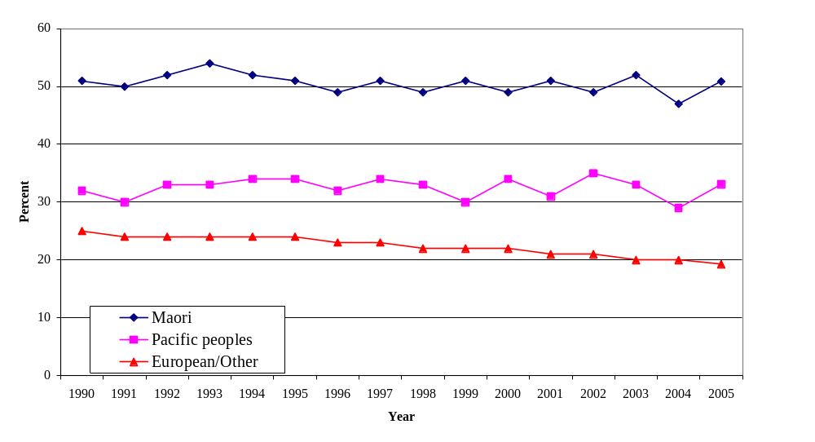
Supplementary tables in Appendix F give more detail, by age and gender, for the year 2004. Smoking prevalence is lower for females than males, with the exception of Māori. Prevalence is highest for the 25-34 age-group for all ethnicities. It then falls with increasing age, particularly for the 55+ age-group.

This means that the younger age structure of Māori and Pacific populations causes an apparent increase in their smoking prevalence rates relative to European/Other. Age-standardisation of prevalence rates reduces the gaps between ethnic groups a little, but they still remain substantial.

Prevalence, by Labour Force status, and by Household Income

Again the Nielsen survey data (tables in Appendix F) show substantial differences in smoking prevalence by socio-economic status, as by labour force status and household income, respectively. For instance, ‘Blue collar’ workers have a significantly higher prevalence than ‘White collar’ workers. Noteworthy is the very high smoking prevalence, nearly 50 percent, reported by Beneficiaries.

Examined by household income, prevalence is relatively high in the household income groups up to $60,000 per annum, and then falls away more or less steadily in the higher income groups.

Other sources of data on prevalence

Sources other than the Nielsen survey data cited above, such as the Census of Population and Dwellings, New Zealand Health Surveys, and the Household Economic Survey (for household purchases of tobacco products), show the same general picture – namely a high smoking prevalence for Māori, and a higher prevalence for people on lower incomes, or of lower socio-economic status on various dimensions (labour force status, educational attainment, etc), or living in more ‘deprived’ areas, as measured by the census-based Deprivation Index.

How many smokers are there?

It is of general interest, as well as useful for subsequent work, to calculate how many smokers there are. As shown in Table F.1 smokers in total number approximately three-quarters of a million, of whom just over 200,000 are Māori. The numbers for other years used elsewhere in this report (for instance in the Section A discussion of excise revenues per smoker) are derived similarly.

Table F.1 Number of Smokers - Total and Māori – Calendar Year 2005

All Māori
Ethnicities Ethnicity

Estimated Resident Population 15+ 3,220,990 411,050

Smoking prevalence 2005 (percent) 23.5 50.9

Number of smokers 757,000 209,000

Sources: Demographic Trends 2006. Tables 1.10 and 1.11
Tobacco Trends 2006. Table C.2

Similar tables have been calculated for ‘household’ smoking prevalence, showing the proportion of households in the Household Economic Survey (HES) that report purchasing tobacco products, and the proportion of individuals, adult and children, living in such households. These tables (D.1 and D.2) are given in Appendix D of Volume II. They draw on the special Household Economic Survey (HES) tables obtained for this report for June years 2000/01 and 2003/04. Thus in 2003/04 tobacco-purchasing households numbered 404,000 or 27 percent of all households in the surveyed population (which is very nearly the whole of New Zealand’s population). The number of adults (15+) living in these tobacco-purchasing households numbered 929,000 or 30.2 percent of all adults.

F.2 Health Inequalities caused by Tobacco; by Ethnicity and Socio-economic Status (SES)

Mortality from lung cancer

To quote the recent paper by Wilson, Blakely and Tobias, 2006 –
“Lung cancer is the cause of death that most directly reflects the (historic) burden of smoking.”

Drawing on the New Zealand Census-Mortality Study (NZCMS), the authors have calculated lung cancer mortality rates by ethnicity and household income for the 1980s and 1990s. The results of this analysis are shown in the excerpted Figure 1 on the following page.

In brief, Figure 1 shows large differences by ethnicity and income in lung cancer mortality, and trends in those differences, which can very plausibly be attributed to historic differences in smoking prevalence, and trends over recent decades in those differences. These would include the higher past prevalence rates for Māori and Pacific peoples, and, for the most recent periods, the widening gap in prevalence between them and the non- Māori/ non-Pacific ethnic group prevalence.

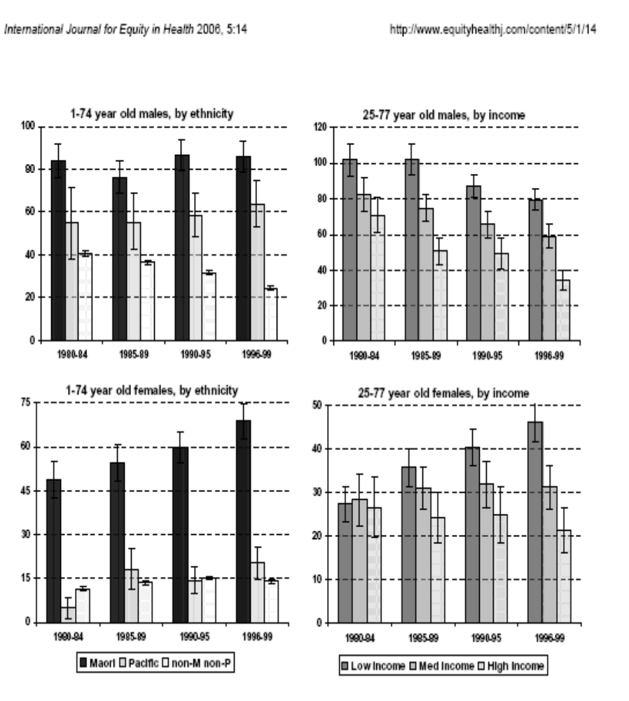

1Figure 1.
Age standardised lung cancer mortality rates in New Zealand by ethnicity and household income, males and females (per 100,000 population).

Source: Nick Wilson, Tony Blakely, Martin Tobias. November 2006. ‘What Potential has Tobacco Control for Reducing Health Inequalities? The New Zealand Situation.’ Int J Equity Health 2006 5:14 www.equityhealthj.com/content/5/1/14

Inequalities in Life Expectancy

A broader measure of health inequalities caused by smoking is given by differences in life expectancy attributable to smoking. One source for these for New Zealand is the set of abridged life tables prepared by the Ministry of Health in the course of work on the publication Inhaling Inequality, 2001. These were based on the Statistics NZ set of Abridged Life Tables for 1995-97, by ethnic group, and expanded to give life tables by Deprivation Level and for the ‘smoking-deleted’ population as well as total population.

Tables in the Statistical Appendix F in Volume II present materials derived from these Inhaling Inequality life tables. In particular they include the so-called ‘smoking-deleted’ tables, obtained in effect by removing the greater mortality experienced by smokers from the original life tables.

There is a degree of supposition in constructing such tables, particularly in estimating changes over time in the mortality of ‘ex-smokers’ after quitting smoking. Nevertheless the data in the tables gives a reasonable impression of the magnitudes involved. Life expectancy at birth in 1995-97 for Māori males was 8.4 years less than that for ‘European’ males; and for females the difference was 9.3 years. For the ‘Smoking-deleted’ numbers, the respective differences are 6.5 and 7.6 years. This does imply a significant contribution of smoking to ethnic life expectancy differences, of the order of one-fifth to one quarter of the differences between whole population groups.

The abridged life tables also give a break-down by Deprivation Group (a scale based on the level of ‘deprivation’ of the census mesh-block in which a person resides, with 1 being the least, and 10 the most, deprived) for Māori. The notable points are the much shorter life expectancies of those Māori in the worst Deprivation Groups, and the larger contributions made by smoking for those in these most deprived groups.

Overall the life tables point to substantial reductions in life expectancy for smokers. The reductions in life expectancy at birth appear to be of the order of 6 to 8 years for males, and of the order of 2.5 to 4 years for females.

The contribution of smoking to health inequalities

Clearly smokers suffer substantial ‘health losses’ from smoking. These losses are greater on average for those populations with higher rates of smoking. These are Māori, and Pacific peoples to a lesser degree, and those in lower socio-economic status groups.

A question sometimes raised is the extent to which smoking contributes to ethnic health inequalities, as against socio-economic determinants and other factors. From the results in Wilson et al; 2006, and excerpted above, it appears that the answer is that the contribution is not quite as substantial as might be expected. For the period 1996-99, Wilson et al state: –

“Regarding the gap in mortality between Māori and non- Māori /non-Pacific, 5% and 8% of this gap for men and women was estimated to be due to smoking.”

This as against their finding that 21% and 11% of the gap in mortality between low and high socio-economic groups for men and women is attributable to smoking.

The authors point out, however, that –

“Despite the modest relative contribution of smoking to these gaps, the absolute number of smoking-attributable deaths is sizable and amenable to policy and health sector responses.”

F.3. The potential health gains from a tobacco tax increase.

The reduction in the number of smokers to be expected from tobacco tax increases.

Appendix D in Volume II contains Household Economic Survey analyses of the number of households purchasing tobacco products by decile of household income, and of the number of persons living in tobacco-purchasing households by ethnicity. From this information estimates have been made of the distribution of smokers across household income deciles, and between Māori and non- Māori, for 2003/04. These are shown in the table following.

Table F.2 Number of Smokers 2003/04; by Household Income Decile and Māori / non- Māori ethnicity.
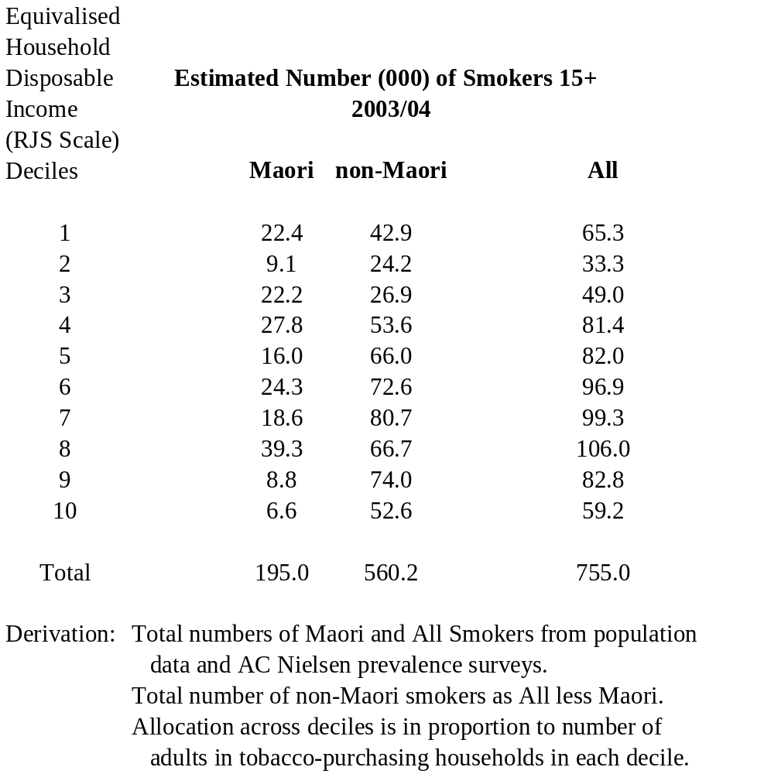

From the information in the previous table, and given an estimated value of the ‘prevalence elasticity’, it is possible to calculate how many fewer smokers there will be as a result of a tobacco tax increase.

For example, assuming a prevalence elasticity of –0.20, a tax and price increase of 20 percent will reduce both smoking prevalence and the number of smokers by 4 percent. That is, a smoking prevalence rate of 25 percent (as seen for the population as a whole) will be reduced to 24 percent, and a smoking prevalence rate of 50 percent (as seen among Māori) will be reduced to 48 percent.

Table F.3 provides the results of such calculations for tax increases leading to price increases of 20 and 50 percent respectively.

Table F.3 Estimated reduction in number of smokers for price increases of 20 percent and 50 percent.
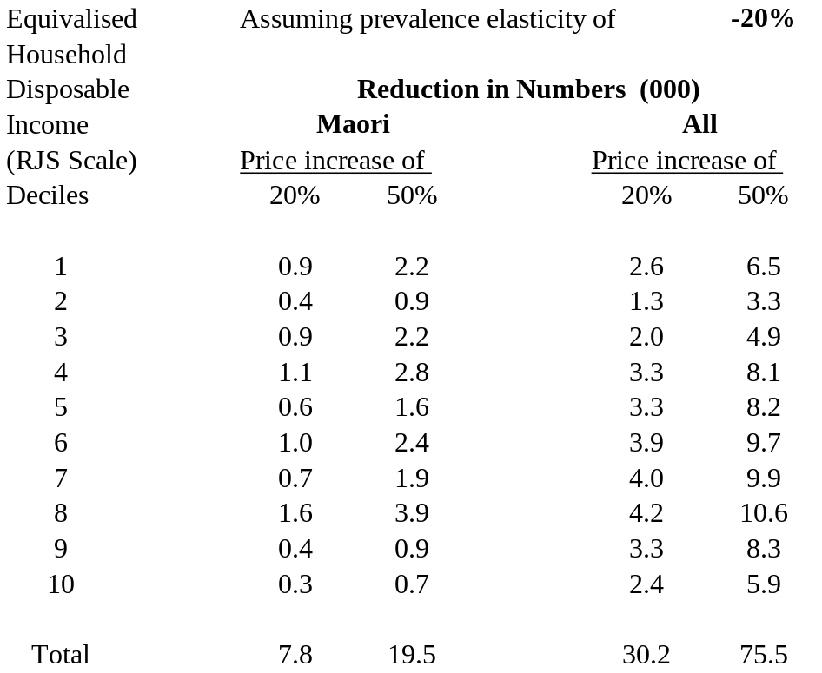

For the assumed prevalence elasticity of –0.20, a price increase of 20 percent leads to there being in total 7,800 fewer Māori smokers, and 30,200 fewer smokers of all ethnicities. The corresponding numbers for a 50 percent price increase would be 19,500 fewer Māori smokers and 75,500 fewer in all.

These reductions are quite substantial numbers, even if only a relatively small proportion of the total number of smokers. Their accuracy depends of course on the accuracy of the underlying numbers, in particular on the accuracy of the estimated prevalence elasticity (which could also vary between sub-populations). If the prevalence elasticity were halved to –0.10, the reduction in the number of smokers would be only half those shown in the table. Conversely a higher prevalence elasticity than –0.20 would give larger reductions in the number of smokers.

The reductions in numbers smoking are more concentrated in the lower income deciles for Māori than for the whole population. For example, 42 percent of the reduction for Māori occurs in the bottom four deciles, compared with 30 percent for all ethnicities. Thus the gain in health equity across incomes from a tobacco price increase would occur more for Māori.

The health gain to be expected from quitting in response to tobacco tax increases

The estimated potential life expectancy gains at birth discussed earlier are applicable only in the long term and where smoking is totally eliminated. They are not directly applicable to the situation in which a proportion of smokers quit following a tax increase. Those quitting will be adults, many middle-aged or elderly. Although some health gains from quitting occur fairly quickly, in particular reductions in cardio-vascular mortality, reductions in mortality from smoking-caused cancers occur less rapidly.

The actual health gains from quitting will therefore be less than the gains in life expectancy theoretically possible from the total elimination of smoking through a lifetime.

As guidance to the actual magnitude of the gains there is an important review by Woolacott et al, 2002; used in an earlier cost-effectiveness analysis of the Nicotine Replacement Therapy supplied by the Quit Group.

To quote from Woolacott et al:-

“An assessment of the results from the range of studies (see Appendix 10) and consideration of the results obtained by Doll and co-workers suggests that a figure of 1.0-3.0 life-years saved per long-term quitter seems reasonable.” (page 51)
And
“It appears that the number of QALYs per quitter should be around one-third greater than the number of life-years saved per quitter, but this requires further work and may well be sensitive to the discount rate (short-term losses and longer term gains in quality of life due to quitting)." (page 51)

For the New Zealand cost-utility analysis of NRT, the upshot was that 1.5 life-years and 2.0 QALYs (Quality-adjusted life years) were the assumed average health gains per smoker quitting for the remainder of their life. These gains were assumed to accrue 10 years after quitting. A discount rate of 5 percent per annum would therefore reduce the present value of these health gains by nearly 40 percent. That is to approximately 0.9 discounted life years and 1.2 discounted QALYs per lifetime quitter.

These numbers may seem conservative. And in fact there is reason to expect somewhat greater gains from persons quitting because of a tax increase compared to those simply trying to quit with the aid of NRT. This is because the price elasticity of demand has been shown in a number of studies to be higher for young people, and so those quitting, or not taking up smoking, as the result of a tax increase are likely to be a rather younger population than those seeking the aid of the Quit Group and NRT without being prompted by a tax increase. The potential lifetime gains would therefore be higher.

One further possible source of health gain is among smokers who do not quit, but do cut back on consumption because of a tax increase. Unfortunately, and counter-intuitively, the available research suggests that there is little, if any, such gain. At least, this is the conclusion reached in two recent papers, by Godtfredsen et al (2002) and Tverdal and Bjartveit K (2006), for Danish and Norwegian populations respectively.

In summary, the average health gains to be expected for a person quitting for life because of a tax increase are expected to be of the order of 1.5 life-years, or, more generally, 2.0 QALYs, before discounting. These estimates are likely to be conservative. It can be noted also that some reduction can be expected in Environmental Tobacco Smoke (ETS) and therefore some reduction in mortality from second-hand smoking.

The following table F.4 gives the estimated gain in QALYs corresponding to the reduction in numbers of smokers given in Table F.3. For a 20 percent price rise the estimated gain for the whole population is 60,400 QALYs, undiscounted, of which total 15,600, or 26 percent, accrue to Māori. For a 50 percent price rise the numbers scale up accordingly to 151,000 and 39,000 QALYs respectively.

The second part of the table gives discounted QALYs. It assumes a discount rate of 5 percent per annum, and that the health gains accrue after a period of 10 years

The accuracy of such estimates depends on the accuracy of the underlying assumptions. In particular of the assumptions on life-years and QALYs gained per smoker ‘quitting’ – which are likely to be on the conservative side – and the assumption of a constant ‘prevalence elasticity’ across all groups of –0.20. We do not have very robust information on the accuracy of this last assumption (for further discussion see the material on elasticities in Part A of this report, and Appendix B).

Table F.4 Estimated Quality-adjusted Life-year (QALY) gains for price increases of 20 per cent and 50 percent.

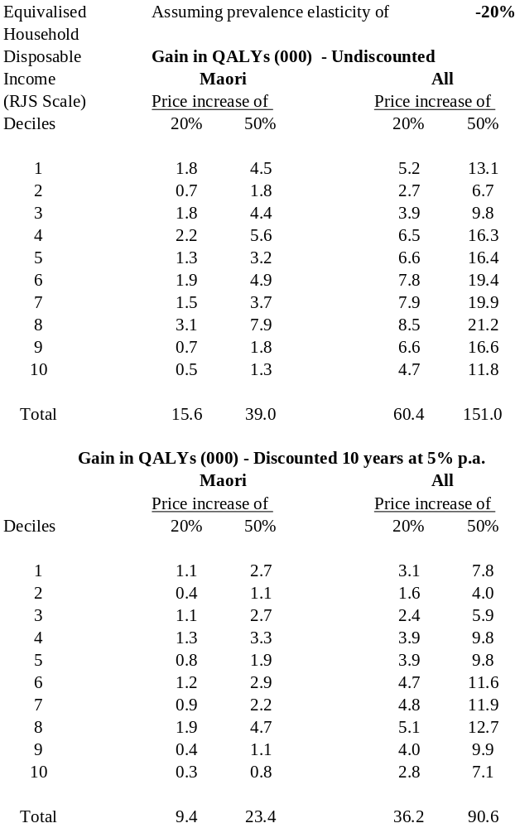

Contribution of the estimated health gains to reducing inequalities, particularly ethnic inequalities.

The projected health gains from reduced prevalence are greater for Māori, and for those in lower household income brackets. This is simply because of the higher prevalence of smoking by Māori and in lower socio-economic status groups, combined with the assumption of a constant prevalence elasticity across all groups. The projected health gains from lower smoking prevalence should therefore reduce absolute gaps in health outcomes. E.g. the average health improvement for Māori overall from a reduction in prevalence from 50 to 45 percent should be greater than for a non-Māori reduction in prevalence from 25 to 22.5 percent. It is less certain whether in addition relative gaps will be reduced, this depending on the interaction of ethnic and socio-economic factors.

Why the high smoking prevalence of Māori?

A striking feature of the trends in smoking prevalence in recent decades is that the prevalence of smoking among Māori has not fallen to anywhere near the extent of the fall in smoking prevalence for the population as a whole. This implies a much lower prevalence elasticity, possibly even zero, for Māori than for non- Māori. It invites questions as to why this might be so.

Dr Gifford’s thesis (2003) examines the issues. She discusses the strong link between smoking and wider socio-economic determinants. In particular, stress linked with a range of issues such as poverty, family violence, and limited control. Her advice regarding tobacco control intervention is that policies and interventions need to be embedded in broader social change that will impact on the socio-economic and cultural determinants of smoking for this population group. She states:

“ In the longer term, the prevalence and social costs of tobacco use can be reduced most effectively and substantially through the adoption of whānau-centred policies aimed at preventing tamariki and rangatahi from initiating tobacco use. “ (Page 3.)

Impact of lower incomes on health

One further issue can be dealt with at this point. A tax increase in effect lowers on average the disposable income available for other purposes for those who do not quit smoking. It is known that ‘health state’ and income have a statistical association - poorer health is associated with lower income levels. It is possible therefore that tax increases will, by reducing available income, lead to a deterioration in average population health.

This issue has been investigated by Wilson et al (2004). They concluded that –

“The estimated harm to life expectancy from tobacco taxation (via financial hardship) is orders of magnitude smaller than the harm from smoking. Although the analyses involve a number of simplistic assumptions, this conclusion is likely to be robust. Policy makers should be reassured that tobacco taxation is likely to be achieving far more benefit than harm in the general population and in socioeconomically deprived populations.” (Page 451.)

This conclusion is for populations including households without any smokers, as well as with smokers. While the harm from tobacco taxation for populations of just those households with smokers would be larger, it is still likely to be orders of magnitude smaller than the harm from smoking.

F.4 The magnitude of the financial burdens of tobacco tax increases, and where they fall.

Household Economic Survey (HES) data on tobacco expenditure.

The previous section discussed health gains from tobacco taxation, and the potential effect on health inequalities. This section discusses the potential impact on household finances, and in particular the impact on those in the lowest income groups.

The detailed calculations underlying the discussion here are spelt out in Appendix D, Volume II, analysing tables obtained from the Household Economic Survey (HES) for 2000/01 and 2003/04. These tables give details on expenditure on tobacco products, by decile of household income (equivalised disposable income), so that average spending on tobacco products can be calculated both for all households and for the sub-set of households who report purchases of tobacco products. There is also data on the ethnic composition of both households purchasing tobacco products and those not.

A first issue is that of “under-reporting”. Analyses given in detail in Appendix E of Volume II show that only some 45 to 50 percent of expenditure on tobacco products is actually reported by respondents to the Household Economic Survey. In the tables below this is corrected for by assuming that the degree of under-reporting is 50 percent across all household categories, and survey reported expenditure has therefore been doubled to allow for this.

Some results from the detailed Appendix D analyses are as follows:

- The proportion of households purchasing tobacco products has been falling over time.
- Average expenditure on tobacco, both for all households and ‘purchasing’ households, has been falling over time, though this is less clear for purchasing households in recent years.
- There is perhaps some concentration of tobacco-purchasing in lower-income deciles, though this is less certain than might be expected. Equivalised household income appears to be less correlated with smoking than other measures of socio-economic status, such as ‘actual’ income, and the deprivation index.
- Higher-income purchasing households report spending substantially more on average on tobacco products than do lower-income households.
- However, expenditure on tobacco products as a percent of total household spending of purchasing households is considerably higher for low-income deciles than for high-income deciles – at around 7 percent for Decile 2 (Decile 1 is ‘anomalous’ in its composition) against 4 percent or less for the four highest income deciles.

Calculation of the impact across deciles of tobacco tax increases

Tables F.5 and F.6, taken from Appendix D of Volume II, show the estimated impact of tax-caused price increases on spending of ‘non-quitting’ households, first for a price increase of 20 percent, and then 50 percent. This is for HES data for the year 2003/04.

The assumptions about price elasticities underlying the numbers are –

- That the overall price elasticity of demand for tobacco has a value of –0.5. The meaning of this is that, for a price rise of 20 percent, the quantity of cigarettes purchased will fall 10 percent, but because of the 20 percent price rise, spending will still increase by a net 10 percent.
- Also that the ‘price elasticity of smoking prevalence’ has a value of –0.20 (meaning that a price increase of 20 percent will lead to a reduction in prevalence of 4 percent; that is for a prevalence of 25 percent a reduction of 1 percent to 24 percent).
- From these two elasticities the ‘non-quitting price elasticity of demand’ has a value of –0.30. This is for purchases by ‘non-quitters’. This means that quantities purchased by ‘non-quitters’ would fall 6 percent for a 20 percent price rise, but spending would still increase by a net 14 percent.
- It is also assumed here that these elasticities apply to households in the same way as to individuals.

For a 20 percent price rise, the extra spending by non-quitting households averages $510 per year (or nearly $10 per week) if under-reporting is allowed for. This amounts to about 1.2 percent of average annual total household expenditure on all goods and services ($43,400), and about 1.1 percent of average annual actual household disposable income ($46,150). The amounts increase proportionately for a price rise of 50 percent.

Increases of such magnitude will not cause undue financial hardship for most households in higher income brackets. The impact will, however, be more painful in the bottom income brackets. Additional spending amounts to $8 or $9 per week on average for Decile 2 and Decile 3 households, for a 20 percent price increase, after correcting for under-reporting. These amounts may appear small. They are not so for Decile 2 households on an average weekly disposable income of around $350. (Annual average actual disposable income in this decile was $18,300 in 2003/04, and in Decile 3 $22,400.)

Offsetting these increases for ‘non-quitters’ are of course the reduction in expenditure by those households which quit spending on tobacco products. This saving – in terms of ‘post-tax’ prices, for a price increase of 20 percent - amounts to a substantial $3,837 a year per ‘quitting’ household, averaged over all income deciles. For lower income deciles the annual savings from quitting would amount to $3,043 in Decile 2 ($59 per week), and $3,441 in Decile 3 ($66 per week).
Table F.5 Effect of a 20 percent real price rise on tobacco purchases.
Using 2003/04 HES data.

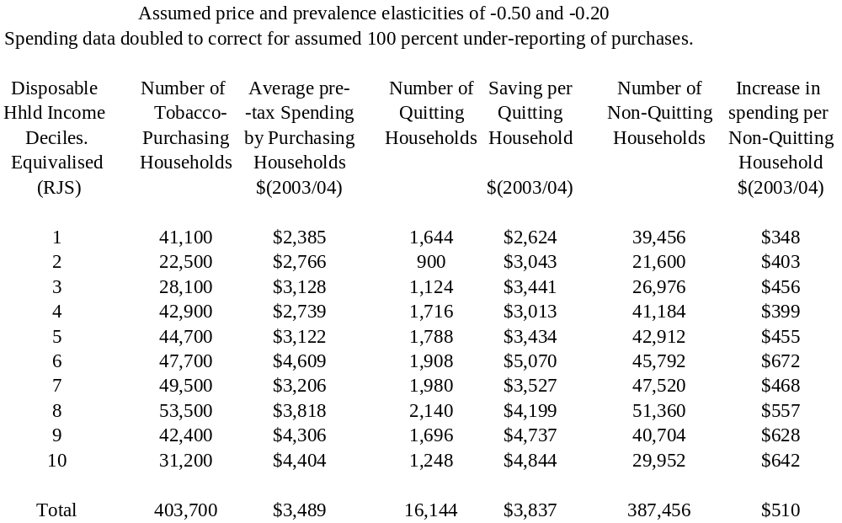

Table F.6 Effect of a 50 percent real price rise on tobacco purchases.
Using 2003/04 HES data.

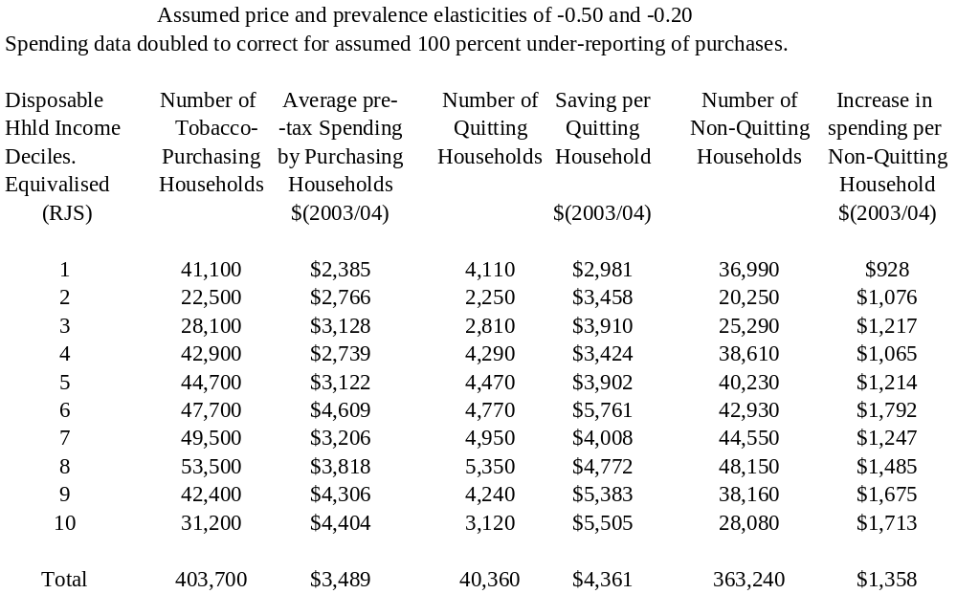

Financial Impact on Māori.

The impact on Māori will be more severe, because more smoke, and more are members of lower-income households. Table F.7 shows the spread of Pākehā and Māori adult populations respectively across deciles for 2003/04.The right-hand columns are for all households, whether purchasing tobacco products or not. Māori are significantly more concentrated in the lower-income deciles, Pākehā in the higher-income deciles. The left-hand columns are restricted to those adults who are members of tobacco-purchasing households. The relative concentration of Māori in lower income deciles is even more marked.

Table F.7 Decile proportions by ethnicity – Pakeha, Māori, and All. 2003/04.

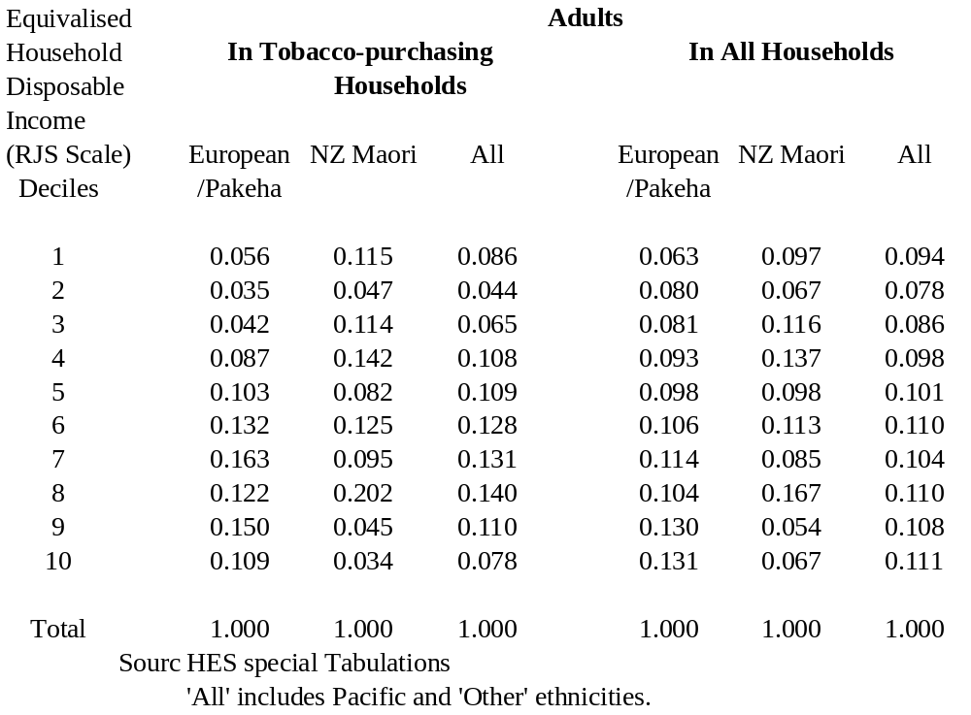

F.5 Policy Trade-offs.

The results above pose a policy dilemma. A tobacco tax increase generates gains for some people, and losses for others, as follows –

Gains
- Significant ‘Health Gains’ for those quitting. Even for relatively small numbers quitting, the value generally given to QALYs gained would equate to a very substantial benefit in dollar terms.
- Significant financial gains for those quitting.
- Reductions in the externality costs associated with smoking.

Losses
- For those not quitting, additional financial pressures on average, bearing particularly heavily on low-income households, including a disproportionate number of Māori.

The gains and losses can be tabulated as in tables F.8 and F.9 following. Table F.8 is for households, and Table F.9 for individuals. The numbers given are for a tax-caused price increase of 20 percent, and assuming a prevalence elasticity of –0.20. The costs and savings given are household financial costs only, not including wider social costs such as lost production and smoking-caused health-care costs. Likewise health gains are for only those directly affected, not including health gains from reduced second-hand smoking, which might add up to another tenth to the total health gain.

The most important result in the table is that which shows the gains for ‘quitting’ households and individuals – those who actually quit plus those who are influenced to not start smoking – as a result of the postulated tax increase. The financial gains for such households average around $3,800 per year, and for individual persons quitting average around $2,200 per year. The aggregate of these financial gains is less than the aggregate financial losses for ‘non-quitters’. But for individual ‘quitter’ households and persons the financial gains are very substantial. The health gains are still more significant, being a conservatively estimated two QALYs on average for each person quitting permanently. If a $ value of $50,000 per QALY is put on these, as at the bottom of Table F.9, the total ‘lifetime health gains’ measured in $ terms from quitting in response to the tax-caused price increase amount to over $3 billion.

Table F.8 Gains and Losses on average for Households.

Tax-caused price increase of 20%.

2003/04 data.
Assumed Prevalence Elasticity of –0.20

Category Number Health Gains Financial Gains/
affected Losses per year.
$(2003/04)
(in post-tax prices)

Tobacco purchasing

households in all

income deciles:

- continuing to purchase 387,500 None. Loss $510 / hhld.

- ceasing to purchase 16,150 2 QALYs per Gain $3,837 / hhld.
person quitting
-------- permanently.
403,650

Tobacco purchasing

households in four

bottom deciles:

- continuing to purchase 129,200 None. Loss $396 / hhld.

- ceasing to purchase 5,400 2 QALYs per Gain $2,988 / hhld.
person quitting
-------- permanently.
134,600

Financial impacts per year summed over ‘Gainer’ and ‘Loser’ households :

All income deciles Gainers +$62.0 mn Losers -$197.6 mn

Bottom 4 deciles Gainers +$16.1 mn Losers -$ 51.2 mn

Source: Table F.5.

Table F.9 Gains and Losses on average for Individuals.

Tax-caused price increase of 20%.
2003/04 data. Assumed Prevalence Elasticity of –0.20
Category Number Health Gains Financial Gains/Losses
affected per year. $(2003/04) (in post-tax prices)

Pre-increase smokers of all ethnicities:
- Non-quitters 725,000 None. Loss $280 / person

- Quitters 30,200 2 QALYs per Gain $2,200 /person
person quitting
-------- permanently.
755,200

Pre-increase Māori smokers:

- Non-quitters 187,000 None. Loss $280 / person

- Quitters 7,800 2 QALYs per Gain $2,200 /person
person quitting
-------- permanently.
194,800

Financial impacts per year summed for ‘Quitters’ and ‘Non-Quitters’ :

All ethnicities: Quitters +$66.4 mn. Non-Quitters - $203 mn.

Māori: Quitters +$17.2 mn Non-Quitters -$52.4 mn

Plus value of lifetime ‘health gains’
If valued at a conservative $50,000 per QALY

All ethnicities: 60,400 QALYs of total value + $3,020.0 mn.

Māori: 15,600 QALYs of total value + $ 780.0 mn

-------------------------------------------------------------------------------------------------------

Sources: Statistics NZ resident population estimates.
Nielsen survey smoking prevalences by ethnicity.
Individual expenditure averages based on total sales for 2004 of $1,525 mn (Laugesen, 2005), for 755,000 smokers in 2003/04. That is, $2,020 per smoker, in 2003/04 prices. The average saving of $2,200 by ‘quitters’ is ‘post-tax’, including the effect on expenditure of the tax rise.
Māori average consumption per smoker can reasonably be assumed to approximately equal total population average consumption per smoker, from the self-reported data (Light/Moderate/Heavy) in Tobacco Trends 2006, Table 6, page 15.

The gains from ‘quitting’ are substantial for both individuals and in aggregate, indeed huge in $ terms if a $ value is placed on the QALY health gains. The offset is the financial pressure put on ‘non-quitting’ households by a tax increase. There is no easy policy solution to the trade-off. The broad options are –

- To give up the use of taxation as a policy instrument for reducing smoking prevalence.
- To associate with the tax increases other control measures aimed at raising quit rates, especially among the less well-off and among Māori.
- To accompany tax increases with measures to redistribute income towards lower-income households (but not specifically smoking households) so as to reduce the financial impacts of tobacco taxation increases.

Option (a) should be rejected. To not use tobacco taxation as an instrument of tobacco control would be to give up one of the most effective interventions for bringing about smoking cessation. The results in the last table are strong evidence for the benefits gained from tobacco taxation.

Option © appears tempting, but could require fiscal intervention and income redistribution on a scale which might not be acceptable to governments or society as a whole. Or put another way, smoking cessation objectives, while important, are not so important that they should be the major driver of government’s income redistribution policies. At the same time, moves to improve a wider range of social and economic indicators for Māori and low-income (or high ‘deprivation index’) households, desirable in themselves, will also help lessen any adverse impacts of tobacco taxation, and, from the material quoted earlier from Gifford (2003), help make tobacco control measures more productive.

Option (b) must therefore be persevered with, retaining tobacco taxation increases as an important tool for reducing smoking, but recognising the need to supplement these with other tobacco control policies. A more detailed discussion of these issues is contained in Wilson and Thomson, 2005. In general, taxation and other tobacco control policies need to be better coordinated, as discussed in the associated report by Thomson; 2007.

These supplementary policies would also help to address the ethical and equity issues around using a lethal, addictive substance to raise general government revenue (see discussion in the associated report by Thomson. 2007).

A substantial component of these supplementary polices, and the resources to ensure their success, needs to be targeted at low-income households, including in particular beneficiaries, and Māori, and also Pacific peoples. Māori presently account for about 27.5 percent of all smokers (209,000 of 757,000). Pacific people account for another few percent.

F.6 Conclusions and Recommendations

To quote an earlier report (Thomson et al. 2000. Page 39.) –

“Tobacco taxes are a broad impact intervention. They benefit smokers who quit, reduce the consumption of tobacco and make quitting attempts move up the personal agenda of smokers who continue to smoke. They benefit non-smokers exposed to second-hand smoke, and young people who are less likely to smoke.”

All these benefits still hold. Tobacco tax increases bear heavily, however, on those ‘tobacco-purchasing’ households who do not succeed in ‘quitting’, more particularly on low-income households, quite a high proportion of whose members are Māori. Against this, those households, and individuals, who do ‘quit’ in response to a tobacco tax increase make useful financial savings in addition to the ‘health gains’ received by the ‘quitting’ individuals.

An effective tobacco-control policy should continue to have as one of its main components the use of high and increasing tobacco tax rates. The ethical and equity impacts of such a policy need, however, to be addressed. We believe, as discussed in earlier sections of this report and in the associated report by George Thomson, that this can be done by dedicating a substantial proportion of tobacco tax revenues to assisting smokers to quit and to preventing others from taking up smoking, particularly the young. These measures should put considerable emphasis on assisting those populations with a high prevalence of smoking, namely those on lower incomes, and Māori and Pacific populations.

Recommendations

- That the use of high and increasing rates of tobacco taxation remain a core component of tobacco control policies.

- That tobacco taxation policies be integrated where possible with overall government policies to reduce social and economic inequalities and to ensure the fulfillment of Treaty of Waitangi obligations.

- That the regressive impact of tobacco tax increases on low-income households and on Māori and Pacific peoples be ameliorated by allocation of a substantial proportion of tobacco control resources to assist smoking cessation by these populations.

- That tobacco control resources targeted at Māori and Pacific peoples be in general used for intervention programmes designed and administered by Māori and Pacific peoples.

G: Summary of Recommendations on Tobacco Taxation Policy

The principal recommendations in this report on future Tobacco Taxation policy are listed below, with some of the supporting reasoning. They relate to

- The future setting of tobacco tax rates
- Dedication of a share of tobacco tax revenues to tobacco control measures
- Equity and Treaty of Waitangi issues

Tobacco Tax Rates and Taxation Mechanisms
(from Section A)

Conclusions

We note that –

- High tobacco tax rates are a valuable tool for deterring smoking, promoting smoking cessation and improving the public health;
- and that, in recognition of this, there were substantial real increases in tobacco tax rates during the 1980s, leading to real price increases of the order of 25 percent or more in 1986 and 1988/89;
- followed by further substantial tax increases leading to real price increases of 15 to 20 percent, in 1991, 1998, and 2000.

We note also that –

- There has been no increase in tobacco tax rates, other than the annual increases to maintain pace with inflation, in the seven years since 2000;
- and that average incomes have been increasing faster than inflation over this period, making tobacco products more ‘affordable’;
- and that although the overall trend in consumption of tobacco products per head is downward, New Zealand’s smoking prevalence rate of 23.5 percent of adults in 2006 is higher than that seen in comparable jurisdictions, and is falling only very gradually.:
- and that high rates of tobacco smoking have persisted for some population groups, particularly Māori, Pacific Islanders and people living in socio-economically disadvantaged communities.

We recommend:

A.1 That government adopt an explicit, planned, long term tobacco tax strategy as a key component of its tobacco control strategy.

A.2 That tobacco taxes should be presented and justified as a public health measure, and levied in such a way as to maximise the public health benefit.

A.3 That as part of a medium or long term tobacco tax strategy there should be further continued substantial increases in tobacco taxation, justifiable in terms of the health benefits to be expected, and by the fact there has been no real increase in tobacco tax rates since the year 2000.

A.4 That such increases should be either of the order of ten percent annually or of the order of twenty to thirty percent every two to three years, with a provisional target of doubling the real cost of tobacco (in terms of affordability) within ten years. The objective of these increases is to contribute to the reduction of smoking prevalence to less than 10 percent, for all ethnic and socio-economic groups, within ten years.

A.5 That the first such increase take place in 2008.

A.6 That prior to any such increases, appropriate additional resources be in place ready to help the expected increase in quit attempts, in particular those by high smoking prevalence groups such as Māori and Pacific peoples, and that the availability of such resources be announced at the same time as the announcement of the tax increases and accompanied by health promotion campaigns to promote quitting.

A.7 That the proposed increases be in addition to the present annual indexation of tobacco tax rates.

A.8 That this indexation should in future be based on annual increases in average incomes, Average Weekly Earnings (AWE) being the preferred benchmark, rather than on annual increases in consumer prices, as at present (it is anticipated this would increase prices by about an annual 1 percent extra above inflation).

A.9 That the annual date at which indexation increases, and tax increases in general, take place should be changed from 1 December, being too near the start of the summer holiday period, with the preferred date being 1 March.

A.10 That indexation on the suggested new basis should begin from the next suitable indexation date.

A.11 That changes in the relativity of tax rates on factory-made and roll-your-own cigarettes should be urgently considered, to ensure that smokers are not continuing to smoke rather than quitting, because of the availability of cheaper hand-rolled cigarettes.

Dedication of a share of tobacco tax revenues to
Tobacco Control measures
(from separate paper by G. Thomson).

The following are the conclusions and recommendations, included here for convenient reference, of the separate report ‘Dedicated tobacco taxes - experiences and arguments’ by George Thomson.

Conclusions

- Tobacco control measures in New Zealand are currently under-funded, both on a comparative cost-effectiveness basis, and in the light of the government’s stated health priorities. There is evidence that policy makers find it difficult to allocate funding to preventive services and programmes, particularly where the benefits are not clearly tangible and are in the long term, and particularly in the face of competing pressures from immediate health care deficiencies and resource shortfalls.

- One option for helping ensure that government’s stated priority on tobacco control is matched by adequate funding, is to have part or all of tobacco tax revenue dedicated to tobacco control spending.

- There are a number of precedents for such dedicated tax revenue in New Zealand and elsewhere. Research indicates that there is far greater support for dedicating tobacco tax revenue when the revenue is spent on tobacco control efforts.

- Dedicating tobacco tax revenue for tobacco control helps to address the ethical and equity issues of using a lethal, addictive substance to raise general government revenue, and the economic hardship potentially caused low-income smokers.

- If tobacco tax revenue is dedicated for tobacco control, consideration needs to be given to:

- The amount of the funding
- Annual adjustments in the amount of funding, and how these adjustments might be linked to changes in overall tobacco tax revenues.
- The structure and degree of autonomy of the agency administering the funding
- Ways of ensuring uses of the fund which meet the criteria commonly applied to health-care funding decisions, including cost-effectiveness and improving the equity of health outcomes.

The recommendations are:

D.1 That an increasing portion of the tobacco tax revenue be dedicated to tobacco control activities encouraging and assisting smokers to cease smoking and deterring non-smokers from starting smoking.

D.2 That the initial amount of dedicated tax revenue should be at least $100 million, (compared to current spending on these activities of approximately $40 million), and should be targeted initially to increase to at least $200 million within five years.

D.3 That the objective of this dedication of revenue should be to reduce the smoking prevalence (including that by Māori and Pacific) to less than one per cent within 20 years, and less than 10 percent for all groups within ten years.

D.4 That the administration of the dedicated revenue be structured to ensure that the revenue is:
  - Not diverted to other uses nor eroded in value over time.
  - Used effectively, with continued evaluation of results against objectives.
  - Sufficiently and effectively devolved to regional and local tobacco control efforts.
- Used so that tobacco-related inequalities are reduced, and so that power and resources are devolved to Māori and other disadvantaged groups.

Equity Issues (from Section F)

Conclusions.

To quote an earlier report (Thomson et al. 2000. Page 39.) –

“Tobacco taxes are a broad impact intervention. They benefit smokers who quit, reduce the consumption of tobacco and make quitting attempts move up the personal agenda of smokers who continue to smoke. They benefit non-smokers exposed to second-hand smoke, and young people who are less likely to smoke.”

All these benefits still hold. Tobacco tax increases bear heavily, however, on those ‘tobacco-purchasing’ households who do not succeed in ‘quitting’, more particularly on low-income households, a high proportion of whose members are Māori. Against this, those households, and individuals, who do ‘quit’ in response to a tobacco tax increase make useful financial savings in addition to the ‘health gains’ received by the ‘quitting’ individuals.

An effective tobacco-control policy should continue to have as one of its main components the use of high and increasing tobacco tax rates. The ethical and equity impacts of such a policy need, however, to be addressed. We believe, as discussed in the accompanying report, that this can be done by dedicating a substantial proportion of tobacco tax revenues to assisting smokers to quit and to preventing others from taking up smoking, particularly the young. These measures should put considerable emphasis on assisting those populations with a high prevalence of smoking, namely those on lower incomes, and Māori and Pacific populations.

Recommendations

- That the use of high and increasing rates of tobacco taxation remain a core component of tobacco control policies.

- That tobacco taxation policies be integrated where possible with overall government policies to reduce social and economic inequalities and to ensure the fulfillment of Treaty of Waitangi obligations.

- That the regressive impact of tobacco tax increases on low-income households and on Māori and Pacific peoples be ameliorated by allocation of a substantial proportion of tobacco control resources to assist smoking cessation by these populations.

- That tobacco control resources targeted at Māori and Pacific peoples be in general used for intervention programmes designed and administered by Māori and Pacific peoples.

References

Ahmad S 2005. Increasing excise taxes on cigarettes in California: a dynamic simulation of health and economic impacts. Preventive Medicine 41 (2005) 276– 283

Australian Bureau of Statistics (ABS) 2006. National Health Survey: Summary of Results. www.ausstats.abs.gov.au

Australian Institute of Health and Welfare (AIHW) 2002. 2001 National Drug Strategy Household Survey. www.aihw.gov.au

Australian Institute of Health and Welfare (AIHW) 2005. 2004 National Drug Strategy Household Survey. www.aihw.gov.au

Blakely T, Tobias M, Robson B, Ajwani S, Bonne M, & Woodward A. 2005. Widening ethnic mortality disparities in New Zealand 1981-99. Soc Sci Med 61 (2005) 2233-2251

Blakely, T, Fawcett, J, Hunt, D, & Wilson, N. 2006. What is the contribution of smoking and socioeconomic position to ethnic inequalities in mortality in New Zealand? Lancet. 368(9529):44-52, 2006 Jul 1.

Bonneux L, Barendregt J J, Nusselder W J, and Van der Maas P J (1998). “Preventing fatal diseases increases healthcare costs: cause elimination life table approach.” BMJ 1998;316: 26-29 (3 January).

Bridge J and Turpin B. 2004. The Cost of Smoking in British Columbia and the Economics of Tobacco Control. Report for Health Canada.

Busschbach J J V., Hessing D J., and de Charro F Th. (1993). ‘The Utility of Health at Different Stages in Life: A Quantitative Approach.’ Soc. Sci. Med. Vol. 37, No. 2. Pp. 153-158.

Canadian Centre on Substance Abuse, 2006. ‘The Costs of Substance Abuse in Canada 2002.’ www.smoke-free.ca

Canadian Coalition for Action on Tobacco. January 2004. A Win-Win: Enhancing Public Health and Public Revenue. Recommendations to Increase Tobacco Taxes. Submission to Minister of Finance, Canada.

Cancer Society of New Zealand (Inc). 2000. Author Murray Laugesen. Tobacco Statistics 2000. Wellington, NZ

Centers for Disease Control and Prevention. Annual Smoking-Attributable Mortality, Years of Potential Life Lost, and Productivity Losses—United States, 1997–2001. Morbidity and Mortality Weekly Report 2005;54:625-628. Available at http://www.cdc.gov/mmwr/preview/mmwrhtml/mm5425a1.htm.

Cnossen S. ‘Taxing Tobacco in the European Union’ 2001 Erasmus University Rotterdam. OCFEB Research Centre for Economic Policy Research Memorandum 0104. ISBN 90-5539-109-3

DJ Collins and HM Lapsley. 2002. Counting the cost: estimates of the social costs of drug abuse in Australia in 1998-9. Commonwealth Department of Health and Ageing.

DJ Collins and HM Lapsley. August 2005. Counting the costs of tobacco and the benefits of reducing smoking prevalence in NSW. Report for NSW Department of Health. August 2005.

Dee, T. S., (1999) The complementarity of teen smoking and drinking. J Health Econ 18, 769-93.

Department of Health. 1992. Drug Statistics 1992.

Devlin N, Hansen P, and Herbison P (2000). “Variations in self-reported health status results from a New Zealand survey.” New Zealand Medical Journal. 8 December 2000. 113: 517-20.

Easton B (April 1997). The Social Costs of Tobacco Use and Alcohol Misuse. Public Health Monograph Series No. 2. Department of Public Health, Wellington School of Medicine, University of Otago.

Edwards, R., Bullen, C., O'Dea, D. et al, (2006) After the smoke has cleared: Evaluation of the impact of a new smokefree law (A report commissioned by the New Zealand Ministry of Health). Wellington: University of Otago, Auckland University, and the Health Sponsorship Council. http://www.moh.govt.nz/moh.nsf/pagesmh/5599/$File/smokefree-evaluation-summary-dec06.pdf

Evans L, Meads C. An Empirical Study of the Effects of Advertising, Prices and
Income on Cigarette Consumption in New Zealand. Victoria University of
Wellington. 1991.

Fishman P A; Ebel B E; Garrison M M; Christakis D A, Wiehe S E; and Rivara F P (2005). ‘Cigarette tax increase and media campaign cost of reducing smoking-related deaths’. American Journal of Preventive Medicine 2005 July; 29(1): 19-26

Gallet C.A. and List J.A. 2003 . ‘Cigarette Demand: a meta-analysis of elasticities’ Health Economics 12: 821-835

Gifford, Heather. October 2003. He Arorangi Whakamua. Reducing the uptake of tobacco in Ngāti Hauiti Rangatahi. Ph.D. Thesis (unpublished), Massey University, New Zealand.

Godtfredsen N S, Holst C, Prescott E, Vestbo J, and Osler M. (2002). ‘Smoking Reduction, Smoking Cessation, and Mortality: A 16-year Follow-up of 19,732 Men and Women from the Copenhagen Centre for Prospective Population Studies.’ American Journal of Epidemiology. 2002; 156:994-1001. http://aje.oupjournals.org

Gruber J, and Koszegi B. (2000). ‘Is Addiction “Rational”? Theory and Evidence.’ NBER Working Paper 7507. National Bureau of Economic Research. January 2000.

Jha, P., Chaloupka, F., Corrao, M. & Jacob, B., (2006) Reducing the burden of smoking world-wide: effectiveness of interventions and their coverage. Drug Alcohol Rev 25, 597-609.

Jha, P. & Chaloupka, F. J., (1999) Curbing the Epidemic: Government and the economics of tobacco control. Washington DC: The World Bank.

Jha, P. & Chaloupka, F. J., (2000) The economics of global tobacco control. BMJ 321, 358-61.

Kaplan R; Ake C; Emery S; and Navarro A. 2001. ‘Simulated Effect of Tobacco Tax Variation on Population Health in California.’ Am. J. Pub. Health. Feb 2001, Vol. 91, No.2.

Laugesen M. 1992. Tobacco Statistics 1991: trends in tobacco consumption and smoking prevalence in New Zealand. Published jointly by Department of Health and Department of Statistics.

Laugesen M, Clements M. Cigarette Smoking Mortality among Māori, 1954-2028.
Wellington: Ministry of Māori Development; 1998.

Laugesen M. 2000. See Cancer Society of New Zealand.

Laugesen, Murray Undated. 2003? Tobacco Taxation and Smuggling Control: New Zealand. New Zealand Health Ltd paper for WHO.

Laugesen M. 31 July 2006. Tobacco returns for the 2005 calendar year. Report to the Ministry of Health by Health New Zealand Ltd. www.ndp.govt.nz/tobacco/tobaccoreturns

Laugesen M. 22 July 2005. Tobacco returns for the 2004 calendar year. Report to the Ministry of Health by Health New Zealand Ltd. www.ndp.govt.nz/tobacco/tobaccoreturns

Manning W G, Keeler E B, Newhouse J P, Sloss E M, and Wasserman J (1991). The Costs of Poor Health Habits. A RAND Study. Harvard University Press.

Miller T, and Guria J (May 1991), “The Value of Statistical Life in New Zealand”, Land Transport Division, Ministry of Transport, Wellington.

Ministry of Health. 1992. Tobacco Statistics 1991. See Laugesen 1992.

Ministry of Health and the Cancer Society of New Zealand (Inc.) 1996. Tobacco Statistics 1996.

Ministry of Health. 1999. Our Health: Our Future.

Ministry of Health. The Burden of Disease and Injury in New Zealand. January 2001. Public Health Intelligence Occasional Bulletin No 1.

Ministry of Health. 2001. Inhaling Inequality: Tobacco’s contribution to health inequality in New Zealand. Public Health Intelligence Occasional Bulletin No. 7.

Ministry of Health (Matthew Allen and Murray Laugesen). May 2000.

Tobacco Tax – The New Zealand experience. Two-page brochure of information.

Ministry of Health and the Quit Group. April 2006. Māori Smoking and Tobacco Use. Fact Sheet 1.

Ministry of Health, December 2006. Tobacco Trends 2006. Monitoring tobacco use in New Zealand.

National Cancer Institute (NCI). 2004. ‘Tobacco and Cancer: Recent Epidemiological Evidence’. Journal of the National Cancer Institute, Vol. 96. No. 2, January 21, 2004. Commentary. 99-106.

O’Dea D. June 2004. An Economic Evaluation of the Quitline Nicotine Replacement Therapy (NRT) Service. Report to the New Zealand Ministry of Health.

Peck Richard N Date not given. About 2001. Equity Issues, Tobacco, and the Poor. Tool 6: Poverty. In World Bank Economics of Tobacco Toolkit. Editors Yurekli A and de Beyer J.

Phillips D, Kawachi I, & Tilyard M (1992). “The Costs of Smoking Revisited”, NZ Med J vol 105, pp. 240-2.

Prescott-Clarke and Primatesta, 1998.

Ridolfo B & Stevenson C. February 2001. The quantification of drug-caused mortality and morbidity in Australia, 1998. AIHW, Canberra. Drug Statistics Series Number 7.

Salter D. The Demand for Cigarettes in New Zealand – An Econometric Analysis of
the Effect of Increased Taxation. Proceedings of the Second Australian
Conference of Health Economists (1980). Economics and Health 1980 (ed.
Tatchell P M). The Australian National University, Canberra. Health Research
Project Technical paper 4. 1981.

Shafey O, Dolwick S, Guindon GE (eds). Tobacco Control Country Profiles 2003, American Cancer Society, Atlanta, GA, 2003.
or
Shafey, Omar; Dolwick, Suzanne; and Guindon G Emmanuel. (Editors). Second Edition 2003. Tobacco Control Country Profiles. The 12th World Conference on Tobacco or Health www.who.int www.uicc.org and www.cancer.org

Single, Eric; David Collins, Brian Easton, Henrick Harwood, Helen Lapsley, Pierre Kopp, and Ernesto Wilson. 2003. International guidelines for estimating the costs of substance abuse. WHO. Second edition.

Statistics NZ Annual. Labour Market Statistics.

George Thomson, Des O’Dea, Nick Wilson, Papaarangi Reid,
Philippa Howden-Chapman. June 2000. The financial effects of tobacco tax
Increases on Māori and low-income households. Report for the Smokefree Coalition
and Aparangi Tautoko Auahi Kore. Department of Public Health. Wellington School of Medicine.

Tax Review 2001. Reports commissioned by NZ Government. www.treasury.govt.nz
- Issues paper
- Overview – final.

Tobias M and Huang K. 2007. ‘Tobacco Consumption in New Zealand: why did it fall?’ Australian and New Zealand Journal of Public Health. Vol 31. No 4. 344-7.

Tverdal A and Bjartveit K. (2006). ‘Health consequences of reduced daily cigarette consumption.’ Tobacco Control 2006;15:472-480

US Surgeon-General. 2004. The Health Consequences of Smoking. US Department of Health and Human Services.

Viscusi W. Kip. October 1994. Cigarette Taxation and the Social Consequences of Smoking. National Bureau of Economic Research. Working Paper No. 4891.

Viscusi W. Kip and Hersch J. 2007. ‘The Mortality Cost to Smokers’. National Bureau of Economic Research Working Paper 13599. November 2007.

Warner, K., Chaloupka, F., Cook, P. et al, (1995) Criteria for determining an optimal cigarette tax: the economist’s perspective. Tob Control 4, 380-6.

WHO. 1998. Guidelines for Controlling and Monitoring the Tobacco Epidemic. Geneva: World Health Organisation.

Wilkins N; Yurekli A; and Hu T. 2001? Economic Analysis of Tobacco Demand. World Bank Economics of Tobacco Toolkit. Tool 3. Demand Analysis. (Editors: Ayda Yurekli & Joy de Beyer.)

Wilson N and Thomson G. 1999. The Impact on Māori and Low-Income Families/ Whānau of Tobacco Tax Increases: A Review. Draft Report to the Smokefree Coalition. 14 December 1999.

Wilson N. December 2003. Review of the Evidence for Major Tobacco Control Interventions Ministry of Health, Wellington, New Zealand. www.ndp.govt.nz

Wilson N, Thomson G, Tobias M, Blakely A. How much downside? Quantifying the relative harm from tobacco taxation. J Epidemiol Community Health 2004;58(6):451-4.

Wilson N, Thomson G. 2005. Tobacco taxation and public health: ethical problems, policy responses Soc Sci Med 61 (2005) 649-659.

Wilson N; Thomson G. 2005 Tobacco tax as a health protecting policy: a brief review of the New Zealand evidence. NZMJ 1 April 2005, Vol 118 No 1212

Nick Wilson, Tony Blakely, Martin Tobias. November 2006. What Potential has Tobacco Control for Reducing Health Inequalities? The New Zealand Situation. Int J Equity Health 2006 5:14
www.equityhealthj.com/content/5/1/14

Wilson N; Thomson G; and Edwards R. 2006. Ethical approaches to Tobacco Taxes: Options to Reduce Harm and Maximise Benefit. Poster for Washington Tobacco Control Conference. 2006.

Yamasaki, A., Chinami, M., Suzuki, M. et al, (2005) Tobacco and alcohol tax relationships with suicide in Switzerland. Psychol Rep 97, 213-6.

D Young, R Borland, D Hammond, K M Cummings, E Devlin, H-H Yong, R J
O’Connor and for the ITC Collaboration. 2006. Prevalence and attributes of roll-your-own smokers in the International Tobacco Control (ITC) Four Country Survey. Tob. Control 2006;15;76-82

Chronology:
Tobacco Taxation changes and Related Events.

Sources: Much of the material below is compiled from the following sources:

- Tobacco Statistics 2000 (Cancer Society of New Zealand (Inc.), 2000). In particular Table 1 ‘Recent events in tobacco control in New Zealand’.

ii) Laugesen, Murray Undated. 2003? Tobacco Taxation and Smuggling Control: New Zealand. New Zealand Health Ltd paper for WHO.

A table of tobacco excise rates since 1989 is appended.

1950-55 Sales per adult of manufactured cigarettes overtake purchases of loose tobacco (grams per adult).

1955 Tobacco products sales per capita peak, at annual 3,339 cigarette equivalents per adult. (Alternative claim for 1963?)

- Minister of Finance Nordmeyer’s ‘Black Budget’ increases taxes on tobacco and alcohol by substantial amounts. Cigarette prices increase 42 percent. Consumption fell 13 percent. (Laugesen 2003).

1960s-1970s Cigarette prices fall in real terms. (Tobacco Statistics 2000 Figure 17. Page 23.)

1970. Health first mentioned by the Finance Minister as a reason to tax tobacco. (Laugesen 2003).

- First warnings on cigarette packets.

1975 Manufactured cigarette sales per capita peak, at annual 2,885 per adult.

- Population census includes question on smoking.

- Population census includes question on smoking. (Not included in 1986 and 1991 censuses.)

1982 July Regular smoking prevalence surveys by AC Nielsen Ltd (formerly OTR Spectrum Research) begin, surveying approximately 10,000 persons per annum.

1985 May The Government’s Advisory Committee on Smoking and Health presents the first attempt at a comprehensive plan for the promotion of non-smoking.

Mid- and late 1980s. Large ‘catch-up’ tax increases needed as general inflation rate surges.

1986 1 Oct. A broad-based Goods and Services Tax (GST), a value-added tax, is introduced, initially at a rate of 10 percent. Replaces a range of sales taxes. Associated with income tax reductions and Family Support package.

1986 Tobacco tax increase; price increases 53 percent.

- July. Tobacco tax increases announced for July 1988, January 1989, and April 1989. (Source: de Cleene T. Hansard 28th July 1988).

1989 1 Jan 20 cents per packet tax increase comes in to effect, as announced by Minister of Finance six months earlier. (Laugesen 2003)

1989 1 July. GST rate increased to 12.5 percent, or one-ninth of price including GST. Rate remains unchanged till start of year 2007, or beyond.

1989 1 Jan 20 cent rise in tax per packet; notified six months earlier.

- Tobacco tax reform. Mix of ad valorem and specific taxes changed to a simple specific tax, based on tobacco weight of the product. (Laugesen 2003).

1990 Aug. Smoke-free Environments Act enacted, banning print media advertising in December 1990, banning smoking in offices from February 1991.

1990 onwards. Regular inflation adjustments of the tobacco tax to take place, to maintain the price of cigarettes relative to other goods. (See 1995.)

- Indexation increases 1 March and 1 September. (Table 15. Tobacco Statistics 2000.)
- Indexation increase 1 March.

- 31 July. Tobacco tax increase of 50 cents per pack of 20 raises prices 17 percent.

- Indexation increases 1 June and 1 December.

- Indexation increases 1 June and 1 December.

- Indexation increase 1 December.

- Indexation increases 1 June and 5 December.

- 5 December. Tax rates on manufactured cigarettes and loose tobacco ‘equalised’; raising loose tobacco rates by 38 percent to a rate per kg of loose tobacco 25 percent higher than the rate per 1,000 manufactured cigarettes. (In effect assuming 0.8 grams of loose tobacco is the equivalent of one manufactured cigarette.)

1995 Inflation adjustment to tobacco excise rate henceforth to take place at annual intervals, on December 1, equal to increase in the All Groups CPI for the year to the just preceding September quarter.

- Population census includes question on smoking.

1996 July Increased Government allocations for tobacco control begin, amounting to $11.5 million over three years, for increased sponsorships, enforcement, a smoke-free schools initiative and a media campaign.

1997 July The Smokefree Environments Amendment Bill No. 2:
- Bans sales of tobacco products to anyone under 18 years of age.
- Bans sales of cigarettes in packs of less than 20 cigarettes from 1 February 1998
- Clarifies regulatory powers to limit harmful constituents in tobacco products
- Bans manufacturers giving incentives to retailers to promote tobacco products
- Reduces allowable in-shop tobacco advertising, from December 1998.

1997 July The Smokefree Coalition Trust formed.

1997 Oct. Apararangi Tautoko Auahi Kore (ATAK), the Māori Smokefree Coalition established.

1998 Feb 1 Packs of less than 20 cigarettes and pouches of under 30g are banned.

1998 May 14 Tobacco tax increase of 50 cents per pack of 20 raises prices 13
percent.

1999 July Launch of national media Quit Campaign.
1999 July National Health Committee launches smoking cessation guidelines.

1999 ASH annual survey of Year 10 students (fourth-formers, aged usually 14 to 15) commences, covering approximately three quarters of New Zealand schools. (Also one earlier survey.)

2000 Jan-June Stronger health warnings required on cigarette packets.

2000 Feb. Indexation correction.

2000 May 9 Tobacco tax increase of 89 cents per pack of 20 raises prices 17 percent. Increase announced ahead of budget (page 22, Tobacco Statistics 2000)

2000 June-July $5 million annually to be made available for Māori quitting programmes, and $6.18 million for nicotine replacement therapy subsidy.

2000 Subsidised nicotine replacement therapy (NRT) begins, principally through Quit group.

2000-2006 1 December Indexation increases at this date in each year.

2003 3 Dec. Smoke-free Environments Amendment Act (SEAA (2003)) passed, amending the 1990 Act.

2004 1 Jan. All schools and early childhood centres made smoke-free from this date, under the SEAA (2003).

- 10 Dec. Most indoor workplaces made smoke-free from this date, including bars, casinos, members’ clubs and restaurants, under the SEAA (2003). Specified partial exemptions remain, including for prisons, hotel and motel rooms, and residential institutions such as long-term care institutions and rest homes.

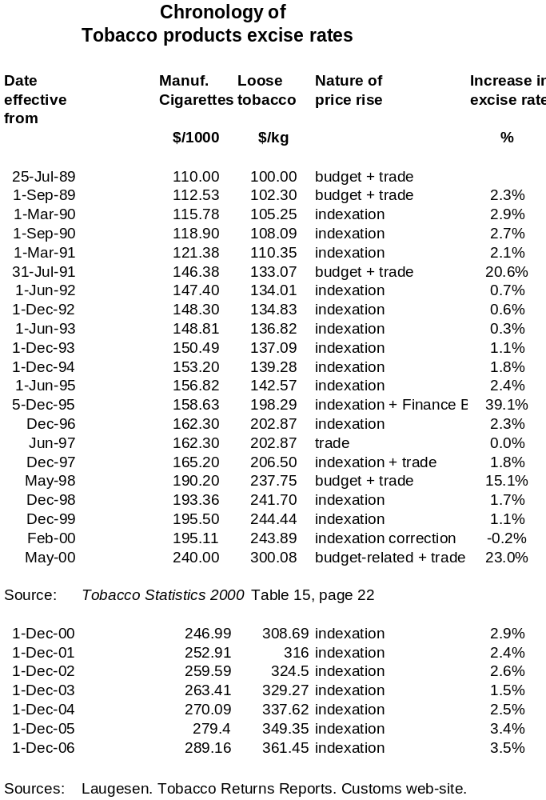

Quality-adjusted Life-years. Representing gains in both extra life-years, and in improved quality of life.
The current ‘value of statistical life’ of about $3 million used in transport sector decision-making implies a significantly higher value.
Some of the financial gain from not smoking could of course go to savings rather than consumption of other goods and services. Therefore, it is possible that a proportion, but probably a small proportion, of the additional GST revenue is due only to nicotine addiction.
On the new 2006 base the All Groups CPI had a value of 832 in June 1999. That is general consumer prices rose over the seven-year period by a factor of 1000/832 or by 20.2 percent. Series previously expressed in June 1999 prices have therefore been scaled up by this factor to give the series in June 2006 prices.
Note that the series has been adjusted for the change in the definition of ‘average population’ by Statistics NZ in 1991. Also the annual data on the release of cigarettes for consumption can be affected year-to-year by shifts in anticipation of tax increases. The long-term trends are, however, robust.
Tobias and Huang in a recent paper (2007) estimate that changes in smoking prevalence account for 48% of the fall in per capita tobacco consumption for the 1984-89 period, and for 39% thereafter, from 1989 to 2004. Conversely, changes in smoking intensity (cigarettes smoked per day) accounted for 52% and 61% of the fall in the two periods respectively. Given there are doubts about the health gains achievable from reducing consumption per head, as against those achievable from reducing smoking prevalence (see discussion in Section F.3 later in this report), the message they take is for the tobacco control programme to re-focus on helping smokers to quit and to stay quit.
That is the relative responsiveness of tobacco products consumption to a change in income.
The large increases in 2000 and 2001 are the consequence of the 23 percent tax-caused increase in May 2000. See Chronology at end of this report.
There are problems of comparability, however. One reviewer of this report comments that the Australian 2001 number is for those smoking daily. Whereas the New Zealand and Canadian prevalences are for all smokers. Adding ‘Weekly’ and ‘Less than weekly’ brings the Australian prevalences in 2001 to 25.7 percent for males, 20.8 percent for females, and 23.1 percent overall. For 2004 results are available from two Australian surveys. The AIHW survey (14+) gave an overall prevalence of 20.6 percent. The ABS 2004-05 survey (18+) gave 23.3 percent, compared with 24.2 percent in 2001. The AIHW and ABS sources are given in the References section of this report.
Though neither are they consistent with ‘manufactured cigarettes’ only.
Though, anecdotally, it is said that the volume of cheaper imports, legal and illegal, from Europe into the United Kingdom could be such that the actual average cost to smokers is significantly less than that shown here. Legitimate retailers of cigarettes in Northern Ireland are reported to have stated they would soon be out of business if illegal sales continued at their present level.
The price elasticity of demand may be, but is not necessarily, a constant. It can have different values for different prices for the commodity.
Salter appears to use ‘log-linear’ to label what Wilkins et al would call a ‘Double-Log’ formulation.
The econometrics of tobacco demand elasticity estimation is comprehensively covered in a World Bank publication from the Economics of Tobacco Toolkit. Wilkins et. al. 2001.
Chosen because it is available for a reasonably long time period in the past, and might be expected to reflect reasonably well changes in personal incomes (more so than broader measures such as GDP per capita) and also be more accurately estimated than income measures.
A generally unsuccessful attempt was made in Thomson et al (2000).
One reviewer would have preferred use of the value -0.45 for the price elasticity, as discussed just previously. The 0.50 is used simply for arithmetical convenience.
This value is used in a later section of this report for calculating the ‘equity impact’ of tobacco tax increases. Strictly the result holds exactly only for infinitesimal increases in the tax rate.
Actually about 4.5 percent assuming the demand function is ‘constant elasticity’. The formula here is more precise when the tax increases are relatively small.
For discussion on this point see Single et al 2003; Appendix C.
Academics teaching health economics tend to warn their students against ‘cost of illness’ studies. This is because they often are intended largely to produce “Gee whiz” numbers. Also to measure the cost of a disease can seem to have little point unless interventions to reduce the burden of the disease are being offered at the same time. It can be said, however, that in this report we do offer the remedy of increasing tobacco taxes, and it is of some interest to know the total cost burden which it is hoped to reduce.
Benefits of smoking are discussed in Section B.5 following.
The difference, at least in the New Zealand estimates, is mainly accounted for by differences in the discount rate used. This is when matching the sum of future discounted life years to Land Transport’s ‘Value of Statistical life’. Contrary to what might be expected, the higher the discount rate, the lower the sum of discounted life-years, and hence the higher each life-year’s value needs to be to match the Value of Statistical life.
In turn using an earlier estimate of Collins and Lapsley that 89 percent of all tobacco consumption in Australia was addictive
It is possible to calculate the approximate ‘fiscal savings’, using the ‘prevalence approach’, by applying average pension rates to those extra persons who would be living and aged 65 and over, had there been no smoking in the past.
Often labelled as ‘social costs’ as distinct from ‘private costs’. For example in Collins and Lapsley (2002) pages 17+.
Collins and Lapsley though would regard costs borne by smokers as also being external costs. Collins and Lapsley, 2002. Page 18.
The very recent work by Viscusi and Hersch (2007) shows just how substantial estimates of the ‘mortality cost’ of smoking can be. Using a new approach to estimating the value of a life year lost from smoking, they estimate the mortality cost at US$222 per pack for men and US$94 for women.
The exchange rate in mid-2007 was of the order of NZ$1 = US$0.75.
This second 50 cent increase consisted predominantly of a price increase by tobacco manufacturers to offset settlement costs from the Multistate Master Settlement Agreement to pay California and 45 other states $206 billion over the next 25 years. There was yet another 22 cents increase in late 1999.
The terms ‘quitters’ and ‘non-quitters’ are a convenient short-hand, so long as it is remembered that ‘quitters’ include those non-smokers deterred by the price increase from taking up smoking, in addition to smokers who quit.
See, for example, Tobias, M., & Cheung, J. (2001). Inhaling inequality: Tobacco's contribution to health inequality in New Zealand. Ministry of Health. Wellington. 2001.
Also life tables constructed in the 1990s do not take account of subsequent research, in particular that undertaken as part of the New Zealand Census-Mortality Study (NZCMS), which has achieved a better match of ethnicity status between mortality and population data. One result of this more recent research has been to show a somewhat larger gap between Māori and non- Māori life expectancies than shown by the numbers used here.
It is possible these reductions in female life expectancies will increase in future, as these numbers could still be reflecting historic prevalence patterns when females had on average fewer years as regular smokers due to later uptake, which will not be the case in the future.
Woolacott NF, Jones L, et al. (2002). ‘The clinical effectiveness and cost-effectiveness of bupropion and nicotine replacement therapy for smoking cessation: a systematic review and economic evaluation.’ Health Technology Assessment. 6:16. September 2002. Pages 1-251.
O’Dea D. June 2004. ‘An Economic Evaluation of the Quitline Nicotine Replacement Therapy (NRT) Service.’ Report to the New Zealand Ministry of Health.
QALYs are a broader measure of ‘health gain’ than life-years gained. They take account of both the improved quality of life because of reduced morbidity, and the extra life-years lived from eliminating premature mortality. There is a substantial literature on the estimation of QALYs and their interpretation. See Drummond et al. 2005.
Godtfredsen N S, Holst C, Prescott E, Vestbo J, and Osler M. (2002). ‘Smoking Reduction, Smoking Cessation, and Mortality: A 16-year Follow-up of 19,732 Men and Women from the Copenhagen Centre for Prospective Population Studies.’ American Journal of Epidemiology. 2002; 156:994-1001. http://aje.oupjournals.org And Tverdal A and Bjartveit K. (2006). ‘Health consequences of reduced daily cigarette consumption.’ Tobacco Control 2006;15:472-480
Gifford, Heather. October 2003. He Arorangi Whakamua. Reducing the uptake of tobacco in Ngāti Hauiti Rangatahi. Ph.D. Thesis (unpublished), Massey University, New Zealand.
How much downside? Quantifying the relative harm from tobacco taxation. N Wilson, G Thomson, M Tobias, T Blakely. J Epidemiol Community Health 2004;58:451–454. doi: 10.1136/jech.2003.01152
The deciles are ranked from Decile 1 – the ‘poorest’ – to Decile 10 – the ‘richest’.
These percent numbers are more exact for small changes, but are still a good approximation for large changes.
That is, costs not borne directly by the smoker him/herself, but by others. For example, publicly-funded health-care costs for smoking-attributable illness; and illness and premature mortality caused by second-hand smoking.
A conservative value, as follows from the earlier discussion in Part B, section B.3, of this report.
Tobacco taxation and public health: ethical problems, policy responses. Nick Wilson, George Thomson. Social Science & Medicine 61 (2005) 649–659. The section on page 654 of that paper on ‘Reducing the conflict between benefits and harms of tobacco taxation’ is particularly relevant.
By ‘real increase’ is meant an increase in excess of general price inflation.

