OPC - Processo de Coaching

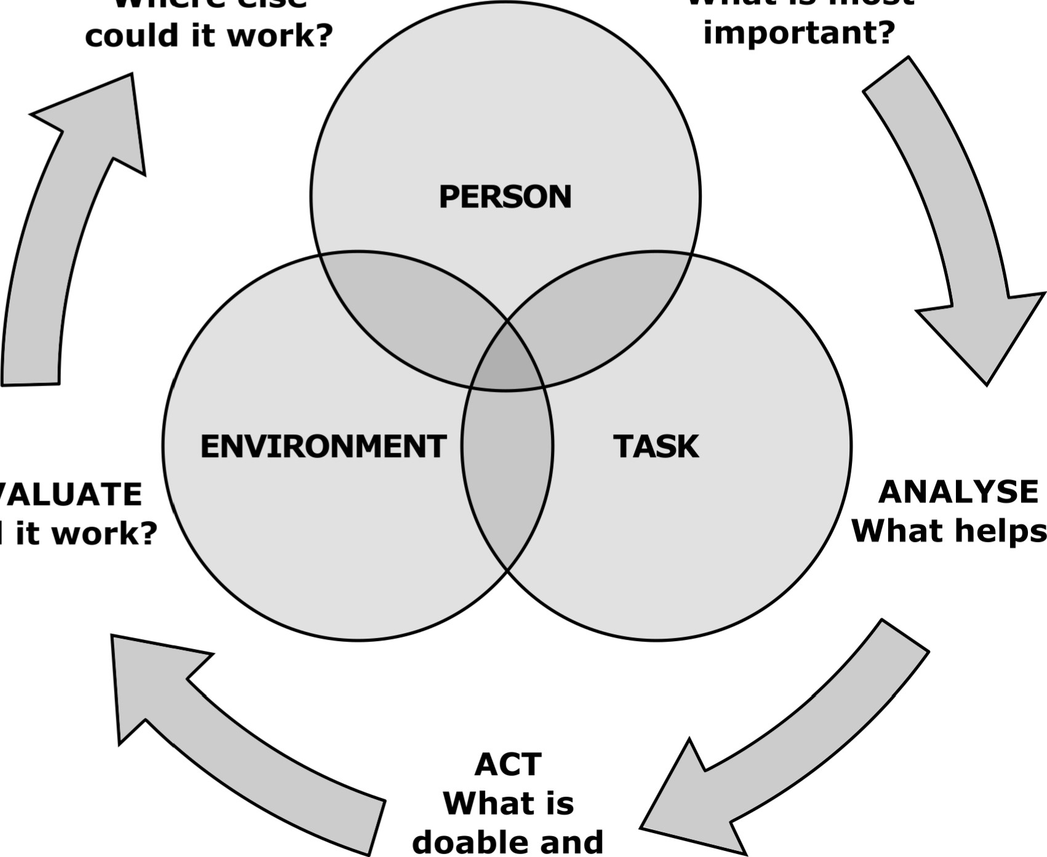
PESSOA
AMBIENTE
TAREFA
AVALIAR
o que é factível e provável que funcione
AGIR
ESCLARECER OBJETIVO
O que é mais
Importante?
GENERALIZAR

O que ajuda?
ANALISAR
Funcionou?
Onde mais poderia funcionar?

Suggested citation: Graham, F., (2020), Occupational Performance Coaching (OPC) Coaching Process. Retrieved from https://www.otago.ac.nz/opc (date retrieved). University of Otago.
cc
BY NC ND
First published Graham, F. (2020), Occupational Performance Coaching Resources.
This work is licensed under a Creative Commons Attribution-NonCommercial-NoDerivatives 4.0 International License.
University of Otago.

