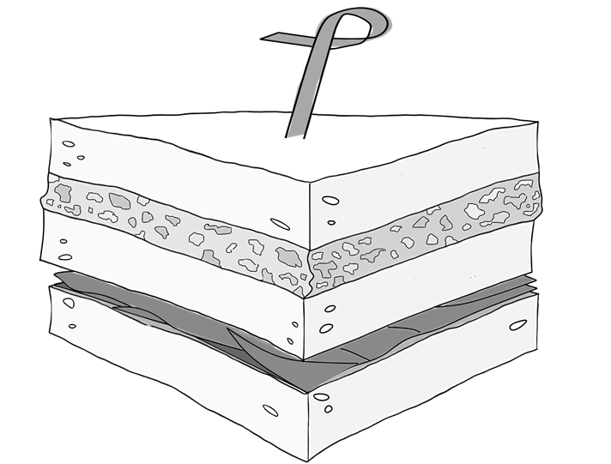
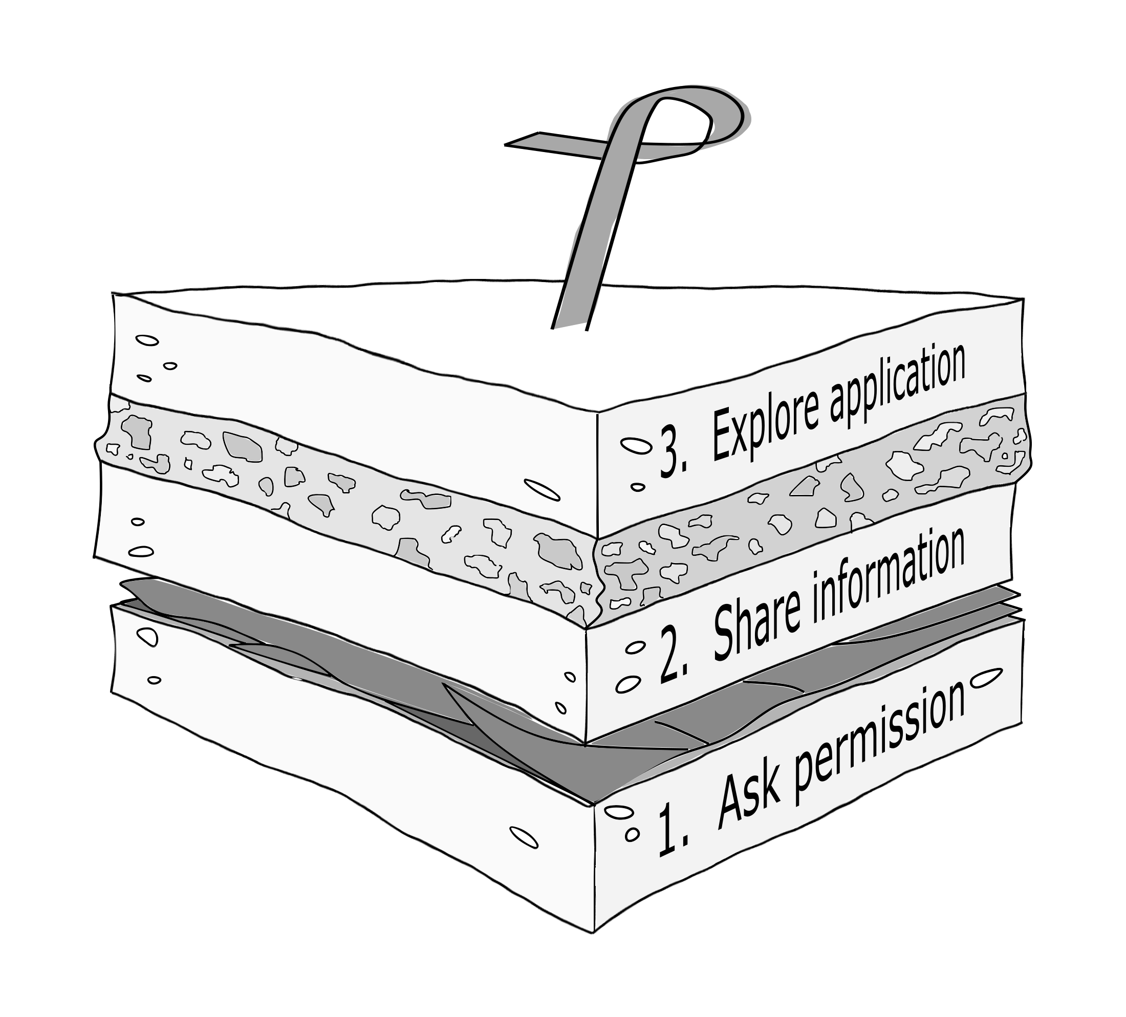
First published Graham, F. (2020), Occupational Performance Coaching Resources. This work is licensed under a Creative Commons Attribution-NonCommercial-NoDerivatives 4.0 International License. University of Otago.

OPC- Guia do Clube de Informações para Compartilhar informações
- Pedir permissão
3. Explorar aplicação
2. Compartilhar Info

